Amit Nijjar

A11489111

CSE 150 Assignment 5

Part 1

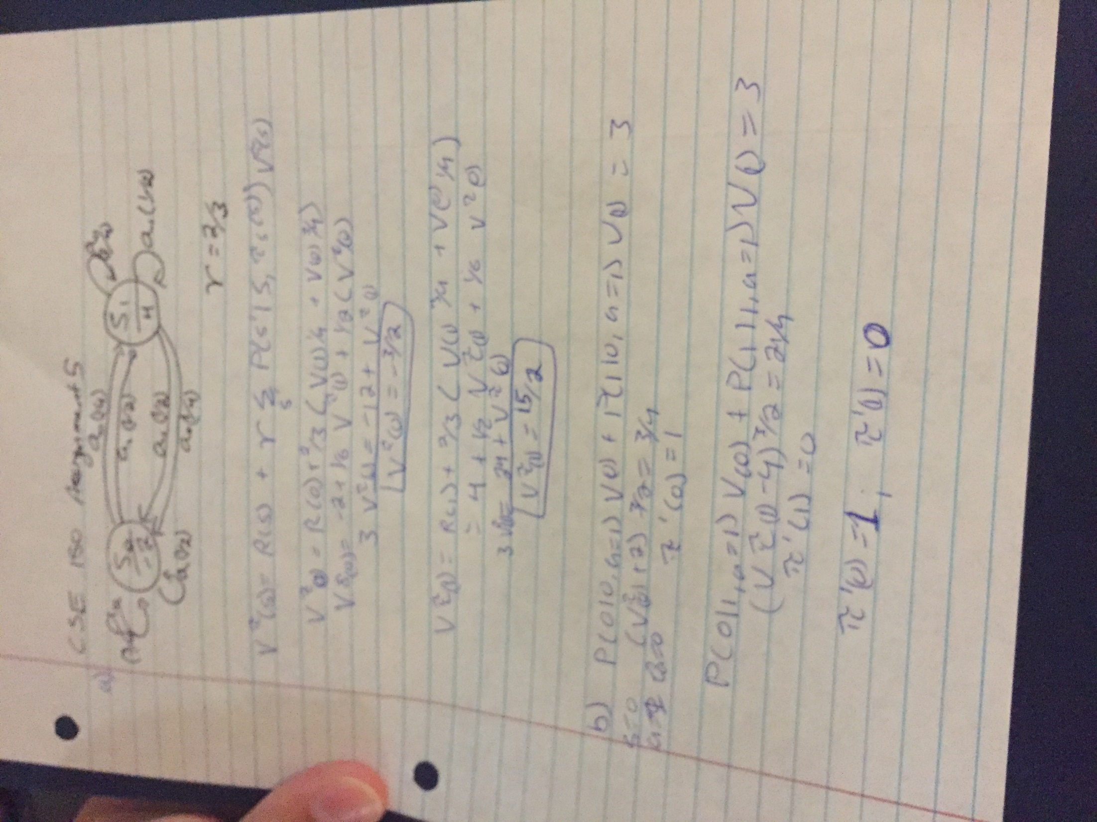

Part 2

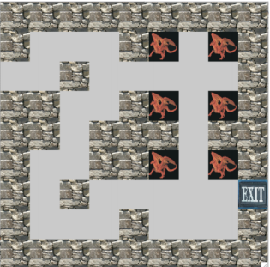

I made a mdp object to make things simpler. The first part of both files are similar, with different imports.

1. Values:
   1. (3, 71.39423924450648, 'EAST')
   2. (11, 72.98307548141419, 'EAST')
   3. (12, 72.17386511668235, 'NORTH')
   4. (15, 79.8281034704119, 'SOUTH')
   5. (16, 80.72376573333952, 'SOUTH')
   6. (17, 81.62947722483922, 'EAST')
   7. (20, 73.80192201304537, 'EAST')
   8. (22, 77.20028225357903, 'SOUTH')
   9. (23, 78.06648130841413, 'SOUTH')
   10. (24, 78.94237892205466, 'WEST')
   11. (26, 82.54535069648871, 'EAST')
   12. (29, 74.62997079468701, 'SOUTH')
   13. (30, 75.46731058752621, 'SOUTH')
   14. (31, 76.34295045844954, 'WEST')
   15. (34, 84.40804092457351, 'EAST')
   16. (35, 83.4715001645621, 'NORTH')
   17. (39, 74.39781781782916, 'WEST')
   18. (43, 85.35508956563932, 'EAST')
   19. (48, 64.8863097098779, 'WEST')
   20. (52, 86.3127639849926, 'EAST')
   21. (53, 90.51903456910568, 'EAST')
   22. (56, 59.66756995481123, 'SOUTH')
   23. (57, 68.94981992730506, 'SOUTH')
   24. (58, 70.31432055607144, 'SOUTH')
   25. (59, 80.32521158926627, 'SOUTH')
   26. (60, 81.47292839949202, 'SOUTH')
   27. (61, 92.20298052160265, 'EAST')
   28. (62, 91.62118640382897, 'EAST')
   29. (66, 59.66756995481123, 'WEST')
   30. (70, 93.67475869133705, 'EAST')
   31. (71, 92.63575448194284, 'NORTH')
   32. (79, 99.9999999999992, 'EAST')
2. Policy:
   1. (3, 'EAST')
   2. (11, 'EAST')
   3. (12, 'NORTH')
   4. (15, 'SOUTH')
   5. (16, 'SOUTH')
   6. (17, 'EAST')
   7. (20, 'EAST')
   8. (22, 'SOUTH')
   9. (23, 'SOUTH')
   10. (24, 'WEST')
   11. (26, 'EAST')
   12. (29, 'SOUTH')
   13. (30, 'SOUTH')
   14. (31, 'WEST')
   15. (34, 'EAST')
   16. (35, 'NORTH')
   17. (39, 'WEST')
   18. (43, 'EAST')
   19. (48, 'WEST')
   20. (52, 'EAST')
   21. (53, 'EAST')
   22. (56, 'SOUTH')
   23. (57, 'SOUTH')
   24. (58, 'SOUTH')
   25. (59, 'SOUTH')
   26. (60, 'SOUTH')
   27. (61, 'EAST')
   28. (62, 'EAST')
   29. (66, 'WEST')
   30. (70, 'EAST')
   31. (71, 'NORTH')
   32. (79, 'NORTH')
3. The way I computed value is I made two lists and got all the probabilities of all of the states. I copied them to a list and recalculated the probabilities with discount factors to get neighboring states. Then I updated the list so that in the end it would contain the maximum utility per state
4. Implementing policy evaluation I used the policy parameter to get the evaluated utility for each of the individual states

I did this assignment on my own.