**Front-End Engineering**

#### Submitted by

**Amitoz Singh (2110990164)**

#### Group🡺 G05

#### in partial fulfillment for the award of the degree of

## BACHELEOR OF ENGINEERING

***in***

COMPUTER SCIENCE & ENGINEERING



**CHITKARA UNIVERSITY**

**CHANDIGARH-PATIALA NATIONAL HIGHWAY**

**RAJPURA (PATIALA) PUNJAB-140401 (INDIA)**

##### May, 2023

###### TABLE OF CONTENTS

|  |  |  |
| --- | --- | --- |
| **Sr. no** | **Section** | **Page no.** |
| **1** | Introduction | **3** |
| **2** | Problem statement | **3** |
| **3** | Technical Details | **4** |
| **4** | Key Features | **5** |
| **5** | Project Advantages | **6** |
| **6** | Bonus Feature | **7-8** |
| **7** | Result | **9-11** |
| **8** | Conclusion and Future Scope | **12** |

**1. Introduction**

**1.1 Clothing Landing Page**

Welcome to Urban Wardrobe, where fashion meets individuality! Our online clothing emporium is a curated haven for fashion enthusiasts who seek trendy, versatile, and distinctive apparel. Explore a world of style and expression with our unique fashion collections, designed to elevate your wardrobe and make every day a fashion statement.

It is specifically designed for the targeted audience which can vary from various age groups and genders.

**2. Problem Statement**

The clothing website faces multiple challenges, including inconsistent sizing and fit issues leading to high return rates, limited personalization options causing reduced customer engagement, slow loading times resulting in potential customer abandonment, inadequate mobile optimization hindering mobile user experience, a lack of sustainable fashion options potentially alienating eco-conscious customers, and customer support challenges that may impact brand reputation and customer retention.

Another challenge in creating a landing page is ensuring that it is optimized for search engines. This involves using relevant keywords in your content and meta tags, as well as ensuring that your website is mobile-friendly and has a fast loading speed. Failure to optimize your page can result in low search engine rankings and reduced visibility, which can ultimately lead to lower sales.

**3. Technical details**

The technical details of a shoe product landing page are crucial to its success. One important aspect is the use of high-quality images that showcase the shoes from multiple angles and in different lighting conditions.

In addition to visual and descriptive elements, there are also technical considerations that must be taken into account.

It should also be designed with mobile devices in mind, as more and more people are using their phones to browse and shop online.

**The Front-End technologies that are used to implement this project are:**

**3.1 HTML**

The Hypertext Markup Language or HTML is standard markup language for documents designed to be displayed in a web browser. Hypertext defines the link between the web pages and markup language defines the text document within the tag that define the structure of web pages.

.

**3.2 CSS**

CSS or cascading style sheets is used for styling and formatting HTML documents. It is used to define styles for HTML elements such as fonts, colors, spacing and layout. It can be used to create a layout — for example turning a single column of text into a layout with a main content area and a sidebar for related information. It can even be used for effects such as animation.

**3.3 Java Script**

JavaScript is a programming language used to add interactivity and functionality to websites. It is commonly used to create dynamic effects, responsive and interactive web pages.  Earlier JavaScript was used to build client-side applications only, but with the evolution of its frameworks namely Node.js and Express.js, it is now widely used for building server-side applications too.

**3.4 VS CODE**

Visual studio code is a free and open-source code editor developed by Microsoft and is designed for building and debugging web and cloud applications. Visual Studio Code is a streamlined code editor with support for development operations like debugging, task running and version control.

.

# 4. Key Features

**4.1 Eye-Catching Homepage:** As soon as visitors land on the homepage, they should be able to get a clear and attractive picture of how to navigate the portal.

**4.2 Easy To Navigate:** The website provides an easy to use, user friendly interface where user is able to choose and buy various shoe products. Our project has scroll navigation.

**4.3 Compatible and Responsive Website:** Customers will be able to use our website in desktop view as well as tablet view.

**4.4 Interactive Dashboard:** A fun and functional dashboard can engage your visitors better and compel them to choose shoe product from the list.

**4.5 Slider Product Catalogue:** Customers can slide left or right to see our products wall which is designed in a contemporary way to help our users navigate easily.

**4.6 Payment Gateway:** A billing option where customers can buy their suited product with just a few clicks.

**4.7Contact Handles:** Contact through mail helps visitors to interact with us and give them a chance to ask anything 24/7.

**5. PROJECT ADVANTAGES**

**5.1 Cost-Effective:** Compared to traditional marketing methods like print or television ads, creating a product landing page using HTML and CSS can be a cost-effective way to promote products and services.

**5.2 Improved User Engagement:** A well-designed product landing page can increase user engagement by providing relevant information about the product in an attractive and easy-to-understand format.

**5.3 Customizable:** With HTML and CSS, developers can create fully customizable landing pages that can be tailored to specific target audiences. This allows for greater flexibility in design and messaging, which can help improve overall marketing efforts.

**5.4 More Conversions and More Leads:** Because landing pages have a single focus and target a specific audience, they have significantly higher conversion rates.

**5.5 We Can Develop Targeted Content For Specific Audiences:** Because landing pages are so targeted, you can get super specific with your messaging, imagery, and offer to ensure it speaks exactly to the audience you’re after.

**6. Bonus feature**

**6.1** Landing pages are an effective way to convert website visitors into leads and sales. Because they have fewer distractions than your homepage and other pages on your site, users are more likely to join your email list or buy your products or services.

However, to accept secure payments on our landing page, we needed a payment processor.

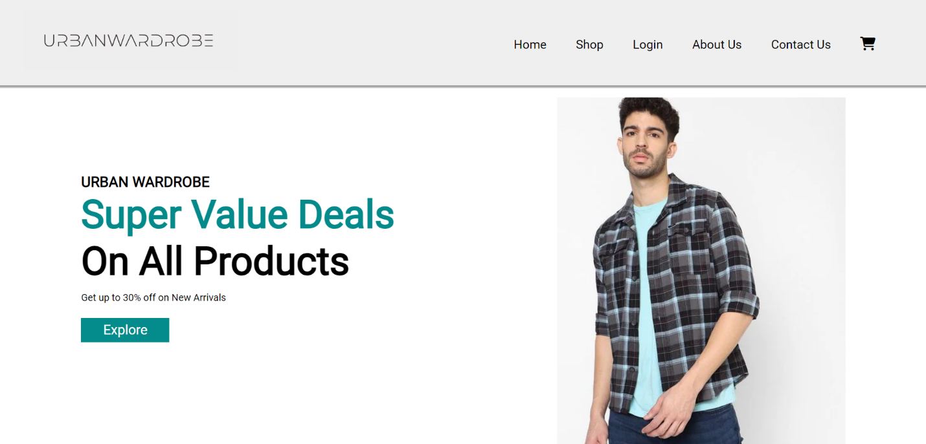

**6.2** Payment services like this allow shoppers to pay via direct bank transfer, credit card, and other online payment options.

**6.3** The bonus feature of the project is a payment processor where customers will be redirected to the payment/billing page once they click on the “BUY NOW” button under our product catalogue section.

**6.4** Our main goal was to make online shopping easier for our customers. Under each product, there is a “BUY NOW” button. That button will perform the function of redirecting our customers to the billing page where they will be able to buy their desired products. Online shopping is made easy with the help of our project.

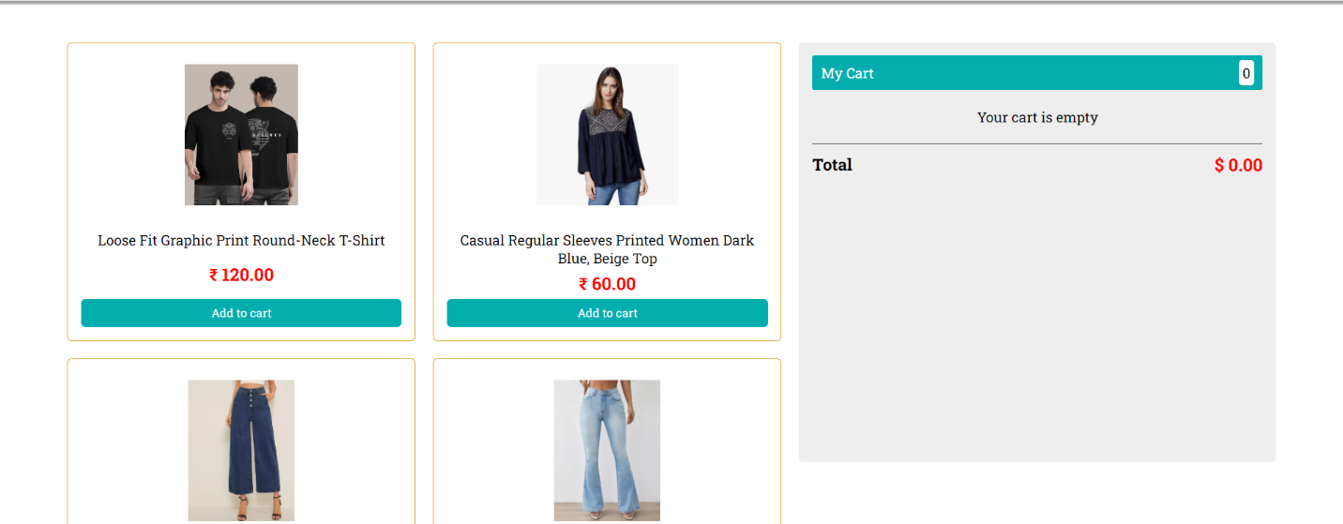

**6.5** Customers will be redirected to the billing page as follows, where they will be asked about their shipping/billing address which includes their full name, email, address, city, state & zip and Payment method which includes various accepted cards, name on card, credit card number, expiry month, expiry year & CVV.

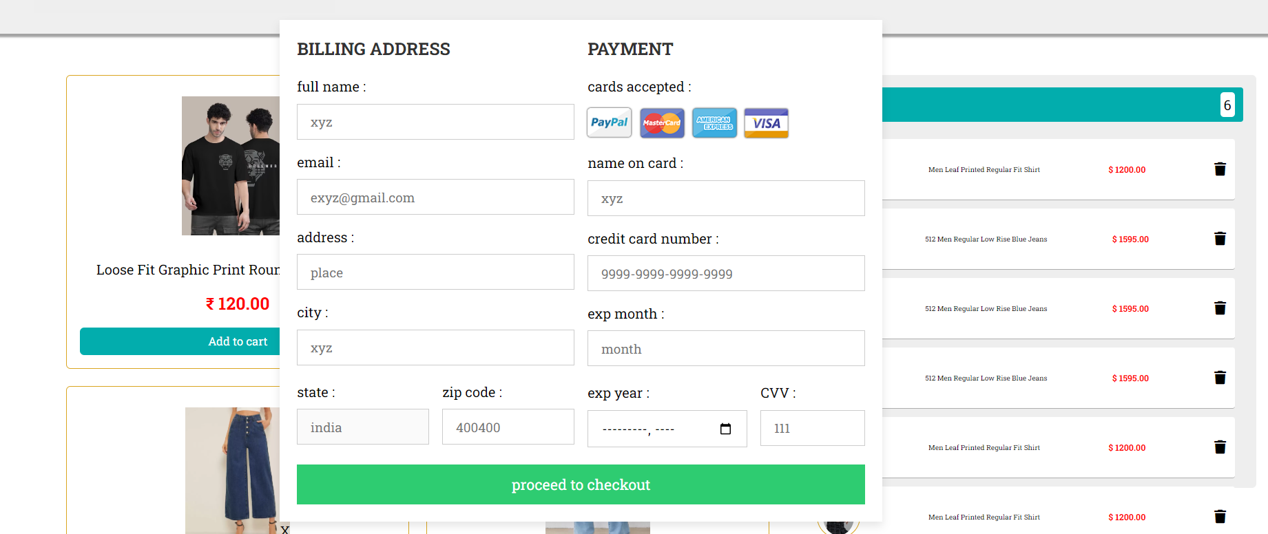

**6.6** Therefore, online shopping for our new customers is made easy. As with just a few clicks, the desired product will be shipped with the help of our secured payment gateway.

**7. Results**

**7.1 Home Page:** It shows off the brand, lets people explore a range of products, and offers additional info about the company and its values.

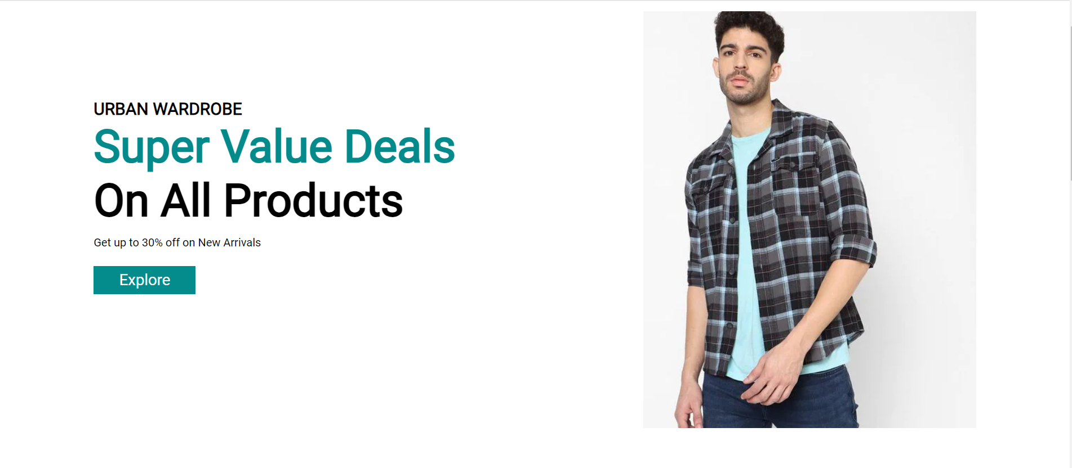

**7.2 About Page:** About page is a goal-oriented sales page, one that focuses on highlighting the biggest selling points of your story and brand, making a strong first impression on curious customers



**7.3 Features Page:** The features page is used to describe and demonstrate your SaaS product or software. In order words, the features page is your sales pitch. Building the best features page is now a simple task. There is not a perfect recipe to build the best features page as not all SaaS products are the same.

**7.4 Product Page:** Product page is a page on a website that describes a particular product or service. This can include specific specs and features, and it may also provide information about the manufacturer and brand. Product page is designed in a way where you can just click on the product name and it will slide to that product. With a functioning “BUY NOW” button, we have made our website more accessible for our users.

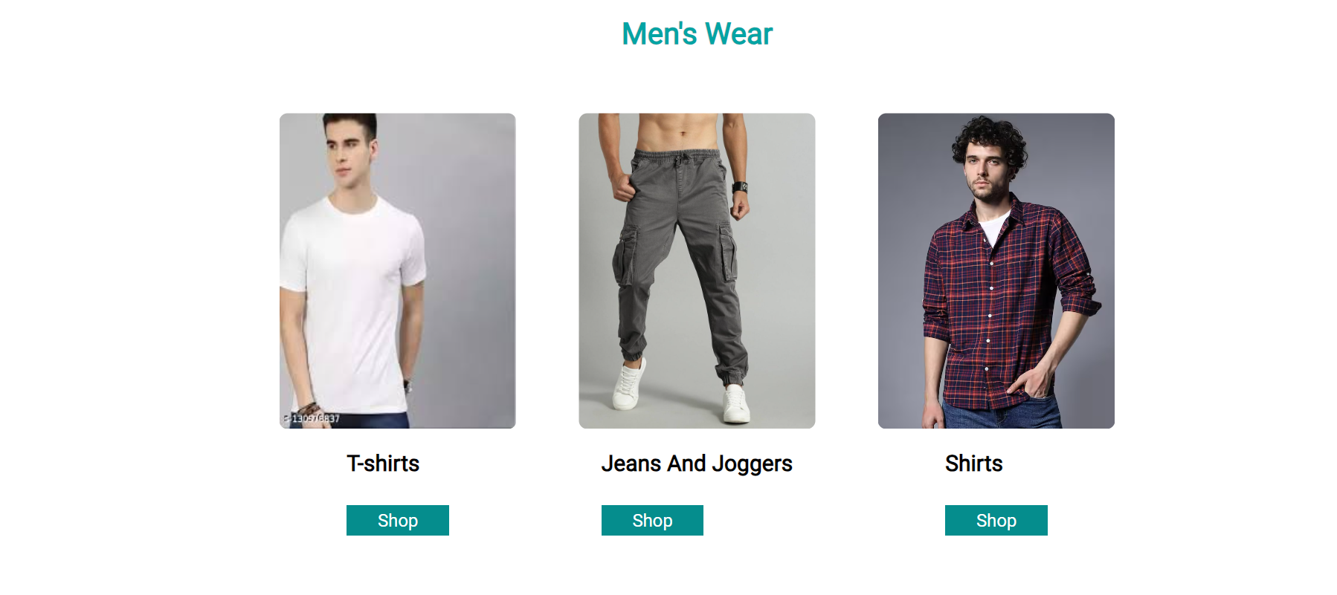

**7.5 Contact Page:** A contact page is a common web page on a website for visitors to contact the organization or individual providing the website. Users can leave comments or messages for us to know more about latest updates with their emails.

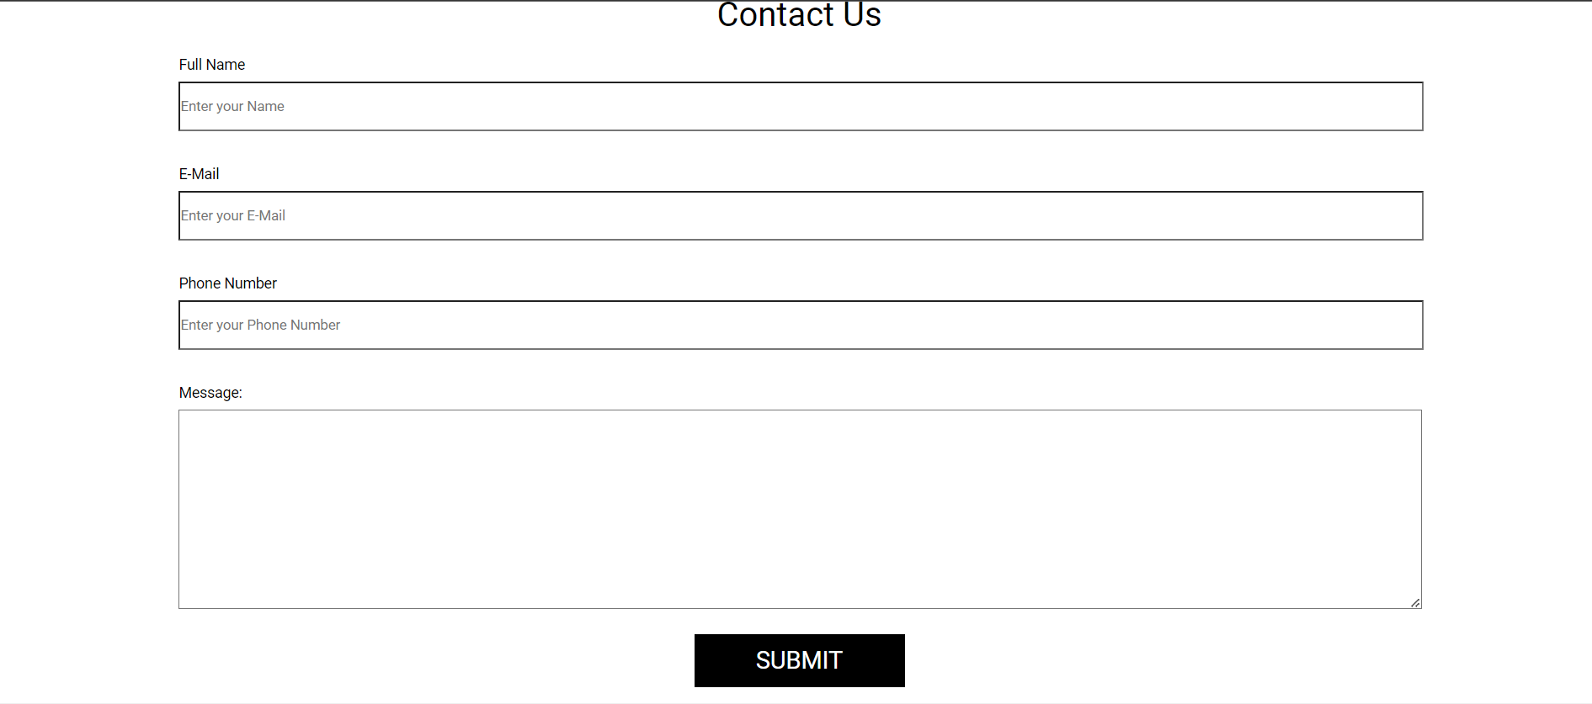

**8. Conclusion with Future scope**

**8.1 Conclusion of the Project**

The Electronics Store is a simple and modern website that promotes and markets products. The website uses HTML, CSS and JAVASCRIPT technologies to structure and style the content of the website. The website is fully responsive and accessible on different devices and screen sizes. The project code is well-structured, organized, and easy to maintain.

Overall, the project was successful in achieving its objectives and provides a high-quality user experience. The project's advantages include increasing brand awareness, generating leads and conversions, and improving customer engagement. In the future, the project could be further developed to include additional features such as interactive product demos or customer testimonials, which would further enhance the user experience and drive sales.

**8.2 Future Scope:**

The future scope of the product landing page project could be to further enhance its functionality and user experience. Another possible improvement could be to making it easier for potential customers to find the product through online searches and a customize feature where users will be able to customize the shoes according to their need. Lastly, incorporating user reviews and ratings on the product page could provide valuable feedback to the company and increase customer trust and satisfaction.