Computer Networks and Security Lab

18B15CS212

(ODD, 2021)

Assignment - 3

**Wireshark**

Patil Amit Gurusidhappa

19104004

B11

Q1. UDP, STUN, HTTP

Q2. 0.363796 Sec

Q3.

IITD IP Address: 128.119.245.12

Internet Address of my computer 

Q4. 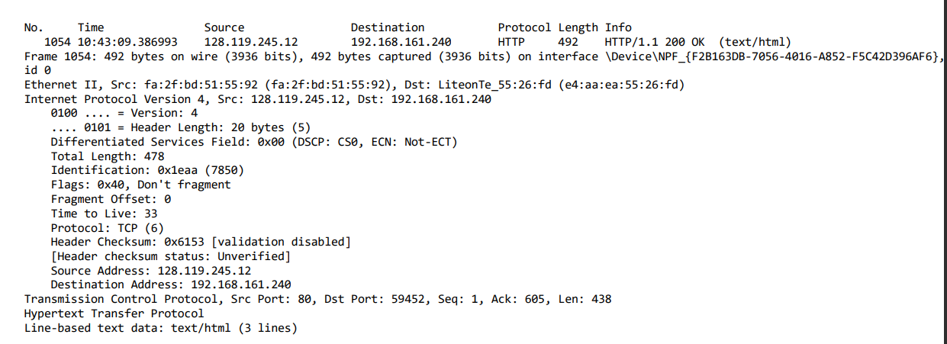

Q5.

Length 1484

Q2.1

import pandas as pd

df = pd.read_csv("ComputerNetworkAndSecurity\Assignment3\exported_pcap.csv", usecols=[

                 'Source', 'Destination'])

print(df)

"""

             Source      Destination

0   145.254.160.237   65.208.228.223

1    65.208.228.223  145.254.160.237

2   145.254.160.237   65.208.228.223

3   145.254.160.237   65.208.228.223

4    65.208.228.223  145.254.160.237

5    65.208.228.223  145.254.160.237

6   145.254.160.237   65.208.228.223

7    65.208.228.223  145.254.160.237

8   145.254.160.237   65.208.228.223

9    65.208.228.223  145.254.160.237

10   65.208.228.223  145.254.160.237

11  145.254.160.237   65.208.228.223

12  145.254.160.237    145.253.2.203

13   65.208.228.223  145.254.160.237

14  145.254.160.237   65.208.228.223

15   65.208.228.223  145.254.160.237

16    145.253.2.203  145.254.160.237

17  145.254.160.237    216.239.59.99

18  145.254.160.237   65.208.228.223

19   65.208.228.223  145.254.160.237

20   65.208.228.223  145.254.160.237

21  145.254.160.237   65.208.228.223

22   65.208.228.223  145.254.160.237

23    216.239.59.99  145.254.160.237

24  145.254.160.237   65.208.228.223

25    216.239.59.99  145.254.160.237

26    216.239.59.99  145.254.160.237

27  145.254.160.237    216.239.59.99

28   65.208.228.223  145.254.160.237

29  145.254.160.237   65.208.228.223

30   65.208.228.223  145.254.160.237

31   65.208.228.223  145.254.160.237

32  145.254.160.237   65.208.228.223

33   65.208.228.223  145.254.160.237

34  145.254.160.237   65.208.228.223

35    216.239.59.99  145.254.160.237

36  145.254.160.237    216.239.59.99

37   65.208.228.223  145.254.160.237

38  145.254.160.237   65.208.228.223

39   65.208.228.223  145.254.160.237

40  145.254.160.237   65.208.228.223

41  145.254.160.237   65.208.228.223

42   65.208.228.223  145.254.160.237 """

Q2

import pandas as pd

import re as re

df = pd.read_csv("ComputerNetworkAndSecurity\Assignment3\exported_pcap.csv", usecols=[

                 'Info'])

contain_val = df[df['Info'].str.contains('>')]

for ind in contain_val.index:

    splitArray = contain_val['Info'][ind].split(">")

    print(splitArray[0], re.search(r'\d+', splitArray[1]).group())

    print('\n')

"""

3372   80

80   3372

3372   80

80   3372

80   3372

3372   80

80   3372

3372   80

80   3372

80   3372

3372   80

80   3372

3372   80

80   3372

3372   80

80   3372

80   3372

3372   80

80   3372

80   3371

3372   80

80   3371

3371   80

80   3372

3372   80

 """

Q3.

import pandas as pd

df = pd.read_csv("ComputerNetworkAndSecurity\Assignment3\exported_pcap.csv", usecols=[

                 'Info', 'Protocol'])

contain_val = df[df['Protocol'].str.contains('HTTP')]

# for ind in df.index:

#     val = df['Info'][ind]

#     print(val)

print(contain_val)

"""

    Protocol                                               Info

3       HTTP                       GET /download.html HTTP/1.1

17      HTTP  GET /pagead/ads?client=ca-pub-2309191948673629...

26      HTTP                       HTTP/1.1 200 OK  (text/html)

37  HTTP/XML                                   HTTP/1.1 200 OK

"""