Computer Networks and Security Lab

18B15CS212

(ODD, 2021)

Assignment - 5

Patil Amit Gurusidhappa

19104004

B11

## **Nslookup -type**

* Practise
* 142.250.192.46

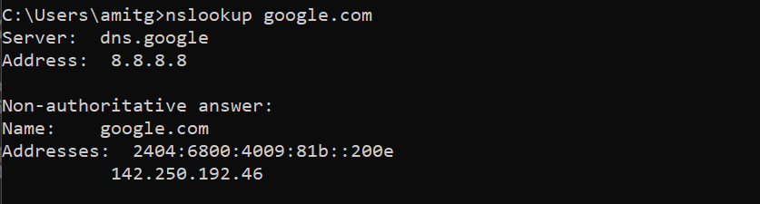

172.28.48.1#53

* 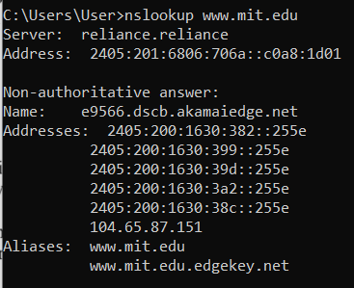
* 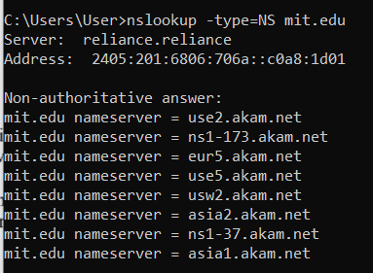
* 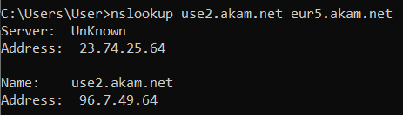
* Questions ⇒

1. 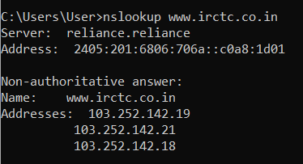
2. 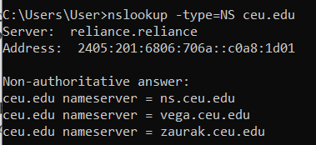
3. 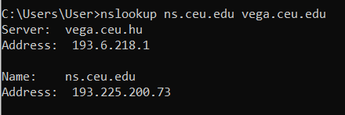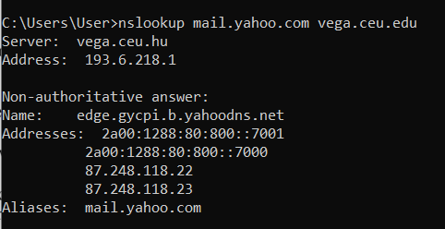

## **ipconfig**

* Practice
* 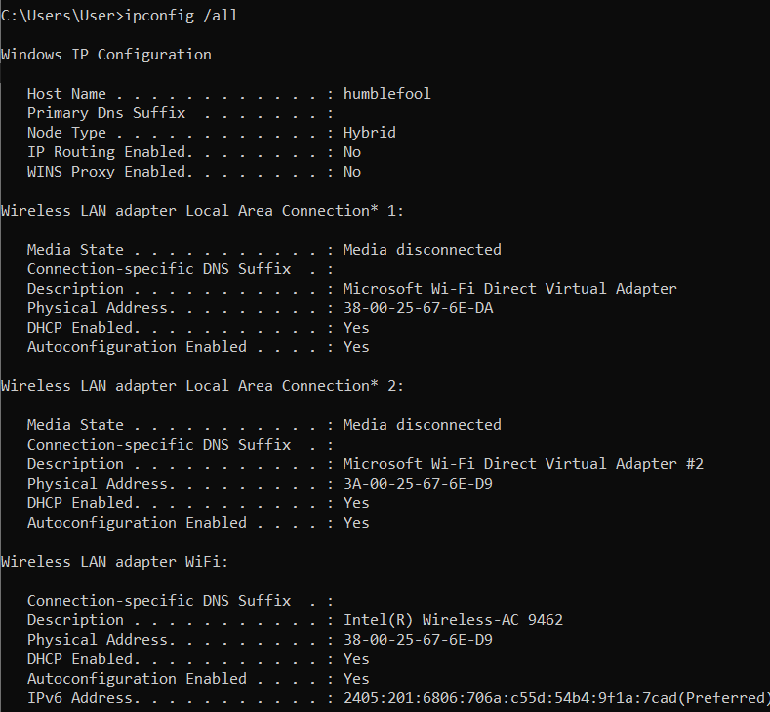
* 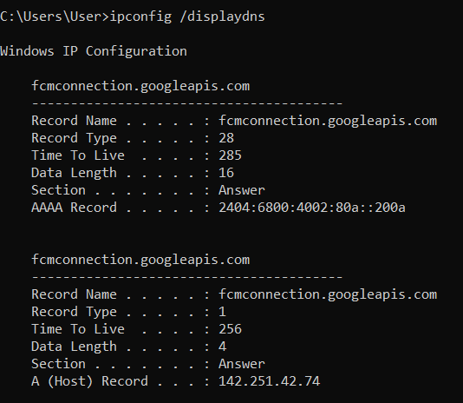
* 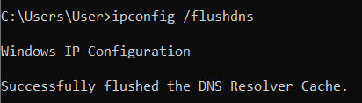

## **Tracing DNS with wireshark**

* my_ip_address= 192.168.29.224

1. Sent over UDP 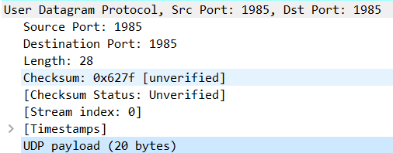
2. DNS
3.  destination IP address, I used the given dns1 file because the [SYN] Packets were not visible otherwise, thus ipconfig cannot be used to confirm this
4. 72 standard query

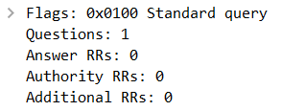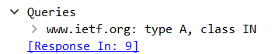

No answers wirth type A query

1. 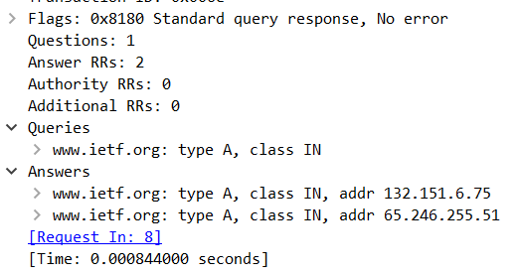

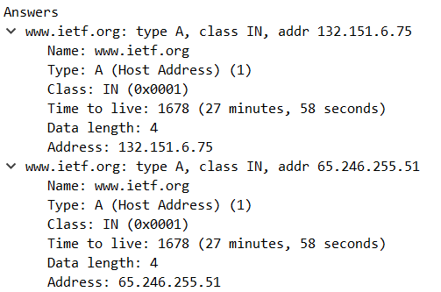

1. 



They both match the answer and the destination address of SYN

1. The DNS query was only on the top once and all the images came one by one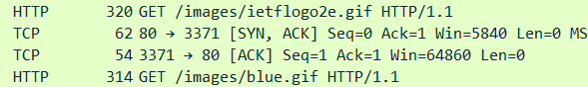
2. 
3. 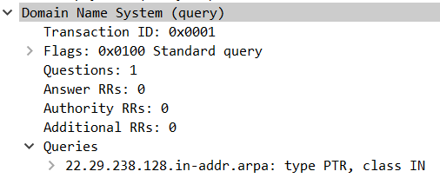
4. 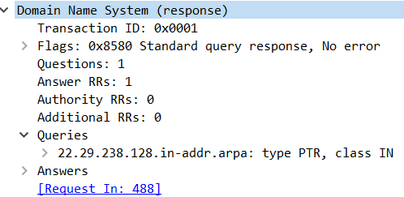

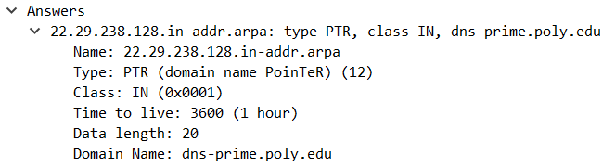

yes

## **TCP Protocol**

1. 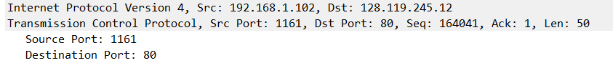
2. 

Source id the IP address of website

1. 

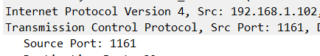

1. First SYN packet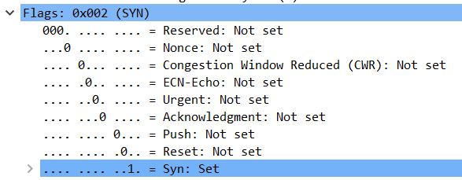
2. response

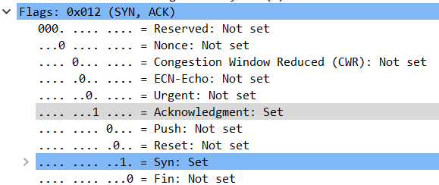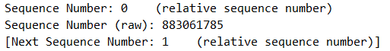

1. HTTP post command

