Computer Networks and Security Lab

18B15CS212

(ODD, 2021)

Assignment – 7

Introduction to NS2 and Creation of Wired Network Scenarios

Patil Amit Gurusidhappa

19104004

B11

Practice: Two nodes connected with an edge

#Create a simulator object

set ns [new Simulator]

#Open the nam trace file

set nf [open out.nam w]

$ns namtrace-all $nf

#Define a 'finish' procedure

proc finish {} {

        global ns nf

        $ns flush-trace

        #Close the trace file

        close $nf

        #Execute nam on the trace file

        exec nam out.nam &

        exit 0

}

#Create two nodes

set n0 [$ns node]

set n1 [$ns node]

#Create a duplex link between the nodes

$ns duplex-link $n0 $n1 1Mb 10ms DropTail

#Create a UDP agent and attach it to node n0

set udp0 [new Agent/UDP]

$ns attach-agent $n0 $udp0

# Create a CBR traffic source and attach it to udp0

set cbr0 [new Application/Traffic/CBR]

$cbr0 set packetSize_ 500

$cbr0 set interval_ 0.005

$cbr0 attach-agent $udp0

#Create a Null agent (a traffic sink) and attach it to node n1

set null0 [new Agent/Null]

$ns attach-agent $n1 $null0

#Connect the traffic source with the traffic sink

$ns connect $udp0 $null0

#Schedule events for the CBR agent

$ns at 0.5 "$cbr0 start"

$ns at 4.5 "$cbr0 stop"

#Call the finish procedure after 5 seconds of simulation time

$ns at 5.0 "finish"

#Run the simulation

$ns run

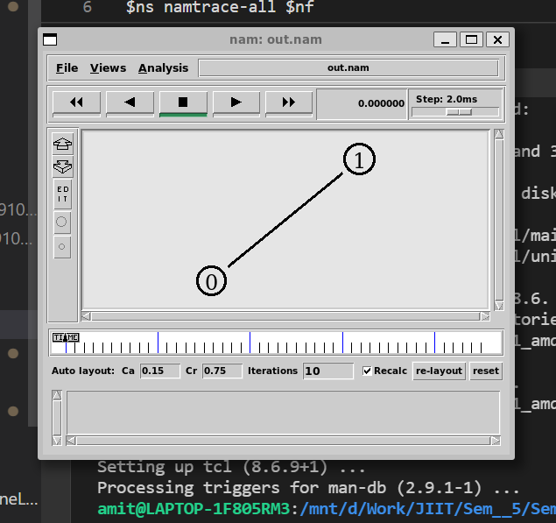

Q1. Build the following two wired network topologies

#Create a simulator object

set ns [new Simulator]

#Open the nam trace file

set nf [open out.nam w]

$ns namtrace-all $nf

#Define a 'finish' procedure

proc finish {} {

        global ns nf

        $ns flush-trace

    #Close the trace file

        close $nf

    #Execute nam on the trace file

        exec nam out.nam &

        exit 0

}

#Create two nodes

set n1 [$ns node]

set n2 [$ns node]

set n3 [$ns node]

set n4 [$ns node]

set n5 [$ns node]

#Create a duplex link between the nodes

$ns duplex-link $n1 $n4 1Mb 10ms DropTail

$ns duplex-link $n2 $n4 1Mb 10ms DropTail

$ns duplex-link $n3 $n4 1Mb 10ms DropTail

$ns duplex-link $n4 $n5 1Mb 10ms DropTail

#Create a UDP agent and attach it to node n1

set udp0 [new Agent/UDP]

$ns attach-agent $n1 $udp0

# Create a CBR traffic source and attach it to udp0

set cbr0 [new Application/Traffic/CBR]

$cbr0 set packetSize_ 500

$cbr0 set interval_ 0.005

$cbr0 attach-agent $udp0

#Create a Null agent (a traffic sink) and attach it to node n1

set null0 [new Agent/Null]

$ns attach-agent $n1 $null0

#Connect the traffic source with the traffic sink

$ns connect $udp0 $null0

#Schedule events for the CBR agent

$ns at 0.5 "$cbr0 start"

$ns at 4.5 "$cbr0 stop"

#Call the finish procedure after 5 seconds of simulation time

$ns at 5.0 "finish"

#Run the simulation

$ns run

Output

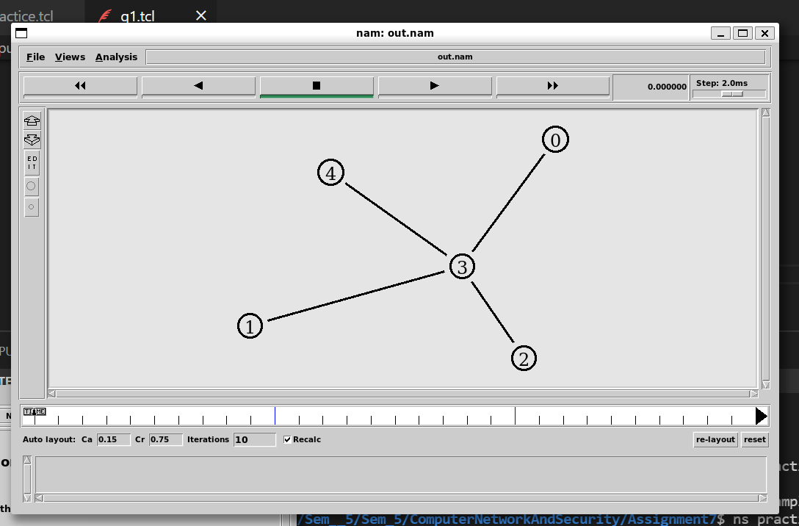

Q2.

#Create a simulator object

set ns [new Simulator]

#Open the nam trace file

set nf [open out.nam w]

$ns namtrace-all $nf

#Define a 'finish' procedure

proc finish {} {

        global ns nf

        $ns flush-trace

    #Close the trace file

        close $nf

    #Execute nam on the trace file

        exec nam out.nam &

        exit 0

}

#Create two nodes

set n1 [$ns node]

set n2 [$ns node]

set n3 [$ns node]

set n4 [$ns node]

set n5 [$ns node]

set n6 [$ns node]

#Create a duplex link between the nodes

$ns duplex-link $n1 $n2 1Mb 10ms DropTail

$ns duplex-link $n1 $n3 1Mb 10ms DropTail

$ns duplex-link $n2 $n4 1Mb 10ms DropTail

$ns duplex-link $n4 $n5 1Mb 10ms DropTail

$ns duplex-link $n5 $n6 1M6 10ms DropTail

$ns duplex-link $n6 $n3 1Mb 10ms DropTail

#Create a UDP agent and attach it to node n1

set udp0 [new Agent/UDP]

$ns attach-agent $n1 $udp0

# Create a CBR traffic source and attach it to udp0

set cbr0 [new Application/Traffic/CBR]

$cbr0 set packetSize_ 500

$cbr0 set interval_ 0.005

$cbr0 attach-agent $udp0

#Create a Null agent (a traffic sink) and attach it to node n1

set null0 [new Agent/Null]

$ns attach-agent $n1 $null0

#Connect the traffic source with the traffic sink

$ns connect $udp0 $null0

#Schedule events for the CBR agent

$ns at 0.5 "$cbr0 start"

$ns at 4.5 "$cbr0 stop"

#Call the finish procedure after 5 seconds of simulation time

$ns at 5.0 "finish"

#Run the simulation

$ns run

