Computer Networks and Security Lab

18B15CS212

(ODD, 2021)

Assignment – 8

Traffic Applications and Analysis of wired Trace file

Patil Amit Gurusidhappa

19104004

B11

Q1.

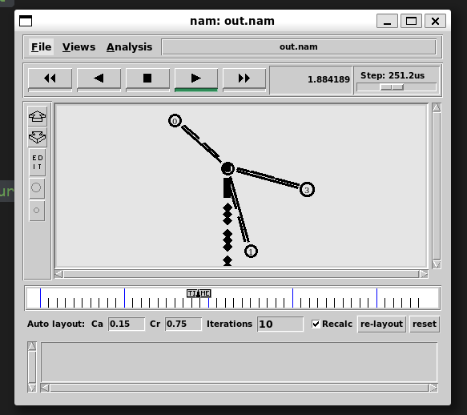

#Create a simulator object

set ns [new Simulator]

#Open trace files

set f [open out.tr w]

$ns trace-all $f

set nf [open out.nam w]

$ns namtrace-all $nf

#Define a 'finish' procedure

proc finish {} {

    global ns nf f

    $ns flush-trace

    close $f

    close $nf

    exec nam out.nam &

    exit 0

}

#Create four nodes

set n0 [$ns node]

set n1 [$ns node]

set n2 [$ns node]

set n3 [$ns node]

#Create links between the nodes

$ns duplex-link $n0 $n2 1Mb 10ms DropTail

$ns duplex-link $n1 $n2 1Mb 10ms DropTail

$ns duplex-link $n3 $n2 1Mb 10ms SFQ

#Create a UDP agent and attach it to node n0

set udp0 [new Agent/UDP]

$udp0 set class_ 1 # fid in trace file

$ns attach-agent $n0 $udp0

# Create a CBR traffic source and attach it to udp0

set cbr0 [new Application/Traffic/CBR]

$cbr0 set packetSize_ 500

$cbr0 set interval_ 0.005

$cbr0 attach-agent $udp0

#Create a UDP agent and attach it to node n1

set udp1 [new Agent/UDP]

$udp1 set class_ 2

$ns attach-agent $n1 $udp1

# Create a CBR traffic source and attach it to udp1

set cbr1 [new Application/Traffic/CBR]

$cbr1 set packetSize_ 500

$cbr1 set interval_ 0.005

$cbr1 attach-agent $udp1

#Create a Null agent (a traffic sink) and attach it to node n3

set null0 [new Agent/Null]

$ns attach-agent $n3 $null0

#Connect the traffic sources with the traffic sink

$ns connect $udp0 $null0

$ns connect $udp1 $null0

#Schedule events for the CBR agents

$ns at 0.5 "$cbr0 start"

$ns at 1.0 "$cbr1 start"

$ns at 4.0 "$cbr1 stop"

$ns at 4.5 "$cbr0 stop"

#Call the finish procedure after 5 seconds of

# simulation time

$ns at 5.0 "finish"

#Run the simulation

$ns run

Q2.

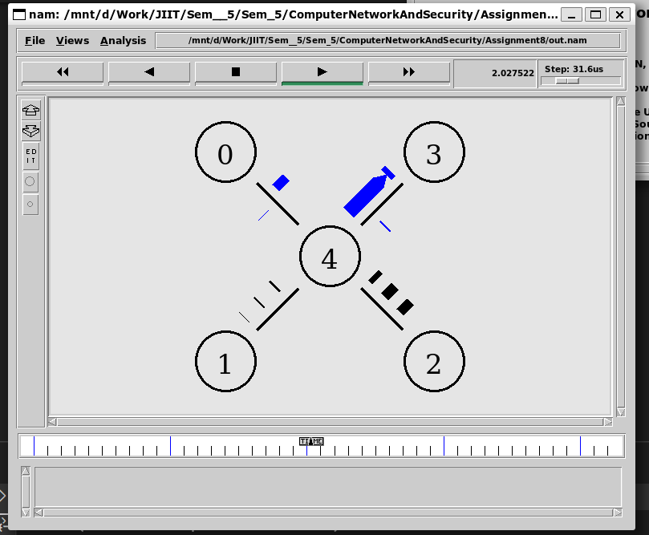

set ns [new Simulator]

$ns color 1 Blue

set nf [open out.nam w]

$ns namtrace-all $nf

set nf1 [open out.tr w]

$ns trace-all $nf1

proc finish {} {

    global ns nf nf1

    $ns flush-trace

    close $nf

    close $nf1

    exec nam out.nam &

    exit 0

}

set n0 [$ns node]

set n1 [$ns node]

set n2 [$ns node]

set n3 [$ns node]

set n4 [$ns node]

$ns duplex-link $n0 $n4 5Mb 10ms DropTail

$ns duplex-link $n1 $n4 5Mb 10ms DropTail

$ns duplex-link $n3 $n4 1Mb 10ms DropTail

$ns duplex-link $n2 $n4 1Mb 10ms DropTail

# if x, y then-----> y x ke konse side m h

$ns duplex-link-op $n0 $n4 orient right-down

$ns duplex-link-op $n1 $n4 orient right-up

$ns duplex-link-op $n3 $n4 orient left-down

$ns duplex-link-op $n2 $n4 orient left-up

#tcp

set tcp [new Agent/TCP]

$tcp set class_ 2

$ns attach-agent $n0 $tcp

set sink [new Agent/TCPSink]

$ns attach-agent $n3 $sink

$ns connect $tcp $sink

$tcp set fid_ 1

# file transfer protocol

set ftp [new Application/FTP]

$ftp attach-agent $tcp

$ftp set type_ FTP

# UDP

set udp0 [new Agent/UDP]

$ns attach-agent $n1 $udp0

#CBR

set cbr0 [new Application/Traffic/CBR]

$cbr0 set ret_ 448kb

$cbr0 attach-agent $udp0

set null0 [new Agent/Null]

$ns attach-agent $n2 $null0

# UDP should be connected with all agents and applications so connecting

$ns connect $udp0 $null0

# simulating

$ns at 1.0 "$ftp start"

$ns at 1.0 "$cbr0 start"

$ns at 4.0 "$ftp stop"

$ns at 4.0 "$cbr0 stop"

$ns at 5.0 "finish"

$ns run

Q3.

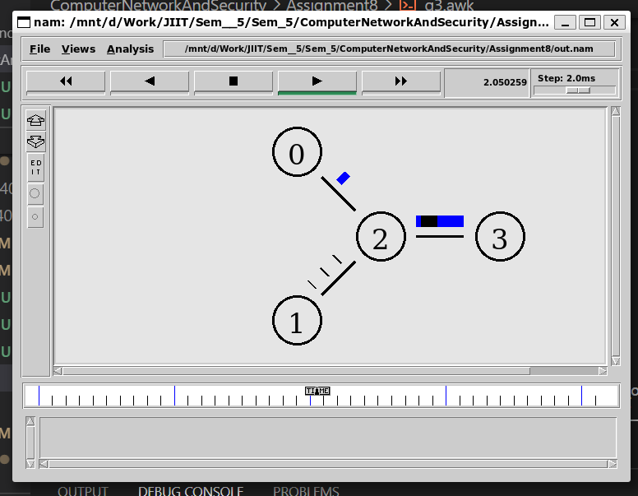

set ns [new Simulator]

$ns color 1 Blue

set nf [open out.nam w]

$ns namtrace-all $nf

set nf1 [open out.tr w]

$ns trace-all $nf1

proc finish {} {

    global ns nf nf1

    $ns flush-trace

    close $nf

    close $nf1

    exec nam out.nam &

    exit 0

}

set n0 [$ns node]

set n1 [$ns node]

set n2 [$ns node]

set n3 [$ns node]

$ns duplex-link $n0 $n2 5Mb 10ms DropTail

$ns duplex-link $n1 $n2 5Mb 10ms DropTail

$ns duplex-link $n2 $n3 1Mb 10ms DropTail

$ns duplex-link-op $n0 $n2 orient right-down

$ns duplex-link-op $n1 $n2 orient right-up

$ns duplex-link-op $n2 $n3 orient right

set tcp [new Agent/TCP]

$tcp set class_ 2

$ns attach-agent $n0 $tcp

set sink [new Agent/TCPSink]

$ns attach-agent $n3 $sink

$ns connect $tcp $sink

$tcp set fid_ 1

# file transfer protocol

set ftp [new Application/FTP]

$ftp attach-agent $tcp

$ftp set type_ FTP

# UDP

set udp0 [new Agent/UDP]

$ns attach-agent $n1 $udp0

#CBR

set cbr0 [new Application/Traffic/CBR]

$cbr0 set ret_ 448kb

$cbr0 attach-agent $udp0

set null0 [new Agent/Null]

$ns attach-agent $n3 $null0

# UDP should be connected with all agents and applications so connecting

$ns connect $udp0 $null0

# simulating

$ns at 1.0 "$ftp start"

$ns at 1.0 "$cbr0 start"

$ns at 4.0 "$ftp stop"

$ns at 4.0 "$cbr0 stop"

$ns at 5.0 "finish"

$ns run

AWK file

BEGIN {

number_of_drops=0;

number_of_received=0;

number_of_enqued=0;

number_of_dequeue=0;

}

{

parameter1=$1

paramter2=$2

parameter3=$3

parameter4=$4

parameter5=$5

parameter6=$6

parameter8=$8

parameter9=$9

parameter10=$10

parameter11=$11

parameter12=$12

if (parameter1=="r" && parameter4="3")

number_of_received++;

if(parameter1=="d"  && parameter4="2")

number_of_drops++;

}

END {

printf("number of received:%d",number_of_received);

printf("\nnumber of drops:%d",number_of_drops);

}