**CNS LAB EVAL 2**

Patil Amit Gurusidhappa

19104004

B11

All 1 to 5 questions screenshot

Client

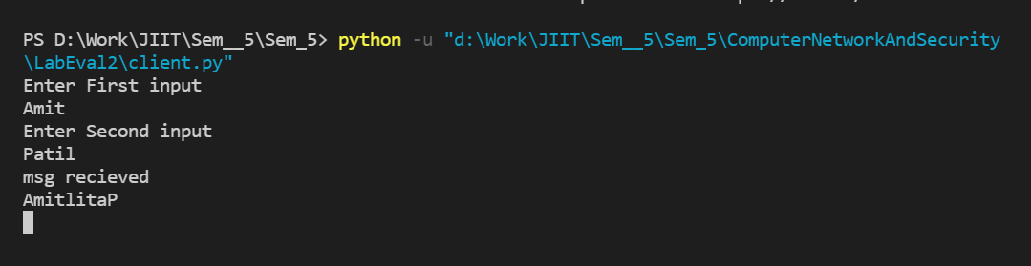

Server

