**Date: 22.10.2021**

B11 Batch

**Lab Test 1**

**CN & Security Lab**

**Time: 50 Minutes Marks: 20 Marks**

**Patil Amit Gurusidhappa**

**19104004**

Q1: Refer the file “B11.pcap” for answering the following questions. Paste appropriate screenshots (from where u accessed that value) with the every answer.

1. What is the packet number of first GET request?

Answer : 7026

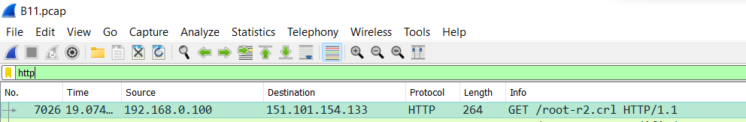

1. What is the packet number of response packet of the identified GET request in part a?

Answer : 7041



1. What time was the GET response provided by the server?

Answer: 19.121050



1. What is the URL of the first GET request?

Answer: [Full request URI: http://crl.globalsign.net/root-r2.crl]



1. What is the Internet address of client computer?

Answer: ip.src == 192.168.0.100

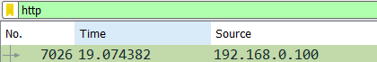

1. What is the Internet address of destination computer?

Answer: ip.dst == 151.101.154.133

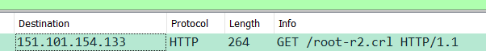

1. Identify the connection establishment packets for the first GET request. What are the packets numbers involved in this phase?

Answer:

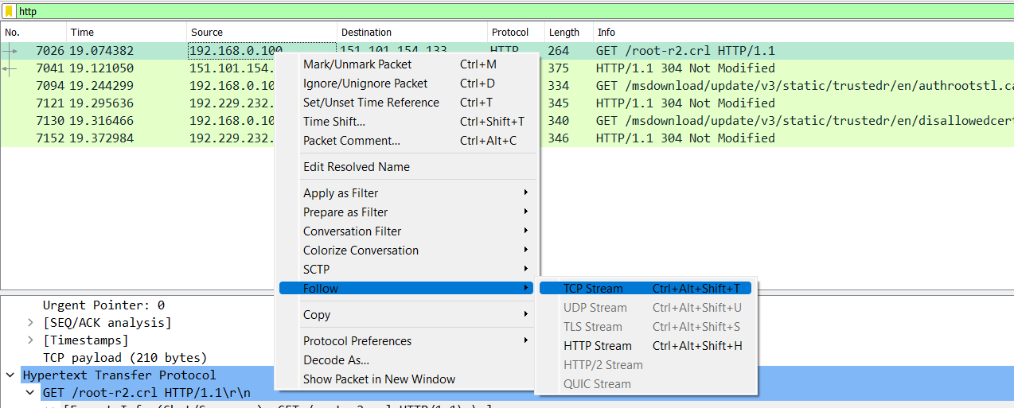

Ans :7002 (syn)

,7024 (syn,ack)

,7025(ack)



1. For the packets involved in connection establishment, what is the maximum segment size for source and destination?

Answer:

Source 1460



Destination1420



Q2. Consider the website www.example.com. Ping the host with packet size 64bytes, 256 bytes, 512 bytes and record the traces via wireshark. Find out average RTT and explain how change in the packet size and time of ping impacts the RTT.

Answer: 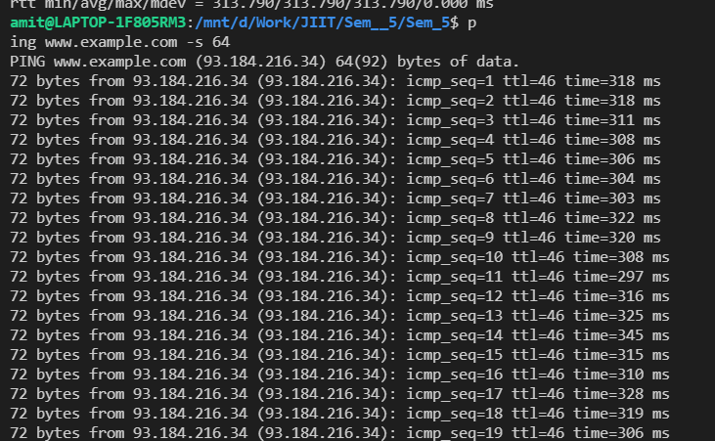

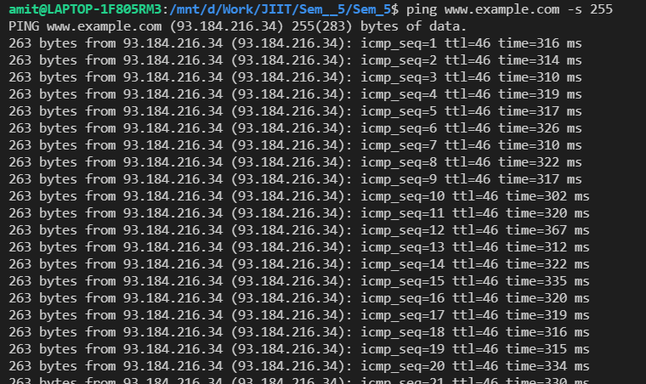

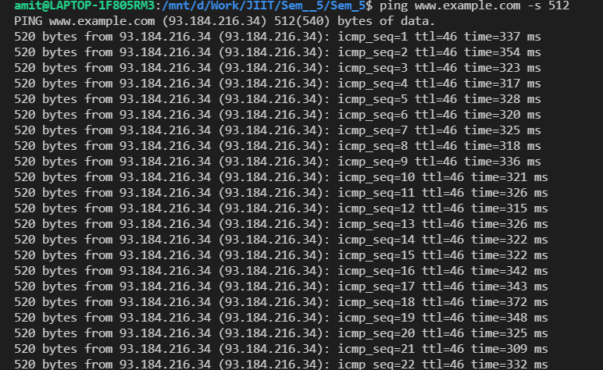

RTT is increased when the packet length increase.

So RTT(512) >RTT (255) > RTT(64)