**Date: 10.12.2021**

B11 Batch

**Lab Test 2**

**CN & Security Lab**

**Time: 50 Minutes Marks: 20 Marks**

**Patil Amit Gurusidhappa**

**19104004**

**TCL file**

Q1

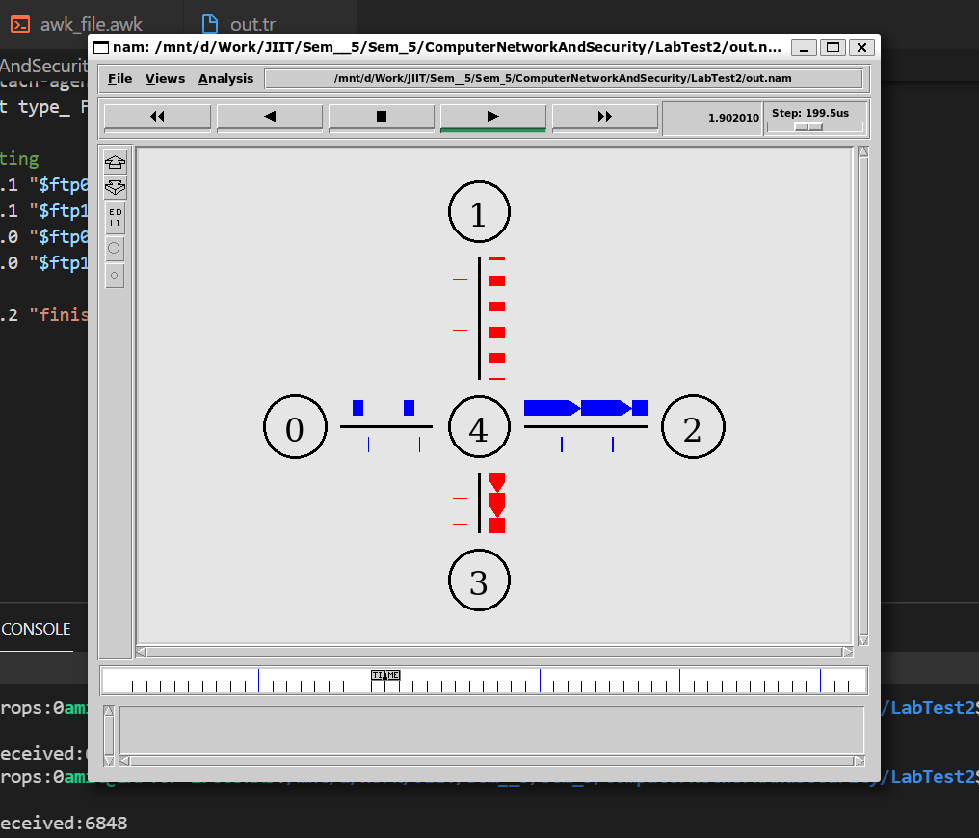

set ns [new Simulator]

$ns color 1 Blue

$ns color 2 Red

set nf [open out.nam w]

$ns namtrace-all $nf

set nf1 [open out.tr w]

$ns trace-all $nf1

proc finish {} {

    global ns nf nf1

    $ns flush-trace

    close $nf

    close $nf1

    exec nam out.nam &

    exit 0

}

set n0 [$ns node]

set n1 [$ns node]

set n2 [$ns node]

set n3 [$ns node]

set n4 [$ns node]

$ns duplex-link $n0 $n4 5Mb 15ms DropTail

$ns duplex-link $n1 $n4 5Mb 20ms DropTail

$ns duplex-link $n3 $n4 2Mb 10ms DropTail

$ns duplex-link $n2 $n4 1Mb 20ms DropTail

$ns duplex-link-op $n0 $n4 orient right

$ns duplex-link-op $n1 $n4 orient down

$ns duplex-link-op $n3 $n4 orient up

$ns duplex-link-op $n2 $n4 orient left

#tcp 0

set tcp0 [new Agent/TCP]

$tcp0 set class_ 1

$ns attach-agent $n0 $tcp0

set sink0 [new Agent/TCPSink]

$ns attach-agent $n2 $sink0

$ns connect $tcp0 $sink0

$tcp0 set fid_ 1

# file transfer protocol 0

set ftp0 [new Application/FTP]

$ftp0 attach-agent $tcp0

$ftp0 set type_ FTP

#tcp 1

set tcp1 [new Agent/TCP]

$tcp1 set class_ 2

$ns attach-agent $n1 $tcp1

set sink1 [new Agent/TCPSink]

$ns attach-agent $n3 $sink1

$ns connect $tcp1 $sink1

$tcp1 set fid_ 2

# file transfer protocol 1

set ftp1 [new Application/FTP]

$ftp1 attach-agent $tcp1

$ftp1 set type_ FTP

# simulating

$ns at 0.1 "$ftp0 start"

$ns at 0.1 "$ftp1 start"

$ns at 5.0 "$ftp0 stop"

$ns at 5.0 "$ftp1 stop"

$ns at 5.2 "finish"

$ns run