Computer Networks and Security Lab

18B15CS212

(ODD, 2021)

Assignment – 1 & 2

UNIX/Linux and Windows General and Networking Commands

Patil Amit Gurusidhappa

19104004

B11

2. UNIX/LINUX Commands

Pwd

4.1 Windows networking commands

Ping

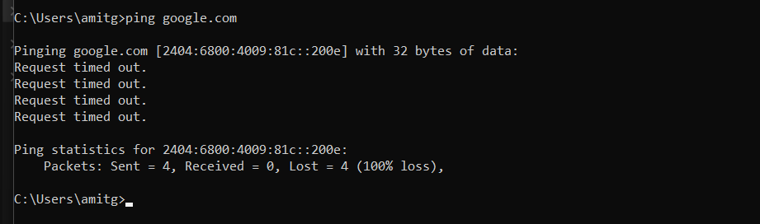

Netstat

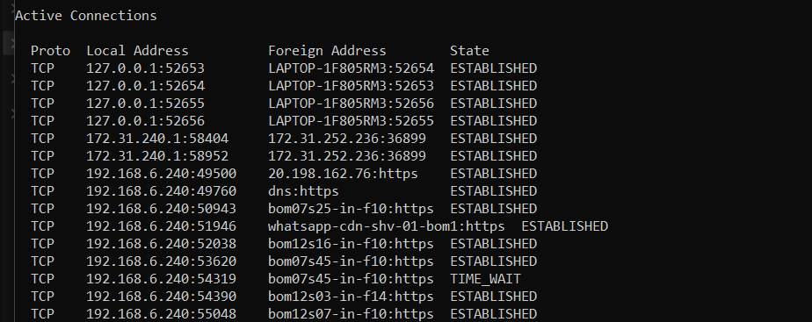

Arp

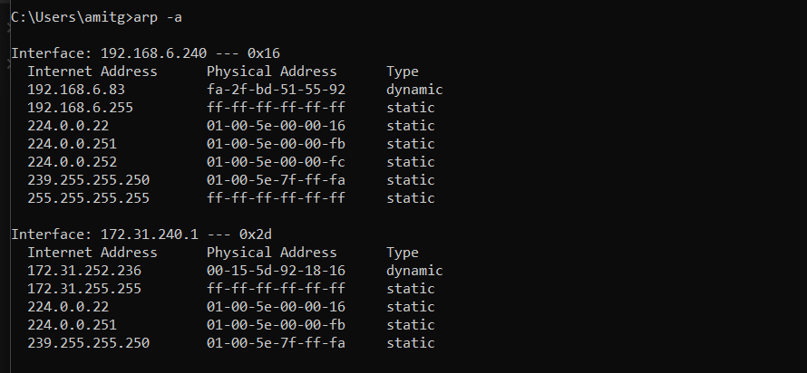

HostName



Ipconfig

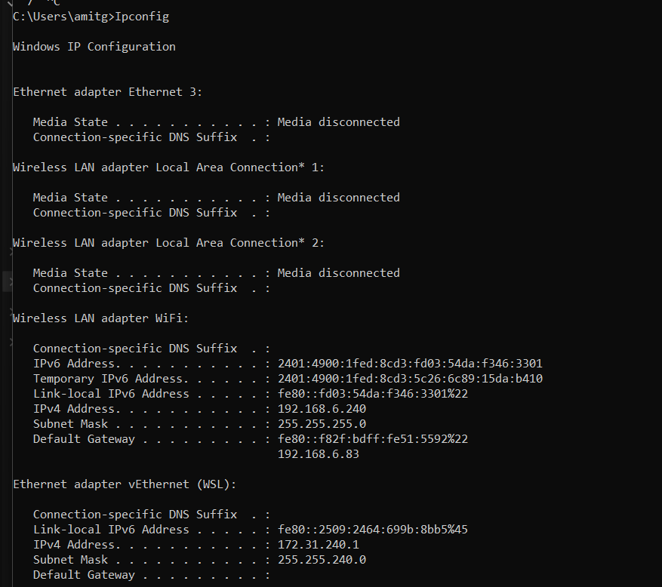

Nslookup

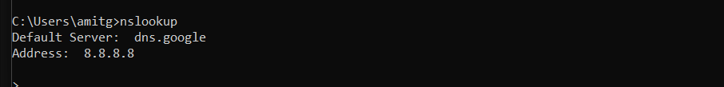

Route

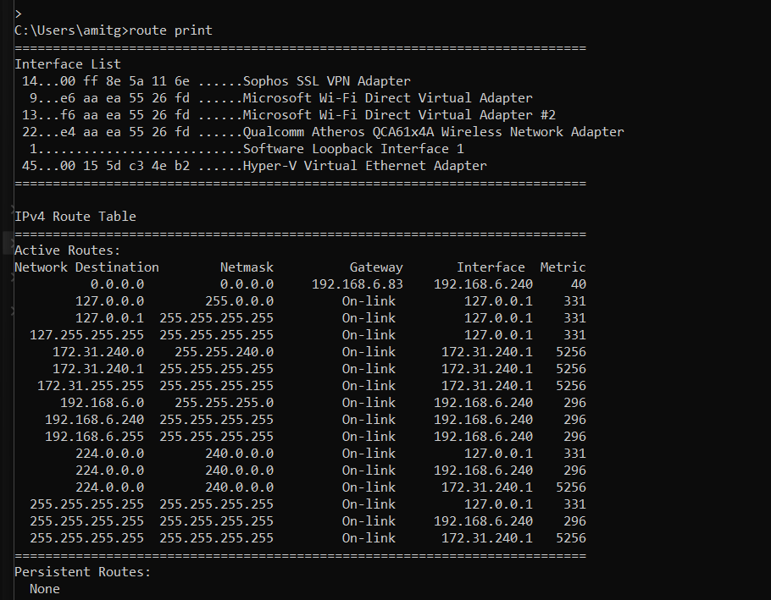

Pathping

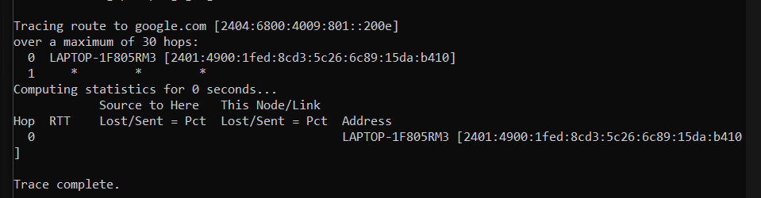

Getmac

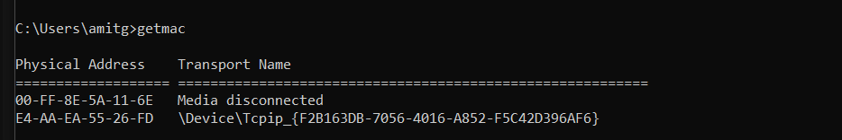

4.2 **Linux networking commands**

Ifconfig

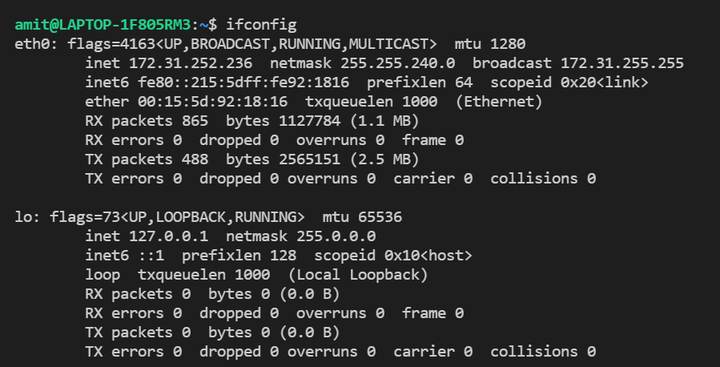

Ip

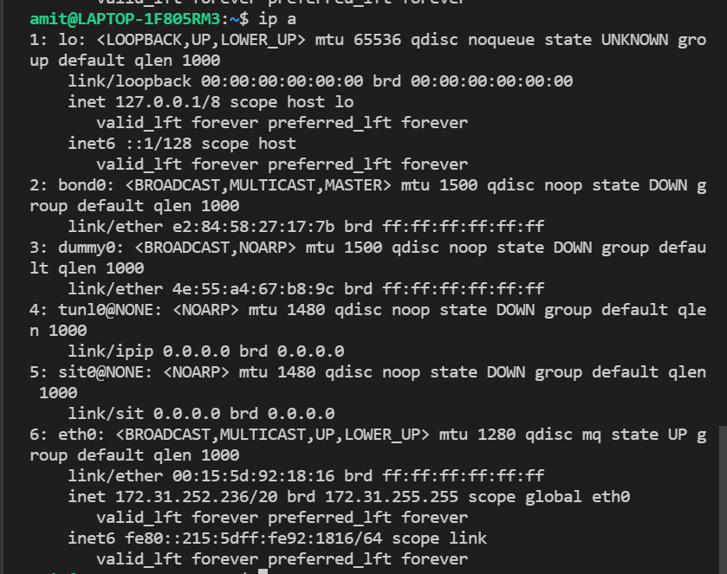

Traceroute

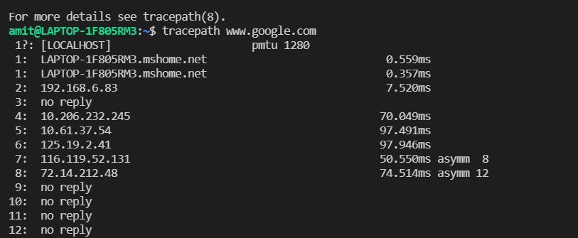

Ping

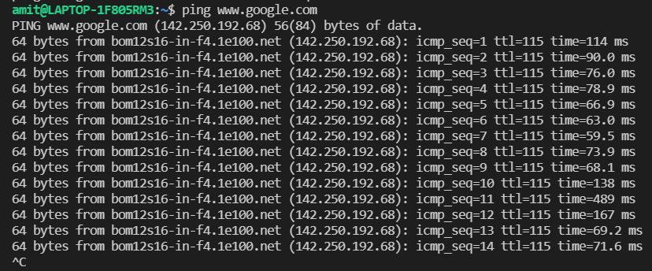netstat

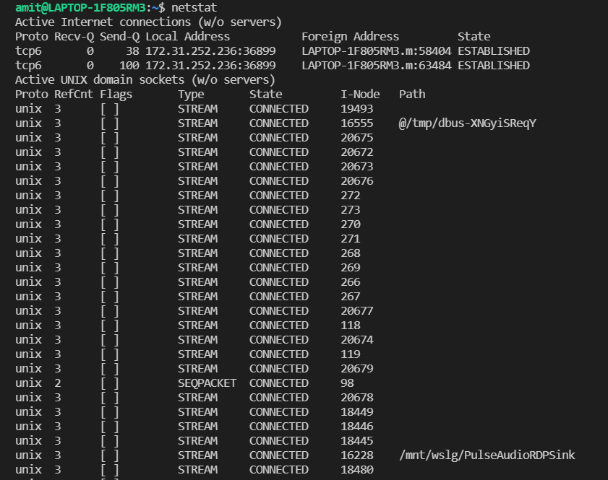

Route

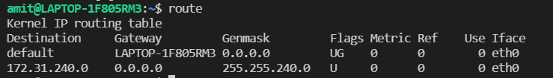

Host

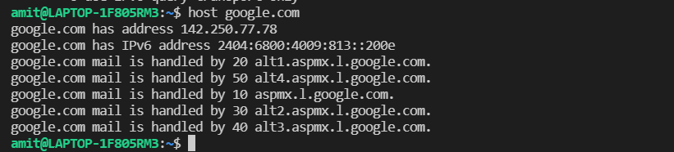

Arp

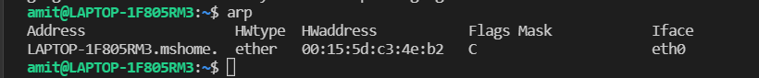

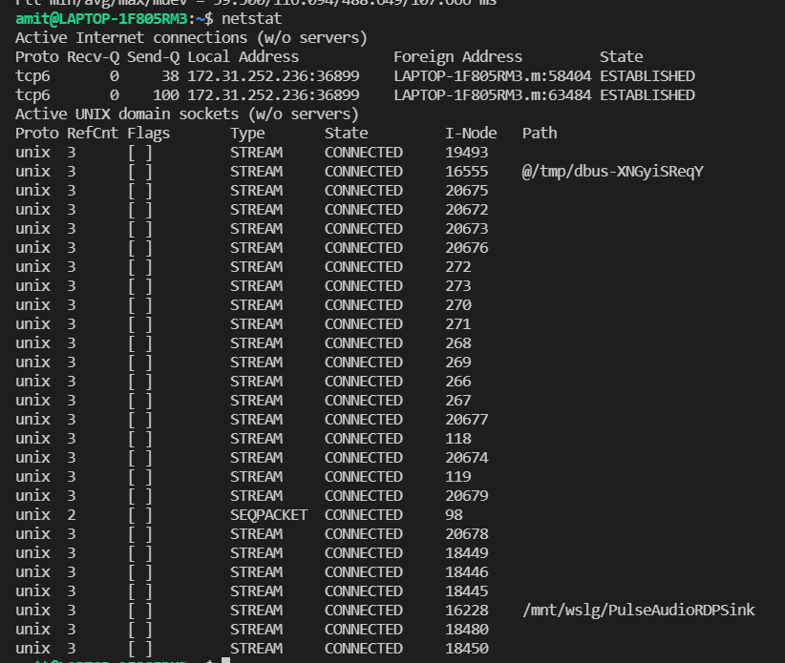

SS

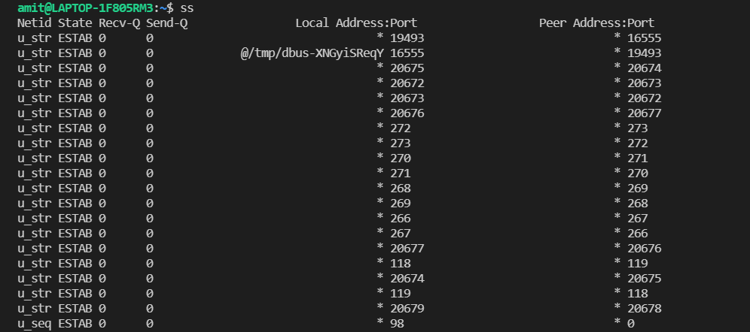

dig

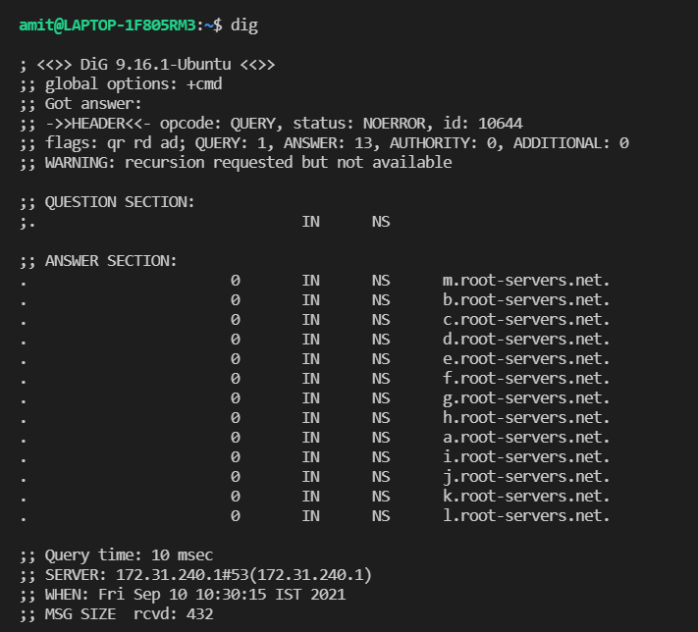

Iwconfig

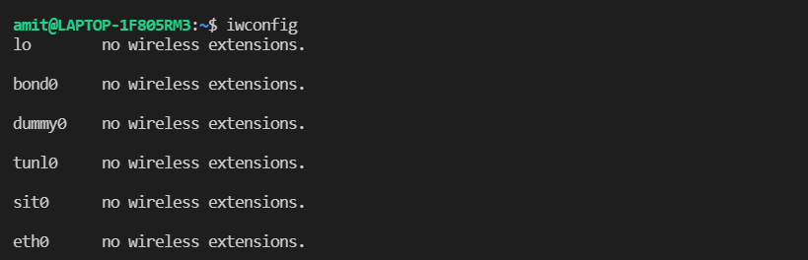

Hostname

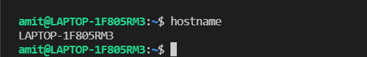

curl or wget

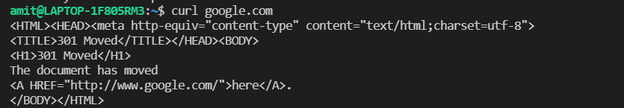

Whois

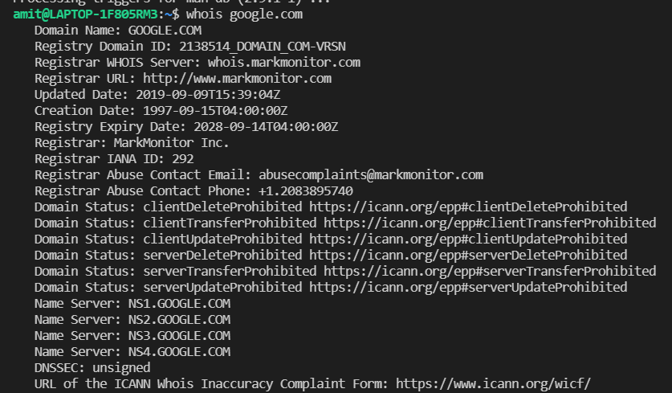

**Network Scanning**

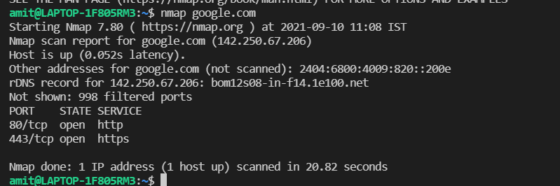

Port scanning (TCP scanning)

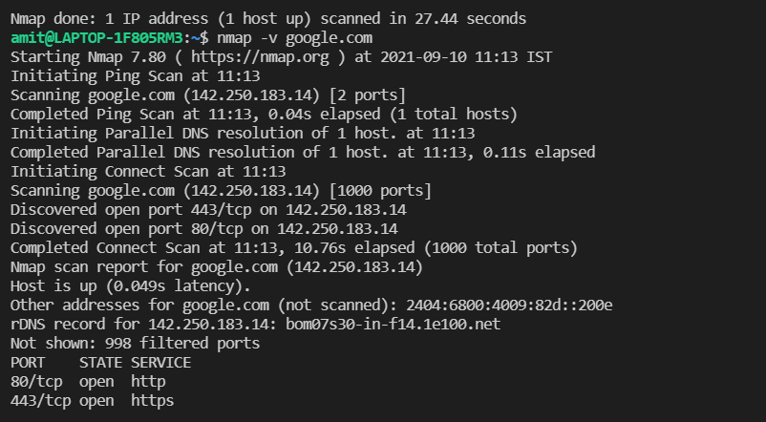

Ping and UDP scanning

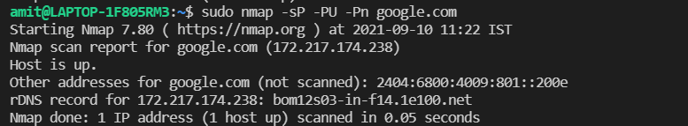

OS fingerprinting

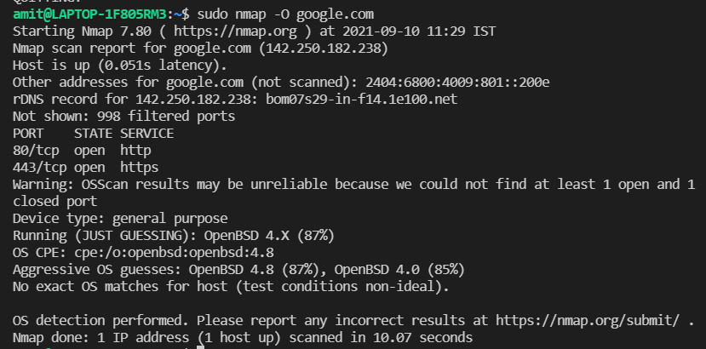

**6. Linux Firewalls**