**Lab Eval 2**

**Open Source Software Lab**

Patil Amit Gurusidhappa

19104004

B11

Q1,2,3,4.

Extract, create db , store dataframe and recive

import urllib.request

from bs4 import BeautifulSoup as bs

import pandas as pd

import pymongo

url = 'https://money.cnn.com/data/hotstocks/index.html'

page = urllib.request.urlopen(url)

soup = bs(page.read())

soup.prettify()

cells = []

for i in range(0, 3):

    table = soup.find_all('table')[i]

    rows = table.find_all('tr')

    output = []

    for row in rows:

        cols = row.find_all('td')

        cols = [item.text.strip() for item in cols]

        output.append([item for item in cols if item])

    df = pd.DataFrame(

        output, columns=['Company', 'Price', 'Change', '%Change'])

    df = df.iloc[1:]

    print(df)

    myclient = pymongo.MongoClient("mongodb://localhost:27017/")

    mydb = myclient["mydb"]

    mycollection = mydb["gainers_losers_db"]

# print(df)

mycollection.insert(df.to_dict('records'))

cursor = mycollection.find()

for records in cursor:

    print(records)

Scarped Data frame

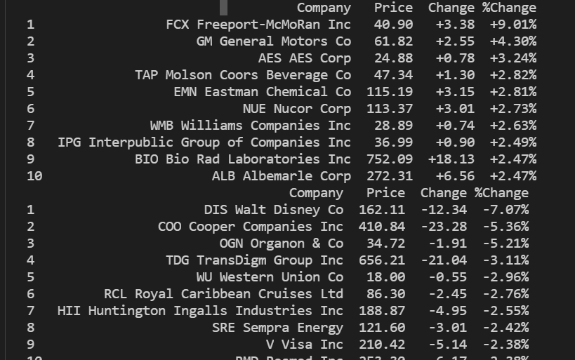

Read from mongodb

