**Lab Test 1**

**Open Source Software Lab**

Patil Amit Gurusidhappa

19104004

B11

Q1. a

L1 = []

L2 = []

n = int(input("No of Elements in L1: "))

print("input elements one by one for l1")

for i in range(0, n):

    each_elemets = int(input())

    L1.append(each_elemets)

m = int(input("No of Elements in L2 : "))

print("input elements one by one for l1")

for i in range(0, m):

    each_elemets = int(input())

    L2.append(each_elemets)

L = []

i = 0

j = 0

lx1 = []

lx2 = []

while(i < n):

    if(L1[i] % 2 != 0):

        lx1.append(L1[i])

    i = i+1

i = 0

while(i < m):

    if(L2[i] % 2 == 0):

        lx2.append(L2[i])

    i = i+1

i = 0

j = 0

while(i < len(lx1) and j < len(lx2)):

    L.append(lx1[i])

    L.append(lx2[j])

    i = i+1

    j = j+1

while(i < len(lx1)):

    L.append(lx1[i])

    i = i+1

while(j < len(lx2)):

    L.append(lx2[j])

    j = j+1

print(L)

Output

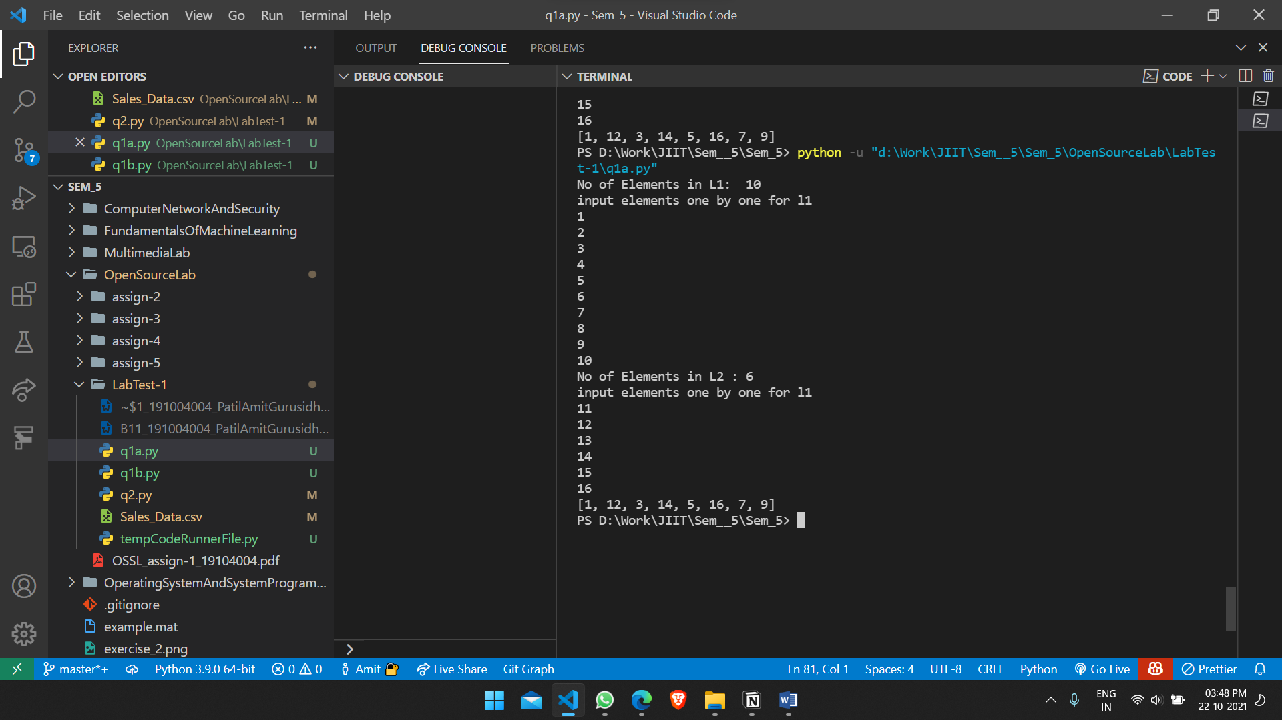

Q1b

Q2

import pandas as pd

from matplotlib import pyplot as plt

# Read data

data = pd.read_csv(

    'D:\Work\JIIT\Sem__5\Sem_5\OpenSourceLab\LabTest-1\Sales_Data.csv')

month = data['Month']

Product_A = data['Product A']

Product_B = data['Product B']

Product_C = data['Product C']

Product_D = data['Product D']

Product_E = data['Product E']

Product_F = data['Product F']

m = []

prod_a_list = []

prod_b_list = []

prod_c_list = []

prod_d_list = []

prod_e_list = []

prod_f_list = []

for item1 in month:

    m.append(item1)

for item2 in Product_A:

    prod_a_list.append(item2)

for item2 in Product_B:

    prod_b_list.append(item2)

for item2 in Product_C:

    prod_c_list.append(item2)

for item2 in Product_D:

    prod_d_list.append(item2)

for item2 in Product_E:

    prod_e_list.append(item2)

for item2 in Product_F:

    prod_f_list.append(item2)

fig, ax = plt.subplots()

# Plot Multiline graph

ax.plot(m, prod_a_list, label='Product A')

ax.plot(m, prod_b_list, label='Product B')

ax.plot(m, prod_c_list, label='Product C')

ax.plot(m, prod_d_list, label='Product D')

ax.plot(m, prod_e_list, label='Product E')

ax.plot(m, prod_f_list, label='Product F')

ax.legend()

ax.set_title('Product Sales per Month')

ax.set_xlabel('Month')

ax.set_ylabel('Sales')

plt.show()

Output

