**Lab Test 2**

**Open Source Software Lab**

Patil Amit Gurusidhappa

19104004

B11

Q1.a

import pandas as pd

from sklearn.model_selection import train_test_split

from sklearn import metrics

from sklearn.linear_model import LogisticRegression

from sklearn.linear_model import LinearRegression

fish = pd.read_csv("Fish.csv")

print(fish.describe())

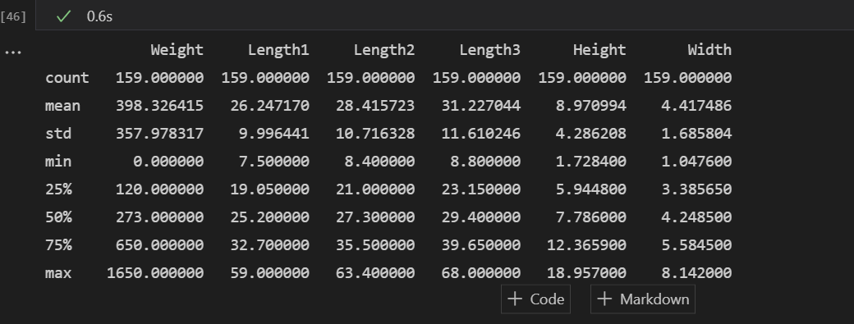

b)

X = fish[['Height', 'Width']]  # Select columns using column name

X.head()

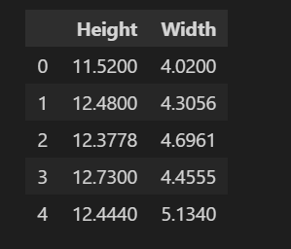

y = fish[['Weight']]

y.head(5)

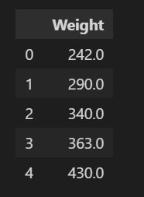

X_train, X_test, y_train, y_test = train_test_split(

    X, y, test_size=0.2, random_state=42)

# Use paramter 'random_state=1' if you want keep results same everytime you execute above code

print('X_train dimension= ', X_train.shape)

print('X_test dimension= ', X_test.shape)

print('y_train dimension= ', y_train.shape)

print('y_test dimension= ', y_test.shape)

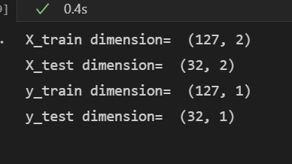

Linear Regression

model = LinearRegression(

    copy_X=True, fit_intercept=True, n_jobs=None).fit(X, y)

model.fit(X_train, y_train)

print('score= ', model.score(X_test, y_test))

Score of linear regression

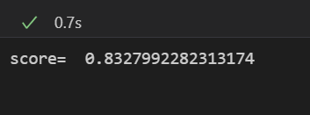

For logistic Regression

model = LogisticRegression(

    copy_X=True, fit_intercept=True, n_jobs=None).fit(X, y)

model.fit(X_train, y_train)

print('score= ', model.score(X_test, y_test))

Graph

df = pd.read_csv("fish.csv")

df

df.columns = ['species', 'weight', 'vertical_length',

              'diagnol_length', 'cross_length', 'height', 'width']

x = np.array(df['vertical_length'])

y = np.array(df['weight'])

n = len(x)

sum_x = np.sum(x)

sum_y = np.sum(y)

sum_xx = np.sum(x*x)

sum_xy = np.sum(x*y)

mean_x = np.mean(x)

mean_y = np.mean(y)

numerator = sum_xy - ((sum_x*sum_y)/n)

denominator = sum_xx - ((sum_x*sum_x)/n)

m = numerator/denominator

b = mean_y - m*mean_x

plt.scatter(x, y)

plt.plot(x, m*x+b, color='red')

plt.title(f'Linear Regression Line , m = {m:.2f}, b = {b:.2f}')

plt.ylabel("Fish Weight")

plt.xlabel("Vertical Length")

plt.figure(figsize=(10, 5))

plt.show()