OPEN SOURCE SOFTWARE LAB (15B17CI575)

Lab Assignment 5 (Practice Lab)

Odd 2021

Week 5 & 6: 28 Sept- 9 Oct

Topic Coverage: Python- BeautifulSoup, Panda, MongoDb

Patil Amit Gurusidhappa

19104004

B11

Q1. Extracting URL's from any website

from bs4 import BeautifulSoup

import requests

url = "google.com"

r = requests.get("https://" + url)

data = r.text

soup = BeautifulSoup(data)

for link in soup.find_all('a'):

    print(link.get('href'))

Output:

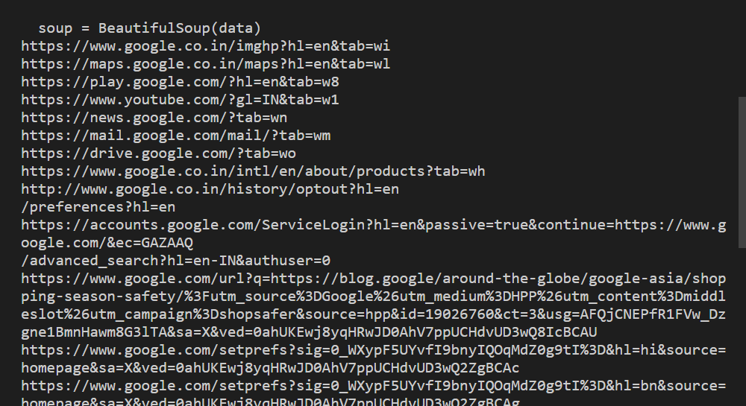

Q2. Extracting Title, Headings, and Links of a website

from bs4 import BeautifulSoup

import requests

req = requests.get(

    'https://en.wikipedia.org/wiki/Python_(programming_language)')

soup = BeautifulSoup(req.text, "lxml")

print(soup.title)

print(soup.title.name)

print(soup.title.string)

Output:

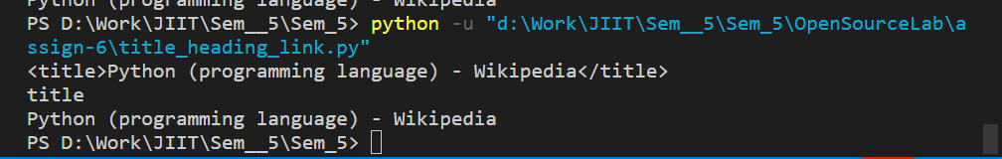

Q3. Extracting the main heading or the first paragraph

from bs4 import BeautifulSoup

import requests

req = requests.get(

    'https://en.wikipedia.org/wiki/Python_(programming_language)')

soup = BeautifulSoup(req.text, "lxml")

print(soup.h1)

print(soup.h1.string)

soup.h1['class'] = 'firstHeading, mainHeading'

soup.h1.string.replace_with("Python - Programming Language")

del soup.h1['lang']

del soup.h1['id']

print(soup.h1)

print(soup.h1.string)

Output:

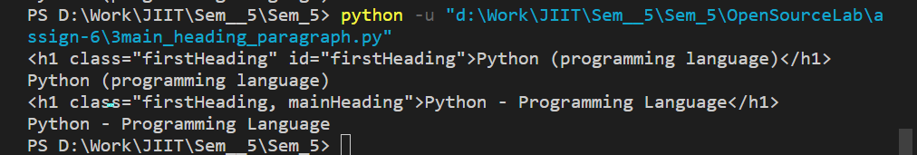

Web Crawling using pyMongo and storing data in MongoDb

from urllib.request import urlopen

from bs4 import BeautifulSoup

from pymongo import Connection

host = 'localhost'

database = 'lotto'

collection = 'mega_millions'

def mongo_connection():

    con = Connection(host)

    col = con[database][collection]

    return col

def main():

    col = mongo_connection()

    page_num = 1

    total_pages = 63

    while True:

        if page_num > total_pages:

            break

        page_num = str(page_num)

        soup = BeautifulSoup(urlopen('http://www.usamega.com/mega-millions-history.asp?p='+page_num).read())

    for row in soup('table')[4].findAll('tr'):

        win_dict = {}

        tds = row('td')

    if tds[1].a is not None:

        win_dict['date'] = tds[1].a.string

    if tds[3].b is not None:

        num_list = []

    #Told you we would get back to it

    number_list = tds[3].b.string.split('&middot;')

    for num in number_list:

        num_list.append(int(num))

        win_dict['numbers'] = num_list

        mega_number = tds[3].strong.string

        win_dict['mega_number'] = int(mega_number)

        col.insert(win_dict)

        page_num = int(page_num)

        page_num += 1

main()

Scarping Table and storing using pymongo

from bs4 import BeautifulSoup

import urllib.request

import pymongo

url = 'https://worldpopulationreview.com/country-rankings/olympic-medals-by-country'

page = urllib.request.urlopen(url)

soup = BeautifulSoup(page.read())

soup.prettify()

table = soup.find("div", {"class": "jsx-1911055634"})

cells = []

for row in table.findAll("tr"):

    result = row.findAll("td")

    if len(result) == 6:

        dic = {}

        dic["Country"] = result[0].get_text()

        dic["Gold"] = result[1].get_text()

        dic["Silver"] = result[2].get_text()

        dic["Bronze"] = result[3].get_text()

        dic["Total"] = result[4].get_text()

        dic["Population"] = result[5].get_text()

        cells.append(dic)

print(cells)

myclient = pymongo.MongoClient("mongodb://localhost:27017/")

mydb = myclient["mydatabase"]

mycol = mydb["customers"]

x = mycol.insert_many(cells)

print(x)

Output

