Operating System Lab-1

Patil Amit Gurusidhappa

19104004

B11

Q1.

• FILE COMMANDS

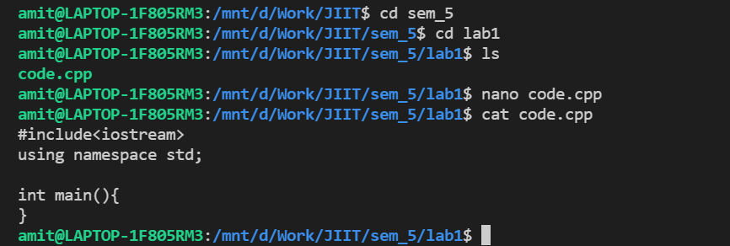

• DIRECTORY COMMANDS

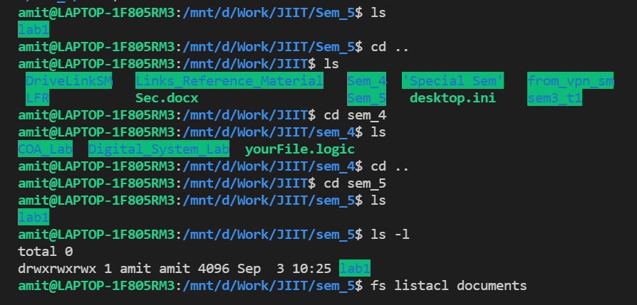

• SYMOLIC LINKS

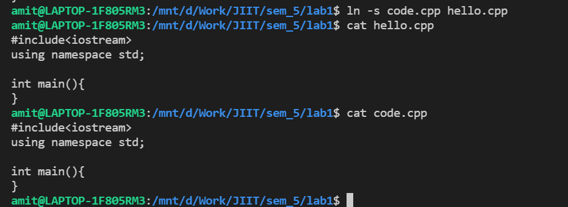

• HELP COMMANDS



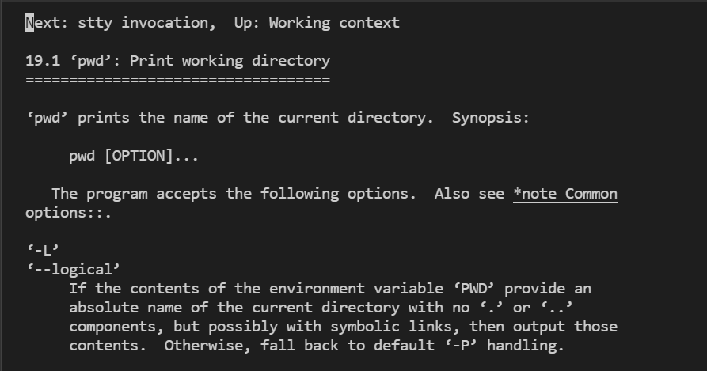

• PERMISSIONS AND FILE STORAGE (UNIX)

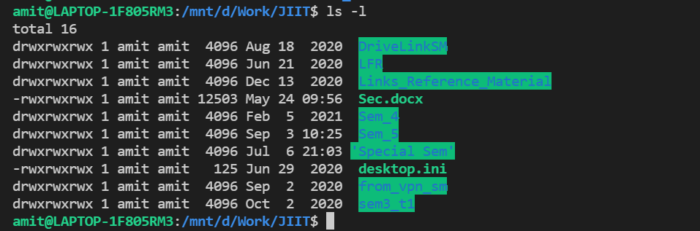

• PERMISSIONS AND FILE STORAGE (ANDREW)

• PROCESSES

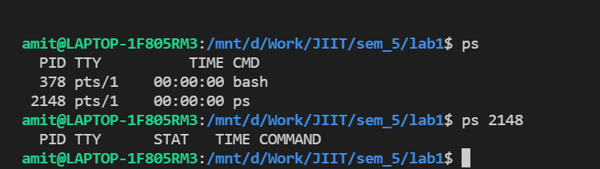

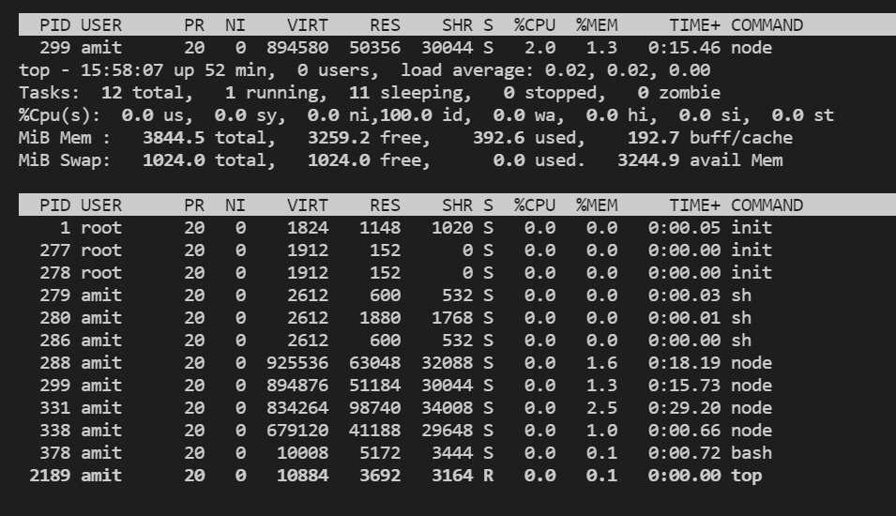

• NETWORKING

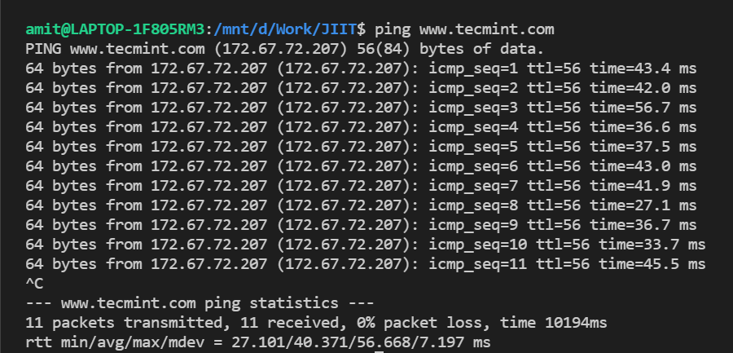

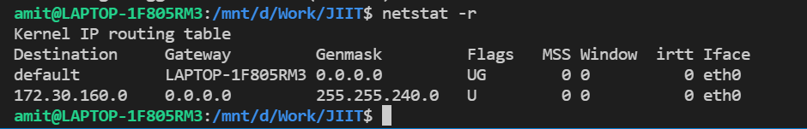

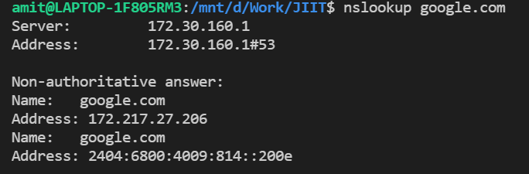

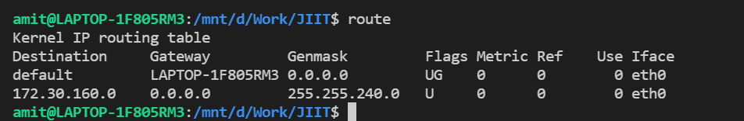

Q2.

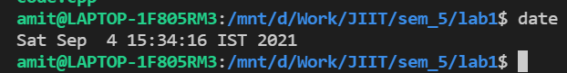

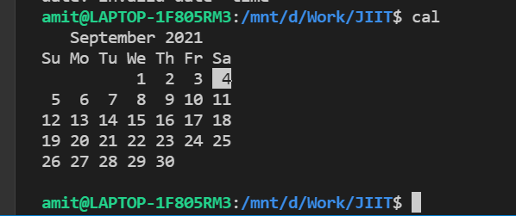

Q3.

