OSSP Eval 1

Patil Amit Gurusidhappa

19104004

B11

Arrange the list of files created in September 2021,

find ./ -type f -ls | grep 'Sep'

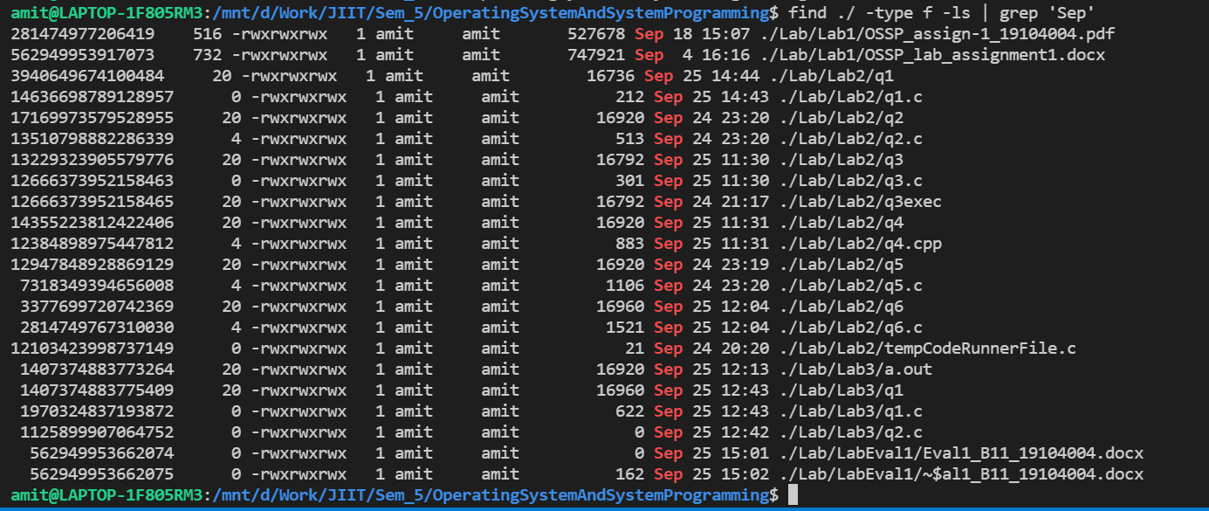

that are larger than

500kb and smaller than 2500kb in descending order of its size. Then, display those

