Introduction To Blockchain

Assignment - 1

Patil Amit Gurusidhappa

19104004

B11

**Q1. What is Solidity and Write is basic syntax.**

1. Solidity is an object-oriented, high-level language for implementing smart contracts. Smart contracts are programs which govern the behavior of accounts within the Ethereum state.

2. Solidity is a curly-bracket language designed to target the Ethereum Virtual Machine (EVM)

3. Solidity is statically typed, supports inheritance, libraries and complex user-defined types among other features.

4. With Solidity you can create contracts for uses such as voting, crowdfunding, blind auctions, and multi-signature wallets.

**Basic Syntax**

// SPDX-License-Identifier: MIT

pragma solidity 0.8.7;

contract HelloWorld{

    string public  myString = "hello world";

}

**Output**

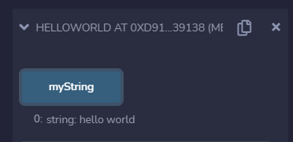

**Q2. Write the syntax of the following**

**i) Array Syntax**

type arrayName [ arraySize ];

**ii) Enum Syntax**

enum <enumerator_name> {

element 1, element 2,....,element n

}

**iii) Struct Syntax**

struct <structure_name> {

<data type> variable_1;

<data type> variable_2;

}

**Q3. Explain the data types available in Solidity.**

|  |  |  |
| --- | --- | --- |
| **Type** | **Keyword** | **Values** |
| Boolean | bool | true/false |
| Integer | int/uint | Signed and unsigned integers of varying sizes. |
| Integer | int8 to int256 | Signed int from 8 bits to 256 bits. int256 is the same as int. |
| Integer | uint8 to uint256 | Unsigned int from 8 bits to 256 bits. uint256 is the same as uint. |
| Fixed Point Numbers | fixed/unfixed | Signed and unsigned fixed point numbers of varying sizes. |
| Fixed Point Numbers | fixed/unfixed | Signed and unsigned fixed point numbers of varying sizes. |

**Q4. Explain the concept of Mapping in Solidity.**

Mapping in Solidity acts like a hash table or dictionary in any other language. These are used to store the data in the form of key-value pairs, a key can be any of the built-in data types but reference types are not allowed while the value can be of any type. Mappings are mostly used to associate the unique Ethereum address with the associated value type.

**Syntax:**

mapping(key => value) <access specifier> <name>;

**Q5. Ashish is an accountant in head and shoulder company, As it was Christmas eve all**

**the employees got bouns salary. Help Ashish to write a smart contract in order to**

**calculate the bonus.**

// SPDX-License-Identifier: MIT

pragma solidity 0.8.7;

contract BonusSalary {

    uint public baseSalary=100;

    uint public bonus=15;

    uint public modifiedSalary=100;

    event ModifiedSalary(uint value);

    function getSalary()view public returns(uint){

        return modifiedSalary;

    }

    function addBonus()public{

        modifiedSalary=baseSalary+bonus;

        // modifiedSalary+=1;

        emit ModifiedSalary(modifiedSalary);

    }

}

**Output**

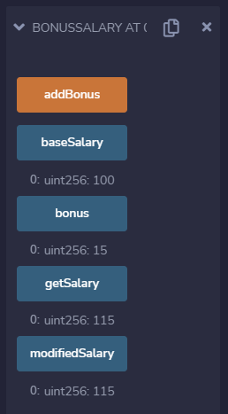

**Q6. Junaid started learning solidity language, He completed his theory classes now it**

**is time for practical session. Junaid was given a problem to print the string “JIIT**

**University”. Help Junaid to print the String.**

// SPDX-License-Identifier: MIT

pragma solidity 0.8.7;

contract PrintString{

    string public  myString = "JIIT University";

}

**Output**

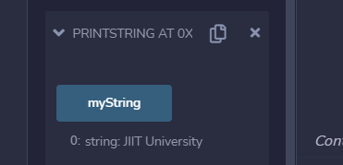

**Q7. Sinchan is a student in Kasukabey city school in Japan, His teacher gave him**

**homework to check whether a number is Even or Odd number, Help Sinchan to solve**

**the problem.**

// SPDX-License-Identifier: MIT

pragma solidity 0.8.7;

contract Number {

    uint public number=100;

    string public message;

    function getIsEvenOrOdd()view public returns(string memory){

        return message;

    }

    function checkIsEvenOrOdd()public{

       if(number%2==0){

           message="true";

       }else{

           message="false";

       }

    }

}

**Output**

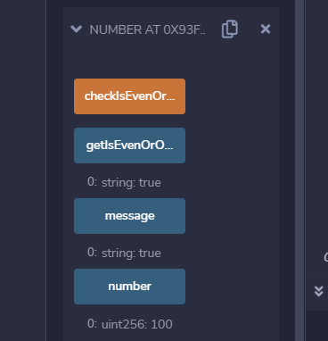

**Q8. Write the Syntax of the following with example.**

**i) Inheritance ii) Enums iii) Struct**

**i) Array**

**Syntax**

type arrayName [ arraySize ];

**Example**

// SPDX-License-Identifier: MIT

pragma solidity 0.8.7;

contract arrayTest {

   function testArray() public pure{

      uint len = 7;

      //dynamic array

      uint[] memory a = new uint[](7);

      //bytes is same as byte[]

      bytes memory b = new bytes(len);

      assert(a.length == 7);

      assert(b.length == len);

      //access array variable

      a[6] = 8;

      //test array variable

      assert(a[6] == 8);

      //static array

      uint[3] memory c = [uint(1) , 2, 3];

      assert(c.length == 3);

   }

}

**ii) Enum**

**Syntax**

enum <enumerator_name> {

element 1, element 2,....,element n

}

**Example**

contract enumtest {

   enum FreshJuiceSize{ SMALL, MEDIUM, LARGE }

   FreshJuiceSize choice;

   FreshJuiceSize constant defaultChoice = FreshJuiceSize.MEDIUM;

   function setLarge() public {

      choice = FreshJuiceSize.LARGE;

   }

   function getChoice() public view returns (FreshJuiceSize) {

      return choice;

   }

   function getDefaultChoice() public pure returns (uint) {

      return uint(defaultChoice);

   }

}

**Output**

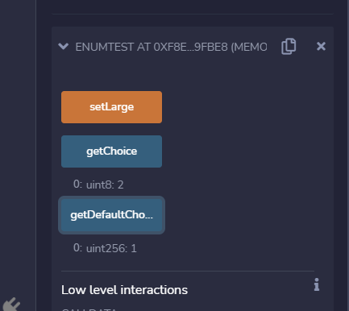

**iii) Struct**

**Syntax**

struct <structure_name> {

<data type> variable_1;

<data type> variable_2;

}

**Example**

contract structTest {

   struct Book {

      string title;

      string author;

      uint book_id;

   }

   Book book;

   function setBook() public {

      book = Book('Learn Java', 'TP', 1);

   }

   function getBookId() public view returns (uint) {

      return book.book_id;

   }

}

**Output**

