Introduction to Blockchain

Assignment - 2

Patil Amit Gurusidhappa

19104004

B11

**Q1. 1. Interact  
with deployed contract  
Requests Volume (Infura.io Dashboard)**

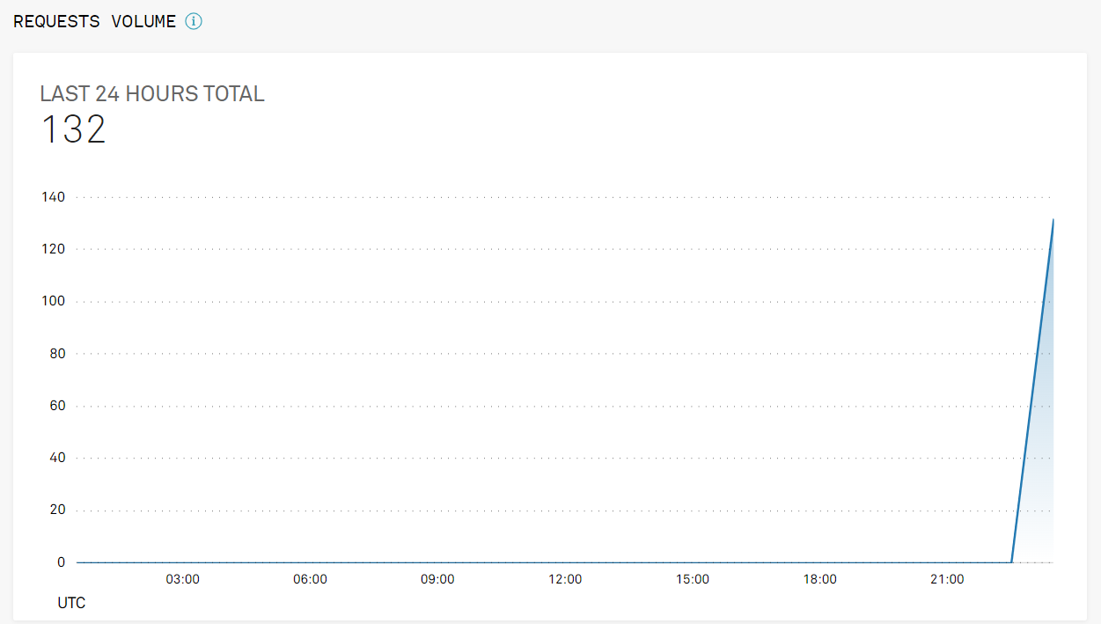

**Increment Count**

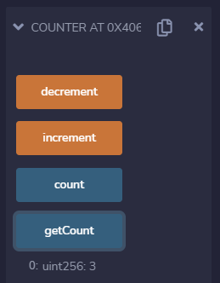

**Decrement Count  
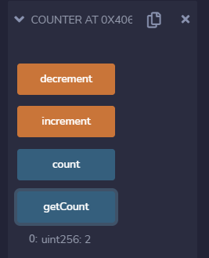**

**2.Deploy  
a new contract**

**Contract**

// SPDX-License-Identifier: MIT

pragma solidity 0.8.7;

contract Counter {

    uint public count=0;

    event Increment(uint value);

    event Decrement(uint value);

    function getCount()view public returns(uint){

        return count;

    }

    function increment() public{

        count+=1;

        emit Increment(count);

    }

    function decrement()public{

        count-=1;

        emit Decrement(count);

    }

}

**Connecting to the Metamask Confirming contract gas fees**

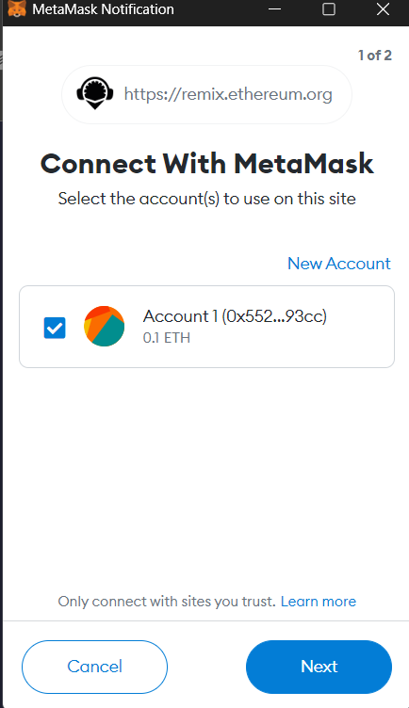 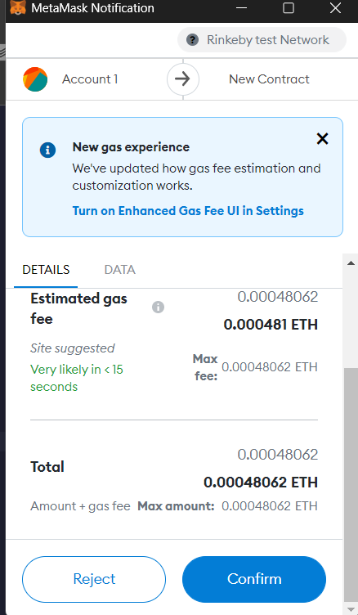

**Transaction Details**

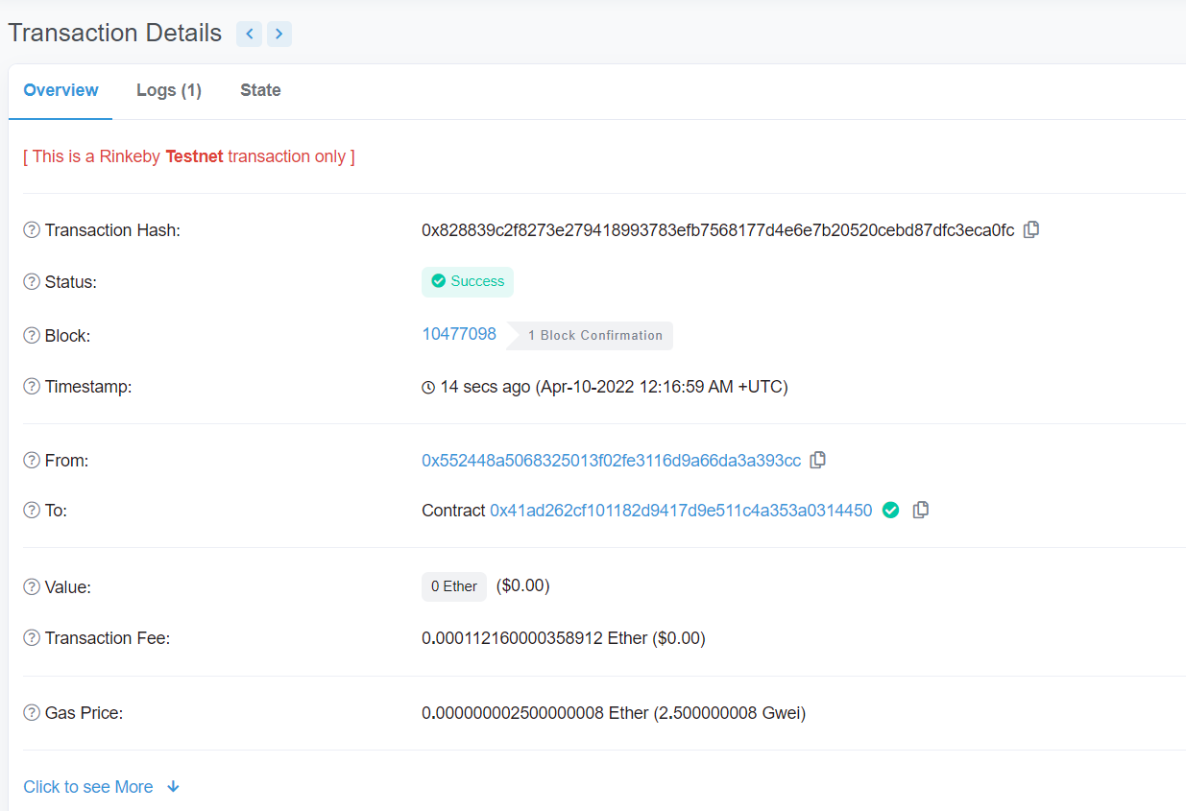

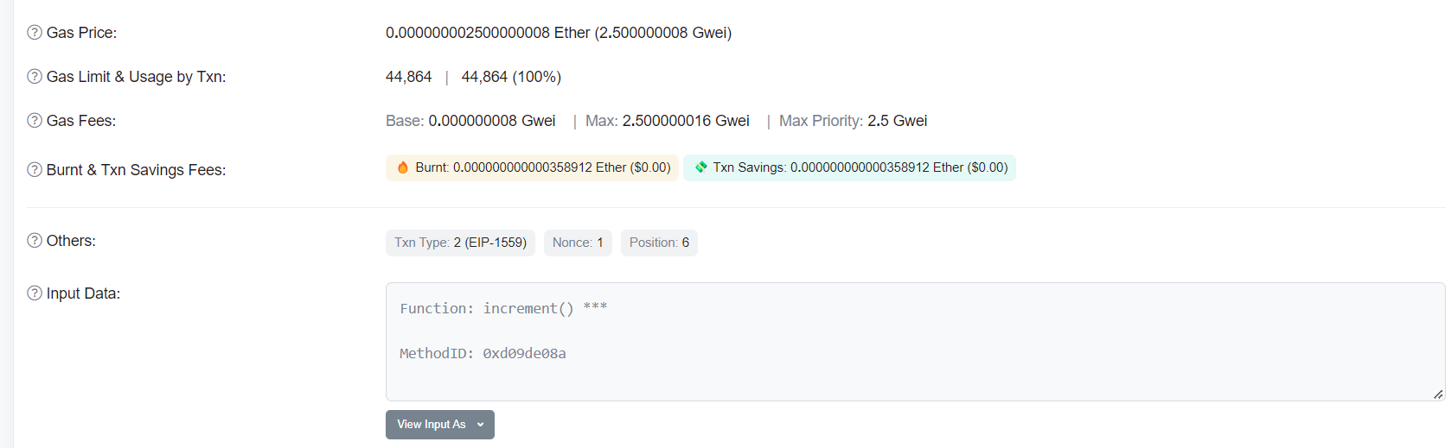

**Functions to call from Remix IDE**

