Code:

#include <iostream>
#include <string>
#include<bits/stdc++.h>
using namespace std;

class bank
{ char name[100], add[100],t;
int balance;
public:
void open_account();
void deposit_money();
void withdraw_money();
void display_account();

};
void bank::open_account()
{
cout<<"enter name\n";
cin.ignore();
cin.getline(name,100);

cout<<"enter address\n";
cin.ignore();
cin.getline(add,100);

cout<<"account type saving (s) or current (c)\n";
cin>>t;

cout<<"deposit amount ";
cin>>balance;
cout<<"account created";

}
void bank::deposit_money()
{ int amount;
cout<<"enetr amount to deposit\n";
cin>>amount;
balance+=amount;
cout<<"total balance\n"<<balance;

}
void bank::display_account()
{
cout<<"Name:"<<name<<"\n";
cout<<"Address:"<<add<<"\n";
cout<<"account type"<<t<<"\n";
cout<<"Balance:"<<balance<<"\n";
}
void bank::withdraw_money()
{
float amount = 0;

cout<<"current balance"<<balance<<"\n";
while (amount<balance)
{
cout<<"enter withdrawal amount:";
cin>>amount;
balance-=amount;
}
cout<<"balance is"<<balance<<"\n";

}

int main()
{

int menu,x;
bank obj;
do{
cout<<"1. open account\n";
cout<<"2. deposit money\n";
cout<<"3. withdraw money\n";
cout<<"4. display account\n";
cout<<"5. Exit\n";
cout<<"choose an option ";
cin>>menu;
switch (menu)
{
case 1:
obj.open_account();
break;
case 2:
obj.deposit_money();
break;
case 3:
obj.withdraw_money();
break;
case 4:
obj.display_account();
break;
case 5: exit (1);
break;
default:
cout<<"enter suitable number\n";
}

cout<<"\n if you want to select an option press :: 1\n";
cout<<"if you want to exit press::0 ";
cin>>x;
if(x==2)
exit(0);
} while (x==1);

}

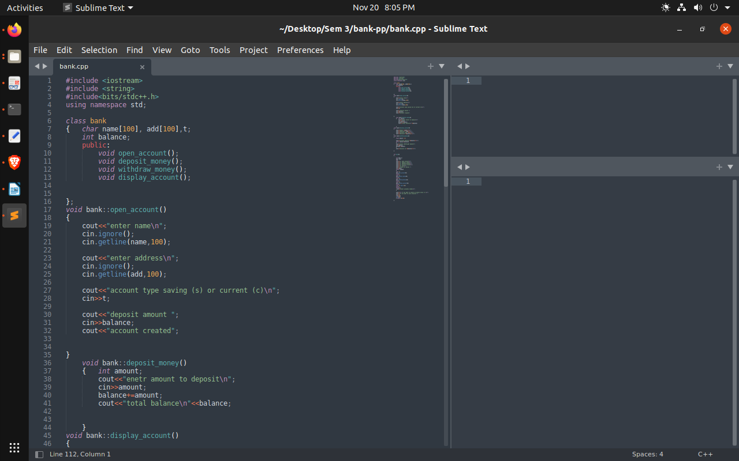
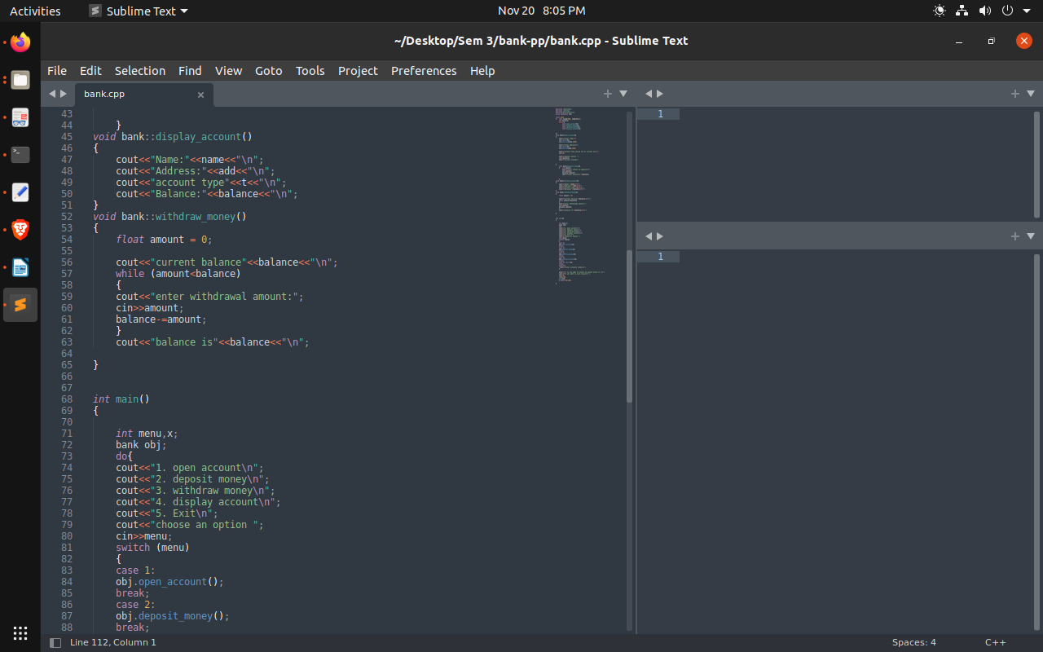
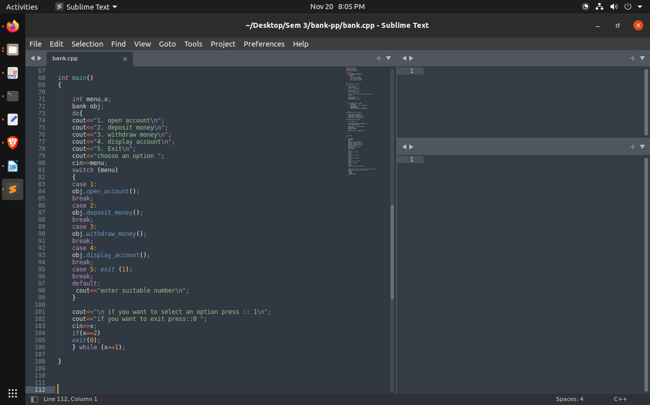

Execution and Compilation:

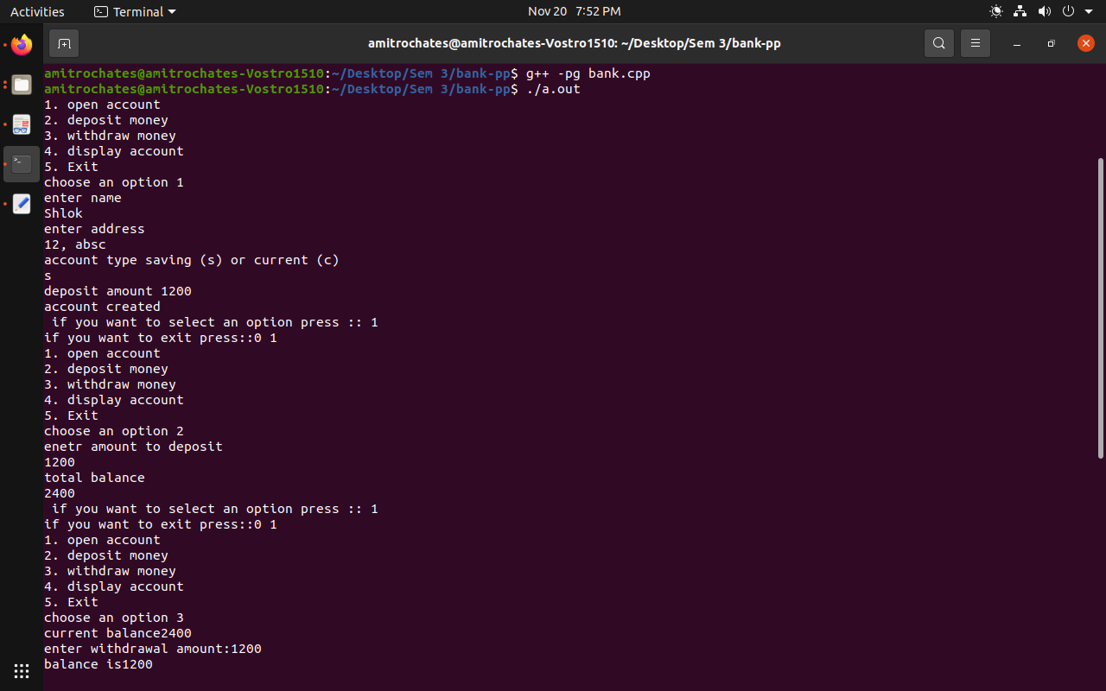
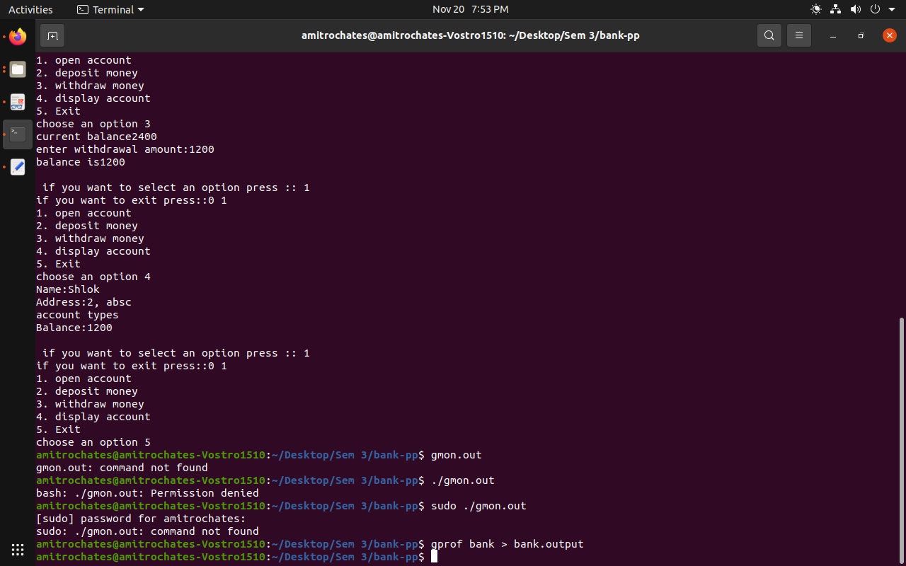

Profiling:

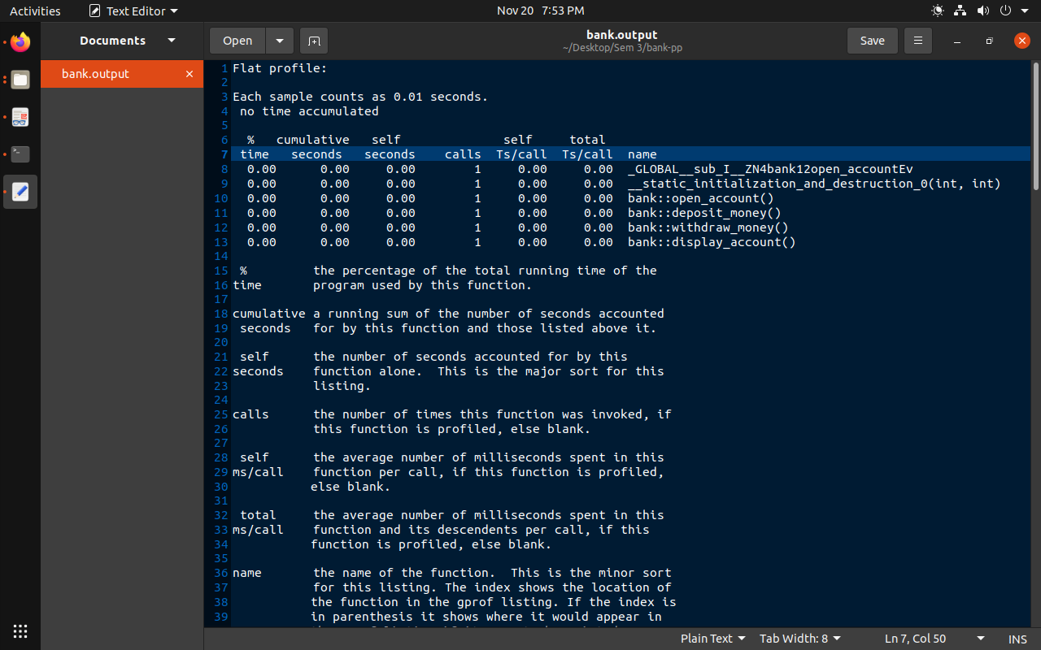
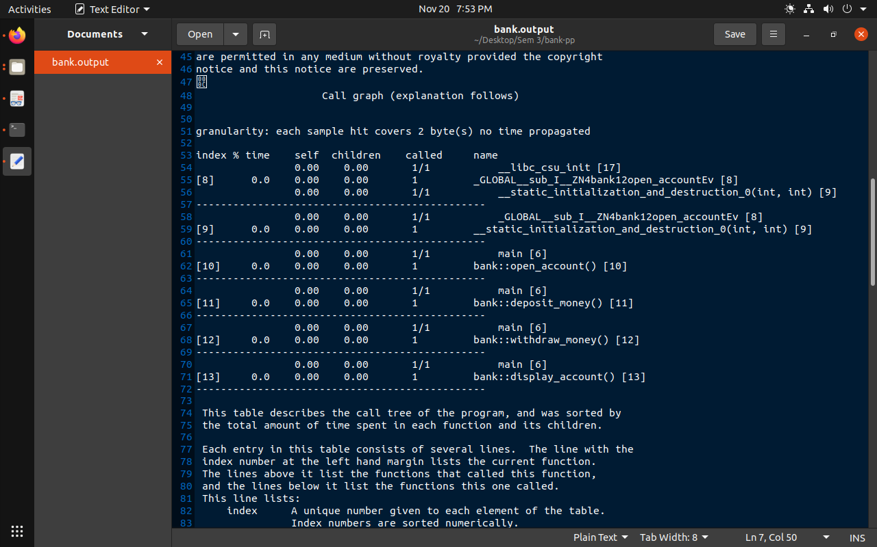

Debugging:

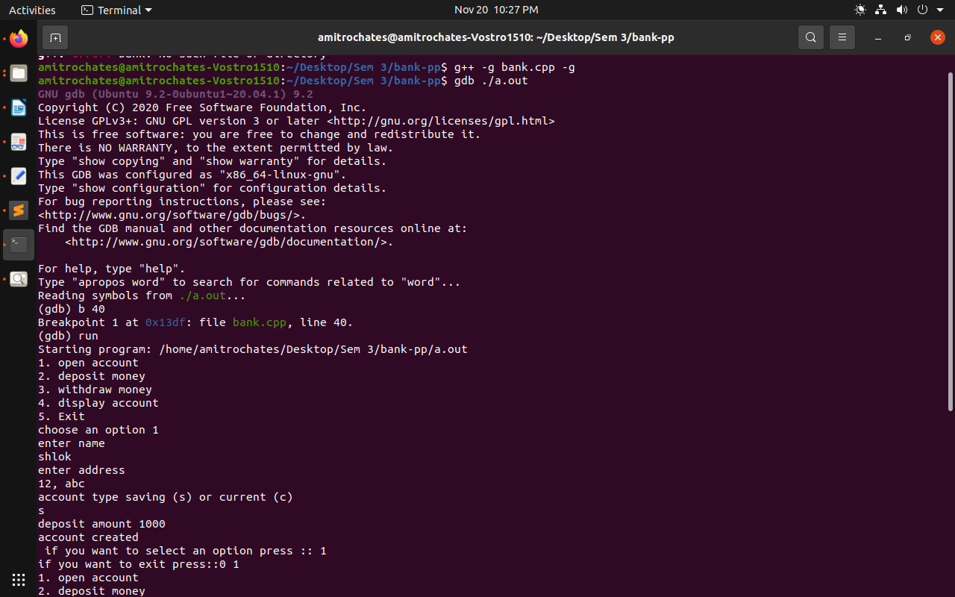
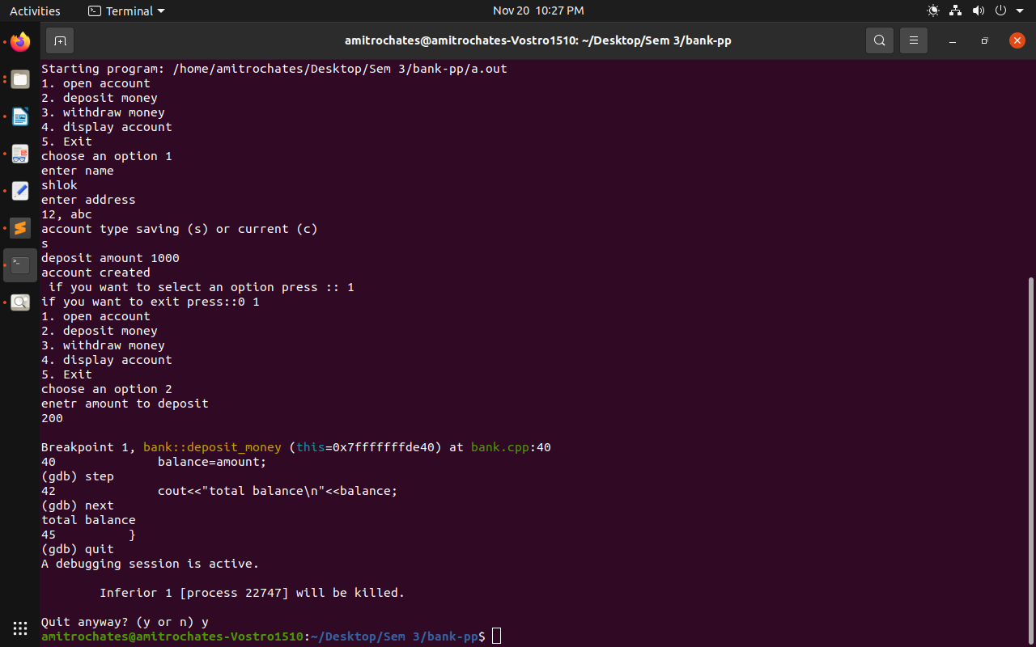

Latex:

