Update for the Workforce Diversity Steering Committee: Equal part-time workforce representation

General Workforce Trends
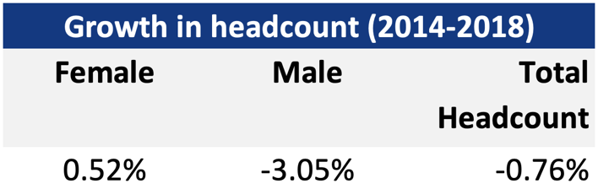
Between 2014 and 2018, the NSW public sector decreased in size. However, this decrease was mainly due to a drop in the number of male employees, as female headcount increased in the sector over the period.
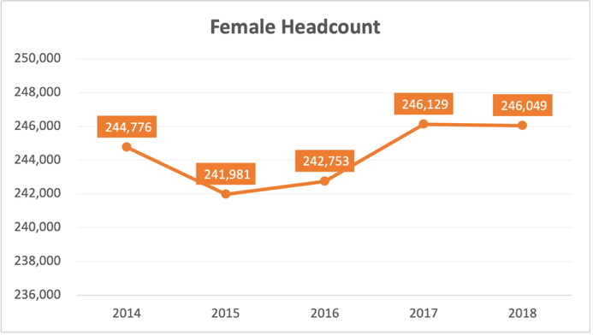
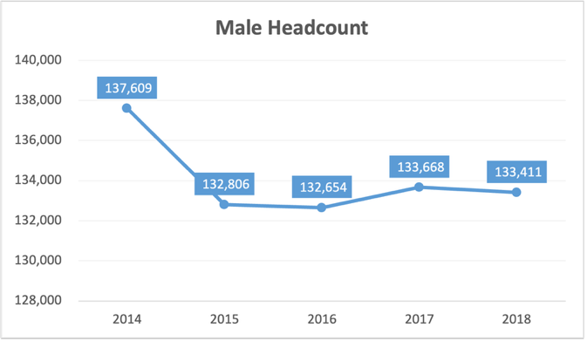
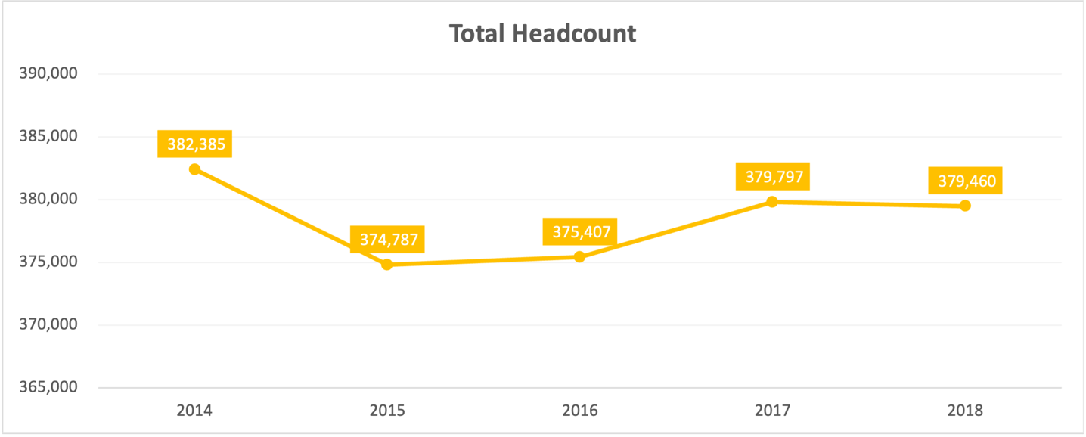

Female employees made up 64.8% of the sector in 2018, an increase from 64% in 2014. While male employee representation dropped from 36% of the sector in 2014 to 35.2% in 2018.
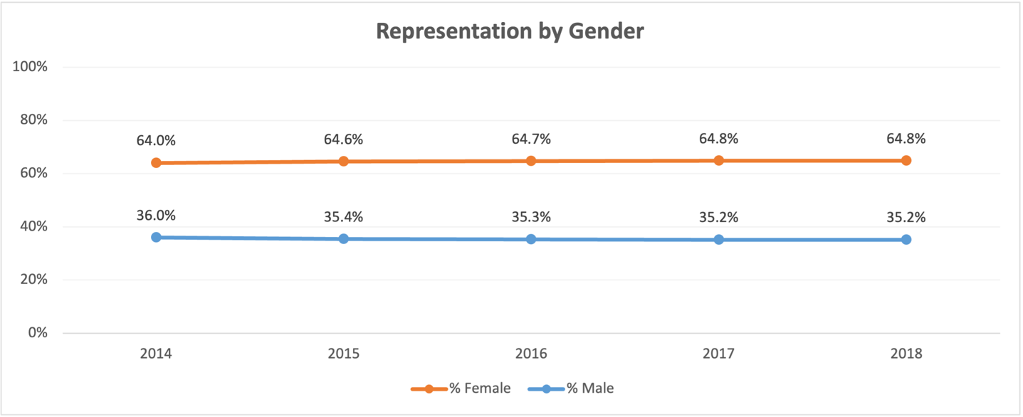

Part-Time Workforce Analysis
Currently:
- From 2014 to 2018, the proportion of employees in the sector who work part-time increased from 26.7% to 29.6%
- For male employees, the figure increased from 10.2% to 16.5%
- For female employees, the figure increased from 35.9% to 36.7%
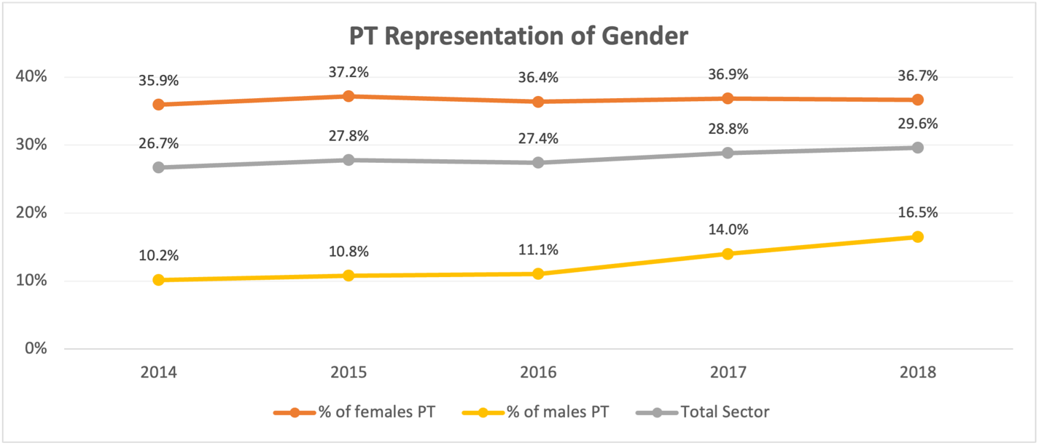
- Only the Education cluster currently has above 40% part-time employees, with female part-time employees making up 46.8% of all female employees and male part-time employees making up 35.3% of all male employees

Representation of part-time employees by cluster and total sector, change, 2014-2018
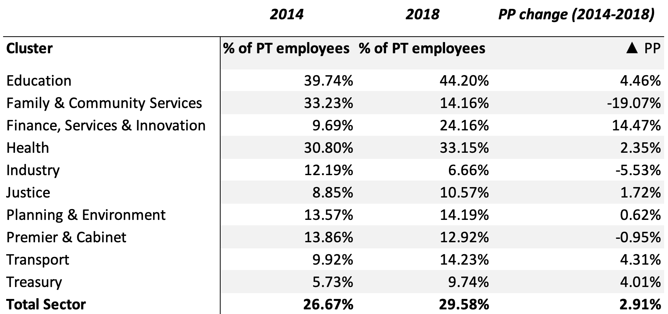

Gender Breakdown of part-time employees by cluster and total sector, change, 2014-2018
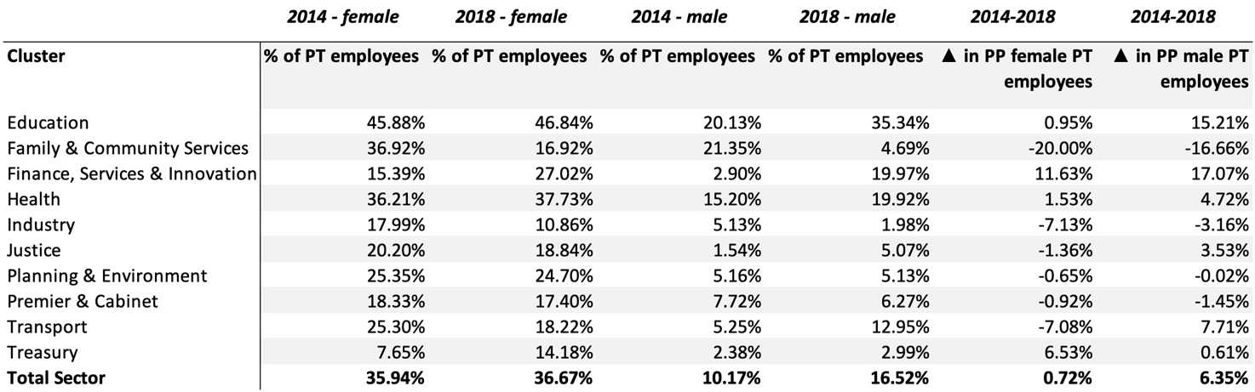
If the changes over the past four years are maintained, by 2025:
- The proportion of employees in the sector who work part-time will increase to 34.7%
- For male employees, the figure will increase to 27.6%.
- For female employees, the figure will increase to 37.9%.

