1.output of first ansible-playbook

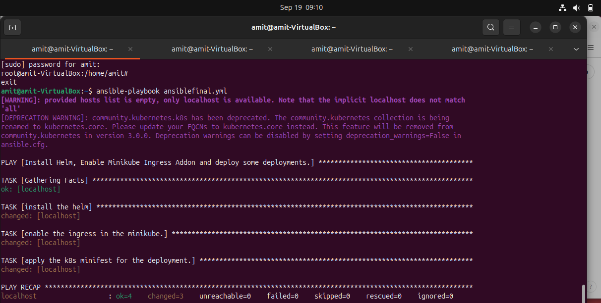

1. Output of second ansible playbook for ingress route.

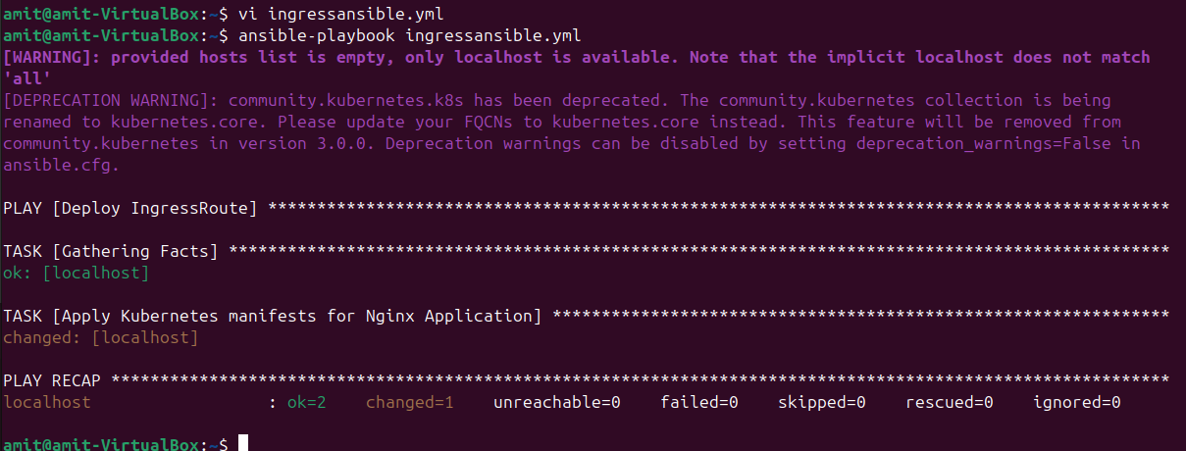

1. Hello world output without certificate.

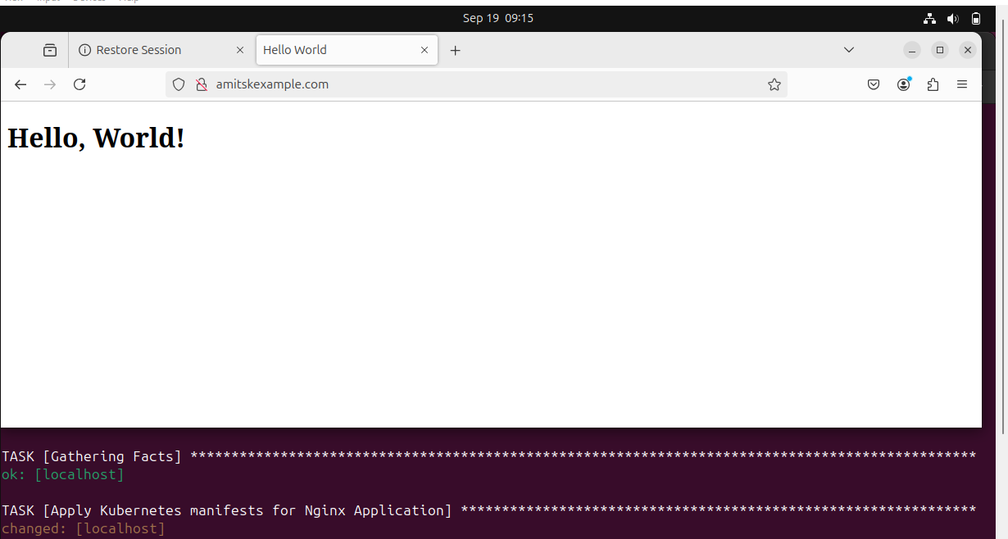

1. Output of ansible playbook for the creation of certificate and adding to ingress route.

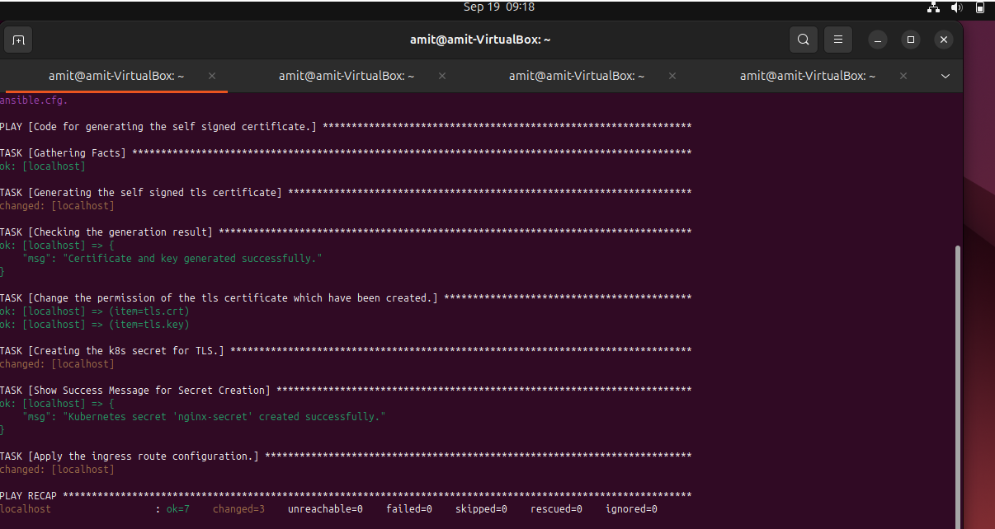

1. Hello world output with certificate.(we can see the https.)

