How to set up minikube k8s cluster.

1. Docker should be installed first.

Below are the Commands to install docker.

**# Add Docker's official GPG key:**

**sudo apt-get update**

**sudo apt-get install ca-certificates curl**

**sudo install -m 0755 -d /etc/apt/keyrings**

**sudo curl -fsSL https://download.docker.com/linux/ubuntu/gpg -o /etc/apt/keyrings/docker.asc**

**sudo chmod a+r /etc/apt/keyrings/docker.asc**

**# Add the repository to Apt sources:**

**echo \**

**"deb [arch=$(dpkg --print-architecture) signed-by=/etc/apt/keyrings/docker.asc] https://download.docker.com/linux/ubuntu \**

**$(. /etc/os-release && echo "$VERSION_CODENAME") stable" | \**

**sudo tee /etc/apt/sources.list.d/docker.list > /dev/null**

**sudo apt-get update**

**sudo apt-get install docker-ce docker-ce-cli containerd.io docker-buildx-plugin docker-compose-plugin**

1. once the docker is installed we need to install the minikube in the system.

Please refer the below commands.

**curl -LO https://storage.googleapis.com/minikube/releases/latest/minikube-linux-amd64**

**sudo install minikube-linux-amd64 /usr/local/bin/minikube && rm minikube-linux-amd64**

1. Now start your cluster of minikube.

**Minikube start - but not logged in as root.**

1. Once the the minikube start command is run we will get the below output.

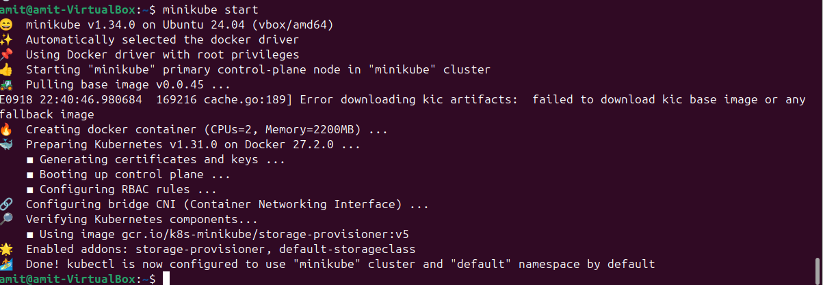

1. Once the output comes , to access the resources using kubectl we need to run the below command.

**Sudo snap install kubectl --classic**

6.Now we are good to go for the deployment.