Q1

public class HelloWorld

{

public static void main(string[] args)

{

System.out.println("HelloWorld");

}

}

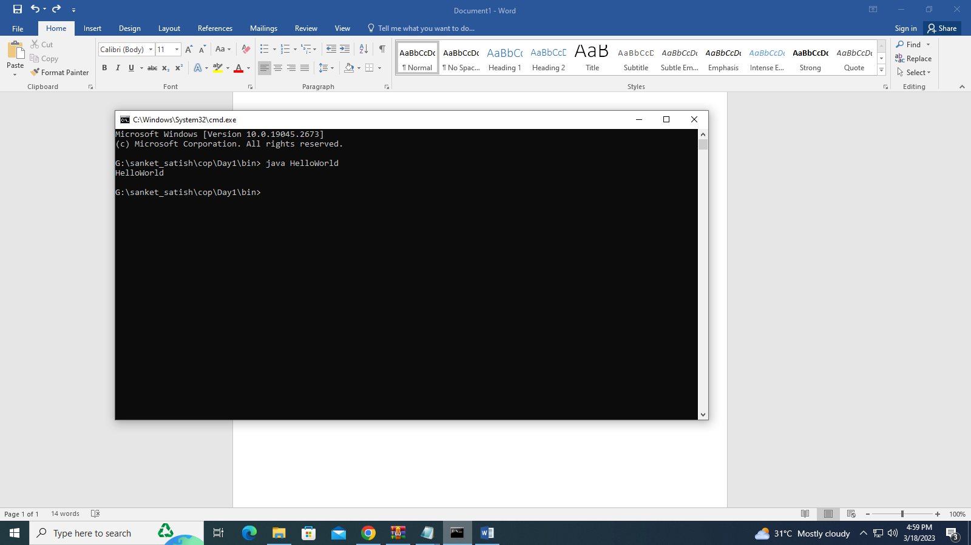

Q2

public class add

{

public static void main(String[] args)

{

int a=10;

int b=20;

int c=a+b;

System.out.println("addition of two numbers is:"+c);

}

}

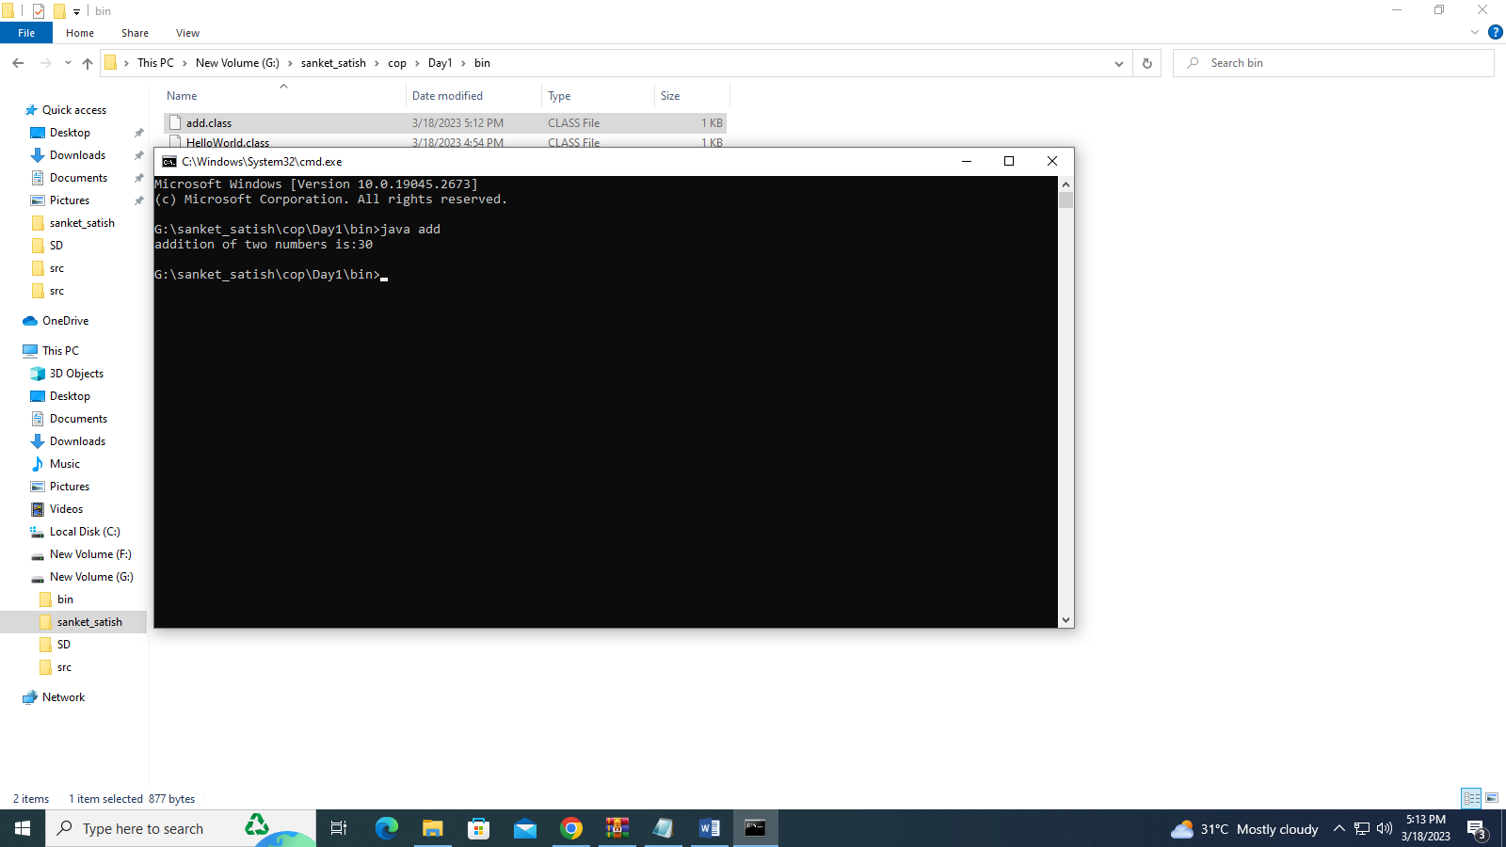

Q3

**package** day1Assignment;

**public** **class** Swap {

**public** **static** **void** main(String[] args) {

**int** a=10;

**int** b=20;

System.***out***.println("values before swapping are:"+a+" "+b);

a=a+b;

b=a-b;

a=a-b;

System.***out***.println("After swaping of two variables of a and b are:"+a+" "+b);

}

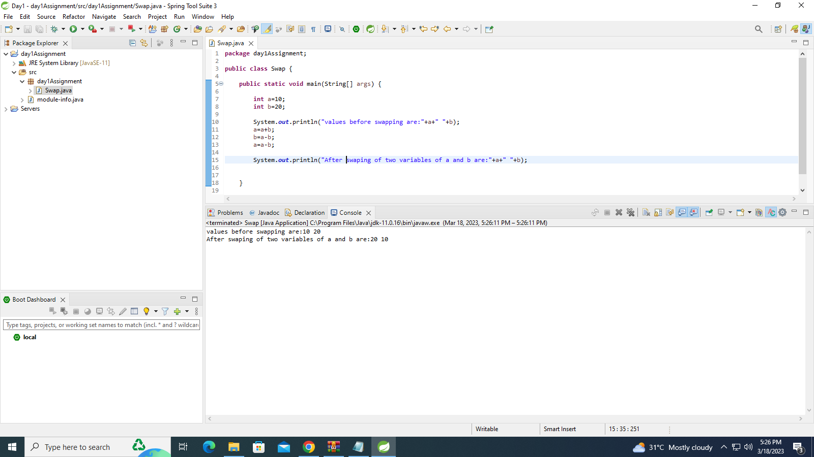

**Q4**

**package** day1Assignment;

**import** java.util.Scanner;

**public** **class** Factorial {

**public** **static** **void** main(String[] args) {

Scanner sc=**new** Scanner(System.***in***);

**int** num=sc.nextInt();

**int** fact=1;

**int** i=num;

**while**(i>=1)

{

fact=fact*i;

i--;

}

System.***out***.println("factorial of a given number is "+fact);

}

}

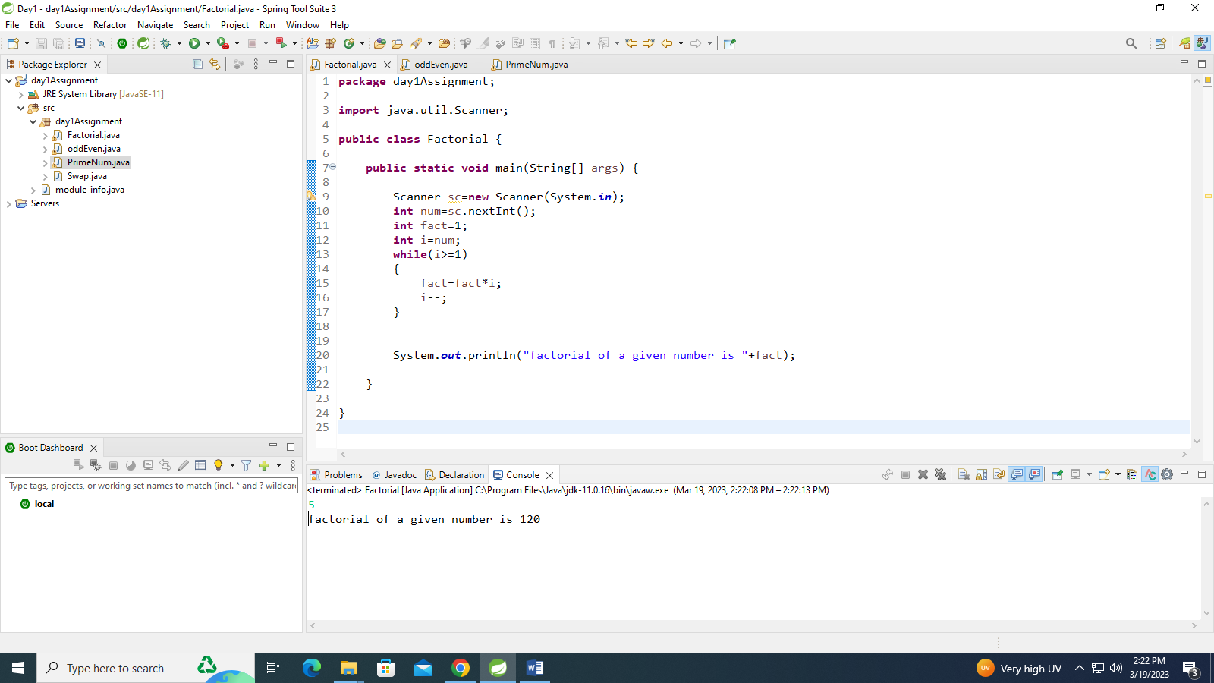

**Q5**

**package** day1Assignment;

**import** java.util.Scanner;

**public** **class** exponential {

**public** **static** **void** main(String[] args) {

Scanner sc=**new** Scanner(System.***in***);

**int** exp=sc.nextInt();

**int** base=sc.nextInt();

**int** res=1;

**while**(exp!=0)

{

res=res*base;

exp--;

}

System.***out***.println("the result of expotential and base is:"+res);

}

}

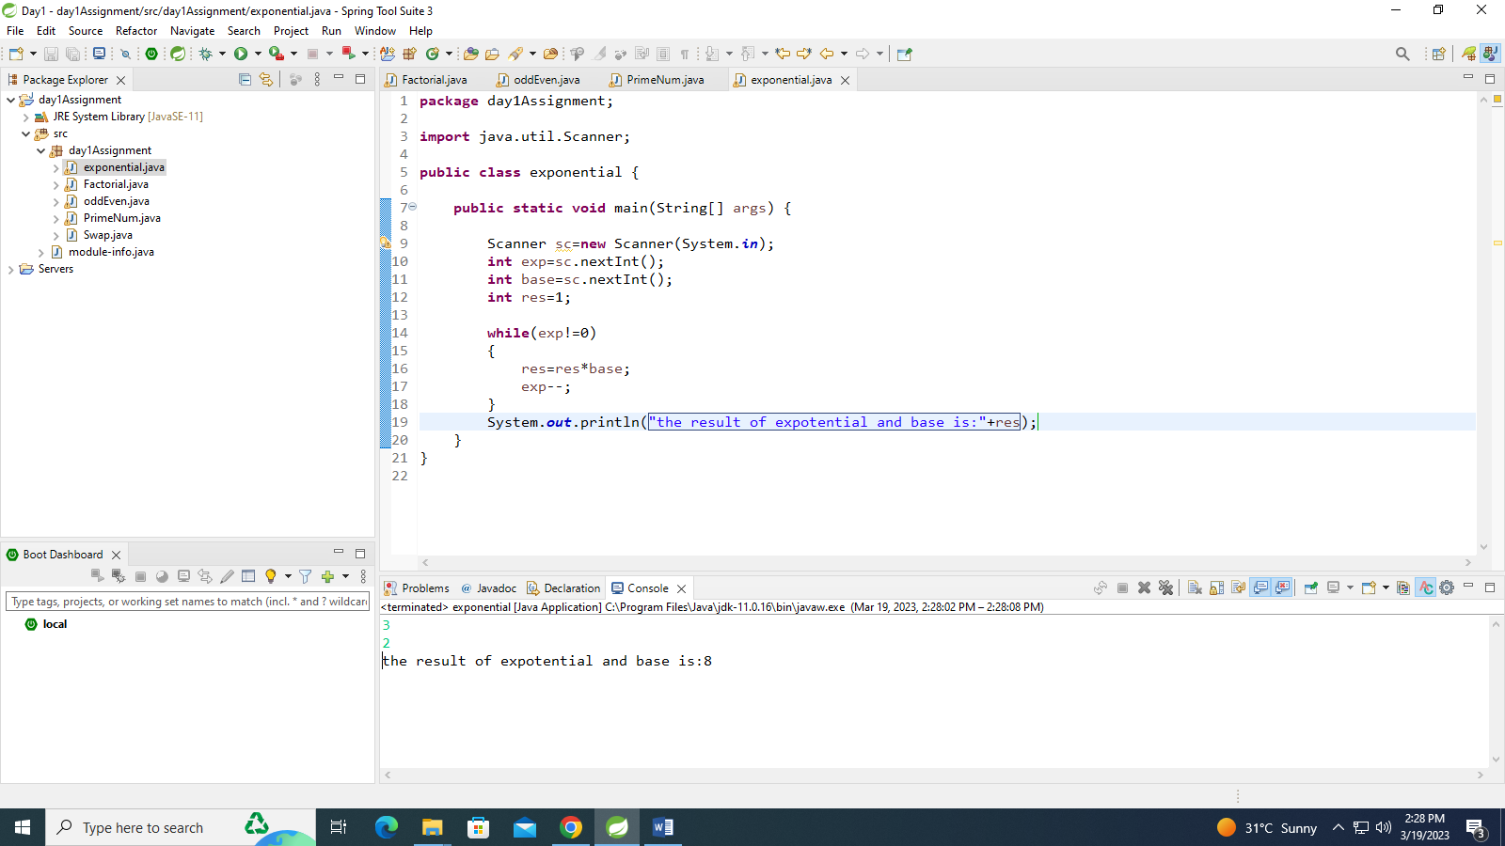

**Q6**

**package** day1Assignment;

**import** java.util.Scanner;

**public** **class** PrimeNum {

**public** **static** **void** main(String[] args) {

**int** i,flag=0;

**int** num;

Scanner sc=**new** Scanner(System.***in***);

num=sc.nextInt();

i=2;

**while**(i<=num/2)

{

**if**(num%i==0)

{

flag=1;

**break**;

}

i++;

}

**if**(flag==0)

System.***out***.println("given number is prime number:"+num);

**else**

System.***out***.println("given number is not a prime")}}

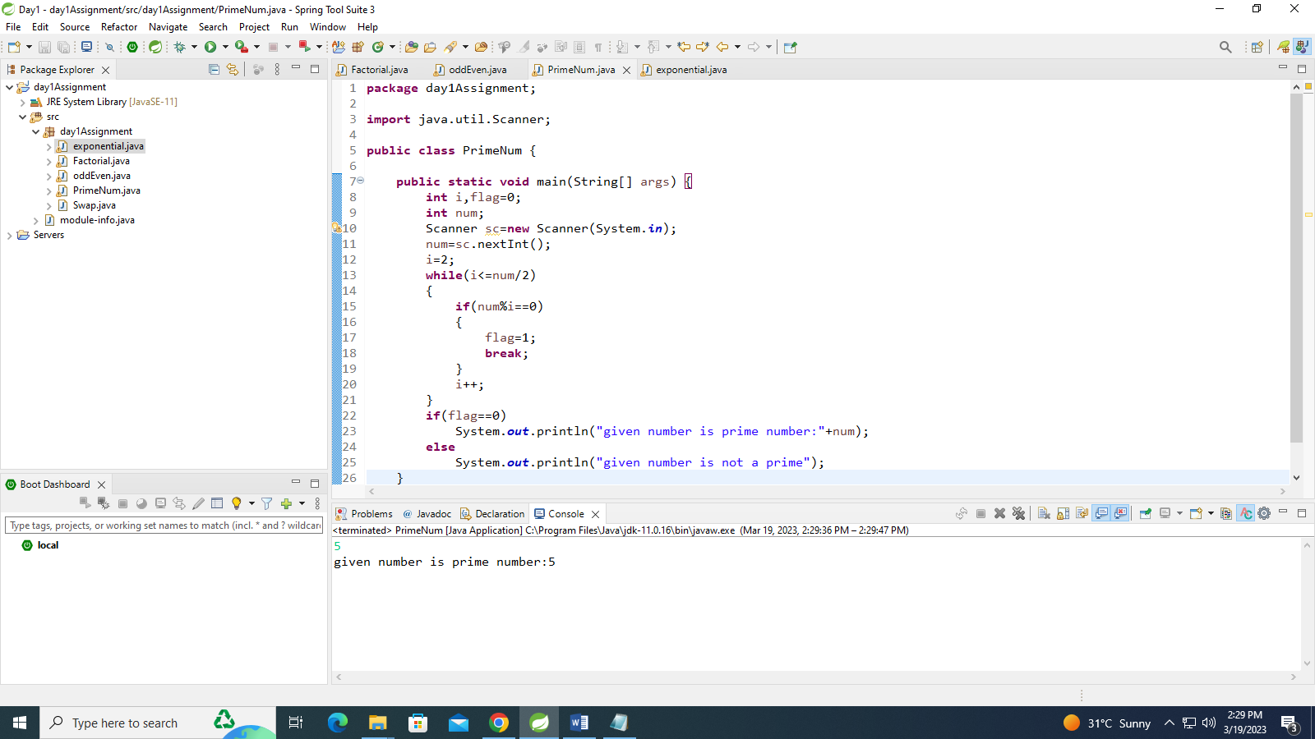

**Q7**

**package** day1Assignment;

**import** java.util.Scanner;

**public** **class** SumOfSeries {

**public** **static** **void** main(String[] args) {

**int** i,n,sum=0;

Scanner sc=**new** Scanner(System.***in***);

n=sc.nextInt();

**for**(i=1;i<=n;i++)

{

sum+=i;

}

System.***out***.println("sum of the given series is:"+sum);

}

}

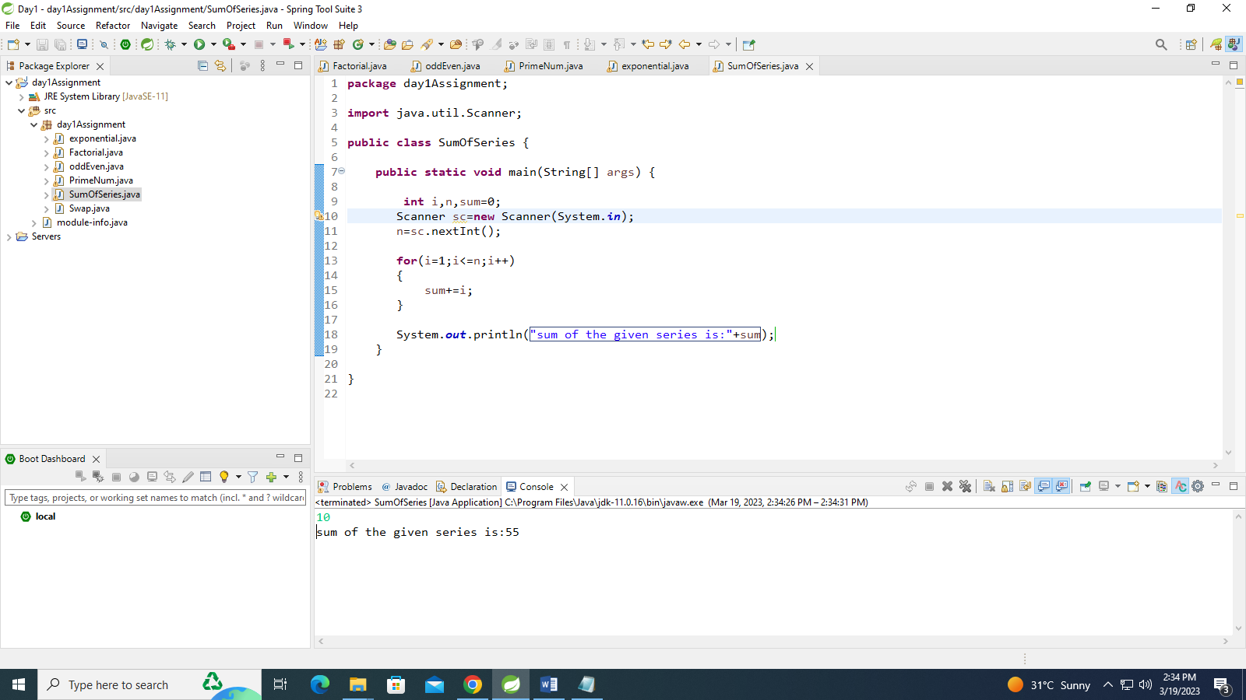

**Q8**

**package** day1Assignment;

**import** java.util.Scanner;

**public** **class** oddEven {

**public** **static** **void** main(String[] args) {

// **TODO** Auto-generated method stub

Scanner sc=**new** Scanner(System.***in***);

**int** n=sc.nextInt();

**int** i;

**int** evensum=0,oddsum=0;

**for**(i=1;i<n;i++)

{

**if**(i%2==0)

{

evensum+=i;

}

**else**

{

oddsum+=i;

}

}

System.***out***.println("addition of even sum is:"+evensum);

System.***out***.println("addition of even sum is:"+oddsum);

}

}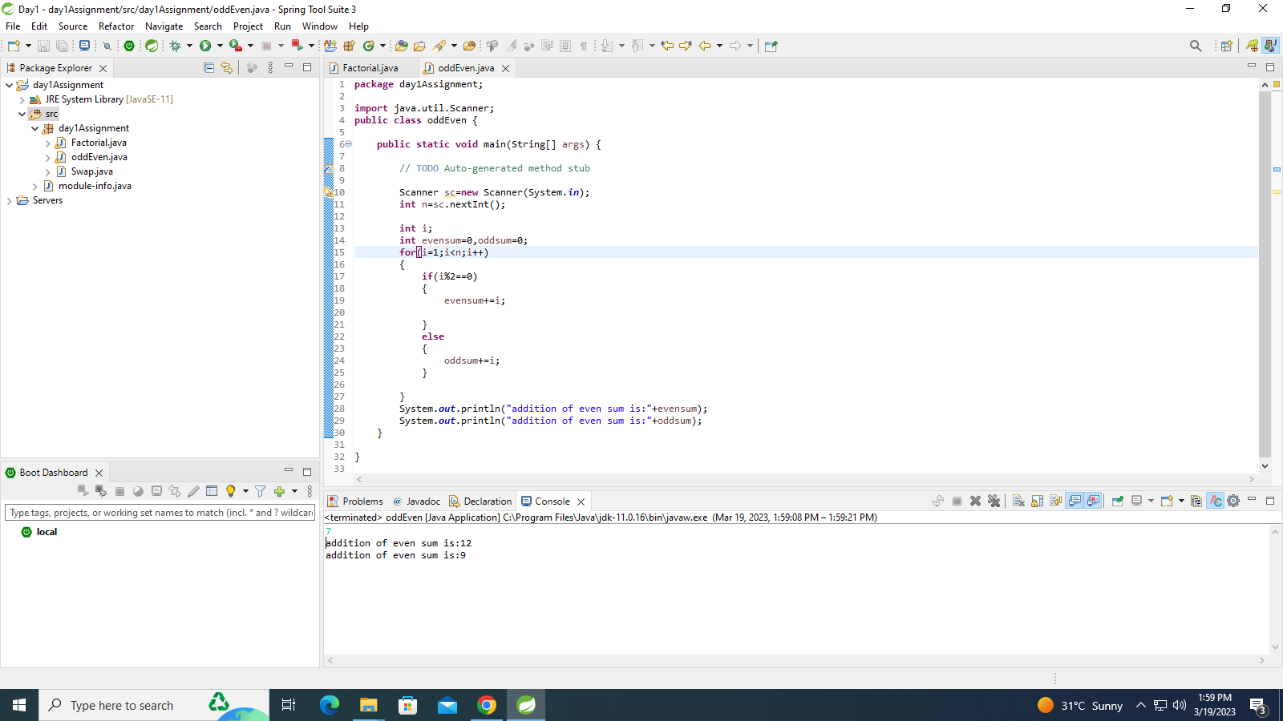

Q10

**package** day1Assignment;

**import** java.util.Scanner;

**public** **class** Reversenum {

**public** **static** **void** main(String[] args) {

**int** n,reverse=0,reminder;

System.***out***.println("enter an integer");

Scanner sc=**new** Scanner(System.***in***);

n=sc.nextInt();

**while**(n!=0)

{

reminder=n%10;

reverse=reverse*10+reminder;

n=n/10;

}

System.***out***.println("reverse of given number is:"+reverse);

}

}

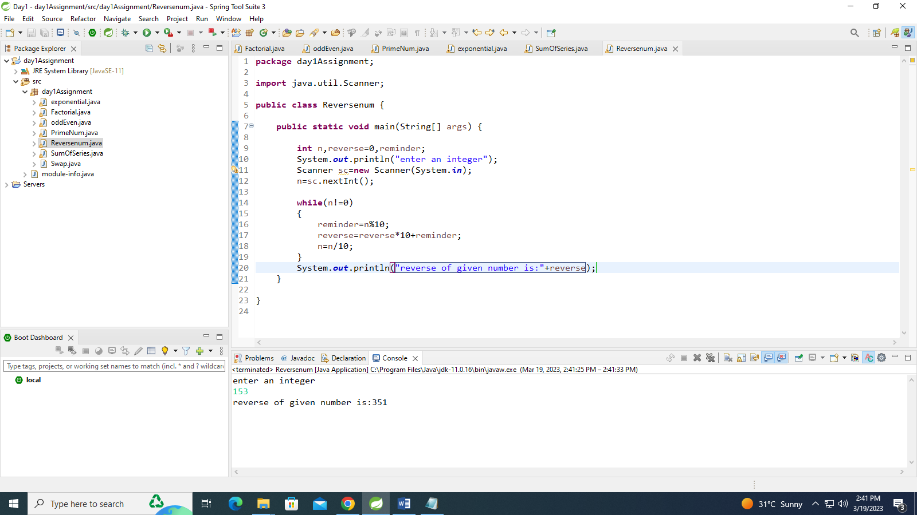

Q11

import java.util.Scanner;

public class Armstrong {

public static void main(String[] args) {

int rem=0;

int res=0;

int temp;

Scanner sc=new Scanner(System.in);

int num=sc.nextInt();

temp=num;

while(num!=0)

{

rem=num%10;

res=res+(rem*rem*rem);

num=num/10;

}

if(temp==res) {

System.out.println("given number is armstrong number");

}

else

System.out.println("given number is not an armstrong number");

}

}

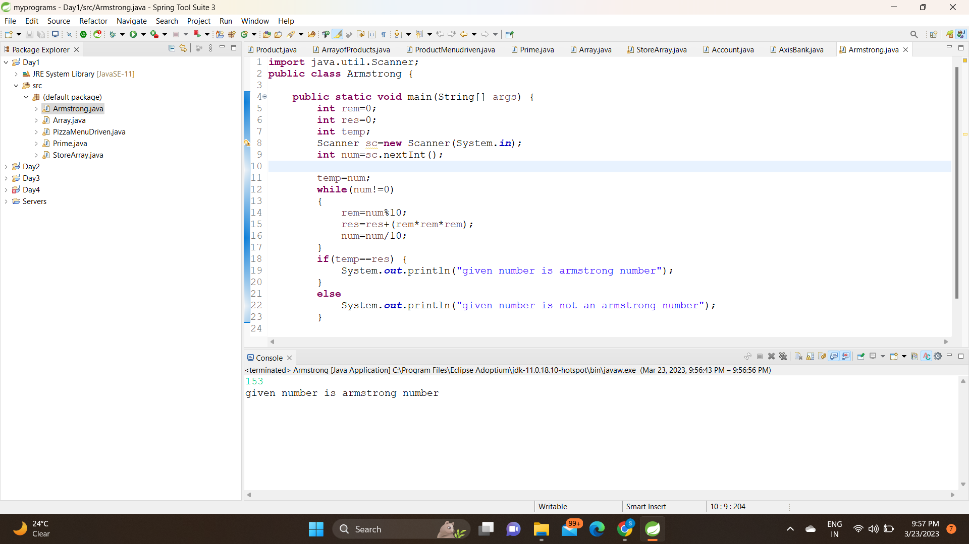

Q12

package day1Assignment;

import java.util.Scanner;

public class Greatestnum {

public static void main(String[] args) {

int a,b,c;

Scanner sc=new Scanner(System.in);

a=sc.nextInt();

b=sc.nextInt();

c=sc.nextInt();

if(a>b && a>c)

{

System.out.println("a is the greatest number:");

}

else if(b>a && b>c)

{

System.out.println("b is greatest number:");

}

if(c>a && c>b)

{

System.out.println("c is the greatest number:");

}

}

}

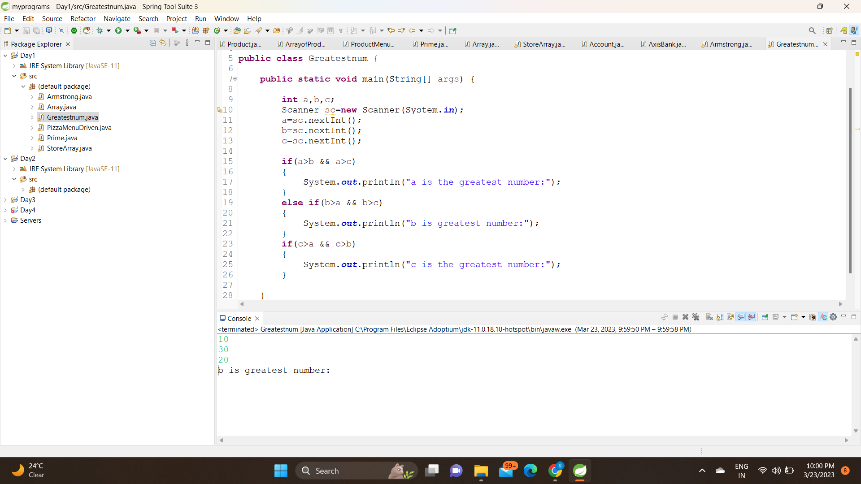

Q13

**package** day1Assignment;

**import** java.util.Scanner;

**public** **class** Greatestnum {

**public** **static** **void** main(String[] args) {

**int** a,b,c;

Scanner sc=**new** Scanner(System.***in***);

a=sc.nextInt();

b=sc.nextInt();

c=sc.nextInt();

**if**(a>b && a>c)

{

System.***out***.println("a is the greatest number:");

}

**else** **if**(b>a && b>c)

{

System.***out***.println("b is greatest number:");

}

**if**(c>a && c>b)

{

System.***out***.println("c is the greatest number:") }}}

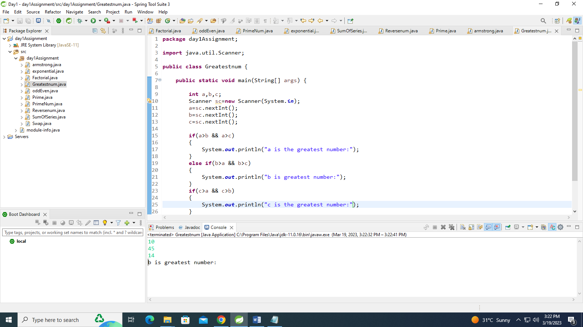

Q14

import java.util.Scanner;

public class PizzaMenuDriven {

public static void main(String[] args) {

System.out.println("1:paneerpizza 300Rs, 2:margerita 200Rs, 3:cheezypizza 200Rs, 4:plainpizza 100Rs, 5:exit, 6:totalamount");

int choice,qty;

int amount=0;

do {

System.out.println("enter your choice:");

Scanner sc=new Scanner(System.in);

choice=sc.nextInt();

switch(choice)

{

case 1:

System.out.println("enter the no of quantity u want to order:");

qty=sc.nextInt();

amount=amount+(300*qty);

break;

case 2:

System.out.println("enter the no of quantity u want to order:");

qty=sc.nextInt();

amount=amount+(200*qty);

break;

case 3:

System.out.println("enter the no of quantity u want to order:");

qty=sc.nextInt();

amount=amount+(200*qty);

break;

case 4:

System.out.println("enter the no of quantity u want to order:");

qty=sc.nextInt();

amount=amount+(200*qty);

break;

case 5:

System.out.println("thank you visit again");

case 6:

System.out.println("total amount of your bill is:"+amount);

break;

default :

{

System.out.println("you have not given your choice");

}

}

}while(choice!=5);

//System.out.println("total amount is "+amount);

}

}

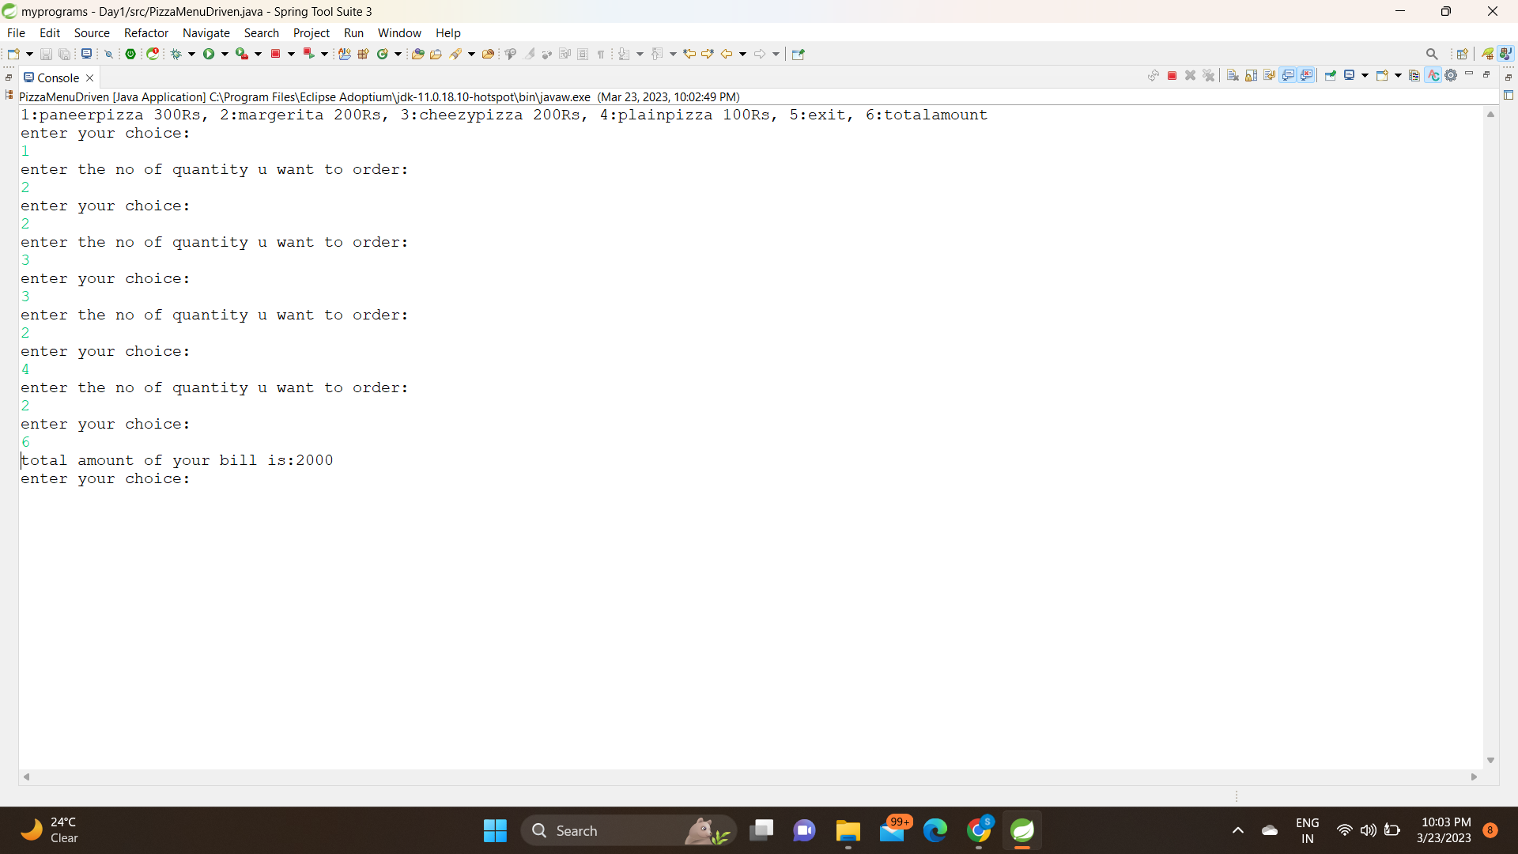

Q15

import java.util.Scanner;

public class ArrayMenDriven {

public static void main(String[] args) {

int[] arr;

arr = new int[5];

// System.out.println("enter the size of array:");

System.out.println(

"1:Read array 2:print array " + "3:search element in array 4:Reverse string 5:Even no from array "

+ "6:sum of array elements 7:exit");

Scanner sc = new Scanner(System.in);

int choice = 0;

do {

System.out.println("enter your chooice:");

choice = sc.nextInt();

switch (choice) {

case 1:

System.out.println("read your array:");

for (int i = 0; i < arr.length; i++) {

arr[i] = sc.nextInt();

}

break;

case 2:

System.out.println("print your array:");

for (int i = 0; i < arr.length; i++) {

System.out.println("" + arr[i]);

}

break;

case 3:

System.out.println("to search element in array...give the number");

int search = sc.nextInt();

boolean flag = false;

for (int i = 0; i < arr.length; i++) {

if (arr[i] == search) {

System.out.println("number is present");

flag = true;

break;

}

}

if (flag == false) {

System.out.println("Number not found");

}

break;

case 4:

System.out.println("enter your original array:");

for(int i=0;i<arr.length;i++)

{

arr[i]=sc.nextInt();

}

System.out.println("reversed array is:");

for(int i=arr.length-1;i>=0;i--)

{

System.out.println(""+arr[i]);

}

break;

case 5:

//System.out.println("enter your array:");

for(int i=0;i<arr.length;i++)

{

if(arr[i]%2==0)

{

System.out.println("even numbers are:"+arr[i]);

}

}

break;

case 6:

System.out.println("enter the elements you want to sum of:");

int sum=0;

for(int i=0;i<arr.length;i++)

{

sum+=arr[i];

}

break;

case 7:

break;

default:

System.out.println("thankyou");

}

} while (choice != 7);

System.out.println("------The End------");

}

}

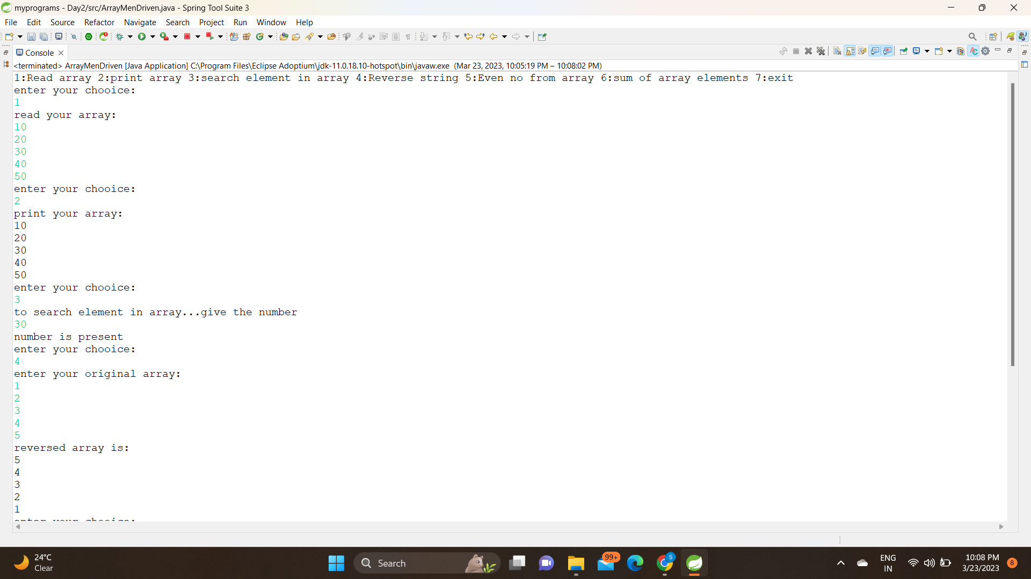

Q16

import java.util.Scanner;

public class StoreArray {

public static void main(String[] args) {

int index=0;

int []arr1= {1,2,3};

int[]arr2= {5,6,7,8,9};

System.out.println("enter elements of first array:");

for(int i=0;i<arr1.length;i++)

{

System.out.println(arr1[i]);

}

System.out.println("enter elements of second array:");

for(int i=0;i<arr2.length;i++)

{

System.out.println(arr2[i]);

}

int[]arr3=new int[arr1.length+arr2.length];

for(int i=0;i<arr1.length;i++)

{

arr3[index]=arr1[i];

index++;

}

for(int j=0;j<arr2.length;j++)

{

arr3[index]=arr2[j];

index++;

}

for(int k=0;k<arr3.length;k++)

{

System.out.println(""+arr3[k]);

}

}

}

