Design and Implementation of a Retrieval-Augmented Generation (RAG) Based PDF Question-Answering System
A locally-run document chat application using open-source embeddings and Groq-hosted LLM inference
Department of Computer Science and Engineering

Abstract
Finding a specific piece of information inside a long PDF, like lecture notes, a lab manual or a research paper, usually means scrolling through the whole document or using Ctrl+F and hoping the exact word was used. Ctrl+F only works when the search term matches the text exactly, so it fails the moment a question is phrased differently from the source. This paper describes a Retrieval-Augmented Generation (RAG) based web application that we built to solve this problem for ourselves, since we were tired of digging through PDFs during exam preparation. The system lets a user upload one or more PDF files, which are parsed, split into overlapping text chunks and converted into embedding vectors using a locally-run MiniLM model. When the user asks a question in natural language, the question is embedded the same way, compared against the stored chunks using cosine similarity, and the most relevant chunks are sent along with the question to a large language model (Llama 3.1 8B, hosted on Groq) which produces a grounded answer along with the source chunks it used. Unlike most RAG tutorials available online, this implementation does not depend on a paid vector database or a paid embedding API — everything except the final answer-generation step runs on the local machine, which keeps the running cost close to zero. We built the backend with Node.js and Express, and the frontend with React. This paper covers the system architecture, the ingestion and query pipelines, implementation details, and the results we observed while testing the system with different types of PDFs, along with the limitations we ran into during development.

Keywords
Retrieval-Augmented Generation, RAG, Large Language Models, Semantic Search, Vector Embeddings, PDF Question Answering, Groq API, Sentence Transformers, Node.js, React

1. Introduction
Large Language Models (LLMs) such as GPT and Llama are very good at answering general questions, but they have two well-known limitations. First, their knowledge is frozen at whatever point their training data ends, so they know nothing about a document that did not exist when they were trained. Second, when an LLM does not know the answer to something it is very likely to “hallucinate”, meaning it confidently generates an answer that sounds correct but is factually wrong. This is a serious problem if a student is using the model to study from their own class notes or a professor is using it to answer questions from a research paper, because there is no way for the model to know what is actually written in that specific document.
Retrieval-Augmented Generation, first proposed by Lewis et al. [1], solves this by combining a retrieval step with a generation step. Instead of asking the LLM the question directly, the system first searches a knowledge base (in our case, the uploaded PDFs) for the pieces of text most relevant to the question, and then gives those pieces of text to the LLM as context along with the question. The LLM is instructed to answer using only that context. This way the model is grounded in the actual document, and can honestly say “I don't have enough information” if the answer is not present, instead of guessing.
The motivation for this project came from a very simple problem we personally faced — before exams we would have a stack of PDF notes and would waste time scrolling to find one specific definition or formula. We wanted a tool where we could just upload all our notes and directly ask a question in plain English and get an answer along with the source, so we can verify it ourselves instead of blindly trusting it. The objective of this project was therefore to design and build a complete, working, end-to-end RAG pipeline — from PDF upload to answer generation — using freely available tools wherever possible, and to understand each stage of the pipeline by implementing it rather than just calling a single high-level library function.
The rest of this paper is organized as follows. Section 2 discusses existing work and tools related to RAG systems. Section 3 explains the overall system architecture. Section 4 walks through the methodology, i.e., how a PDF actually moves through the system from upload to being searchable, and how a question is answered. Section 5 gives implementation details and the technologies used. Section 6 presents our results and the issues we faced during testing. Section 7 lists the limitations and possible future improvements, followed by the conclusion and references.

2. Literature Review / Related Work
The idea of combining retrieval with generation was introduced by Lewis et al. [1] in their 2020 paper “Retrieval-Augmented Generation for Knowledge-Intensive NLP Tasks”, where they showed that giving a generative model access to retrieved documents improves factual accuracy on open-domain question answering compared to a purely parametric model. This idea is now the base of almost every modern “chat with your document” application.
For the retrieval step, most RAG systems rely on dense vector embeddings rather than older keyword-based approaches like TF-IDF or BM25. Reimers and Gurevych [2] introduced Sentence-BERT, showing that sentence-level embeddings could be compared efficiently using cosine similarity while still capturing semantic meaning, which is what makes it possible to match a question like “what causes overfitting” against a passage that never literally uses those words. The all-MiniLM-L6-v2 model used in this project [3] is a distilled sentence-transformer model that produces 384-dimension embeddings and is small enough to run in the browser or a lightweight Node.js server using an ONNX runtime, which is why we picked it over larger models.
On the tooling side, frameworks like LangChain [4] and LlamaIndex have become extremely popular for building RAG applications quickly, since they provide ready-made document loaders, text splitters and chains that connect an embedding model to a vector database and an LLM in a few lines of code. Vector databases such as Pinecone, Weaviate and Chroma are usually used alongside these frameworks to store and search embeddings at scale. However, these frameworks and hosted vector databases add a layer of abstraction that can hide what is actually happening internally, and most of them also require either a paid API key (OpenAI embeddings) or a hosted database subscription once the free tier is exceeded. For a small-scale academic project this felt unnecessary, so instead of using LangChain we implemented the chunking logic, the vector similarity search and the ingestion pipeline ourselves, which also helped us actually understand what a RAG pipeline is doing step by step instead of treating it as a black box.
For the generation step, we considered OpenAI's GPT models, which are the most commonly used in tutorials, but they require a paid API key with no meaningful free tier. We instead used Groq [5], which hosts open-weight models like Llama 3.1 and is known for extremely fast inference because of its custom LPU hardware, and offers a usable free tier which was sufficient for our testing. A comparison of our design choices against a typical cloud-based RAG stack and against plain keyword search is given later in Table 1.

3. System Architecture
The system follows a fairly standard three-tier architecture: a React frontend, an Express backend exposing REST APIs, and a set of backend services that together implement the RAG pipeline. Figure 1 shows the overall architecture with the main components and how data moves between them.
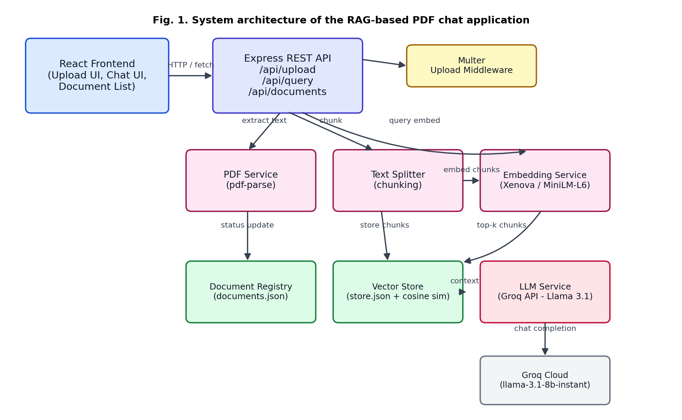
Fig. 1. System architecture of the RAG-based PDF chat application
The frontend is a React single-page application with three main components — a file upload zone that supports drag-and-drop, a document list that shows the processing status of every uploaded file, and a chat window where the user types questions and sees answers along with the sources used to generate them. The frontend talks to the backend only through a small REST API client (client.js) that wraps fetch calls to three endpoints: /api/upload, /api/query and /api/documents.
The backend is split into routes, middleware and services. The routes layer (upload.routes.js, query.routes.js, documents.routes.js) is intentionally kept thin — its only job is to validate the incoming request and call the right service function. All the actual logic lives in the services layer: pdfService.js extracts text from PDFs, textSplitter.js breaks the text into chunks, embeddingService.js converts text into vectors, vectorStore.js stores and searches those vectors, documentRegistry.js keeps track of every uploaded document's metadata and status, and llmService.js talks to the Groq API to generate the final answer. ragService.js sits on top of all of these and coordinates the two main pipelines of the application, which are explained in the next section.

4. Methodology

4.1 PDF Ingestion Pipeline
When a user uploads one or more PDF files, the multer middleware first saves each file to the data/uploads folder on disk using a randomly generated UUID as the filename, so that two files with the same original name never overwrite each other. After that, ragService.ingestPdf() is called for each file, which runs through the steps shown in Figure 2.
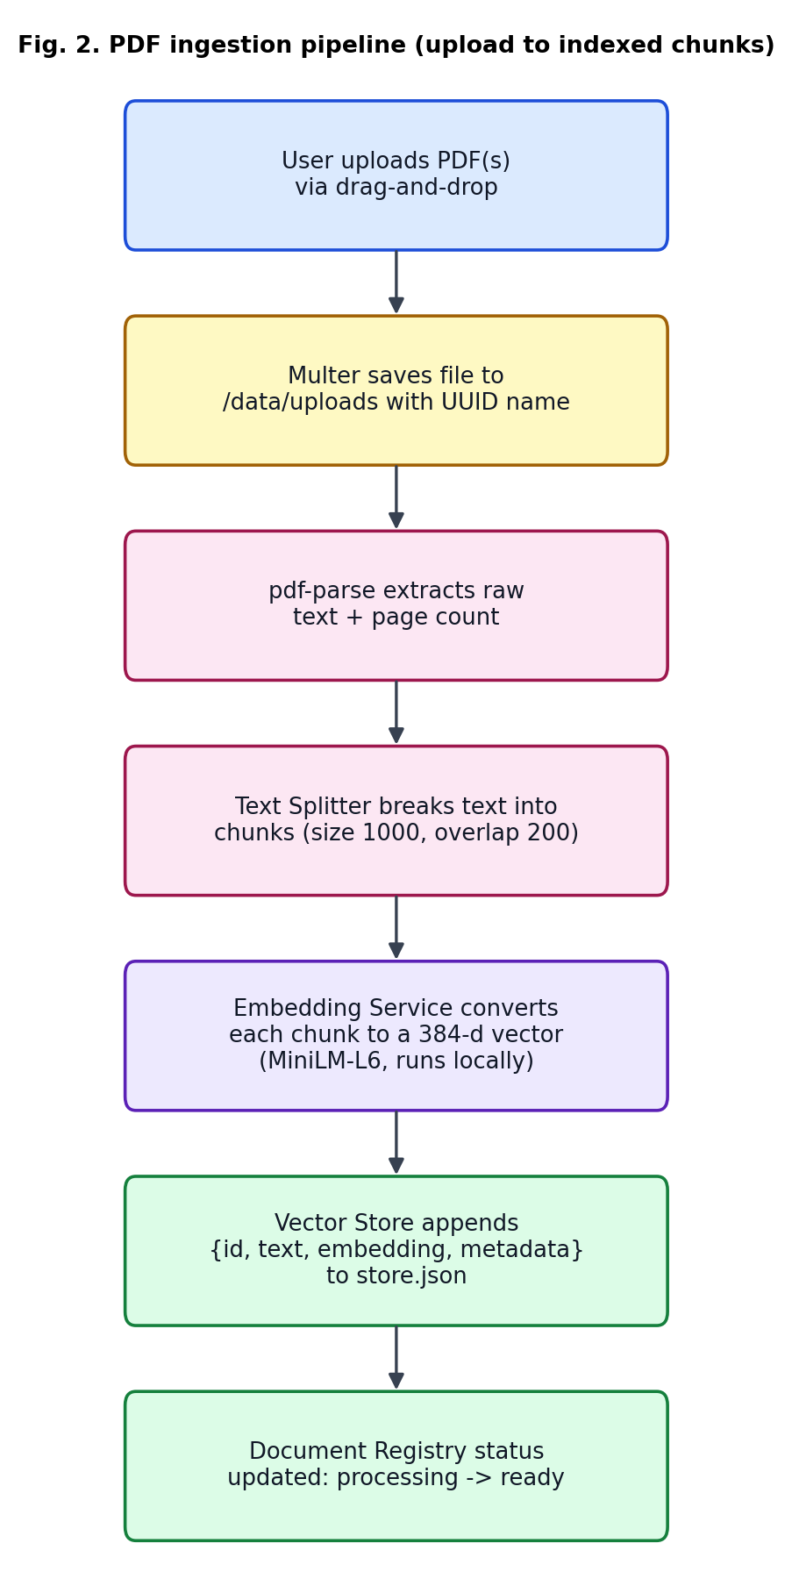
Fig. 2. PDF ingestion pipeline (upload to indexed chunks)
The text extraction step uses the pdf-parse library, which reads the raw text stream from the PDF along with the number of pages. We chose pdf-parse over writing our own PDF parser because parsing the PDF binary format from scratch (handling different encodings, embedded fonts, etc.) is a fairly deep rabbit hole on its own and was not the focus of this project.
Once we have the plain text, it needs to be split into smaller chunks before it can be embedded, because embedding models have a maximum input length and because retrieving a whole 20-page PDF as one chunk would defeat the purpose of retrieval in the first place. We implemented a recursive character text splitter (textSplitter.js) similar in spirit to the one used in LangChain. It tries to split on paragraph breaks first, then line breaks, then sentence boundaries, then spaces, and only falls back to splitting mid-word as a last resort, so that chunks stay under the configured chunk size (1000 characters by default) while remaining reasonably readable. Consecutive chunks are given an overlap of 200 characters so that a sentence that gets cut at a chunk boundary is not completely lost from the model's context. Getting the overlap logic right took a few attempts — our first version was either producing duplicate chunks or losing the overlap entirely when a single split was already larger than the chunk size, and we had to add a separate code path to recursively split oversized pieces using the next separator in the list.
Each chunk is then passed through the embedding model to get a 384-dimension vector. We used the all-MiniLM-L6-v2 model through the @xenova/transformers package, which runs the model locally using ONNX Runtime instead of calling an external API. The first time the server starts, the model weights (roughly 90 MB) are downloaded automatically and cached, and every embedding call after that runs fully offline. This was one of the main design decisions of the project since it means a user does not need an OpenAI key just to upload documents; the only paid/external dependency is the final answer-generation call.
Finally, each chunk along with its embedding vector and metadata (document id, filename, chunk index) is appended to a flat JSON file (data/vector_store/store.json) through the vectorStore service, and the document's status in the document registry is updated from “processing” to “ready” (or “empty” if no extractable text was found, or “failed” if an error occurred, for example a corrupted or scanned/image-only PDF).

4.2 Query Answering Pipeline
Once at least one document is ready, the user can type a question into the chat window. Figure 3 shows what happens after the question is submitted.
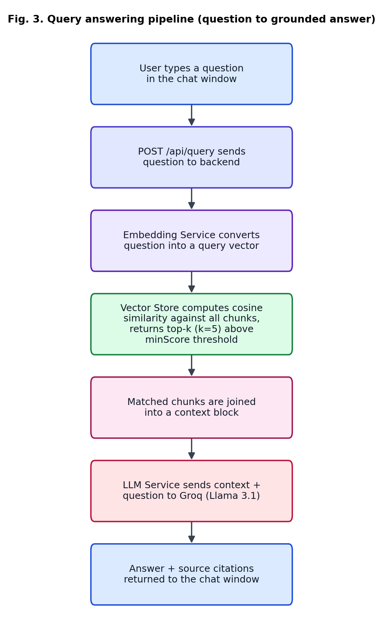
Fig. 3. Query answering pipeline (question to grounded answer)
The question text is embedded using the exact same MiniLM model used during ingestion, which is important — if a different embedding model were used for the query than for the documents, the vectors would not be comparable and similarity search would give meaningless results. The resulting query vector is compared against every stored chunk vector using cosine similarity, computed manually in vectorStore.js (dot product of the two vectors divided by the product of their magnitudes). The top-k chunks (k=5 by default) that score above a minimum similarity threshold (0.2 by default) are selected.
If no chunk crosses the similarity threshold, the system does not call the LLM at all and instead directly returns a fixed response saying it does not have enough information, which both saves an unnecessary API call and avoids the LLM trying to hallucinate an answer from nothing. Otherwise, the selected chunks are joined together into a single context block, labelled with their source filename and chunk index, and sent to llmService.js along with the user's question. The system prompt explicitly instructs the model to answer using only the given context and to say so honestly if the answer is not present, which is the core idea of RAG. The model used is llama-3.1-8b-instant, served through Groq's API, chosen mainly for its very fast response time (usually under two seconds) compared to other providers we initially considered.
The final response sent back to the frontend includes the generated answer plus a list of the source chunks used (filename, chunk index, similarity score, and a short excerpt), which the chat window displays under each assistant message. This was an important design choice for us because it lets the user actually verify the answer against the source instead of blindly trusting the model.

5. Implementation Details
The backend was built using Node.js with Express.js as the web framework, using ES modules throughout. The following libraries were used for specific tasks:
- multer — handles multipart/form-data file uploads and enforces file type (PDF only) and size limits (25 MB per file, up to 20 files per request)
- uuid — generates unique IDs for uploaded files and document records
- pdf-parse — extracts raw text and page count from PDF buffers
- @xenova/transformers — runs the MiniLM embedding model locally via ONNX
- groq-sdk — official Node client used to call the Groq chat completion endpoint
- cors — enables the React dev server (a different port) to call the Express API during development
Persistence was kept intentionally simple. Instead of setting up a database like MongoDB or Postgres, both the document metadata (documents.json) and the vector chunks (store.json) are stored as plain JSON files under a data/ directory, read into memory on first access and rewritten to disk after every write operation. This was a conscious trade-off for a project of this scale — it removes the need to install and configure a database server, but it does mean the whole file is re-read/re-written on every change, which is one of the limitations discussed in Section 7.
On the frontend side, we used React with Vite as the build tool (for its fast dev-server reload). The App component holds the top-level state (list of documents), and passes callbacks down to FileUpload, DocumentList and ChatWindow. We used plain CSS rather than a UI framework like Tailwind or Material UI, mainly because the UI was small enough that a component library felt like overkill, and writing the CSS ourselves in index.css gave us more control over the dark theme. Figure 4 shows a wireframe of the resulting layout — a sidebar on the left for uploading and managing documents, and a chat panel on the right.
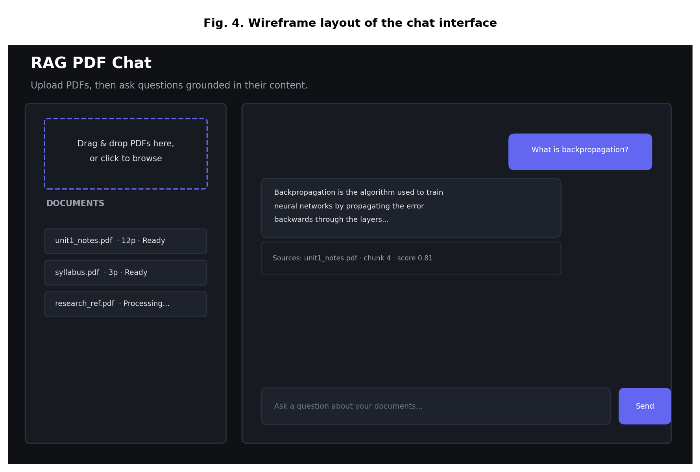
Fig. 4. Wireframe layout of the chat interface
Error handling on the backend is centralized through a single Express error-handling middleware (errorHandler.js) that every route forwards caught errors to via next(err), so that error responses are consistent across all endpoints instead of every route writing its own try/catch response formatting.

6. Results and Discussion
We tested the system by uploading a mix of PDFs of different sizes — short single-page notes, a ~15 page lecture PDF, and a scanned image-only PDF used specifically to test the failure case. For text-based PDFs, ingestion completed successfully every time, producing anywhere from 4 chunks (short notes) to around 40 chunks (the 15-page document) depending on content density. The scanned PDF, as expected, produced an “empty” status since pdf-parse cannot extract text from an image — this is a known limitation discussed further in Section 7.
For query answering, we tried a set of questions ranging from direct fact lookups (e.g. asking for a definition that appears almost word-for-word in the notes) to paraphrased questions (asking the same thing in different words). Direct lookups worked reliably, usually retrieving the correct chunk as the top match with a similarity score above 0.6. Paraphrased questions worked noticeably better than a plain Ctrl+F or keyword search would have, though the similarity scores were generally lower (0.3-0.5 range), which confirmed why we added a configurable minScore threshold rather than a hard-coded one. When we asked a question completely unrelated to the uploaded content, the system correctly responded that it did not have enough information instead of making something up, which was one of the main things we wanted to verify since hallucination was the whole reason for building a RAG system in the first place.
In terms of response time, embedding a single question took under 200ms on a normal laptop CPU since the MiniLM model is small, and the similarity search itself was fast even with a few hundred stored chunks because it is a simple linear scan. The Groq API call for answer generation was consistently the fastest part of the whole pipeline, usually returning a full answer in 1-2 seconds, which we found surprising compared to our experience with other LLM APIs. The slowest part of the whole system was actually the very first request after starting the server, because the embedding model has to be loaded into memory (and downloaded on the very first run), which took several seconds; every request after that was fast since the model stays loaded.
Table 1 summarizes how our approach compares against plain keyword search and a typical cloud-based RAG stack built with LangChain and a hosted vector database.
Table 1. Comparison of the proposed system with traditional and cloud-based approaches
Feature | Traditional keyword search | Cloud RAG stack (LangChain + Pinecone/OpenAI) | Proposed system
Search method | Exact / fuzzy string match | Vector similarity via managed DB | Vector similarity via cosine sim (local JSON store)
Understands meaning/paraphrasing | No | Yes | Yes
Embedding cost | N/A | Per-call API cost (OpenAI) | Free, runs locally (Xenova/MiniLM)
External DB required | No | Yes (Pinecone/Chroma server) | No (flat JSON file)
Answer generation | None | LLM (GPT-3.5/4) | LLM (Groq - Llama 3.1 8B)
Source citation shown to user | No | Depends on implementation | Yes, per-chunk with score
Approx. monthly cost for small scale use | Free | $10-50+ (vector DB + LLM API) | Free (Groq free tier + local embeddings)

One issue we did not fully anticipate was memory usage during ingestion — when we uploaded several large PDFs at once, processing them in parallel caused noticeable slowdowns on our test machine, since the embedding model was being called concurrently for multiple documents. We fixed this by processing uploaded files sequentially instead of in parallel (in ingestMultiplePdfs), which is slower for a batch of files but kept memory usage predictable, which mattered more for a local, resource-constrained setup like ours.

7. Limitations and Future Scope
While the system works as intended for the scope of this project, there are several limitations that came up during development which would need to be addressed before this could be used at a larger scale:
- Storing vectors in a flat JSON file works for a few hundred or even a few thousand chunks, but the similarity search is a brute-force linear scan over every stored vector, so both memory usage and query time will grow linearly as more documents are added. A proper vector database (e.g. Chroma, Pinecone or pgvector) or at least an approximate nearest-neighbour index would be needed to scale beyond a personal/small-team use case.
- The application currently has no user authentication or multi-user separation — every uploaded document is visible to every user of the deployment, which is acceptable for a single-user local tool but not for anything deployed publicly.
- pdf-parse can only extract text that is already stored as text in the PDF; scanned documents or image-based PDFs return no text at all. Adding an OCR step (for example using Tesseract.js) would be a natural next step to handle these cases.
- The system depends on the Groq API being reachable for answer generation, so it is not fully offline even though the retrieval half of the pipeline is local. A future version could allow a locally-hosted open-weight model (through Ollama, for example) as a fallback option.
- Chunking is purely character-based and does not understand document structure like headings, tables or bullet lists, so a chunk boundary can sometimes fall in the middle of a logically connected block of text such as a table row.
- Right now the whole store.json file is read into memory and rewritten on every single insert, which is inefficient; an incremental storage format or an embedded database like SQLite (with a vector extension) would remove this bottleneck.
Given more time, we would also like to add support for other file formats (DOCX, PPTX), a way to ask a question scoped to a single document instead of searching across all of them, and streaming responses from the LLM so the answer appears word-by-word instead of all at once, which is a small UX detail we noticed felt slow with the current implementation even though the actual API call is fast.

8. Conclusion
This project implements a complete Retrieval-Augmented Generation pipeline for chatting with PDF documents, built without relying on paid embedding APIs or hosted vector databases, using a locally-run MiniLM embedding model, a self-implemented JSON-based vector store, and Groq's hosted Llama 3.1 model for the final answer generation step. Building every stage of the pipeline ourselves, from PDF text extraction and chunking to cosine-similarity search, helped us understand what tools like LangChain actually do internally instead of just using them as a black box. Testing showed that the system reliably answers questions grounded in the uploaded documents, correctly refuses to answer when the information is not present, and performs well within the scale it was designed for, i.e. a small number of documents used by a single user. The limitations identified, particularly around storage scalability and the lack of OCR support, give a clear direction for extending this project further.

9. References
[1] P. Lewis et al., “Retrieval-Augmented Generation for Knowledge-Intensive NLP Tasks,” in Advances in Neural Information Processing Systems (NeurIPS), 2020.
[2] N. Reimers and I. Gurevych, “Sentence-BERT: Sentence Embeddings using Siamese BERT-Networks,” in Proc. of EMNLP-IJCNLP, 2019.
[3] Hugging Face, “Xenova/all-MiniLM-L6-v2 Model Card,” Hugging Face Model Hub. [Online]. Available: https://huggingface.co/Xenova/all-MiniLM-L6-v2
[4] LangChain Documentation, “Retrieval Augmented Generation (RAG),” 2024. [Online]. Available: https://python.langchain.com/docs/
[5] Groq Inc., “Groq API Documentation,” 2024. [Online]. Available: https://console.groq.com/docs
[6] Express.js, “Express - Node.js web application framework,” Official Documentation. [Online]. Available: https://expressjs.com/
[7] React, “React - A JavaScript library for building user interfaces,” Official Documentation. [Online]. Available: https://react.dev/
[8] J. Johnson, M. Douze, and H. Jégou, “Billion-scale similarity search with GPUs,” IEEE Transactions on Big Data, 2019.

