 | Smart Shop (20)  Technical Design Document
 | Prepared By / Last Updated By | Reviewed By | Approved By
Name | Amit Kumar
Role | Team member
Signature
Date | 23/12/2019

Table of Contents

1.0 Introduction 3
1.1 Purpose of this document 3
1.2 Project overview 3
2.0 Solution Summary 3
2.1 Scope 3
2.2 Assumptions 3
2.3 Dependencies 3
2.4 Risks 3
3.0 Schematic Diagram 3
4.0 System Design 4
4.1 Proposed design 4
4.2 Component inventory 4
5.0 Database Design 4
5.1 Data Model 4
5.2 Tables Structure 4
6.0 Appendices 4
6.1 Glossary 4
6.2 Other 5
7.0 Terms & Conditions 5
8.0 Change Log 5

Introduction

Purpose of this document
The purpose of this document is to document the technical design, component details and Database design. This will also capture the scope, assumptions, risk, dependencies of this project.

Project overview
The application “Smart Shop” addresses the problems of the consumer and enhances their shopping experience by assisting the customer to know the location of the products in the store and also allows the manager to manage the stock efficiently.

Solution Summary

Scope
Our project’s scope includes three services inventory management and display, offers management and billings .The shop manager can add or modify products and offers which will be displayed to the customers along with the details. Admins can add or modify shop managers while Super user will be able to approve shop managers. The customers can view various products which are in stock and the offers for the day on each product.

Assumptions
We assume the following while development of our project:
- There is a single shop.
- There is a single super user.
- There are multiple admins.
- There can be multiple shop managers
- There can be multiple customers.

Dependencies
There are no dependencies related to our project the technologies we used in our project are the ones we were trained on.

Risks
None as of now.

Schematic Diagram

Flow Diagram
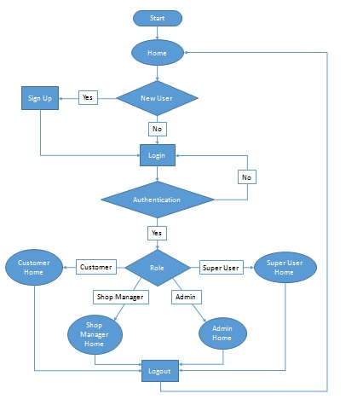

Customer Flow
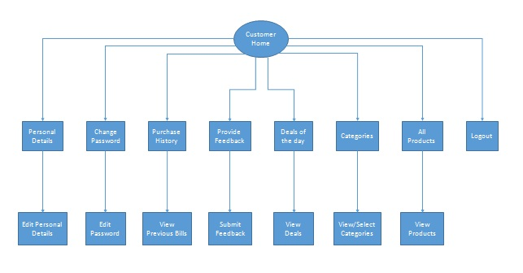

Shop Manager Flow
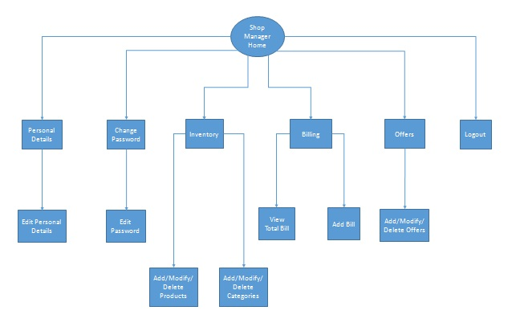

Admin Flow
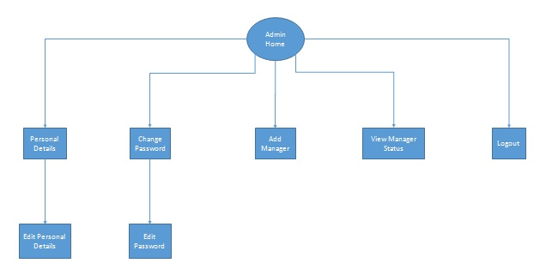

Super User Flow
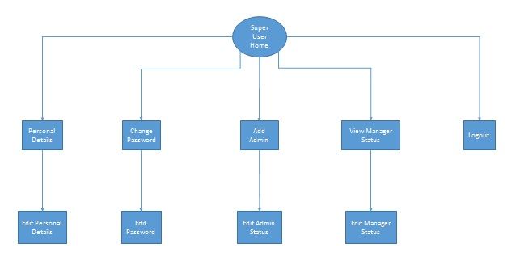

System Design

Proposed design
Below are the design objectives that shall be fulfilled post the execution of this project:
- Role based registration & credential authentication
- Listing the Products from database.
- Displaying recommendations.
- Adding, modifying, deleting products.
- Listing, adding, modifying, deleting of offers for the day.
- Generation of bill.
- Viewing of Purchase History
- Getting reward points on purchase and redeeming on purchase.
- Giving feedbacks.

Component inventory
High level component breakdown:
- User component
- Products component
- Billing component
- Offers component
- Reward points component.
- Feedback component

Database Design

Data Model
<This sub section will give the schematic view of the database design>
Database includes various tables and their interdependencies with one another which can be seen in the below table structure.
The tables include:
- User table: Includes all the details about the user, their roles, status etc.
- Role table: Includes name of the role and id of the role which is the primary key of the table
- Products table: Includes all the details of a product.
- Category table: Includes the list of categories.
- Offer table: Includes the list of offers based on product and date.
- Bill Table: Stores the bills of customers.
- Purchase Item table: Stores the item details of each bill.
- Reward points table: Stores the reward points of each user.
- Feedback table: Stores the feedback of each user.

Model structure
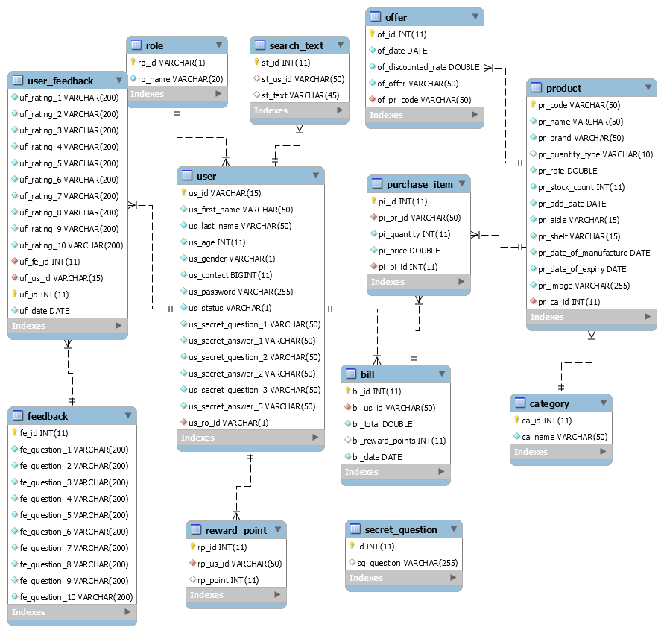

Appendices

Glossary
Acronyms | Definitions
null | null

Other

Terms & Conditions
Interns shall be solely responsible for all its acts and omissions under this program. Interns will comply at all times with all applicable laws. Interns shall not use Cognizant’s name, logo and trademark in any promotional materials or other communications with third parties without the prior written consent of Cognizant. Any materials used by interns in relation to program will not infringe the copyrights, trademarks, patents, trade secrets or other intellectual property rights, privacy or similar rights of any person or entity. Interns agrees not to post, draw, make, display any content that is threatening, libelous, obscene, defamatory, abusive, pornographic, or advocates/encourages any conduct that could constitute a criminal offence or give rise to any civil liability. Cognizant its associates’ personal details including but not limited to name, address, contact number shall not be shared or forwarded to any third party, without prior written consent of Cognizant, its associates. All intellectual property provided by Cognizant, as part of program shall be owned exclusively by Cognizant. Intern shall indemnify, defend and indemnify Cognizant its associates, officers, directors from and against any claims, demands, loss, damage, liability, causes of action, judgments, or costs and expenses of every nature (including attorney’s fees and expenses) incurred by Cognizant based on any claim that any breach of terms and conditions of this program

Change Log
Please note that this table needs to be maintained even if a Configuration Management tool is used.
Version Number | Changes made
V<n.n> | <If the change details are not explicitly documented in the table below, reference should be provided here>
V<n.n> | Page no | Changed by | Effective date | Changes effected

