**Assisted Practice: Test Kitchen Setup**

This section will guide you to:

Set up the test kitchen for Chef

This lab has two sub-sections, namely:

3.2.1 Installing and configuring Ruby

3.2.2 Setting up test kitchen

**Step 3.2.1:** **Install and configure Ruby**

1. Check if you have Ruby installed by default

$ which ruby

1. Check your Ruby installation by executing the below command in the terminal:

$ ruby --version

1. The latest is **2.7.0**. If you do not have the latest version installed, follow these steps:

$ sudo apt update

$ sudo apt install git curl libssl-dev libreadline-dev zlib1g-dev autoconf bison build-essential libyaml-dev libreadline-dev libncurses5-dev libffi-dev libgdbm-dev

$ curl -sL https://github.com/rbenv/rbenv-installer/raw/master/bin/rbenv-installer | bash -

$ echo 'export PATH="$HOME/.rbenv/bin:$PATH"' >> ~/.bashrc

$ echo 'eval "$(rbenv init -)"' >> ~/.bashrc

$ source ~/.bashrc

# Put on path: .rbenv/versions/2.7.0/bin

$ rbenv install 2.7.0

$ rbenv global 2.7.0

**Step 3.2.2:** **Setting up test kitchen**

1. Run the below command to set up test kitchen

sudo gem install kitchen

gem install kitchen-vagrant

1. Once the kitchen is installed, run the kitchen init command to add vagrant drivers.

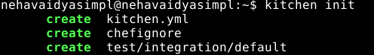

1. Create a **.kitchen.yml** in the home directory to set up test kitchen using the below commands:

vi kitchen.yml

On entering this, you will get a file as shown below. Modify the same with the help of below commands.

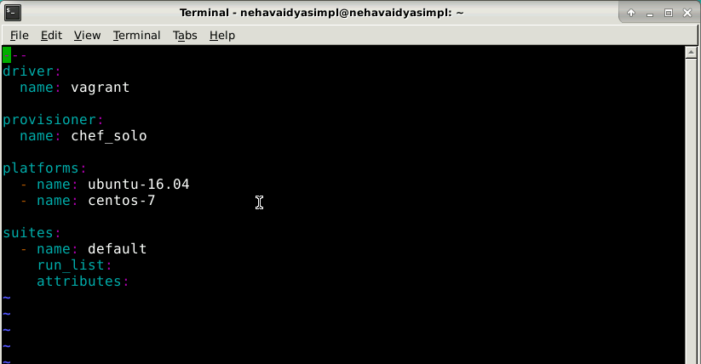

driver:

name: vagrant

provisioner:

name: chef_solo

platforms:

- name: ubuntu-16.04

suites:

- name: default

run_list:

- recipe[apache::httpd]

-attributes:

This file uses Vagrant as the driver, which requires no additional configuration because it’s the default driver used by Test Kitchen, chef-solo as the provisioner, and a single (default) test suite that runs on Ubuntu 16.04.

Type the following command to see what will be created:

kitchen list

● If you get an error concerning vagrant then typically you will need to install vagrant and virtualbox (a virtualization tool for linux)

sudo apt update  
sudo apt install virtualbox  
curl -O <https://releases.hashicorp.com/vagrant/2.2.9/vagrant_2.2.9_x86_64.deb>  
sudo apt install ./vagrant_2.2.9_x86_64.deb

● Check the version by typing:

vagrant --version

Then type the following command to see what will be created:

kitchen list

To start Test Kitchen and to spin up some vagrant virtual machines type:

kitchen create

● You can list the virtual machines using the command:

kitchen list

● You can connect to a running instance by entering the command:

kitchen login <instance_name>