**Assisted Practice: Configure Chef Knife**

This section will guide you to:

Configure Knife for Chef

This lab has four sub-sections, namely:

3.3.1 Generating Chef repository directory  
 3.3.2 Adding the RSA Private Keys  
 3.3.3 Configuring Git

3.3.4 Configuring Knife

**Step 3.3.1 Generating Chef repository directory**

* Execute the below command to generate a chef repository on the machine:

chef generate repo chef-repo   
  
(chef-repo is the name of the repo. You can give any name of your choice). To check the repo components use the below command.

cd chef-repo

Repository file should comprise of:

$ ls -1

chefignore

cookbooks

data_bags

environments

LICENSE

README.md

roles

**Step 3.3.2 Add the RSA Private Keys**

1. If you do not already have an RSA key-pair on your workstation, generate one. This key-pair will be used to gain access to the Chef server and then transfer their .pem files:

ssh-keygen -b 4096

Press Enter to use the default names id_rsa and id_rsa.pub in **/home/your_username/.ssh** before entering your passphrase.



Enter a password of your choice for passphrase (minimum of five characters). Refer to the screenshot below for the same.

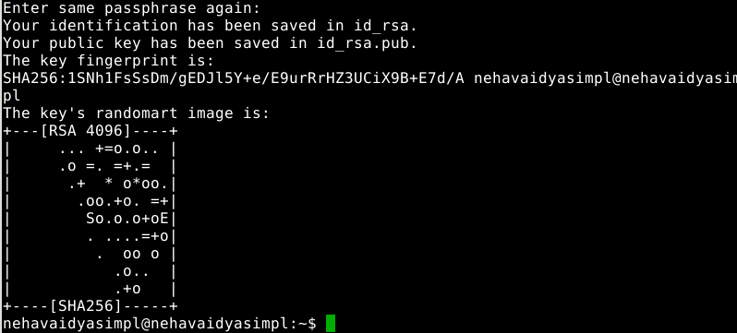

1. Upload your workstation’s public key to host the Chef server. Ensure you replace example_user with the Chef server’s user account and 192.0.2.0 (IP that you get when configuring kitchen and chef environment) with its IP address:

ssh-copy-id example_user@192.0.2.0

If this throws an error then use the below command:

sudo ssh-copy-id -p 42006 your_username@localhost

**{Provide the username of your lab}**

1. Copy the .pem files from your Chef server to your workstation using the scp command.

cd chef-repo  
mkdir .chef  
scp ~/.chef/*.pem ~/chef-repo/.chef/

Confirm that the files have been copied successfully by listing the contents of the .chef directory:

ls ~/chef-repo/.chef

Your .pem files should be listed.

**Step 3.3.2:** **Configuring Git**

* The ChefDK adds the Git component to your workstation and initializes a Git repository in the directory used to generate the Chef repo.

git config --global user.name gitusername

git config --global user.email [user@example.com](mailto:user@example.com) **{Provide a valid email address of your git repository}**

* Add the .chef directory to the .gitignore file using the below command:

echo ".chef" > ~/chef-repo/.gitignore

Move into the ~/chef-repo directory, if you are not already there and add and commit all existing files:

cd ~/chef-repo

git add .

git commit -m "initial commit"  
Make sure the directory is clean:

git status

It should output:

On branch master  
nothing to commit, working directory clean

**Step 3.3.2:** **Configuring Knife**

While configuring knife, the names of the key and the url depend on what you have created when creating the chef user in the chef manage console using: https://localhost/chef

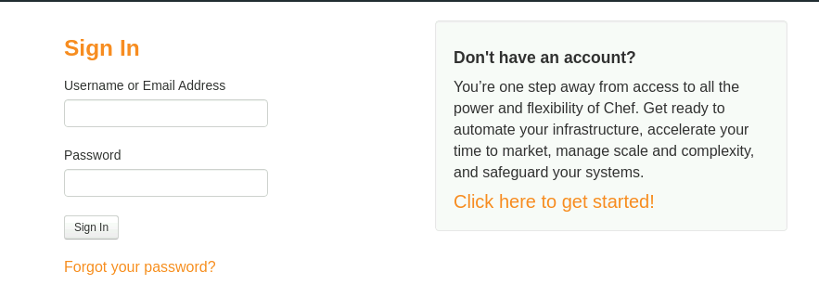

The username will be your node_name. If you do not have an account, create one and then sign in. On sign-in you will have the UI of the chef as shown below:

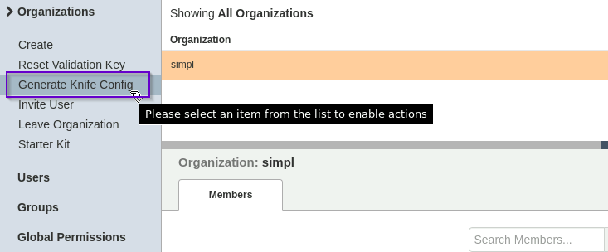

Once you generate a knife config, the file looks as shown below:

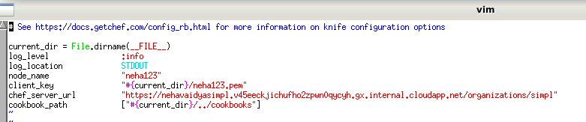

Now enter the below commands into knife config file as shown below:

* Create knife.rb file using the below command:

$ vim knife.rb

* Add the content to the file as show below:

current_dir = File.dirname(__FILE__)

log_level :info

log_location STDOUT

node_name "Your_node_name"

client_key "#{current_dir}/neha123.pem"

chef_server_url "<https://chef-server/organizations/company>" **{one mentioned in the above screenshot}**

cookbook_path ["#{current_dir}/../cookbooks"]

* Company should match the name of your organization as created on the Chef server
* chef-server is the domain name of your Chef server – resolvable on the workstation machine
* **username** should be the username that was created on the Chef server
* You can also use the organization validator, but first download the validator private key as shown below:

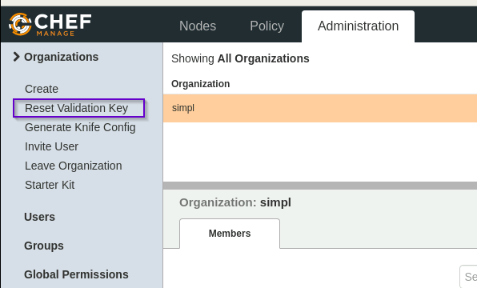

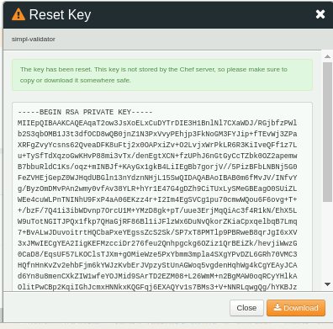

$ scp chef-server:/home/simpl-validator.pem .

* Configure knife using the below commands in the knife.rb file
* vim knife.rb

current_dir = File.dirname(__FILE__)

log_level :info

log_location STDOUT

node_name 'neha123' **{Node name}**

client_key "#{current_dir}/neha123.pem"

validation_client_name 'simpl-validator' **{ Name of your validator}**

validation_key "#{current_dir}/simpl-validator.pem"{ **Name of your validator key as shown above}**

chef_server_url "<https://chef-server/organizations/company>" **{The URL that you get in config.rb file}**

cookbook_path ["#{current_dir}/../cookbooks"]

* Fetch the SSL certificate from your Chef server as shown below:

$ knife ssl fetch

* Validate the downloaded SSL certificate using the below command:

$ knife ssl check

Connecting to host chef-server:443

Successfully verified certificates from `chef-server'

$ file trusted_certs/chef-server.crt

trusted_certs/chef-server.crt: PEM certificate

* Confirm the knife.rb setup by running the client list using the following command:

$ knife client list

This command will output the validator name.