**Assisted Practice: Create a Chef Role and Run the Chef Client**

This section will guide you to:

Create a role and run the Chef client

This lab has one sub-section namely:

4.2.1 Creating a Chef role

**Step 4.2.1 Creating a Chef role**

* Create a Chef Role using the below command:

knife role create roleexample

In case you get an error, define the environment variable and run the below command:

export EDITOR=$(which vi)  
echo $EDITOR

To persist this, add it to ~/.bashrc or ~/.bash_profile.

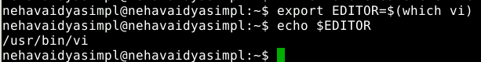

In the $EDITOR enter the role data in JSON: Type $EDITOR on the terminal and it will lead you to this page.

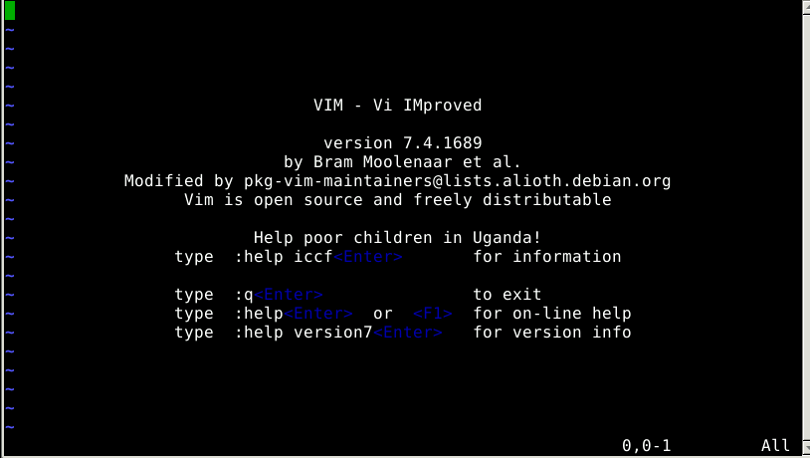

Add the below commands and save it.

{

"name": "role1",

"default_attributes": {

},

"json_class": "Chef::Role",

"run_list": ["recipe[cookbook_name::recipe_name]",

"role[role_name]"

],

"description": "",

"chef_type": "role",

"override_attributes": {

}

}

Once done, save the file and exit. Chef role will be created. If you want to delete a role, just use the below command:

knife role delete ROLE_NAME