**Assisted Practice: Create and Test Chef Environment**

This section will guide you to:

Create and Test Chef Environment

This lab has two sub-sections namely:

4.3.1 Creating a Chef environment

4.3.2 Testing the Chef environment

**Step 4.3.1 Creating a Chef environment**

* Write the below command to open a Shell’s default editor, so that one can modify the environment definition. Navigate to the chef repo as shown below and create the environment.

cd chef-repo

Open an editor to write the below command.

knife environment create Exampleenv{

"name": "Exampleenv",

"description": "",

"cookbook_versions": {

},

"json_class": "Chef::Environment",

"chef_type": "environment",

"default_attributes": {

},

"override_attributes": {

}

}

Created Environment

You can also create the chef environment through Chef Manage console at <https://localhost/chef>. Refer to the below screenshot.

Under **Policy** you can see options as shown below:

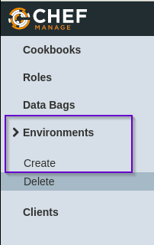

Choose **Create**.

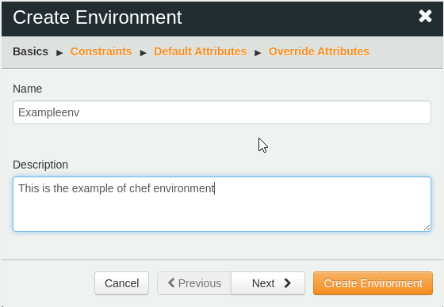

Once you create, you can see as something like this:

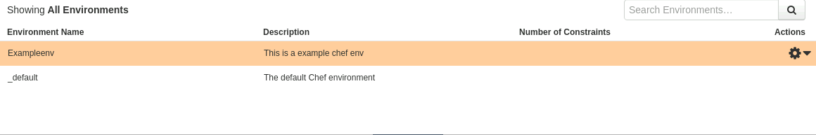

**Step 4.3.2 Testing a Chef environment**

* Execute the below code to test a Chef environment

chef-repo $ knife environment list

_default

Exampleenv

* **List all the nodes in the environment using the below command:**

chef-repo $ knife node list

my_server