**Assisted Practice: Execute Chef Shell**

This section will guide you to:

Execute Chef shell in a Standalone mode.

This lab has six sub sections namely:

4.5.1 Executing Chef shell in a standalone mode  
 4.5.2 Switching to attribute mode in the Chef shell

4.5.3 Setting attribute value

4.5.4 Switching to recipe mode

4.5.5 Creating a file resource

4.5.6 Commencing Chef run

**Step 4.5.1 Executing Chef shell**

* Execute Chef shell in the chef repo using the below command:

cd chef-repo

chef-shell

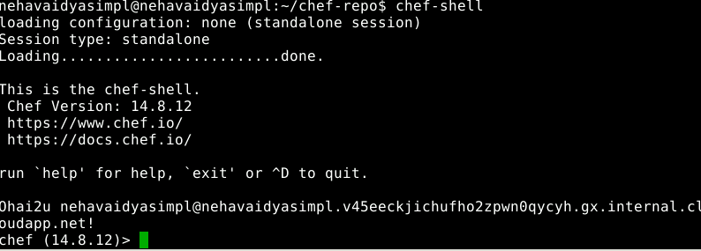

**Step 4.5.2 Switching to attribute mode in the Chef shell**

* Execute the below command to switch to attribute mode:

chef>attributes_mode

**Step 4.5.3 Setting attribute value**

* To set the attribute values, use the below commands:

**chef:attributes > default[:title] = "Chef Cookbook"**

"Chef Cookbook"

**chef:attributes > quit**

:attributes

**chef >**

**Step 4.5.4 Switching to recipe mode**

* Execute the below command to switch to recipe mode:

chef>recipe_mode

**Step 4.5.5 Creating a file resource**

* Execute the below command to create a file resource in the recipe:

chef:recipe > file "/tmp/book.txt" do

chef:recipe > content node.title

chef:recipe ?> end

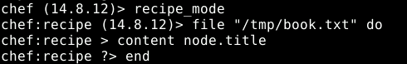

**Step 4.5.6 Commencing Chef run**

* Commence the Chef run to create the file with the given content using the below command:

chef:recipe > run_chef

