# Sales Performance Dashboard

## 1. Introduction

This document provides a comprehensive overview of sales performance based on the provided dataset. It leverages interactive visuals to highlight key trends, top-performing areas, and insights into profitability.

## 2. Executive Summary & Key Performance Indicators (KPIs)

Our analysis reveals the following key metrics for the sales period:  
  
Total Sales: $1.57 Million  
Total Profit: $175.26 Thousand  
Total Orders: 5901  
Average Order Quantity: 3.78  
  
These metrics provide a high-level snapshot of the business's health.

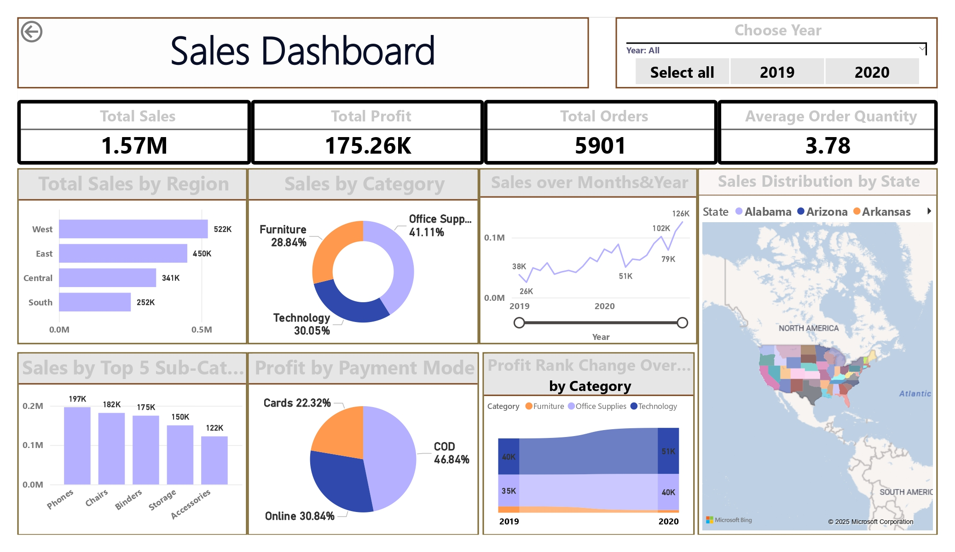

## 3. Sales Trend Over Time

The "Sales over Months & Year" line chart illustrates the sales performance chronologically.  
  
Visual Description: A line chart showing the total sum of sales over individual months and across the years 2019 and 2020.  
Key Takeaway: Sales show a fluctuating trend with a significant peak in October 2020, reaching $126K. There's a notable dip around April 2020 ($51K), followed by a recovery. This pattern suggests potential seasonality or the impact of specific events on sales volume.

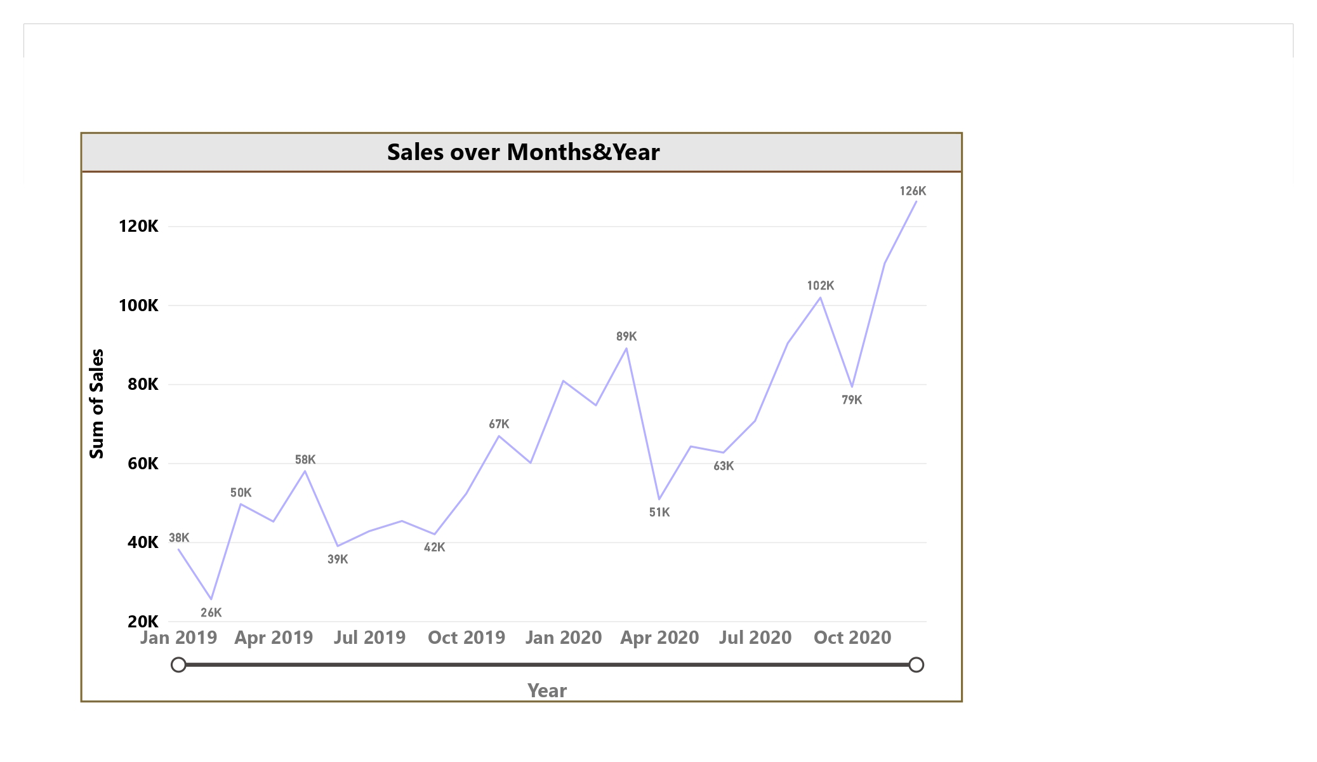

## 4. Regional Sales Performance

Understanding sales distribution across different regions is crucial for strategic planning. The "Total Sales by Region" bar chart provides this insight.  
  
Visual Description: A horizontal bar chart displaying total sales for each geographical region (West, East, Central, South).  
Key Takeaway: The West region leads significantly in sales with $522K, substantially outperforming other regions such as East ($450K), Central ($341K), and South ($252K). This highlights the West as the strongest sales market.

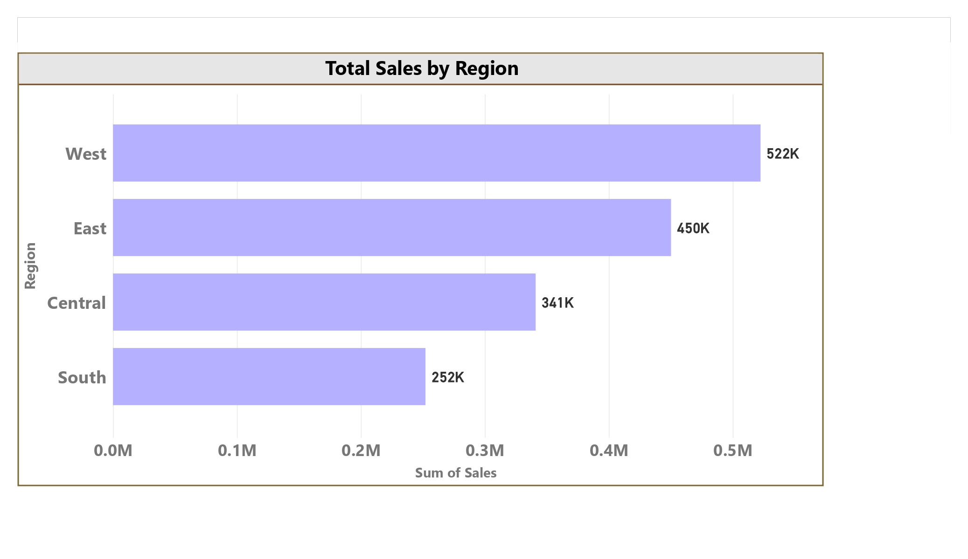

## 5. Sales Contribution by Category

The "Sales by Category" donut chart breaks down sales by product categories.  
  
Visual Description: A donut chart illustrating the percentage distribution of total sales across main product categories (Office Supplies, Technology, Furniture).  
Key Takeaway: Office Supplies contribute the largest share of sales at 41.11% ($643.71K), followed by Technology (30.05% / $470.59K) and Furniture (28.84% / $451.51K). This indicates Office Supplies as the primary revenue generator.

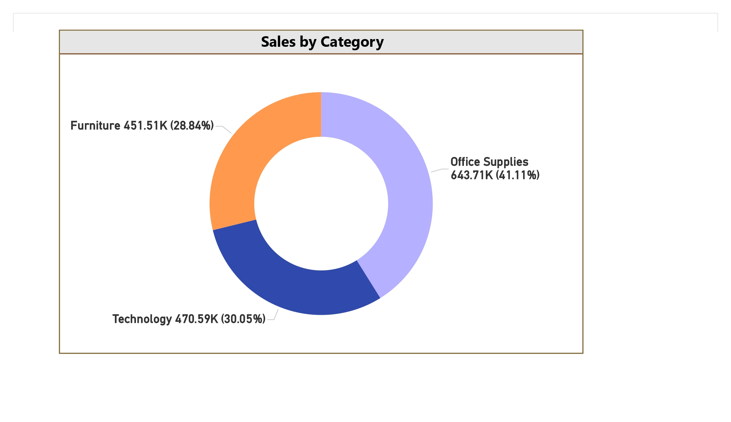

## 6. Top Sub-Category Performance

Drilling down further, the "Sales by Top 5 Sub-Category" bar chart identifies specific top performers.  
  
Visual Description: A vertical bar chart showing the sales for the top 5 sub-categories.  
Key Takeaway: "Phones" is the top-selling sub-category with $197K in sales, closely followed by "Chairs" ($182K) and "Binders" ($175K). These sub-categories are critical drivers of overall sales volume and should be strategically focused on.

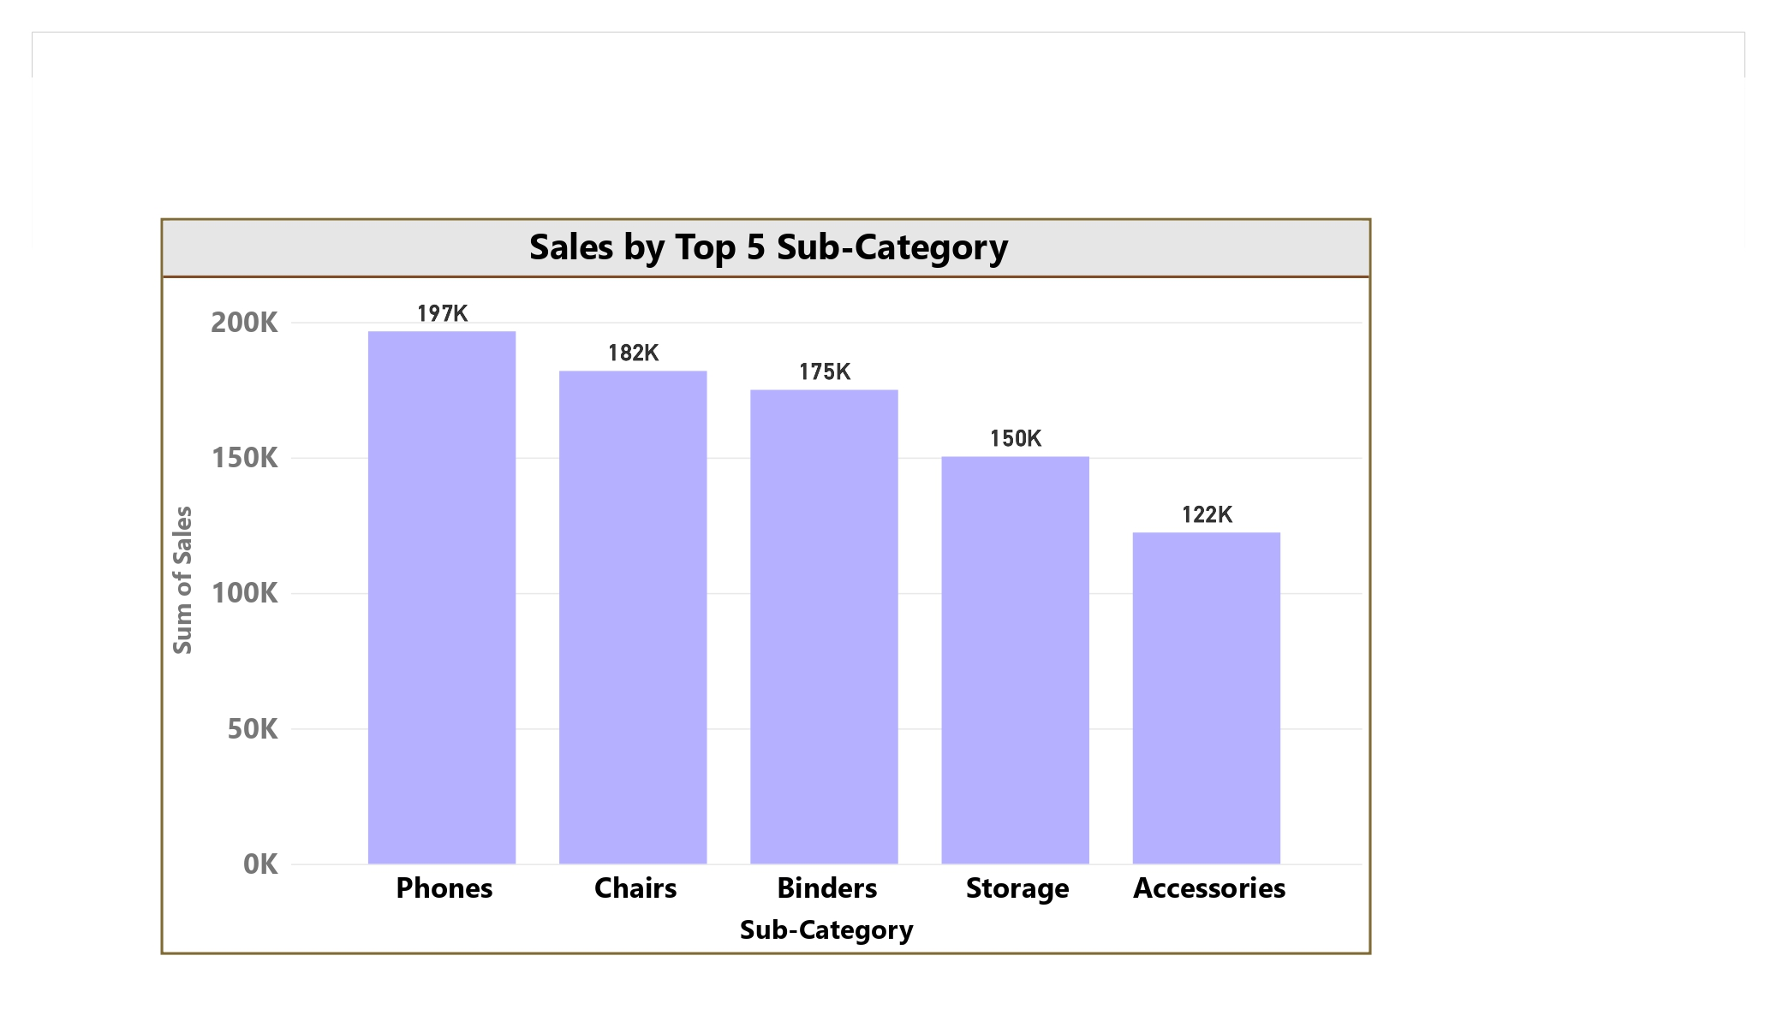

## 7. Profitability by Payment Mode

Analyzing profit by payment mode helps in understanding the efficiency of different transaction methods.  
  
Visual Description: A pie chart showing the distribution of total profit across different payment modes (COD, Online, Cards).  
Key Takeaway: COD (Cash on Delivery) accounts for the highest portion of profit at 46.84% ($82.09K). Online payments contribute 30.84% ($54.05K), and Cards contribute 22.32% ($39.12K). This suggests COD is currently the most profitable transaction method, possibly due to lower transaction fees or higher average order values.

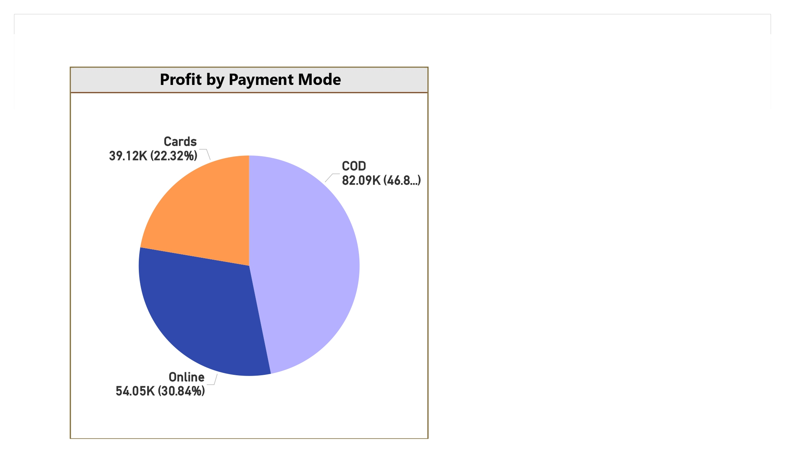

## 8. Profit Rank Change Over Time

The "Profit Rank Change Over Time by Category" ribbon chart illustrates dynamic shifts in category profitability.  
  
Visual Description: A ribbon chart demonstrating how the profit ranking of different categories (Furniture, Office Supplies, Technology) changed from 2019 to 2020.  
Key Takeaway: Office Supplies consistently holds a strong profit position, while Technology shows a steady or increasing contribution. Furniture appears to maintain a lower profit contribution compared to the other two categories over the years, warranting further investigation.

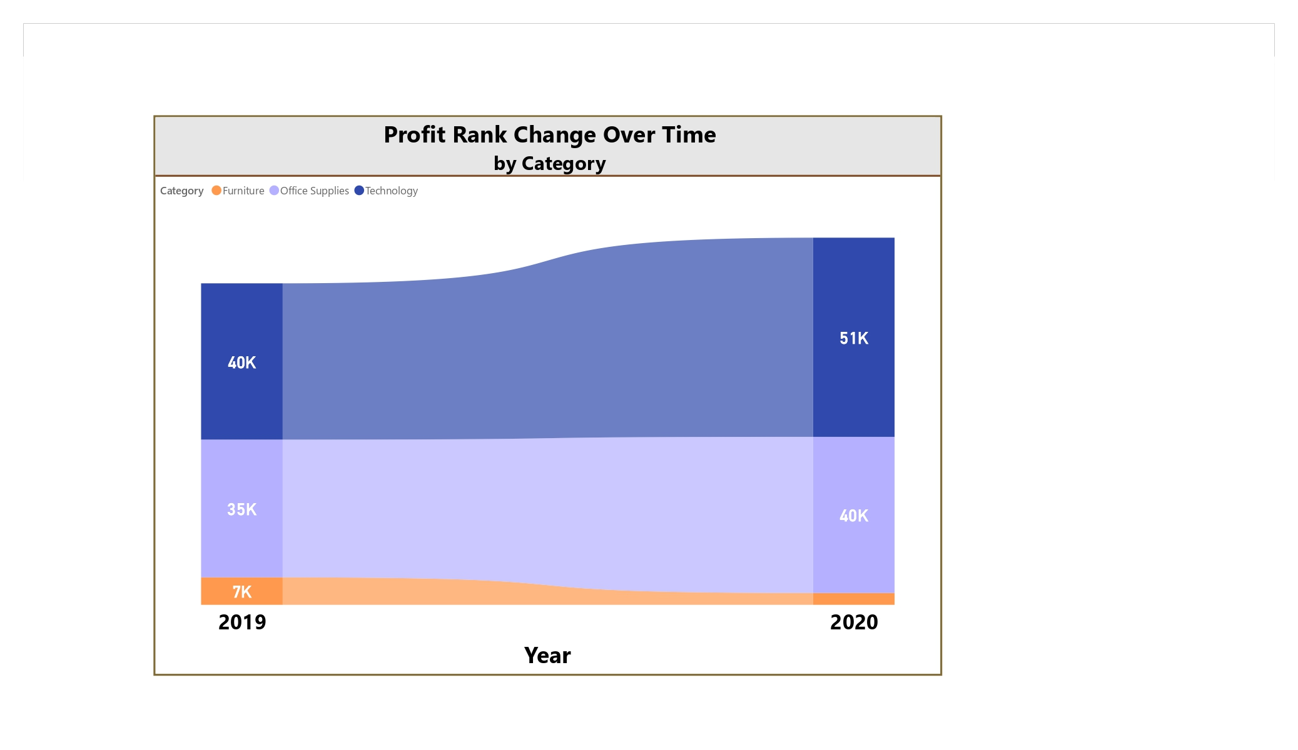

## 9. Geographical Sales Distribution

A filled map provides a visual representation of sales across different states.  
  
Visual Description: A filled map of the United States, where states are colored based on their total sales (darker shades indicate higher sales).  
Key Takeaway: The map visually confirms the higher sales concentration in the Western and Eastern parts of the United States, aligning with the "Total Sales by Region" chart. Specific states within these regions are top contributors to overall sales.

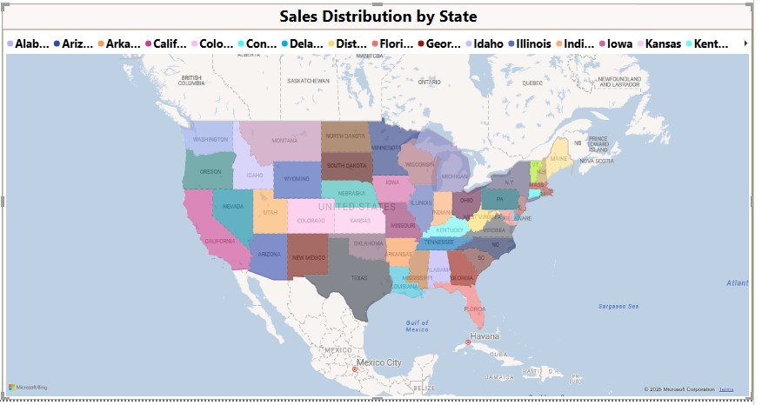

## 10. Key Insights

Insights:  
- The West region is the strongest sales performer, indicating concentrated market strength there, while the South region shows the lowest performance.  
- Office Supplies and Technology are the primary revenue drivers, with specific sub-categories like "Phones," "Chairs," and "Binders" being top contributors.  
- COD (Cash on Delivery) is identified as the most profitable payment method, contributing nearly half of the total profit.  
- Sales exhibit noticeable seasonal fluctuations, with peaks and dips that require proactive planning.  
- While Office Supplies and Technology consistently contribute to profit, the relatively lower profit contribution from Furniture needs attention.