**Assignment 3:  
Function Design and Modularization - Create a document that describes the design of two modular functions: one that returns the factorial of a number and another that calculates the nth Fibonacci number. Include pseudocode and a brief explanation of how modularity in programming helps with code reuse and organization**.

Function of factorial of a number:

If n equals to 0

Return 1;

Else

Return n\*(n-1) factorial;

Flowchart:

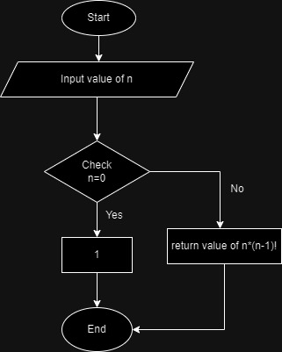

Function of Fibonacci number:

If n equals to 0

return 0;

else if n equals to 1

return 1;

else

return (n-1) + (n-2);

Flowchart:

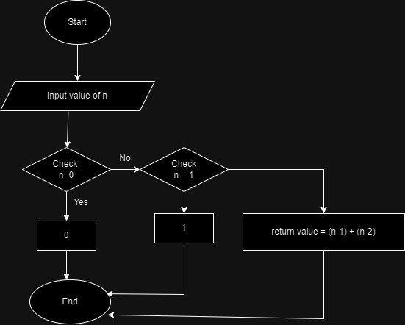

Modularization means breaking of program into smaller , independent function to perform specific task.

1. Code Reusability : Function which perform specific task and can reuse in other program like factorial and Fibonacci function, we can use them in other program without rewriting its code.
2. Code Organizatin: This helps us to organize our code by breaking in smaller. It helps to understand overall structure easily and also helps in fix bug when they occur.