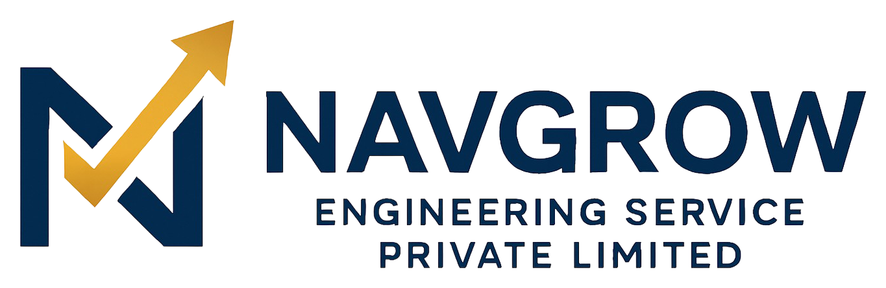
CAPABILITIES STATEMENT
Railway · Industrial · Civil · Sustainability
Navgrow Engineering Service Pvt. Ltd. is a DPIIT-recognised, MSME-registered engineering and sustainability company incorporated in 2022 and headquartered in Siliguri, West Bengal. We deliver railway, industrial, civil and sustainability engineering for Indian Railways, industrial plants, government departments and private developers — with audit-ready documentation on every project.

Core Competencies
Domain | Capabilities
Railway Infrastructure | Track, ROB, OHE/electrification, signalling & telecom, station development, shed works — to RDSO standards
Civil & Construction | Buildings, bridges, roads, industrial structures, structural & earthworks, survey & planning
Industrial Engineering | Fabrication, plant engineering and engineered installations for manufacturers
Sustainability | Solar (rooftop/ground-mount), rainwater harvesting, STP/ETP & ZLD, energy audits, green buildings
Maintenance & AMC | Preventive & corrective maintenance for electrical, mechanical, civil, plumbing & facilities — 24/7
Government Contracts | Tender-based execution via GeM & IREPS with complete departmental documentation

Why Navgrow
- Approved-vendor discipline — trained to Indian Railways and departmental norms, ready for block-working and live-plant conditions.
- Quality-first — ISI-marked materials, tested components, and a full handover dossier (drawings, MTCs, certificates, reports).
- One accountable partner — design, supply, execution and maintenance under a single, named point of responsibility.
- On-time, on-budget — method-approved planning and financial discipline; 100% on-time delivery track record.
- GST-compliant billing and traceable measurement books & approvals on every engagement.

Company Snapshot
Field | Detail
Legal name | Navgrow Engineering Service Pvt. Ltd.
CIN | U74999WB2022PTC256012
Incorporated | 2022 — Siliguri, West Bengal
Recognitions | Startup India (DPIIT) · Udyam MSME · Make in India
Registered office | Ward No-47, Old Matigara Road, Pati Colony, Siliguri, WB – 734001
Contact | info@navgrow.org · +91 89270 70972 · www.navgrow.org
Procurement channels | GeM · IREPS · direct tender & RFQ
OUR COMMITMENT
We deliver work that is safe to build, built to last, and ready for audit — on every single project.
Navgrow Engineering Service Pvt. Ltd. • Engineering Excellence. Sustainable Solutions.

