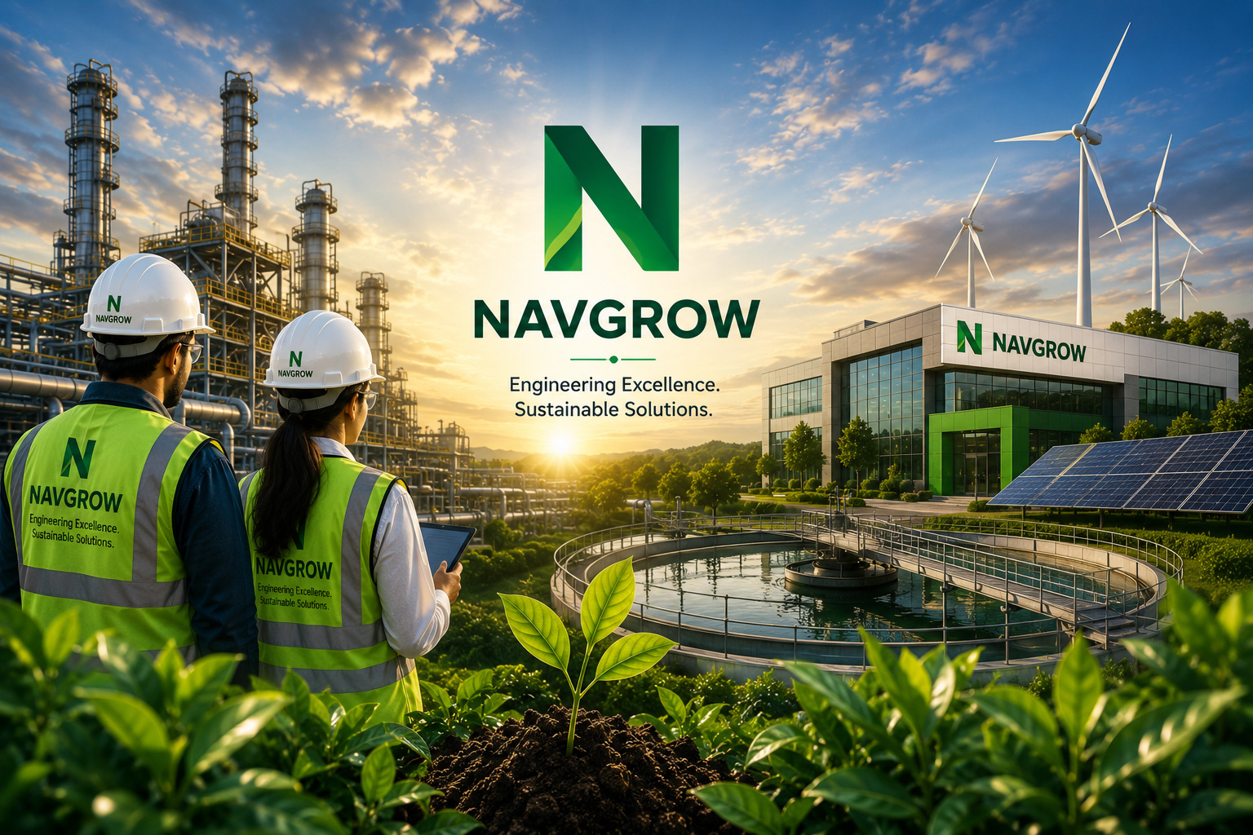
RAILWAY · INDUSTRIAL · CIVIL · SUSTAINABILITY
Company Profile & Capabilities
2026 Edition
Startup India (DPIIT) · Udyam MSME · Make in India
CIN: U74999WB2022PTC256012 · www.navgrow.org · Siliguri, West Bengal

ABOUT THE COMPANY

Building a Sustainable Tomorrow
Navgrow Engineering Service Pvt. Ltd. is a Siliguri-based, DPIIT-recognised engineering & sustainability company incorporated in 2022. We combine engineering excellence with modern technology to deliver reliable, quality-first solutions for railway, industrial and civil projects — alongside solar, water and green-building systems.
We serve Indian Railways, industrial plants, government departments and private developers across North Bengal and beyond, following one consistent discipline on every project: study the specification, get the method approved, execute under supervision, and hand over an audit-ready dossier.

Who We Are  A team of engineers, planners and innovators delivering high-quality engineering, infrastructure and sustainable-energy solutions across India. | Our Vision  To be India's most trusted engineering company, recognised for innovation, quality and sustainable impact. | Our Mission  To provide cost-effective, reliable and eco-friendly engineering solutions that empower clients and contribute to a better planet.

What We Value
- Integrity & Transparency
- Safety & Quality
- Innovation & Excellence
- Sustainability
- Customer Commitment
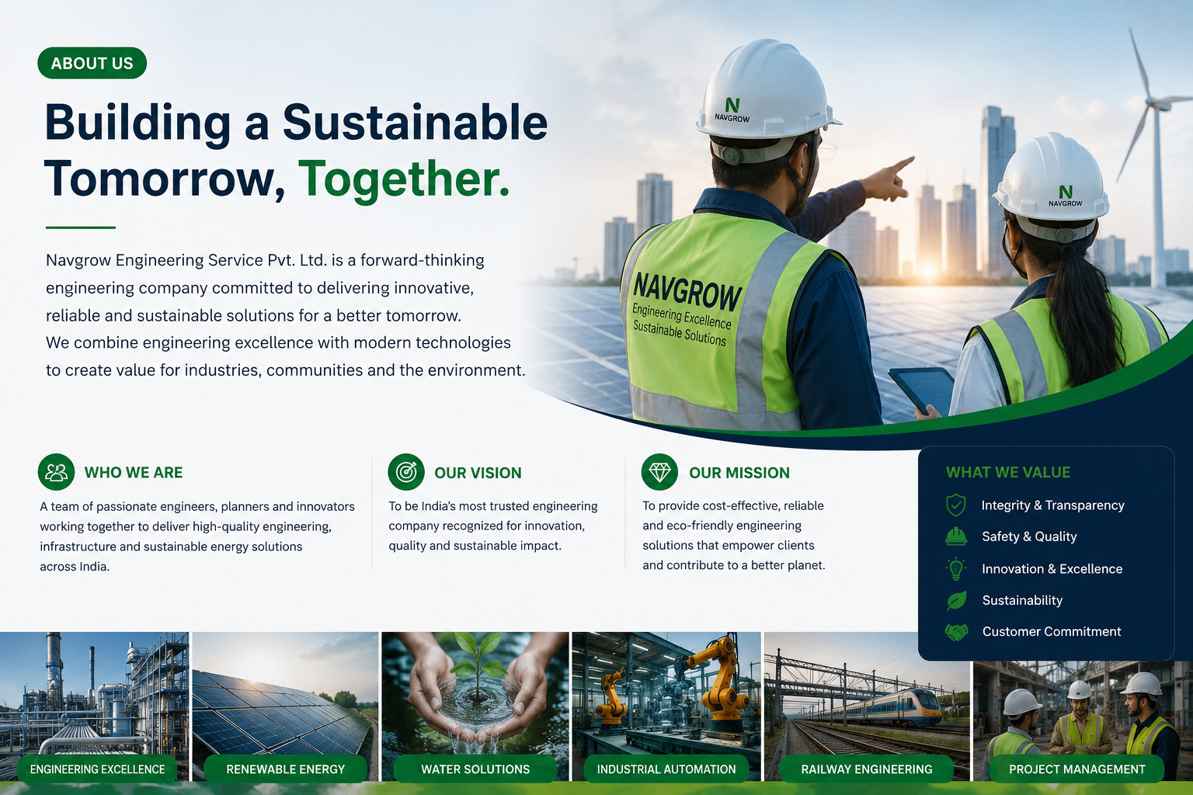
Engineering excellence across energy, water, industry and infrastructure.

CAPABILITY OVERVIEW

Ten Service Lines. One Standard.
- Railway Infrastructure — Track, ROB, electrification, signalling and shed works delivered to RDSO standards.
- Industrial Engineering — Fabrication, plant engineering and engineered installations for manufacturers.
- Civil & Construction — Buildings, bridges, roads and structural works — built to last, delivered on schedule.
- Government Contracts — Tender-based execution via GeM and IREPS with complete departmental documentation.
- Maintenance & AMC — Preventive and corrective upkeep that maximises the uptime of your assets.
- Rainwater Harvesting — Catchment, recharge and storage systems for long-term water security.
- Solar Energy Solutions — Rooftop and ground-mount solar for cleaner, cheaper power.
- Wastewater Treatment & Recycling — STP/ETP, water reuse and zero-liquid-discharge systems.
- Energy Efficiency & Audits — Audits and retrofits that cut energy cost and carbon footprint.
- Green Building & Sustainability — Consulting for efficient, certified, low-impact buildings.

SERVICE LINE

Railway Infrastructure
Building Sustainable Connections. Powering Progress.
End-to-end railway works — new and upgraded track, bridges and ROBs, OHE and traction electrification, signalling and telecom, station and platform development, and ongoing maintenance — planned, executed and documented to Indian Railways standards.

What We Deliver
- Railway Track Construction & Upgradation
- Bridges & ROBs (major, minor and curved)
- Electrification, OHE & traction systems
- Signalling, telecom & control systems
- Station & platform development
- Maintenance and project planning & consultancy
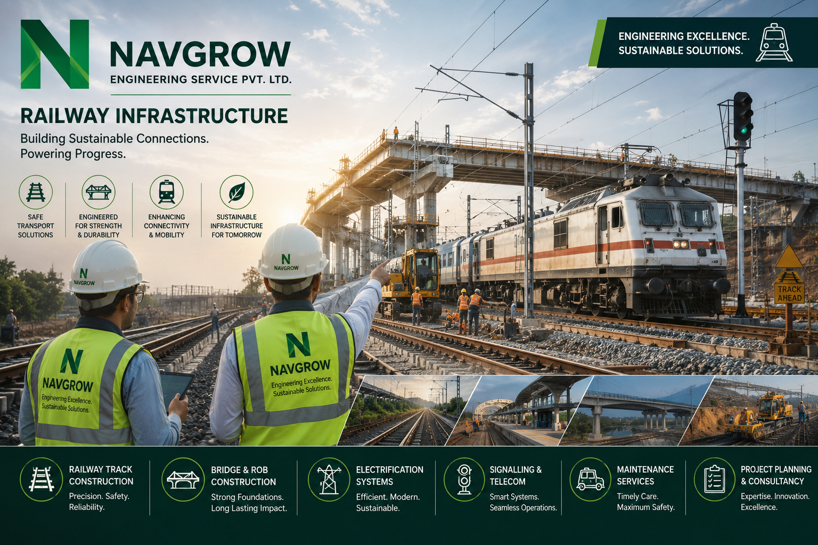
Navgrow — Railway Infrastructure

SERVICE LINE

Civil & Construction
Building Today. Shaping Tomorrow.
End-to-end civil construction with quality, safety and sustainability at the core — from residential and commercial buildings to industrial structures and public infrastructure.

What We Deliver
- Residential & commercial buildings
- Industrial structures
- Roads, highways, bridges & flyovers
- Structural works & earthworks
- Renovation & remodeling
- Survey, planning & project management
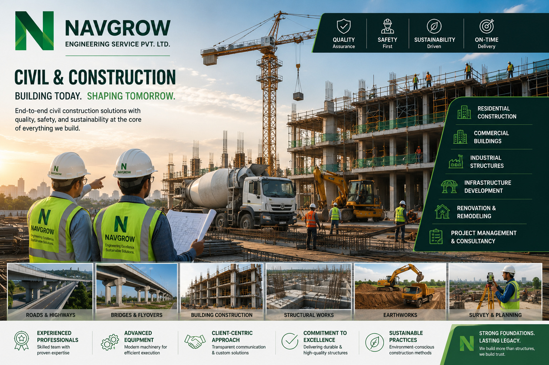
Navgrow — Civil & Construction

SERVICE LINE

Government Contracts
Building the Nation. Delivering Trust.
A trusted partner for government and public-sector infrastructure — delivering compliant, transparent and accountable execution across roads, buildings, water, energy and strategic projects.

What We Deliver
- Infrastructure development (roads, bridges, urban infra)
- Public buildings, institutions & complexes
- Water supply, drainage, STPs & irrigation
- Substations, transmission lines & renewables
- Defence & strategic construction
- AMC, facility management & lifecycle support
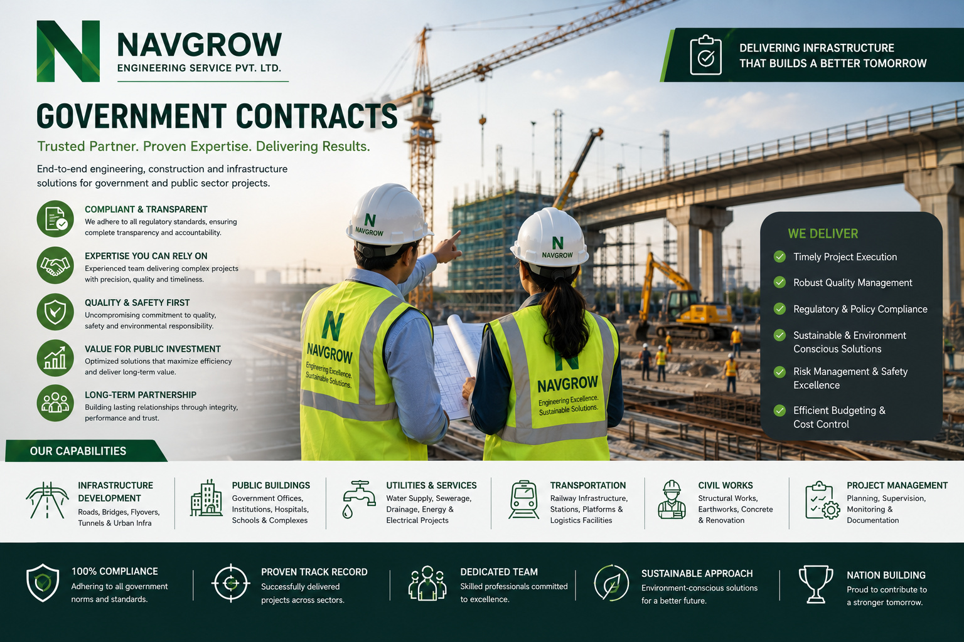
Navgrow — Government Contracts

SERVICE LINE

Maintenance & AMC
Reliable Maintenance. Uninterrupted Performance.
Comprehensive Maintenance and Annual Maintenance Contract (AMC) services that protect the longevity, efficiency and safety of your critical assets — with tailored plans and round-the-clock support.

What We Deliver
- Electrical systems (panels, switchgear, DG sets)
- Mechanical systems (pumps, motors, HVAC, machinery)
- Civil infrastructure & waterproofing
- Plumbing & water systems
- Facility management
- 24/7 support with preventive & corrective plans
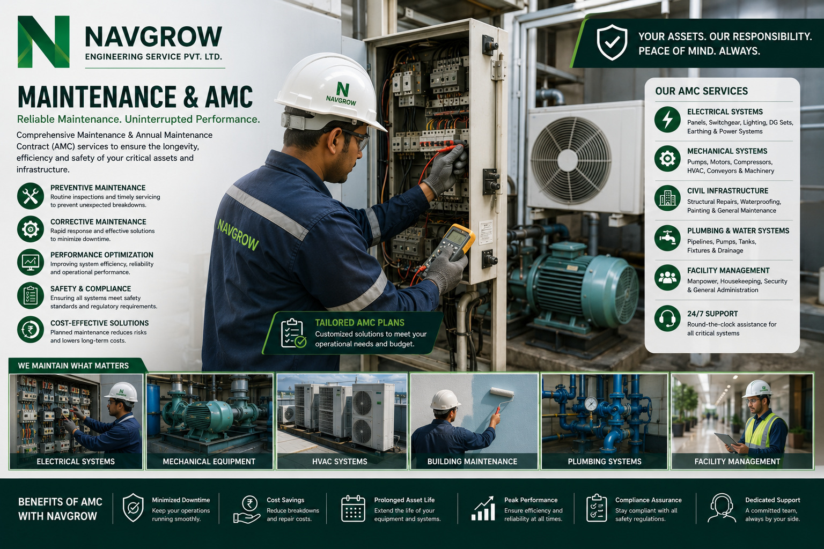
Navgrow — Maintenance & AMC

SERVICE LINE

Wastewater Treatment & Recycling
Treat Today. Recycle Tomorrow. Sustain Forever.
End-to-end solutions for wastewater treatment, resource recovery and reuse — design, build, operate and maintain systems that turn wastewater into a valuable resource.

What We Deliver
- Industrial effluent treatment (ETP)
- Sewage treatment plants (STP)
- Zero liquid discharge (ZLD)
- Water reuse & recovery
- Sludge management
- Operation, maintenance & 24/7 monitoring
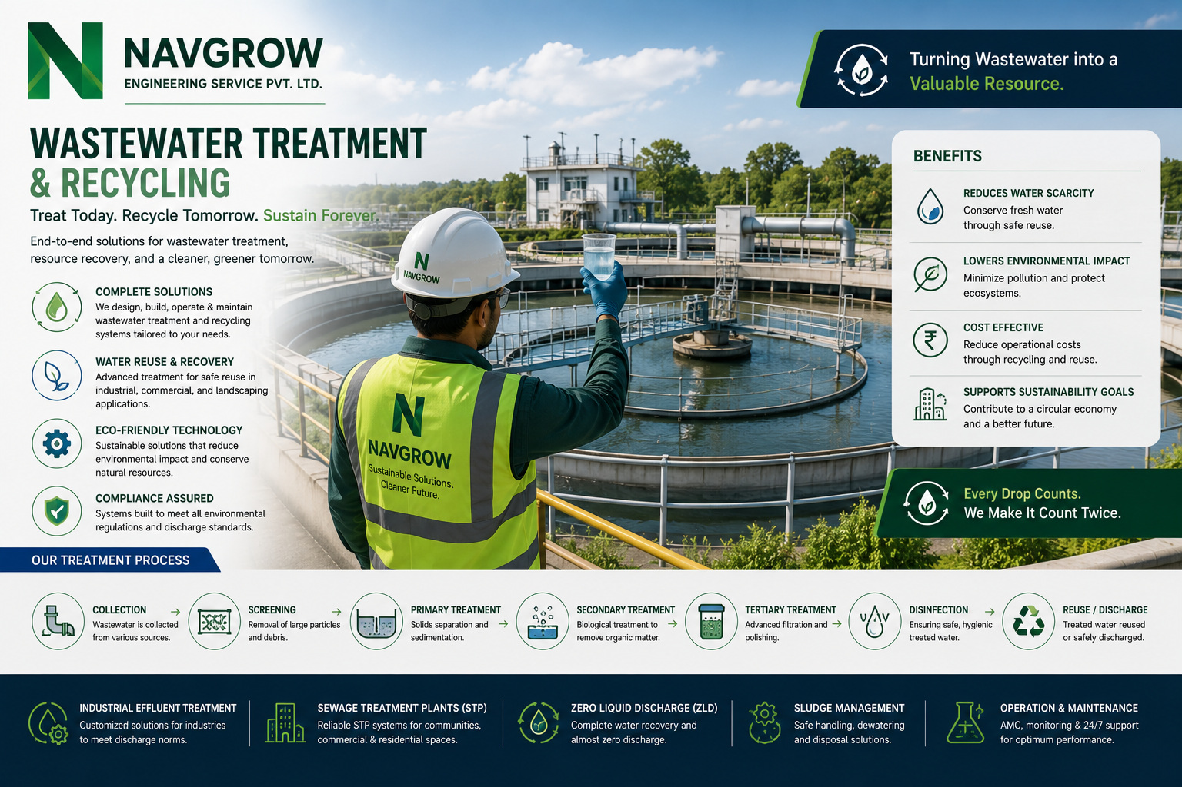
Navgrow — Wastewater Treatment & Recycling

HOW WE WORK

A Process Built for Approval
- 01 Scope & Specification Study — Drawings, specifications and site constraints are studied before a single tool moves.
- 02 Method & Safety Approval — Method statements, safety plans and material test certificates submitted for engineer approval.
- 03 Execution Under Supervision — Qualified supervisors on site every day; hold points respected and deviations escalated immediately.
- 04 Testing & Handover Dossier — Stage tests, final inspection and a complete handover dossier — drawings, certificates, reports and warranty.

The Navgrow Assurance
- Approved-Vendor Assurance — Working to Indian Railways and departmental vendor norms — documentation ready for audit.
- Zero-Surprise Compliance — Statutory, safety and quality requirements engineered in at the start, not patched at the end.
- Live-Environment Discipline — Trained for block-working and operating-plant conditions where downtime is not an option.
- Audit-Ready Records — Every stage documented — measurement books, certificates, photos and approvals, filed and traceable.

OUR COMMITMENT

Quality, Safety & Compliance
Every Navgrow project is governed by three non-negotiables — the quality of what we build, the safety of how we build it, and full compliance with the standards our clients answer to. This is engineered into our workflow, not inspected in at the end.

Quality — Built to Standard
- ISI-marked materials & tested components
- Material test certificates on every batch
- Stage inspections with defined hold points
- Handover dossier: drawings, MTCs & reports

Safety — Zero-Harm Mindset
- Method statements & job safety analysis
- Trained crews for block-working & live-plant conditions
- PPE compliance and site safety supervision
- Incident reporting and corrective action

Compliance — Audit-Ready Always
- Indian Railways / departmental vendor norms
- Statutory & regulatory conformance
- GST-compliant billing & documentation
- Traceable measurement books & approvals
Our commitment: we deliver work that is safe to build, built to last, and ready for audit — on every single project.

WHY NAVGROW

Built on Trust. Proven by Delivery.

What Sets Us Apart
- Quality-First, Every Time — ISI-marked materials, tested components and documentation ready for audit on every job.
- Approved-Vendor Discipline — Working to Indian Railways and departmental norms — trained for block-working and live-plant conditions.
- One Accountable Partner — Design, supply, execution and maintenance under a single, named point of responsibility.
- On-Time, On-Budget — Method-approved planning and financial discipline that keep projects predictable end to end.
- Sustainability Built In — Solar, water-recycling and energy-efficiency expertise woven through our engineering.

By the Numbers
- 2022 — Incorporated in Siliguri, West Bengal
- 10 service lines — Railway, industrial, civil and sustainability engineering
- 100% on-time — Delivery track record across projects
- 3 recognitions — DPIIT (Startup India), Udyam MSME, Make in India
- 24-hour — Typical formal quotation turnaround

WORKING WITH US

From Enquiry to Handover
- 1. Share Your Requirement — Send drawings, BOQs or a simple description — by email, phone or the online quote calculator at navgrow.org.
- 2. Receive a Formal Quotation — Detailed, GST-compliant quotation with scope, timeline and terms — typically within 24 hours.
- 3. Execution & Updates — A named supervisor, agreed milestones and photographic progress records throughout the job.
- 4. Handover, Invoice & Support — Complete dossier, GST invoice and post-handover support — with AMC options where relevant.

Start a Project
- Share your requirement — Send drawings, a BOQ or a simple brief — by email, phone or the online calculator.
- Receive a quotation — A GST-compliant quote with scope, timeline and terms, typically within 24 hours.
- Execution & handover — Supervised delivery, progress records, and a complete handover dossier.

Contact
Registered Office: Ward No-47, Old Matigara Road, Pati Colony, Siliguri, West Bengal – 734001, India
Phone: +91 89270 70972
Email: info@navgrow.org
Web: www.navgrow.org
WhatsApp: +91 89270 70972
CIN: U74999WB2022PTC256012

Engineering Excellence. Sustainable Solutions.

