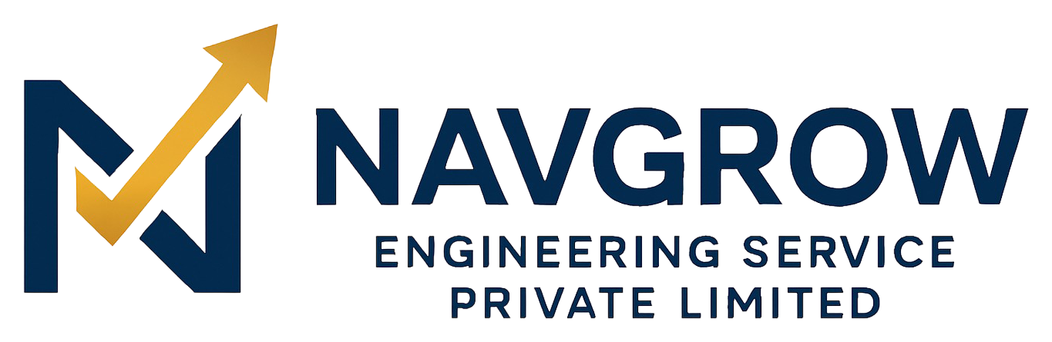
EXECUTIVE BRIEF
Engineering India’s Sustainable Infrastructure — and its Digital Backbone
Navgrow Engineering Service Pvt. Ltd. is a DPIIT-recognised, MSME-registered engineering company that pairs on-the-ground delivery — railways, industrial, civil and water infrastructure — with a proprietary digital platform for B2B commerce. One brand sells both services and products, fully GST-compliant, run from a single admin console.

The Opportunity
India’s infrastructure pipeline exceeds $1.4T and its B2B commerce is moving online, yet regional engineering suppliers still run on offline procurement, manual quotes, and weak digital discovery. Navgrow closes that gap.

What We’ve Built
- A production-ready storefront: catalogue, GST-inclusive pricing, cart, Razorpay + Cash on Delivery checkout.
- An RFQ and instant-quote engine that converts enquiries into orders.
- A full operations console: coupons, delivery zones, tax rules, orders, content, analytics, notifications.
- SEO-ready, discoverable pages with structured data — and DLT-compliant, configurable SMS/email.

Why Navgrow Wins
- Services + commerce in one — capturing the whole buyer journey, from project to parts.
- Owned technology, not a rented template — fast to adapt, cheap to scale.
- Compliance-first (GST, HSN/SAC, DLT, audit logs) — enterprise and government ready.
- A regional moat in North Bengal — a gateway to the Northeast and neighbouring countries — plus credentials (DPIIT, MSME) that open tenders and schemes.
THE ASK
We’re raising to accelerate what’s already built — deepening inventory, driving growth and delivery, and expanding the team — to turn a working platform and regional base into a category leader.
Navgrow Engineering Service Pvt. Ltd. • info@navgrow.org • +91 89270 70972
www.navgrow.org • Siliguri, West Bengal, India • CIN: U74999WB2022PTC256012

