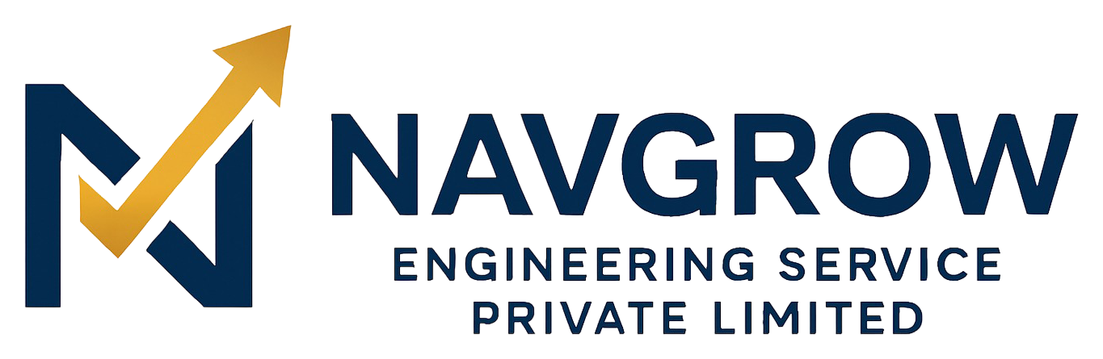
PRODUCT OVERVIEW
The Navgrow Platform
Engineering Services, Delivered Digitally
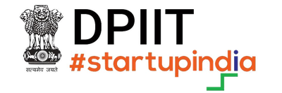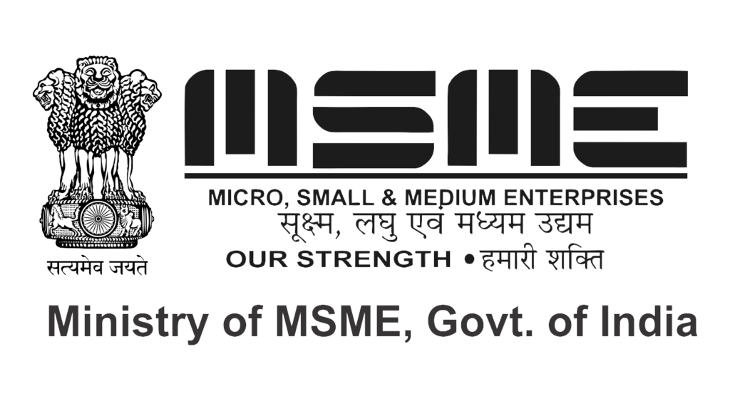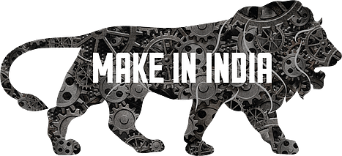
Navgrow Engineering Service Pvt. Ltd.
Siliguri, West Bengal, India • www.navgrow.org • info@navgrow.org
CIN: U74999WB2022PTC256012
2025 • Company & Product Profile

1. Who We Are
Navgrow Engineering Service Pvt. Ltd. is a DPIIT-recognised, MSME-registered engineering company based in Siliguri, West Bengal — a strategic gateway to Northeast India and the neighbouring markets of Nepal, Bhutan and Bangladesh. We deliver engineering across railways, industrial and civil works, and water infrastructure, with a strong commitment to sustainability.
What sets us apart is that our engineering capability is matched by our own digital platform: a single, branded system through which clients discover our work, request quotes, and buy the industrial products they need — with full GST compliance and pan-India delivery.
WHAT WE DO
Services and commerce, unified under one brand — from project execution to the parts that keep operations running.

2. What the Platform Offers

Engineering Services
End-to-end delivery across our core domains — railway infrastructure and loco services, industrial and civil engineering, and sustainable water solutions such as rainwater harvesting — supported by tendering and procurement expertise.

B2B Online Store
A professional storefront for safety equipment, tools, machinery and consumables. Buyers browse a categorised catalogue, compare products, see GST-inclusive pricing with a clear tax breakdown, and order online or by Cash on Delivery — every purchase backed by a proper GST invoice with HSN codes.

Quotations & RFQ
An instant quote calculator gives prospects an indicative figure in seconds. For larger or bulk needs, a full Request-for-Quote workflow lets buyers submit requirements and receive a formal, itemised quote with a validity period — which they can accept online.

Content & Trust
Projects, a gallery, and a regularly updated news section demonstrate capability and build authority, while careers and contact channels keep the business connected to talent and clients. Certifications — DPIIT, MSME, Make in India — are presented prominently to reinforce trust.

3. Built for Indian B2B Commerce
Capability | What it means for buyers and the business
GST-compliant pricing | Tax-inclusive prices with a transparent per-slab GST breakdown and correct HSN/SAC codes
Flexible payments | Razorpay online payments (card/UPI/netbanking) and Cash on Delivery
Smart delivery | Per-product charges reflecting weight and destination, shown once a pincode is entered; free within Siliguri
Promotions | Configurable coupons with minimums, caps and once-per-customer rules
Bulk & institutional | RFQ workflow for contractors, factories and government buyers
Reliable communication | Configurable, DLT-compliant SMS and email for every order and quote

4. Run Entirely From One Console
Behind the storefront is a role-based administration console that runs the whole business — no spreadsheets, no scattered tools:
- Catalogue, pricing, stock, and per-product delivery charges.
- Orders, coupons, delivery zones, and category tax rules.
- RFQs, quotes, tenders, and captured leads.
- Content — news, projects, gallery, and careers — via a dedicated editor role.
- Notification routing (careers, orders, quotes, contact) with email/SMS switches and test tools.
- Analytics on traffic and commerce, plus audit logs of privileged actions.

5. Discoverable by Design
The platform is engineered so that search engines and buyers can find Navgrow. Every key page is prerendered into indexable HTML with page-specific titles, descriptions and structured data; a sitemap includes individual product pages; and hreflang signals target both the Indian and global English markets. Product pages carry rich data (price, availability, ratings) that enables enhanced search results.

6. Technology
Navgrow runs on owned, production-grade technology — not a rented template — which means it adapts quickly and scales with demand rather than requiring rebuilds.
Layer | Technology
Front end | React, Vite, Tailwind CSS — responsive across desktop, tablet and mobile
Back end | Java Spring Boot — secure REST APIs
Database | PostgreSQL with versioned migrations
Payments | Razorpay (online) + Cash on Delivery
Notifications | DLT-compliant SMS (e.g. MSG91) and SMTP email, admin-configurable
Security | JWT authentication, role-based authorization, audit logging

7. Why It Matters
For buyers, Navgrow makes sourcing engineering services and industrial products as simple as any modern online experience — transparent, compliant, and fast. For the business, it converts engineering credibility into measurable online revenue and turns day-to-day operations into a single, controllable system. For partners and investors, it is a defensible, scalable, compliance-first asset with room to grow across products, geographies, and business lines.
GET IN TOUCH
Navgrow Engineering Service Pvt. Ltd. • Engineering Excellence. Sustainable Solutions.
Ward No-47, Old Matigara Road, Pati Colony, Siliguri, West Bengal – 734001, India
www.navgrow.org • info@navgrow.org • +91 89270 70972

