Experiment 6 :

Objective : Develop a simulation to demonstrate multiple access protocols such as Pure ALOHA, Slotted ALOHA, CSMA/CD, and CSMA/CA. Analyze the performance of each protocol in handling network collisions and maximizing data transmission efficiency

Components required :
Hardware Components (in Cisco Packet Tracer):
- Components for CSMA/CD (Wired Ethernet)
Required Devices:
- PCs
- Hub (important – collision domain)
- Copper Straight-through Cables
2. Components for CSMA/CA (Wireless Network)
Required Devices:
- Laptop
- Access Point
- Wireless NIC (built-in in laptops)
CSMA/CD (Collision Detection)
Collision Handling:
- Device checks channel before sending
- If two devices send together → collision happens
- Collision is detected instantly
- Transmission stops and jam signal is sent
- Devices wait random time, then resend
Performance:
- Works well when network traffic is low
- Performance decreases as devices increase
- More collisions → more delays
Efficiency:
- Good efficiency in small networks
- Poor efficiency in heavy traffic
- Bandwidth gets wasted due to retransmissions

CSMA/CA (Collision Avoidance)
Collision Handling:
- Device checks channel before sending
- Waits for a random backoff time
- Uses RTS/CTS signals to avoid collision
- Collisions are minimized before they happen
Performance:
- Suitable for wireless networks
- Stable even when traffic increases
- Slight delay due to waiting mechanism
Efficiency:
- Better efficiency than CSMA/CD in busy networks
- Less data loss due to fewer collisions
- Some bandwidth used for control signals
Conclusion:
- CSMA/CD is simple but not efficient for large or busy networks
- CSMA/CA provides better performance by reducing collisions, especially in wireless networks

CSMA/CD:
Steps:
  - Place hub in centre
  - Place 4 PCs around hub
  - Connect all PCs to the Hub using Copper Straight-Through Cable
  - Click each PC → Desktop → IP Configuration
Assign IPs in same network:
PC1 → 192.168.1.1
PC2 → 192.168.1.2
PC3 → 192.168.1.3
PC4 → 192.168.1.4

  - Click Add Simple PDU (envelope icon)
  - Send data:
From PC1 → PC2
Quickly send another from PC3 → PC2
This creates simultaneous transmission → collision

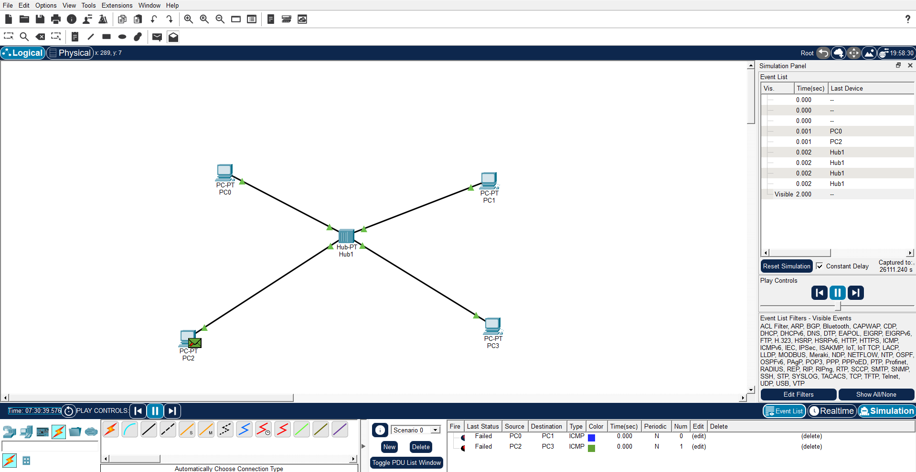

CSMA/CA:
Steps:
1. Place Devices
- Drag and drop:
  - Access Point
  - 4 Laptop

2. Configure Wireless Network
- Click Access Point → Config
- Set:
  - SSID (e.g., MyWiFi)
  - Security (optional, e.g., WPA2)

3. Connect Wireless Devices
- Click Laptop → Desktop → PC Wireless
- Select your SSID → Connect

4. Assign IP Addresses
- Desktop → IP Configuration
- Use: DHCP (automatic)

5. Switch to Simulation Mode
- Click Simulation Mode

6. Generate Traffic
- Use Add Simple PDU (envelope icon)
- Send data between laptops

