Experiment 1 :
Objective : To design and simulate a simple computer network using various connection topologies(bus, star, ring, mesh). Compare the advantages and disadvantages of each topology in terms of data flow and network efficiency.

Components required :
Hardware Components (in Cisco Packet Tracer):
PCs
Switches
Hub
Routers
Copper Straight-Through Cable
Copper Cross-Over Cable

Network Design :

Bus Topology
Advantages:
Simple and easy to implement.
Low cost (less cable required).
Suitable for small networks.
Disadvantages:
High collision rate.
Performance decreases as devices increase.
If backbone fails, entire network fails.
Difficult to troubleshoot.

Star Topology :
Advantages:
Better performance than Bus.
Easy to add/remove devices.
Failure of one cable does not affect others.
Disadvantages:
If central switch fails, entire network fails.
More cable required.
Slightly higher cost.

Ring Topology :
Advantages:
No collision.
Equal access for all devices.
Predictable performance.
Disadvantages:
Failure of one node can break entire network.
Difficult to troubleshoot.
Adding/removing devices affects the whole network.

Mesh Topology :
Advantages:
Very high reliability.
High fault tolerance.
No traffic congestion (multiple paths).
Disadvantages:
Very expensive.
Complex configuration.
Requires large number of cables.

Basic Setup (Common for all topologies)
- Open Cisco Packet Tracer
- Drag required devices from bottom panel:
  - PCs (End Devices)
  - Switches / Hubs
- Use Connections (lightning icon) to connect devices
- Assign IP addresses:
  - Click PC → Desktop → IP Configuration
  - Example:
    - PC1: 192.168.1.1
    - PC2: 192.168.1.2

Bus Topology
- Place multiple PCs in a line
- Use Hub (or simulate shared medium)
- Connect all PCs to the hub using straight-through cable
- Assign IPs in same network
- Test using Command Prompt → ping
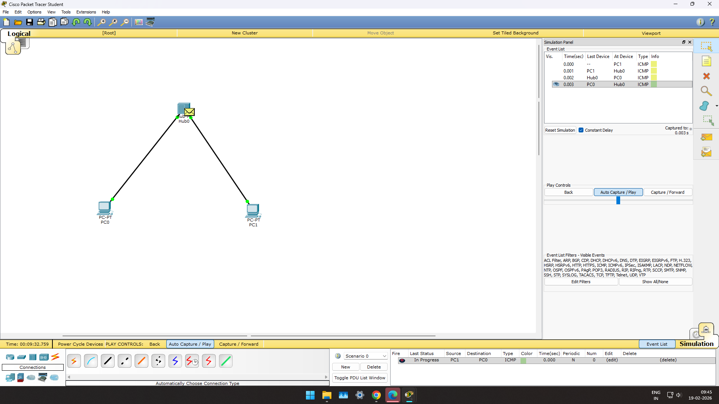

Star Topology
      - Place one Switch in center
      - Connect all PCs to the switch
      - Use Copper Straight-through cables
      - Assign IP addresses
      - Ping between PCs to verify
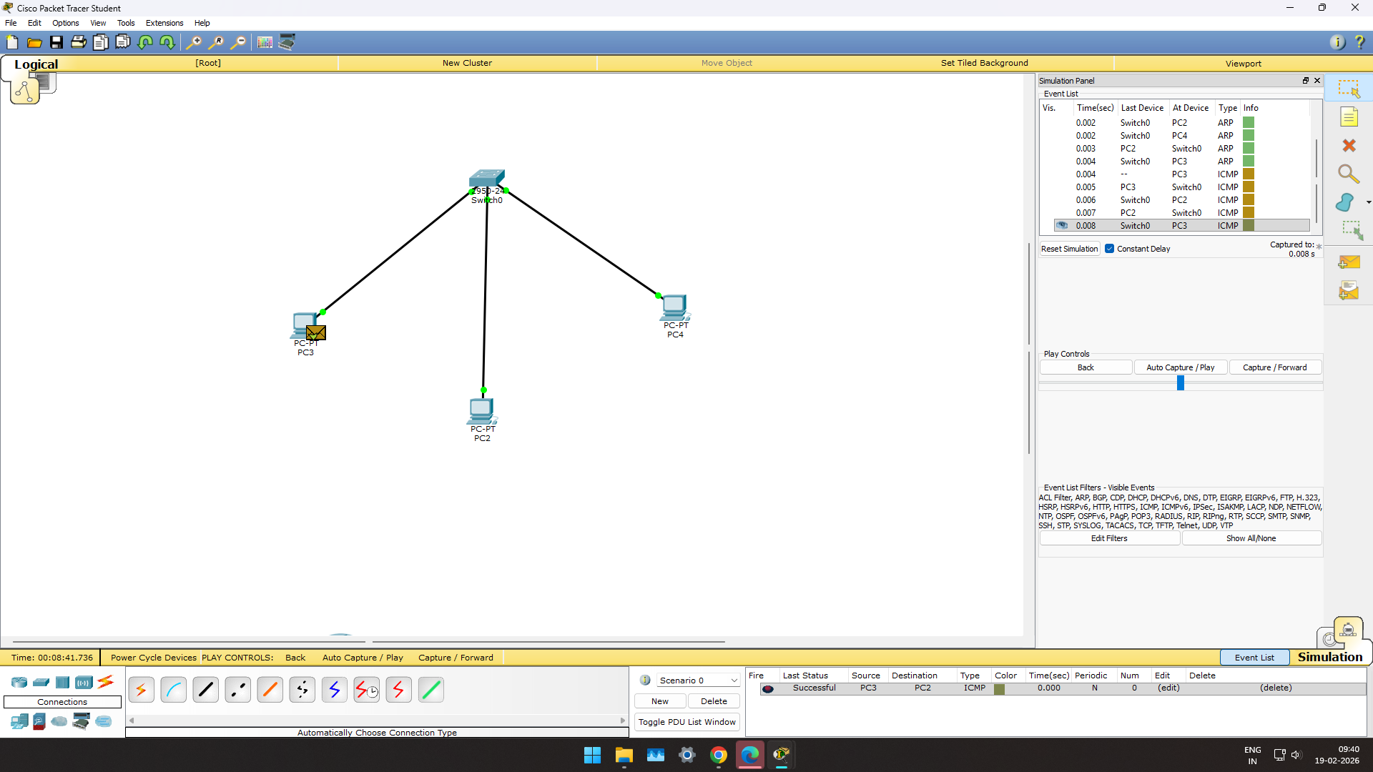

Ring Topology
      - Place PCs (or switches) in circular layout
      - Connect each device to next device
      - Last device connects back to first (forming ring)
      - Assign IPs
      - Test connectivity using ping
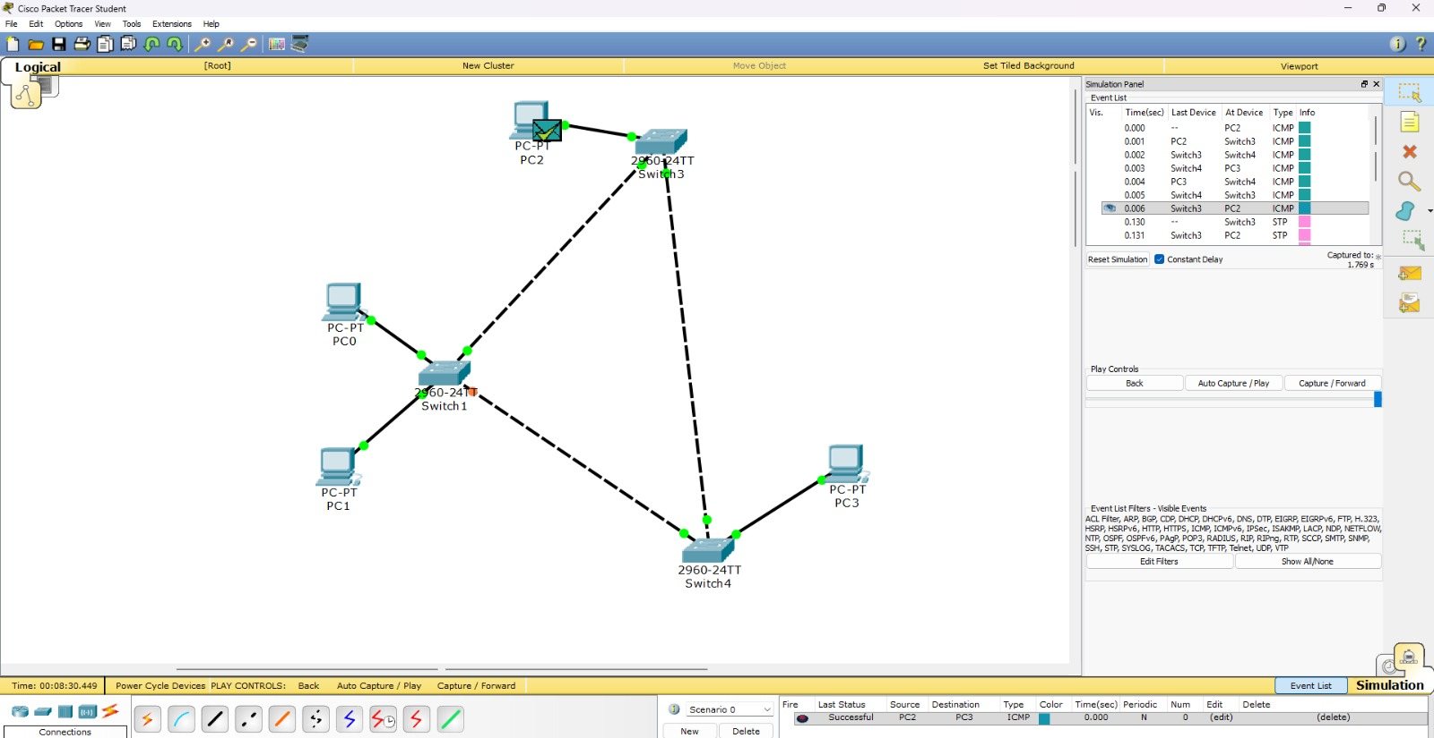

Mesh Topology
      - Place multiple PCs or switches
      - Connect each device to every other device
      - Use multiple cables (fully connected network)
      - Assign IP addresses
      - Test communication

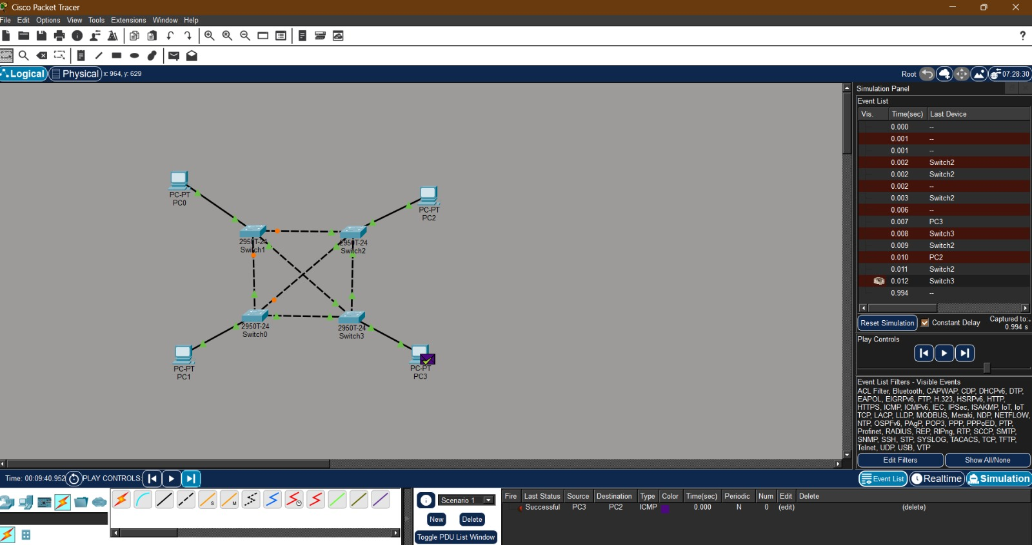

Conclusion :
Bus topology is simple but inefficient for large networks.
Star topology provides better performance and is widely used in modern LANs.
Ring topology avoids collisions but is less flexible.
Mesh topology offers the highest reliability and efficiency but at high cost and complexity.
·

