During my numerous UrbanCode Deploy demos, PoTs, PoCs I was always afraid of one question: How do you handle database deployments? You had two options: run database scripts or use DBUpgrader (which is nice but not very well documented). Now there is a new option. You can use Liquibase.

Liquibase is open source command line tool that run database deployment and rollbacks. It supports all major database types: DB2, Oracle, MSSQL, MySQL, PostgreSQL, Sybase, Informix, etc. Liquibase uses database change log files to run all db commands (same strategy that DBUpgrader is using). Change logs can be described in many different formats. I usually prefer XMLs or SQLs. You can read about all Liquibase functionality here <http://www.liquibase.org/>

Our Prague DevOps lab (me and Ondrej Hubacek) has developed UrbanCode Deploy plugin that can be used to execute all Liquibase commands as part of your deployment process. In example below I use sql log file to insert two new rows in MySQL database table department. Please notice I also declare my rollback strategy.

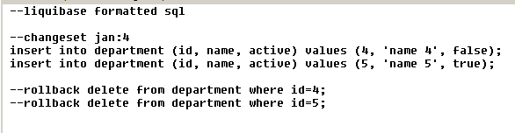

In deploy process I can download latest version of the database log file and I just call Update step to run Liquibase update command with this log file. I also validate if everything was ok and generate database html documentation.

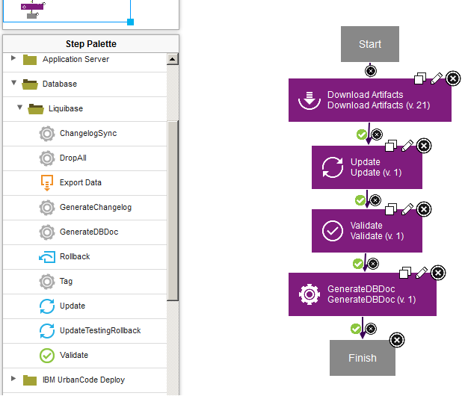

You can read more details about all commands here <http://www.liquibase.org/documentation/command_line.html>

You also need to define standard Liquibase properties such as liquibase command, jdbc driver, classpath, jdbc url in your Resource properties:

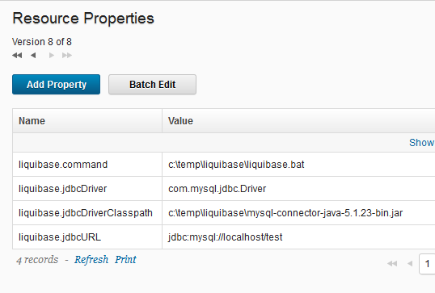

In your deployment process step you can reuse these properties and add username and password for database access. Most important is to state your change log file (xml, sql or any other supported format). For rollback step below you can define your rollback strategy (rollback number of change sets, rollback to date, rollback to tag). Then for rollback value you need to enter value related to your rollback type.

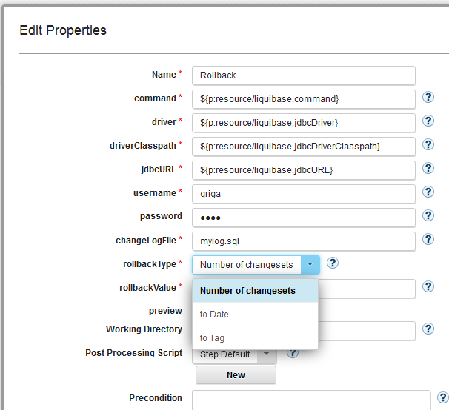

Then you can happily execute your deployment process to run specified database updates:

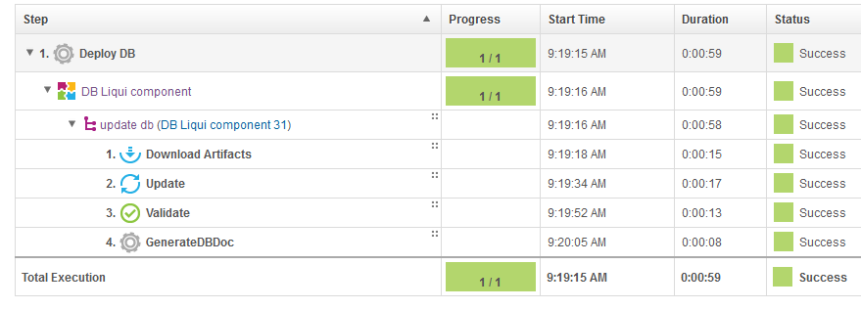

You can also view this generated html report that summarizes all database changes:

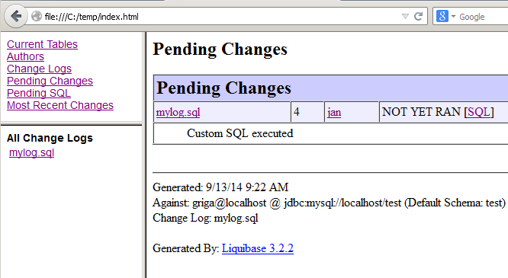

That’s it. It’s pretty simple but powerful. Liquibase has lot of useful database commands you can use to handle your database deployments better. There is also lot of documentation about database update strategies. Hope you find it useful. Please let me know if there any plugin improvements you would like to see.