

**Computer Science Department**

**COMP133 ( Spring 2024 )**

**Project Phase One *Due Date: Wed (8/5/2024) by 10:00 pm ( on itc )***

**Notes:**

1. This project phase should be submitted by the due date and time ***( Late project phases will not be accepted for any reason ) on itc.***

Each student will have to build a ***bookstore management system*** for adding, deleting, or searching for books in the store. Each book will have a title (*string*), bin number (*four digit integer*), and a price (*double*). When the program starts, it will load existing book information from a text file and when the program exits, it will save all changes made while running the program to that same file.

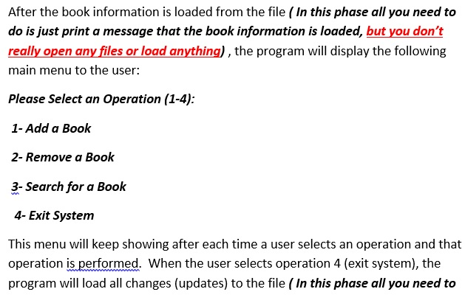

***do is just print a message that the book information is updated, but you don’t really open any files or update anything)*** and will then exit.

Your program should at least contain the following functions:

void displayMainMenu(); // displays the main menu shown above

void addBook(); // adds information for a new book

void removeBook(); // removes information of old book

void searchForBook(); // searches for a book in the store

void uploadDataFile(); // uploads book data from file

void updateDataFile(); // saves book data updates to file

**For this phase those functions are just void functions that will mostly contain *printf* statements just to print what they are supposed to do. In later phases, the function prototypes will change and the functions will do more.**

**VERY IMPORTANT:**

1. Turn in your project phase by ***attaching your mainu.c code file under the meta lab section on itc*** .
2. You must include your full name, student id number, and lecture + lab section numbers in a comment at the beginning of your ***main.c*** code file.

Make sure your program works **very similar** to the following sample run:

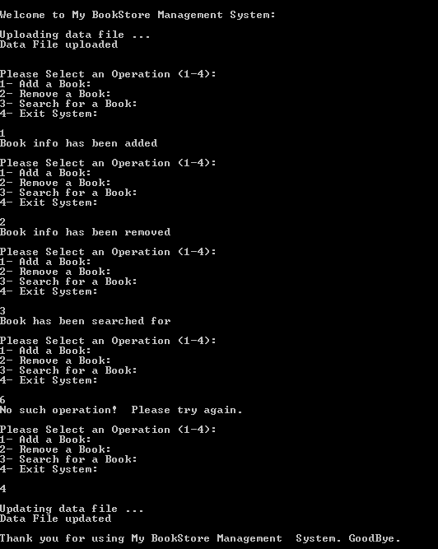

***Late project phases or those not turned in on itc as specified will not be accepted for any reason***. ***It is your responsibility to make sure that your code file has been uploaded correctly to itc.***