

**Computer Science Department**

**COMP133 ( Spring 2024 )**

**Project Phase Two *Due Date: Wed (22/5/2024) by 10:00 pm ( on itc )***

**Notes:**

1. This project phase should be submitted by the due date and time ***( Late project phases will not be accepted for any reason ) on itc.***

In this phase, you need to implement the major parts of the functions you created in phase one as follows:

***void displayMainMenu();*** // displays the main menu shown above

This function will remain similar to that in phase one with one minor addition which is the option:

***4- Print Book List***

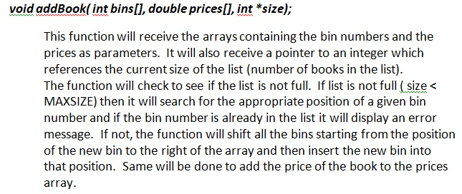

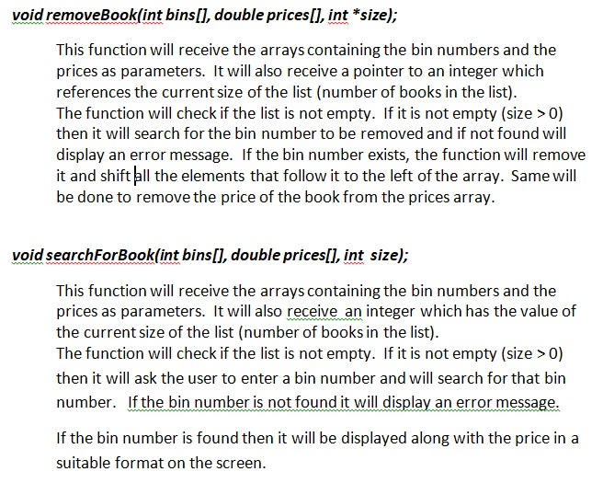

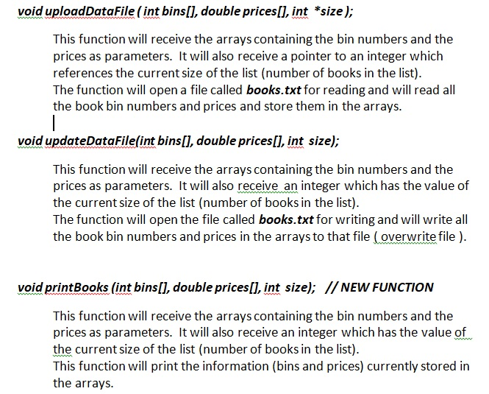

**IMPORTANT: The book info stored in the arrays should always be stored in ascending order based on the books’ bin numbers that exist in the bins array. You should NOT use any sorting functions to do this but should depend completely on the shifting procedure described above in the *addBook* and *removeBook* functions to keep the data in the correct order.**

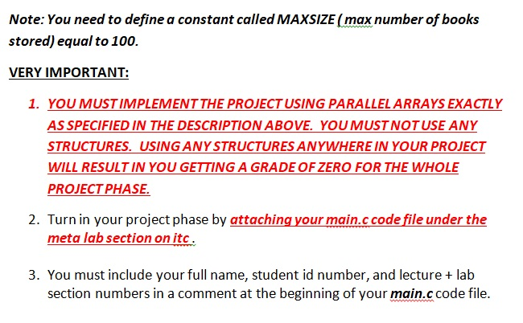

***SAMPLE RUN:***

Make sure your program works **very similar** to the following sample run:

***Assuming that at the beginning of the run file books.txt has the following information stored (first column = bins second column = prices):***

1234 72.45

2345 25.20

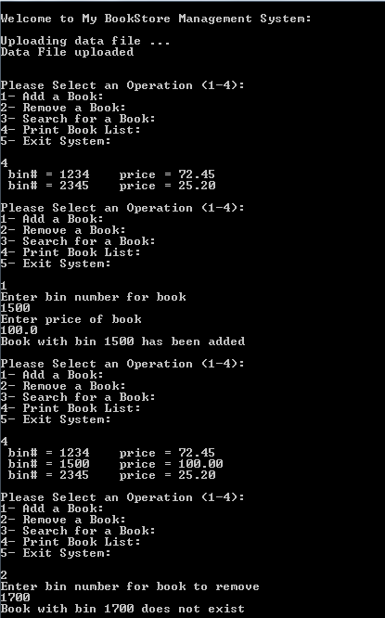

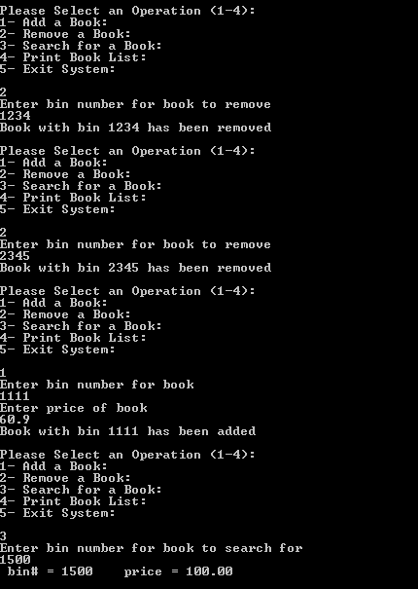

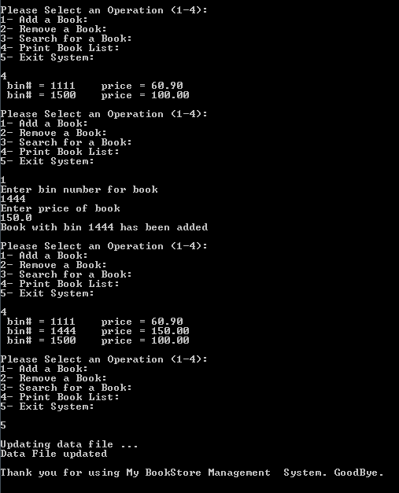

***Late project phases or those not turned in on itc as specified will not be accepted for any reason***. ***It is your responsibility to make sure that your code file has been uploaded correctly to itc.***