**Calculating the Minimum Value of Gandalf's Chests**

(Dynamic programing project)

**-Introduction:** in this report we are going to solve Gandalf chest problem using dynamic programming method and using c++ to program the solution.

**Part1:Divde and Conquer:**

1-Define the value returned by the function f which we want to optimize:

The returned value of function is the minimum of the chest with a weight (W).

2-Define the parameters which f depends on: W(weight) and n(to specify treasure in the vector).

Tree Draw:

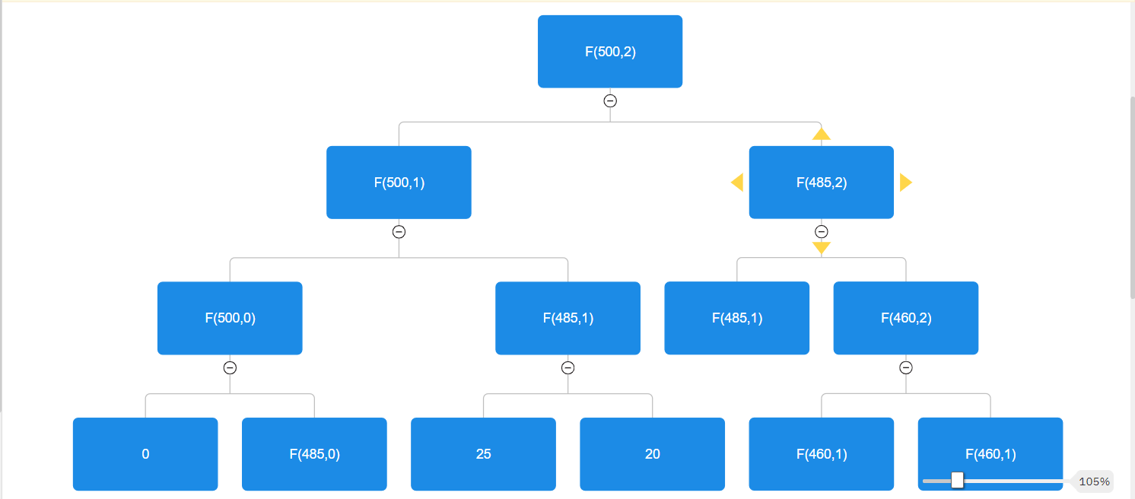

4-Code: 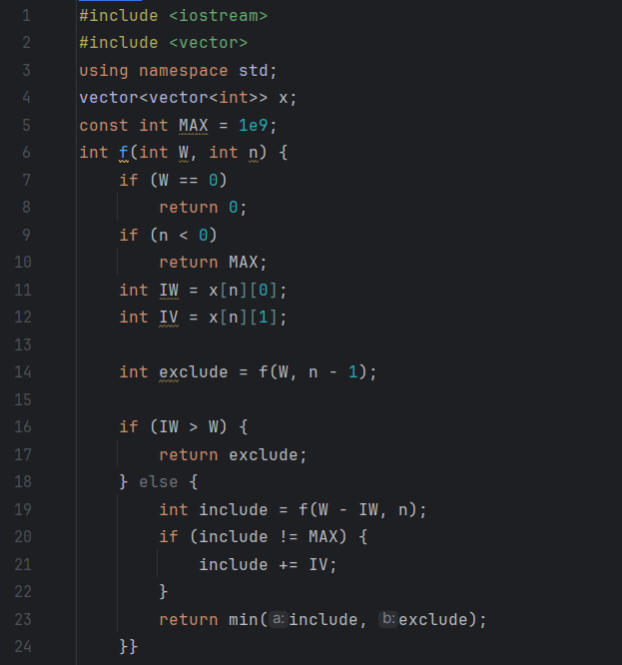

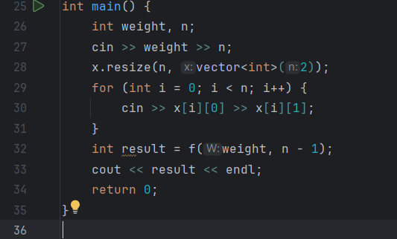

**Part2:Dynamic Programming:**

1. Draw the table and determine the dependencies between the table cells.

|  |  |
| --- | --- |
| **Weight** | **Find_min** |
| 0 | 20 |
| 5 | 20 |
| 15 | 25 |
| 25 | 30 |
| 30 | 50 |
| 50 | 50 |
| 75 | 75 |
| 100 | 100 |
| 150 | 150 |
| 200 | 200 |
| 250 | 250 |
| 350 | 350 |
| 400 | 400 |
| 450 | 450 |

1. Determine the direction of movement within the table: We moved in the table from left to right and line by line
2. Code (Function): 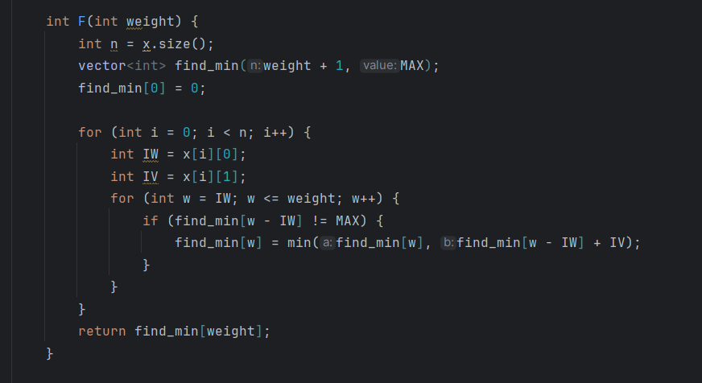

4-Code(Main):

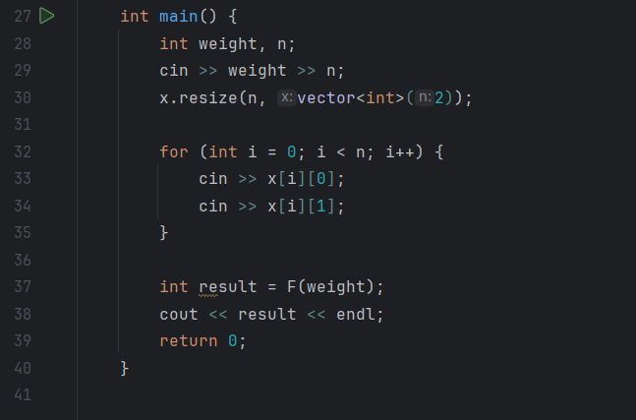

**Done By : Amjad Mousa.**

**ID:12112520.**