# Weather Forecast AI Web App

This document contains a complete overview of the AI-integrated Weather Forecast web application. It uses the OpenWeatherMap API to fetch real-time weather data and OpenAI's API to provide AI-based activity suggestions. The system supports input through typed text, voice commands, and geolocation. It is built with PHP (backend), HTML/CSS/JavaScript (frontend), and uses modern APIs.

Live application below :

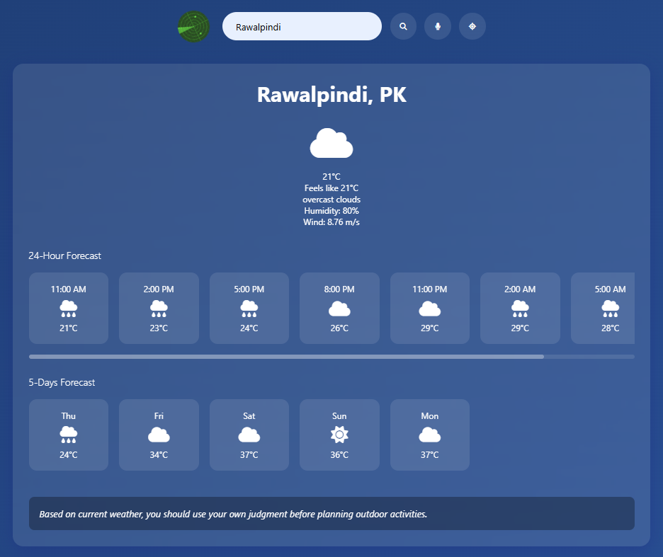

## Key Features

- Real-time weather data using OpenWeatherMap API

- AI-powered suggestions using OpenAI GPT-3.5-turbo

- Text, voice, and geolocation input options

- Forecasts: Current, 24-hour, and 5-day

- Responsive and animated user interface

## Technology Stack

- Frontend: HTML5, CSS3, JavaScript, FontAwesome

- Backend: PHP 8.2, cURL

- APIs: OpenWeatherMap, OpenAI GPT

- Environment: XAMPP for local server, VS Code

## Project Structure

weather-ai/

├── index.html # Main HTML file

├── style.css # Styling for UI

├── script.js # JavaScript logic

├── weather.php # PHP to fetch weather data

├── ai.php # PHP to communicate with OpenAI

└── radar.svg # Radar icon used in UI

## How it Works

1. User enters city or speaks city name or uses GPS.

2. JavaScript fetches weather data from OpenWeatherMap using weather.php.

3. Weather data is displayed in real-time including temperature, humidity, wind, and forecast.

4. AI suggestion is auto-triggered with a forecast summary using ai.php and OpenAI API.

5. AI replies with a suggestion like: 'It’s raining tomorrow, avoid hiking' or 'Weather is clear, perfect for hiking'.

6. If AI fails, a default message is shown depending on weather conditions.

## Troubleshooting

- Ensure your OpenWeatherMap and OpenAI API keys are correctly placed in PHP files.

- If AI response fails, check internet connection or possible cURL/OpenAI errors.

- Run XAMPP as Administrator. Ensure both Apache and MySQL are running.

- Use latest browser supporting fetch and speech recognition.