**Part One - Quality Assurance Web Automation Test**

**Testing Tool : Protractor using JavaScript.**

**Framework : Jasmine ( BDD )**

**File Details:**

1. **Configuration.js**
2. **MyStoreHomePage.js**
3. **TestData.json**
4. **Spec File ( Test Scenario Covered )**
5. **TC01_To_OpenEcommerceURL.js**
6. **TC02_To_SearchIteam.js**
7. **TC03_To_CreateNewAccount.js**
8. **TC04_To_AddIteam to Cart.js**
9. **TC05_To_Place the Order.js**

**How To SetUP Tool( Protractor ):**

**Download Node Js and Config it**

**Download Selenium Standalone Server**

**Download Chrome Driver**

Use npm to install Protractor globally with:

npm install -g protractor

This will install two command line tools, protractor and webdriver-manager. Try running protractor --version to make sure it's working.

The webdriver-manager is a helper tool to easily get an instance of a Selenium Server running. Use it to download the necessary binaries with:

webdriver-manager update

Now start up a server with:

webdriver-manager start

This will start up a Selenium Server and will output a bunch of info logs. Your Protractor test will send requests to this server to control a local browser. You can see information about the status of the server at <http://localhost:4444/wd/hub>.

**Jasmine Configuration**

Install below package from cmd or terminal

1. npm install -g jasmine
2. jasmine init
3. npm install -g protractor-jasmine2-html-reporter --save-dev
4. npm install protractor-jasmine2-screenshot-reporter --save-dev

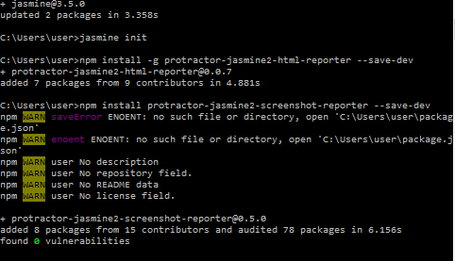

**Note : Create one Test Execution folder**

**To Run the Test Senarios:**

**Open CMD**

**Give the Folder Path of the project**

**And type:: protractor Configuration.js ( Enter )**

**e.g C:\Users\user\ProjectFolderName>protractor Configuration.js**

**Note: Make sure the Selenium server is running up.**

**NOTE::: For Refernce Puprose Please use below URL for more details on protractor**

<https://www.protractortest.org/#/>

***How to Improve the FrameWork:***

We can use other frame work like mocha , chai also and TypeScript to write the code also we can implement cucumber to write the test case