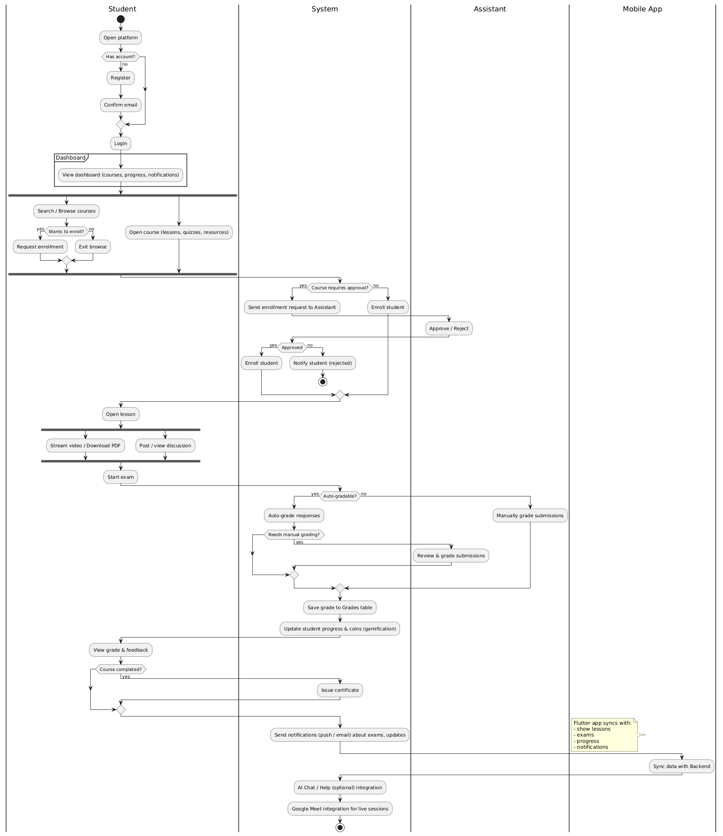

@startuml
|Student|
start
:Open platform;
if (Has account?) then (no)
:Register;
:Confirm email;
endif
:Login;
partition Dashboard {
:View dashboard (courses, progress, notifications);
}
fork
|Student|
:Search / Browse courses;
if (Wants to enroll?) then (yes)
:Request enrollment;
else (no)
:Exit browse;
endif
fork again
|Student|
:Open course (lessons, quizzes, resources);
end fork

|System|
if (Course requires approval?) then (yes)
:Send enrollment request to Assistant;
|Assistant|
:Approve / Reject;
|System|
if (Approved) then (yes)
:Enroll student;
else (no)
:Notify student (rejected);
stop
endif
else (no)
:Enroll student;
endif

|Student|
:Open lesson;
fork
:Stream video / Download PDF;
fork again
:Post / view discussion;
end fork

|Student|
:Start exam;
|System|
if (Auto-gradable?) then (yes)
:Auto-grade responses;
if (Needs manual grading?) then (yes)
|Assistant|
:Review & grade submissions;
endif
else (no)
|Assistant|
:Manually grade submissions;
endif

|System|
:Save grade to Grades table;
:Update student progress & coins (gamification);

|Student|
:View grade & feedback;
if (Course completed?) then (yes)
|System|
:Issue certificate;
endif

|System|
:Send notifications (push / email) about exams, updates;

|Mobile App|
note left
Flutter app syncs with:
- show lessons
- exams
- progress
- notifications
end note
:Sync data with Backend;

|System|
:AI Chat / Help (optional) integration;
:Google Meet integration for live sessions;

stop
@enduml

