Monica Atef

monicaatef46@gmail.com

Project Management Plan for Foodies app

Version 1.2

VERSION HISTORY

|  |  |  |  |  |  |
| --- | --- | --- | --- | --- | --- |
| **Version #** | **Implemented**  **By** | **Revision**  **Date** | **Approved**  **By** | **Approval**  **Date** | **Reason** |
| 1.0 | Aml Nasser | 09/04/2022 | Hager Hany | 15/04/2022 | Initial Version |
| 1.1 | Aml Nasser | 28/04/2022 | Hagar Nassar | 29/04/2022 | After Hagar Nassar Review |
| 1.2 | Aml Nasser | 05/05/2022 | Amr Helal | 06/05/2022 | After Amr Review |
| 1.3 | Monica Atef | 13/05/2022 | Hagar Nassar | 13/05/2022 | After Hagar Nassar Review |

Contents

1. Introduction 3

1.1 Purpose of project management plan 3

1.2 Summary of project charter 3

I. Introduction 3

II. Company’s role and strength. 3

III. Business need 3

IV. Unique Solution 3

V. Timeline 3

VI. Team 4

VII. Conclusion 4

1.3 Assumptions and Constraints 4

I. Assumptions: 4

II. Constraints: 4

1.4 Scope Management 4

1.5 Work Breakdown Structure 5

I. Diagram 5

II. Roles 5

2. Change Control Management 6

3. Schedule / Time Management 6

3.1 Milestones 6

3.2 Project Schedule 7

3.3 Dependencies 8

4. Quality Management 8

5. Configuration Management 8

6. Communication Management 9

I. Communication goals: 9

II. Stockholders' communication: 9

III. Project Teams' communication: 9

6.1 Communication Matrix 10

7. Risk Management 10

7.1 Risk Log 10

8. Issue Management and Escalation 10

8.1 Issue Log 10

9. Naming Convention for Foodies Project 11

APPENDIX A: REFERENCES 12

APPENDIX B:  KEY TERMS 13

# Introduction

## Purpose of project management plan

The intended audience of the Foodies PMP is all project stakeholders including the project sponsor, senior leadership and the project team.

## Summary of project charter

### Introduction

Our vision: Be Number One choice for our Customer in Food Delivery.

Our mission: Make Ordering Food Easier for every one everywhere.

### Company’s role and strength.

Roles:

Project Manager, Business Analyst, Developers, Tester.

Strength:

Cooperate, Flexible, Self-motivated, Cross-Functional and team-oriented

### Business need

Provides the easiest way to order food 24/7, the fastest delivery, and also the app provides food offers.

### Unique Solution

Our website tries to be different as the customer actually finds a user-friendly interface with the highest performance possible to satisfy the customer.

Users reserve Loyalty Points as much as they use Restaurants through our app.

### Timeline

We plan to provide Five milestones for the project and define the project as ready for publishing within 5 weeks of working as it needs approximately 212.5 hours. (5 Engineers each work daily for 2 hours 85% Capacity)

### Team

Our team consists of 5 members as follow:

1. Monica Atef: project & configuration manager
2. Hagar Hany: Team Leader, Developer
3. Marina Hatem: Developer and Tester
4. Noura Amr: Developer and Tester
5. Hagar El-Sayed: Developer and Tester

### Conclusion

This project will provide the needed luxury for user and provide the customer with the needed functionality to achieve the highest market value (profit).

## Assumptions and Constraints

### Assumptions:

* Null

### Constraints:

* Should use Web based System
* Should obtain Unique user IDs
* Should add Admin features

(ADD/DELETE/UPDATE users, restaurants, menus and promotions)

## Scope Management

|  |
| --- |
| Justification |
| Foodies is a web app that will provide a good source of restaurants so users can discover and order their food.  Also, restaurant owners can promote their menus. |

|  |  |
| --- | --- |
| Scope Description | |
| In Scope | Out of Scope |
| * Design * Fully functional Food website – designed and developed according to the specifications as well as the requirement of the project stakeholders. * Development * Browsing capability – allow customers to browse Menus and make Orders. * Design, develop and host the website. * Search engine optimized Fixed list of Restaurants. * Loyalty Points as much as they use Restaurants through our app. * Testing * Deployment | * Marketing Plan * Promotional Plan * Sales Projections * ROI calculations * Credit card processing system. * Merchant account. * Financial Analysis * Market Share * Payment Method will include MasterCard or Visa. |

|  |
| --- |
| Business Objectives |
| **Launch date**: After Five working weeks  **Better customer satisfaction:**  Providing easier access to make an order and being available 24/7, providing reliable feedback from previous Users. |

|  |
| --- |
| Project Deliverables |
| • Web-based System  • Project plan  • SRS (Software Requirements Specification)  • Sample in Question  • Project high-level Design  • Project Low-level Design  • Test plan  • Quality Reports |

## Work Breakdown Structure

## Diagram

## Roles

Illustrated in the RACI Matrix in the below Link:

https://github.com/MonicaAtef/QA_Foodies/tree/master/Concept

# Change Control Management

External Change Management Plan File (deferred).

# Schedule / Time Management

## Milestones

| **Milestones** | **Estimated Completion Timeframe** |
| --- | --- |
| - Sample in Question (SIQ)  - Software Requirements Specification (SRS)  -Project Management Plan (PMP)  -Configuration Management Tool setup  -Project Schedule  -Finish User Acceptance Testing | * Release One |
| -Cover SRS Audit Comments  -Design include (ERD, Use case, sequence, wireframe)  -RTM | * Release Twoس |
| -FrontEnd.  -BackEnd.  -Middleware.  -Database. | * Release Three |
| TBD | * Release Four |
| TBD | * Release Five |

## Project Schedule

External Project Schedule File

Can accessed through below Link:

<https://hagar-nassar.monday.com/boards/2612037162>

## Dependencies

We are following the Waterfall Model of SDLC

(But we are also using some Agile methodologies in reviewing and daily meetings)

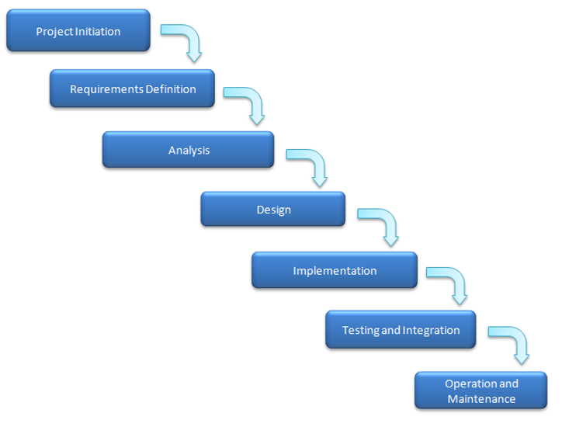Each step depends on the previous step (Finish to Start)

# Quality Management

External Quality Management File in the below Link:

https://github.com/MonicaAtef/QA_Foodies/blob/master/Concept/F_Quality_Management_Plan.doc

# Configuration Management

We tailored our Configuration Management tool to use Git and GitHub instead of

Tortoise SVN.

The guidelines on how we will use the CM:

for the baseline

internal changes

Master Branch

Development Branch

* Tags Format (DayMonthYear-Inter/Release-no of release)

|  |  |
| --- | --- |
| Ex: 160422-Release-01 | Ex: 160422-Inter-01 |

* Pull requests are required for the master branch only

* Folder Structure:

Readme File is provided to help identifying the location of each file in the below Link:

<https://github.com/MonicaAtef/QA_Foodies>

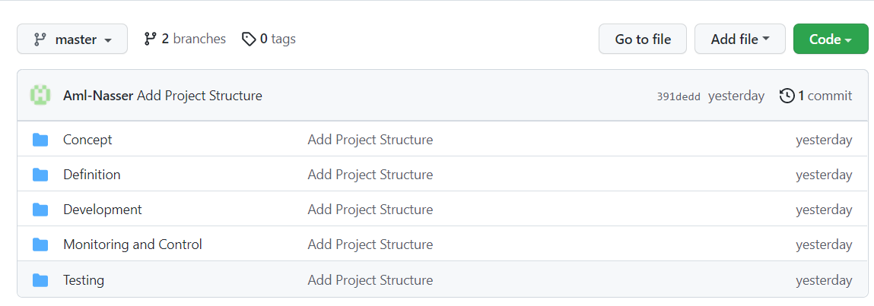

# Communication Management

Communication plan: Foodies

### Communication goals:

-keep the stakeholder informed with all new updates and all the project needs

-Provide clear insight into any decisions needed or roadblocks

-Provide structured opportunities for feedback from stockholders

### Stockholders' communication:

-We are going to use formal mails to communicate and clarify some points in addition to the meetings whether it's an online or offline so as to take their feedback on the work and if they want to introduce any changes or suggestions

### Project Teams' communication:

-We are going to use formal mails to communicate and clarify some points in addition to the meetings whether it's an online or Face-to-face so as that we can discuss all what we have and take each other opinions

-Also, we can use some social media apps as slack or what's app or Trello for easier and faster communication

## Communication Matrix

Communication Management Matrix

|  |  |  |  |  |
| --- | --- | --- | --- | --- |
| Communication Type | Objectives | Medium | Frequency | Audience |
| Project Team Meeting | Discuss the work progress | * Conference call * Face-to-face | Daily | -Whole team |
| Customer Meeting | Clarifying some information  Providing the customer with some information | * Conference call * Emails * Face-to-face | As Needed | - Project manager  - Customer |
| Technical Design Meetings | Discuss and develop technical design solutions for the project. | * Conference call * Face-to-face | As Needed | - Project Technical  - Staff |
| Project Status Reports | Report the status of the project including activities, progress, and issue. | * Emails | Weekly | - Project manager  - Project Team  - Customer |

# Risk Management

External Risk Management File in the below Link:

https://github.com/MonicaAtef/QA_Foodies/tree/master/Monitor%20and%20Control

## Risk Log

External Risk Log File in the below Link:

https://github.com/MonicaAtef/QA_Foodies/tree/master/Monitor%20and%20Control

# Issue Management and Escalation

External issue Management File in the below Link:

https://github.com/MonicaAtef/QA_Foodies/tree/master/Monitor%20and%20Control

## Issue Log

External issue Management File in the below Link:

https://github.com/MonicaAtef/QA_Foodies/tree/master/Monitor%20and%20Control

# Naming Convention for Foodies Project

* Serial Number (S.N) Consists of three digits (00X)
* Project Name for short will be (F)
* Space Separation between words by (‘_’)
* In Files Naming

- Must Capitalize Each Word

- Acronym Must Be Uppercase

* When using Excel sheet Must stick to the previous rule with meaningful naming

|  |  |  |
| --- | --- | --- |
| Document/File | Naming Convention | Examples |
| 1-Files(Word/Excel/etc.) | ProjectName_docType | F_SRS  F_SIQ  F_Customer_Requirment |
| 2-Review ID | ProjectName_docType_VersionNo_S.N | F_REVIEW_SRS_V1.0_001  F_REVIEW_PMP_V1.0_001 |
| 3-Requirements ID | ProjectName_docType_Actor_Module_S.N | F_REQ_U_Reg_001  F_REQ_A_Reg_001 |
| 3-Design Wireframe | ProjectName_ docType_Actor_Module | F_WIREFRAME_U_Login |
| 4-Testing (TC) | ProjectName_ TC_ Module_S.N | F_TC_Login_001 |
| 4-Testing (Bug Report) | ProjectName_ Bug_ Module_S.N | F_Bug_Login_001 |

# APPENDIX A: REFERENCES

The following table summarizes the documents referenced in this document.

|  |  |  |
| --- | --- | --- |
| **Document Name** | **Description** | **Location** |
| Change Management Plan | Describe [change control](https://www.stakeholdermap.com/project-dictionary/project-dictionary-c.html#change-control) policies and procedures and how [change control](https://www.stakeholdermap.com/project-dictionary/project-dictionary-c.html#change-control) will interface with other aspects of [project management](https://www.stakeholdermap.com/project-dictionary/project-dictionary-p.html#project-management-pm). | *Deferred* |
| External Project Schedule File | Describe the roadmap of the project | <https://hagar-nassar.monday.com/boards/2612037162> |
| External Quality Management File | Identifying the quality requirements and standards for the project and product. | <https://github.com/MonicaAtef/QA_Foodies/tree/master/Monitor%20and%20Control> |
| External Risk Management File | Contain Probable Risk with risk Impact and Probability of Occurrence | *Log:*  https://github.com/MonicaAtef/QA_Foodies/tree/master/Monitor%20and%20Control  *Plan:*  <https://github.com/Aml-Nasser/QA_Foodies/tree/master/Monitor%20and%20Control> |
| External Issue Management File | Identifying track and resolve project issues throughout the life of the project ensuring effective communication | https://github.com/MonicaAtef/QA_Foodies/tree/master/Monitor%20and%20Control |

# APPENDIX B:  KEY TERMS

The following table provides definitions for terms relevant to this document.

|  |  |
| --- | --- |
| **Term** | **Definition** |
| Communication | The effective sending and receiving of information. Ideally, the information received should match the information sent. It is the responsibility of the sender to ensure this takes place. |
| Stakeholder | Individuals or groups involved in the project or whose interests may be affected by the project’s execution or outcome. |
| Communications Management Plan | Portion of the overall Project Management Plan which details how project communications will be conducted, who will participate in communications, frequency of communications, and methods of communications. |
| SDLC | Software Development Life Cycle. |
| TBD | To Be Determined. |