

Sequence Diagram



User Functionalities:

Register an Account Sequence

ID: F_SQ_Reg_001

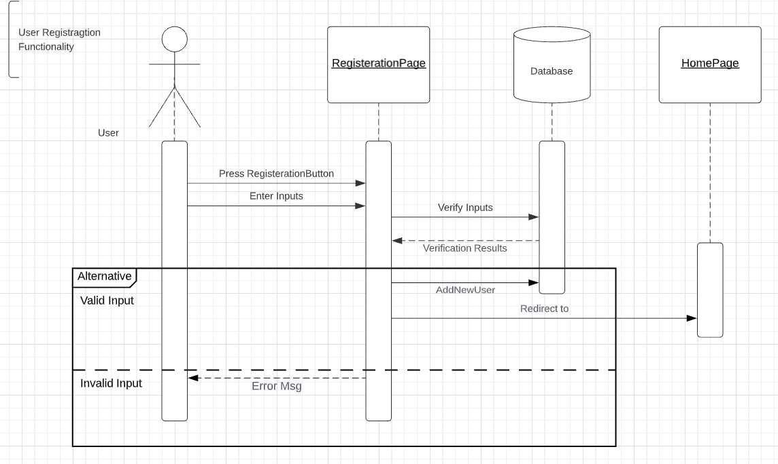

Sign In Sequence

ID: F_SQ_SignIn _002

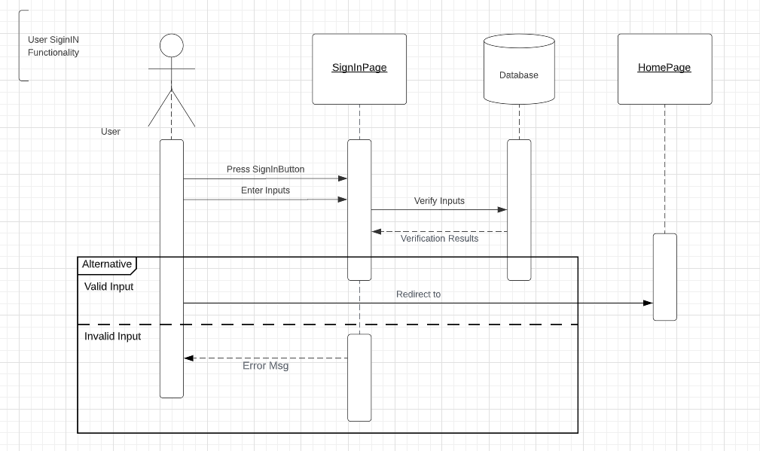

Select a restaurant

ID: F_SQ_SelectRes_004

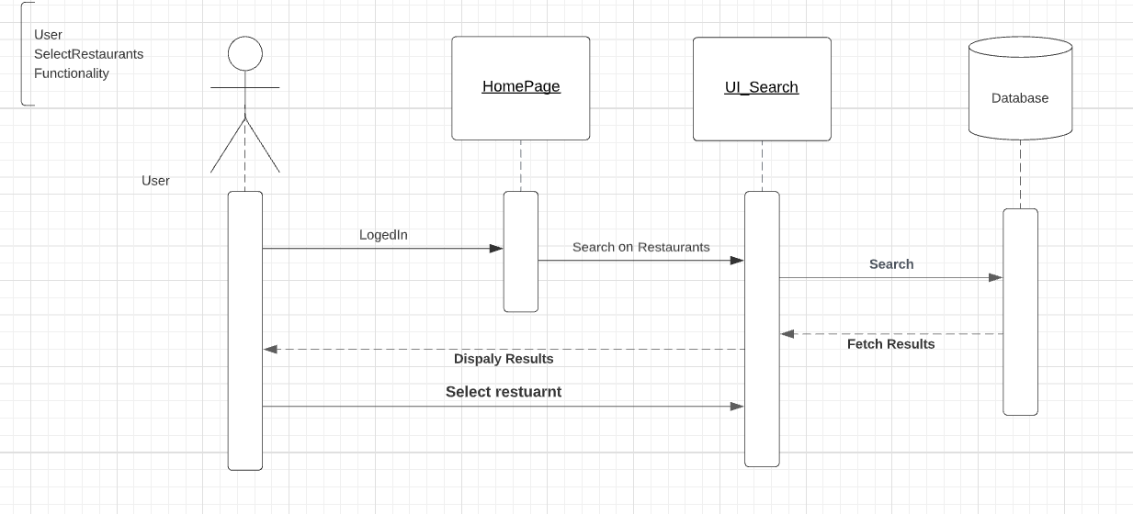

Select meals Sequence

ID: F_SQ_SelectMeal_005

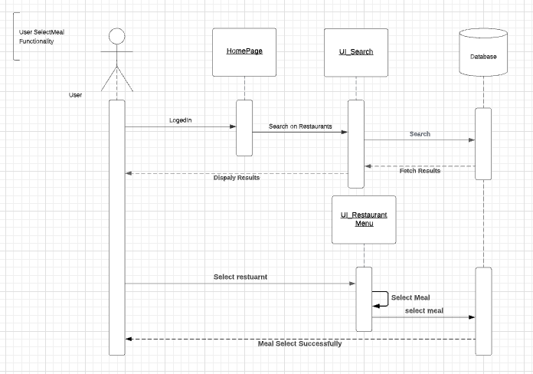

Confirm order sequences

ID: F_SQ_ConfirmMeal_006

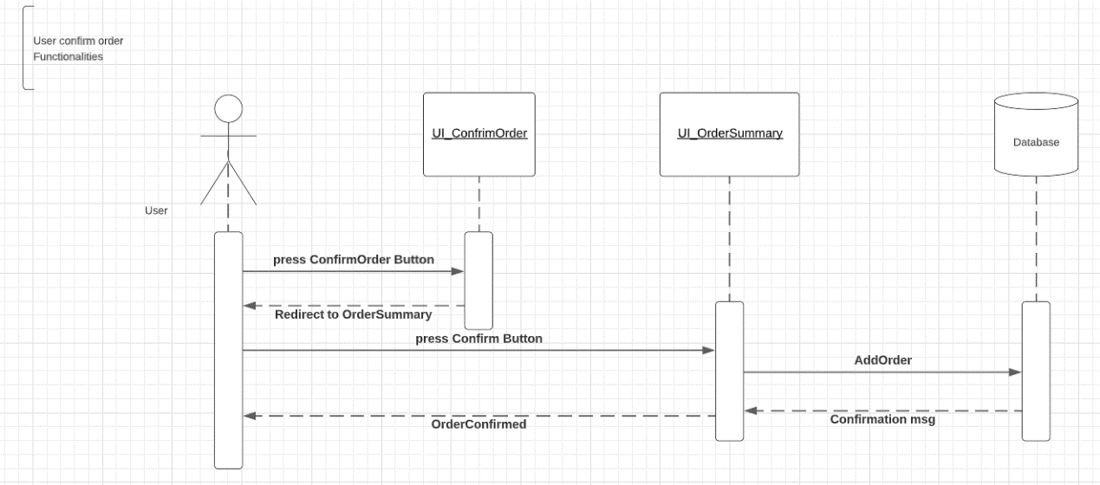

View Offers and Promotions sequences

ID: F_SQ_ViewOffers&Promotions_007

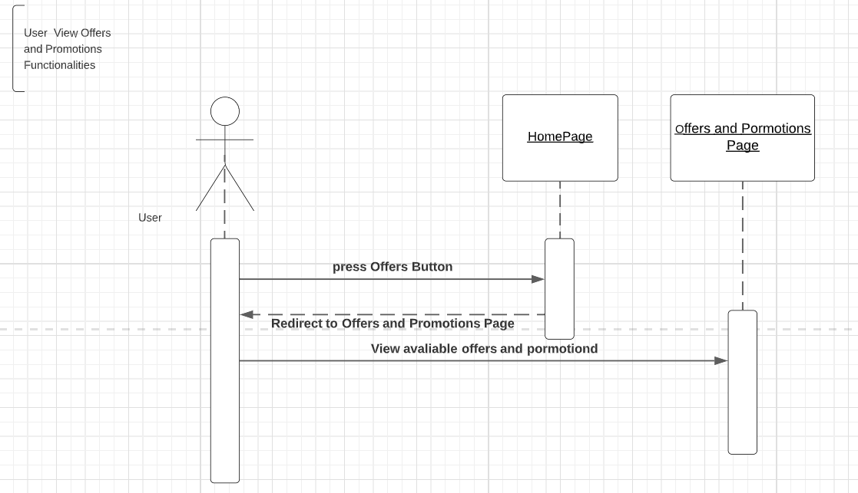

Select an offer/Promotion to apply Sequence

ID: F_SQ_SelectOffers&Promotions_008

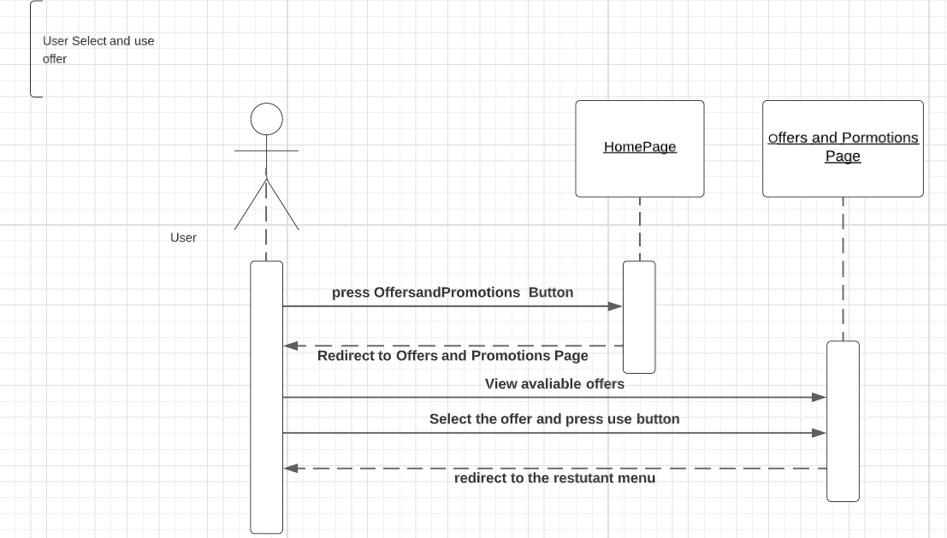

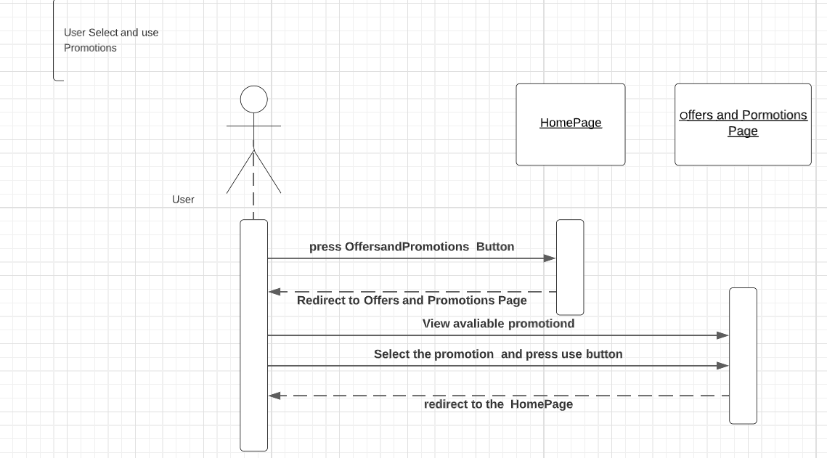

Admin Functionalities:

Add Restaurant Sequence

ID: F_SQ_AddRes_010

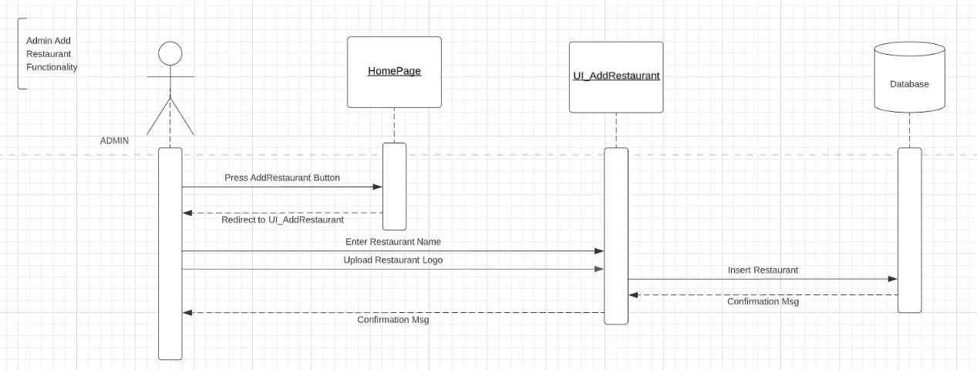

Add menu item Sequence

ID: F_SQ_AddMenuItem_011

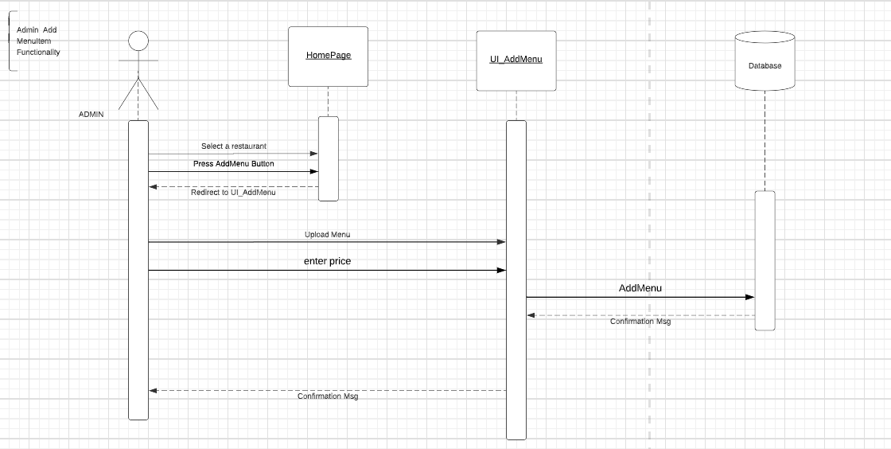

Add Offers Sequence

ID: F_SQ_AddOffers_012

