Software Requirements Specification

for

*Foodies web app*

**Version** *1.2*

**Prepared by**

*-Aml Nasser -Marina Hatem*

*-Hagar Hany -Hagar Nasser*

*-Noura Amr*

**ITI Smart Village**

**12-4-2022**

**Table of Contents**

**Table of Contents ii**

**Revision History ii**

**1.** **Introduction 1**

1.1 Purpose 1

1.2 Document Conventions 1

1.3 Intended Audience and Reading Suggestions 1

1.4 Project Scope 1

1.5 References 1

**2.** **Overall Description 2**

2.1 Product Perspective 2

2.2 Product Features 2

2.3 Operating Environment 2

2.4 Design and Implementation Constraints 2

2.5 User Documentation 2

2.6 Assumptions and Dependencies 2

**3.** **System Features [Functional Requirements] 3**

3.1 System Feature 1 3

3.2 System Feature 2 (and so on) 3

**4.** **External Interface Requirements 3**

**5.** **Nonfunctional Requirements 4**

5.1 Performance Requirements 4

5.2 Safety Requirements 4

5.3 Security Requirements 4

5.4 Software Quality Attributes 4

**6.** **Other Requirements 4**

**Appendix A: Glossary 4**

**Appendix B: Analysis Models 5**

**Appendix C: Issues List 5**

**Revision History**

| **Name** | **Date** | **Reason For Changes** | **Version** |
| --- | --- | --- | --- |
| Marina | 22/4 | First version | FoodiesWebApp_SRS_V1 |
| Noura | 29/4 | Modify features of user and admin | FoodiesWebApp_SRS_V1 |
| Noura & Marina | 6/5 | fix Amr comments and added “sign out” functionality. | FoodiesWebApp_SRS_V1.2 |

# Introduction

## Purpose

*Foodies is a web app that will provide a good source of the nearby restaurants so the users can discover and order their food .Also the restaurant owner can promote their menus and different services.*

## Document Conventions

*We using a template without change the font or headers ,tailoring the content based on type of project*

## Intended Audience and Reading Suggestions

*Intended Audience :developers, project managers, marketing staff, users, testers, and documentation writers. This SRS contains Product Scope, User Needs, Assumptions and Dependencies, Functional & nonfunctional Requirements, and System Features.*

*sequence for reading the document:*

*Purpose and project scope*

* *Project functionality (what should be done and what should not be done)*
* *System performance criteria.*
* *Implementation issues (risks) if any.*

## Project Scope

*The Scope of the project is as follows:-*

* *To build a system that the user can register for getting the nearby restaurant*
* *After choosing the restaurant, the user can select items and set an order.*
* *Users can get offers and promotions based on frequency of using the app.*

## References

*N/A*

# Overall Description

## Product Perspective

*It is Web based application that facilitate for user to access near by restaurant’s menus and make the order of food easier  
help the restaurants owner reach more users.*

## Product Features

**User’s features**

* *Users create their accounts using the registration form fields [Email, Password, User ID, Phone Number, and Location].*
* *Users will be redirected to the home screen with all nearby restaurants after registering successfully.*
* *Users can search for specific restaurants.*
* *Users can select items and set an order*
* *Users can get offers and promos from nearby restaurants*

**Admin features**

* *ADD/DELETE/UPDATE users, restaurants, menus.*
* *Admin determines promotions and offers based on more user using the app*
* *add another admin*

## Operating Environment

* *Operating system: Windows.*
* *database: file-based*
* *platform: html ,css, java script*

## Design and Implementation Constraints

* Web-based system/pc based
* Unique user-id
* Admin features needed

## User Documentation

*Firstly, users can register with Email, Password, User ID, Phone Number, and Location.*

*After this will be redirected to the home page where he can see all nearby restaurants by the entered location and can search on specific restaurant.*

*Then, after selecting, the restaurant he can show the menu items and set an order.*

*Cash on Delivery is the only payment method.*

*Users can get offers and promotion based on frequency of using the app.*

## Assumptions and Dependencies

***Assumptions***

* *Login page*

*Tracking order*

***Dependencies***

*Features of admin – features of users*

***Features of users:***

***(start-start)***

*Feature Select item/restaurant – Feature register*

***Features of admin:***

***(start-start)***

*Features promotion – Features menu – Add another admin*

### System Features [Functional Requirements]

1. **USERS FUNCTIONALITIES :**

***General Table of Normal User features***

| ***General* Description** | In “foodies App”, we have two characters admin and normal users. |
| --- | --- |
| **User Functionalities** | -Register an Account.  -Sign In.  -Update profile.  -Search for a Restaurant.  -Select a Restaurant.  -Select meals.  -Confirm order.  -Navigate to the “Offers and Promotions” page.  -Select an offer/Promotion to apply.  -Sign out. |

## Register an Account

| ID | Description | Priority |
| --- | --- | --- |
| F_REQ_U_Reg_3.1.1 | In “foodies App”, the user can **register** in our app to get a fixed list of restaurants and make an order.  When he navigates to the web app he will be navigated to the Register page.  The user will be required to fill the following fields in order to register an account:  -Full Name  -user name  -User mail  -Password  -Confirm Password  -Address  -Phone Number  After that he will have to click on “Register” Button. | HIGH |
| F_REQ_U_Reg_3.1.2 | The fields must match the following criteria:  1- the **full name** must contain characters only except for space  in case of invaild full name,an error message will appear that ”the full name must be characters only”  2- the **user name** must contain characters only  in case of invaild username,an error message will appear that ”the user name must be characters only and unique”  3-the **email** in the valid email format  in case of invaild email an error message will appear that ”the user’s email must be in this format [example@mail.com](mailto:example@mail.com)”  4- the **password** at least 5 characters and contain letters/numbers/special characters  in case of invaild password an error message will appear ”password must be at least 5 characters and contain letters/numbers/special characters”  5-the **confirmation password** must match password  if confirmation password didn’t match the password  an error message will appear “Confirmation password didn’t match the password”  6-**Address** contain characters and numbers only  in case of invaild address, an error message will appear that ”the address must be characters and numbers only”  7-**Phone Number** must contain numbers only  in case of invaild Phone Number, an error message will appear saying “the Phone Number must be numbers only”  If all the fields meet the constraints a pop up message should appear saying “Account created successfully, welcome to Foodies!”. And then get navigated to the home page that has all the restaurants in it.  If the user already has an account, under the register button he will find a line saying “Have an account? Login here”. The ‘Login here’ will be clickable to navigate the user to the sign in page. | HIGH |

**Sequence Diagram:  
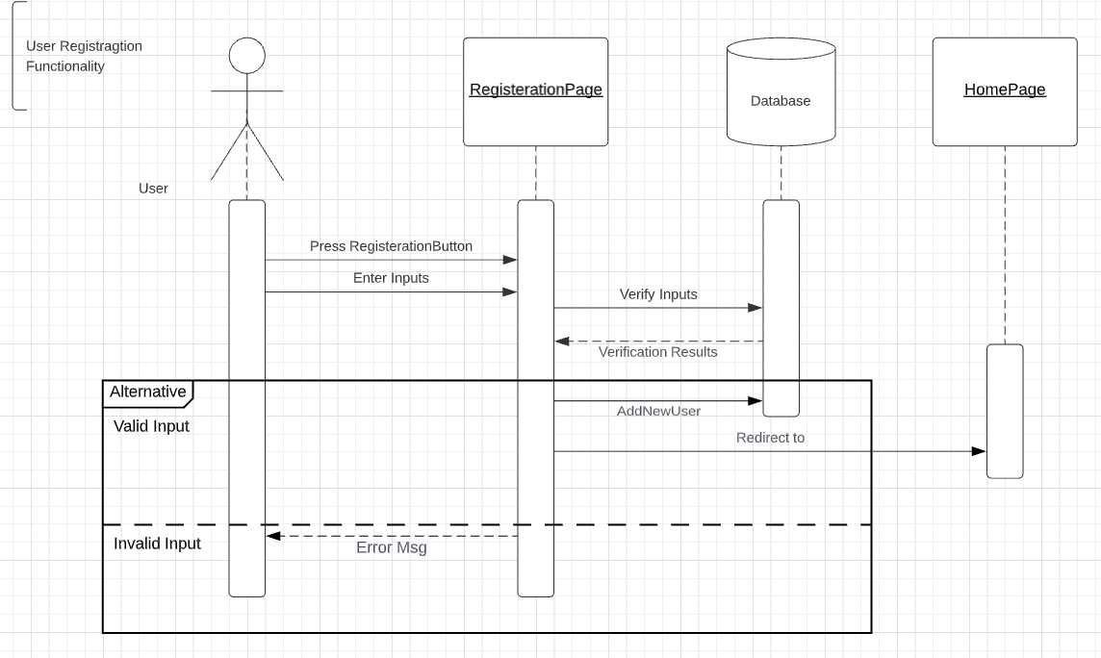**

## Sign In

| ID | Description | Priority |
| --- | --- | --- |
| F_REQ_U_sig_3.2.1 | If the user already has an account, he will click on the “Login here” button in the Register page. |  |
| F_REQ_U_sig_3.2.2 | The user will be required to fill the following fields in order to sign in to his pre-registered account:  -user name  -Password  And then click on the “ **sign in**” Button. | HIGH |
| F_REQ_U_sig_3.2.3 | The fields must match the following criteria:  1- The **user name** field mustmatch the usernames in the database file.  in case of invaild username, an error message will appear saying that “Invalid **username or password**”  2- The **password** field mustmatch the password of the username in the database file.  in case of invaild password, an error message will appear saying that “Invalid **username or password**”  In case the user enters a **valid username and password that match** then the user will be navigated to the home page that has a fixed list of restaurants.  Under the “sign in” button there will be “Not a member? Sign up”. The ‘Sign up’ will be clickable to navigate the user to the Register page. | HIGH |

**Sequence Diagram:**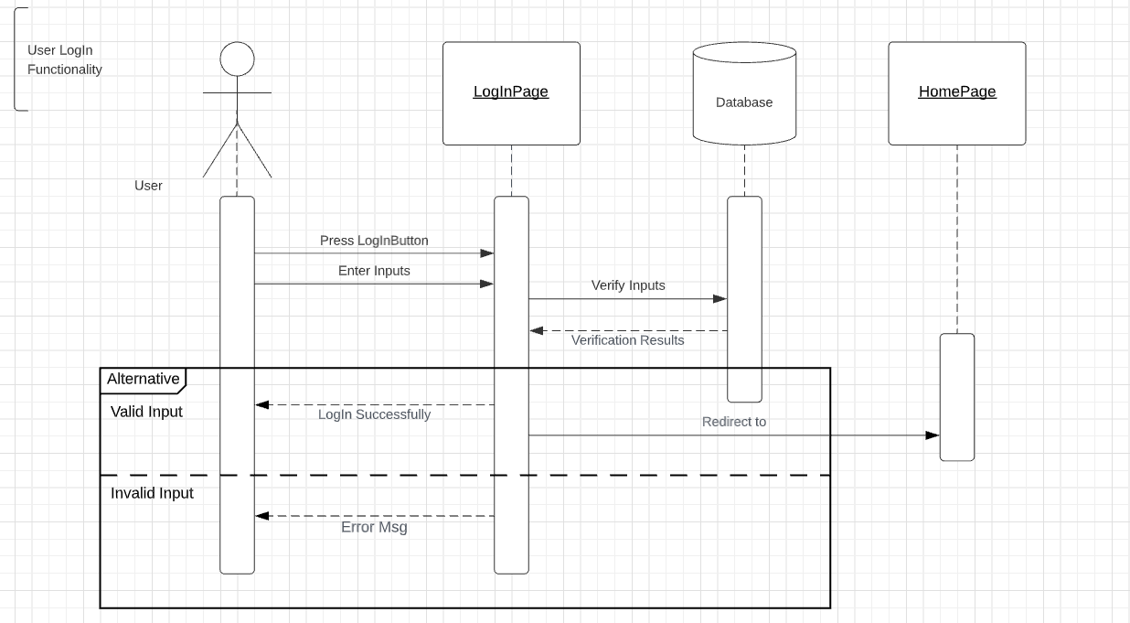

## Update Profile

| ID | Description | Priority |
| --- | --- | --- |
| F_REQ_U_Upd_3.3.1 | In “foodies App”, the user has to sign into his pre-registered account. | *HIGH* |
| F_REQ_U_Upd_3.3.2 | The user will click on his profile icon from the nav bar.  The user will click on the “Update Profile” button.  The user can update the data entered previously while registering his account.  He can update in the following fields:  -Full Name  -user name  -User mail  -Password  -Confirm Password  -Address  -Phone Number  After that he will have to click on “Update” Button. | *Low* |
| F_REQ_U_Upd_3.3.3 | The fields must match the following criteria:  1- the **full name** must contain characters only except for space  in case of invaild full name,an error message will appear that ”the full name must be characters only”  2- the **user name** must contain characters only  in case of invaild username,an error message will appear that ”the user name must be characters only and unique”  3-the **email** in the valid email format  in case of invaild email an error message will appear that ”the user’s email must be in this format [example@mail.com](mailto:example@mail.com)”  4- the **password** at least 5 characters and contain letters/numbers/special characters  in case of invaild password an error message will appear ”password must be at least 5 characters and contain letters/numbers/special characters”  5-the **confirmation password** must match password  if confirmation password didn’t match the password  an error message will appear “Confirmation password didn’t match the password”  6-**Address** contain characters and numbers only  in case of invaild address, an error message will appear that ”the address must be characters and numbers only”  7-**Phone Number** must contain numbers only  in case of invaild Phone Number, an error message will appear saying “the Phone Number must be numbers only”  If all the fields meet the constraints a pop up message should appear saying “Account updated successfully!”. And then get navigated to the normal profile page. | *Low* |

**Sequence Diagram:  
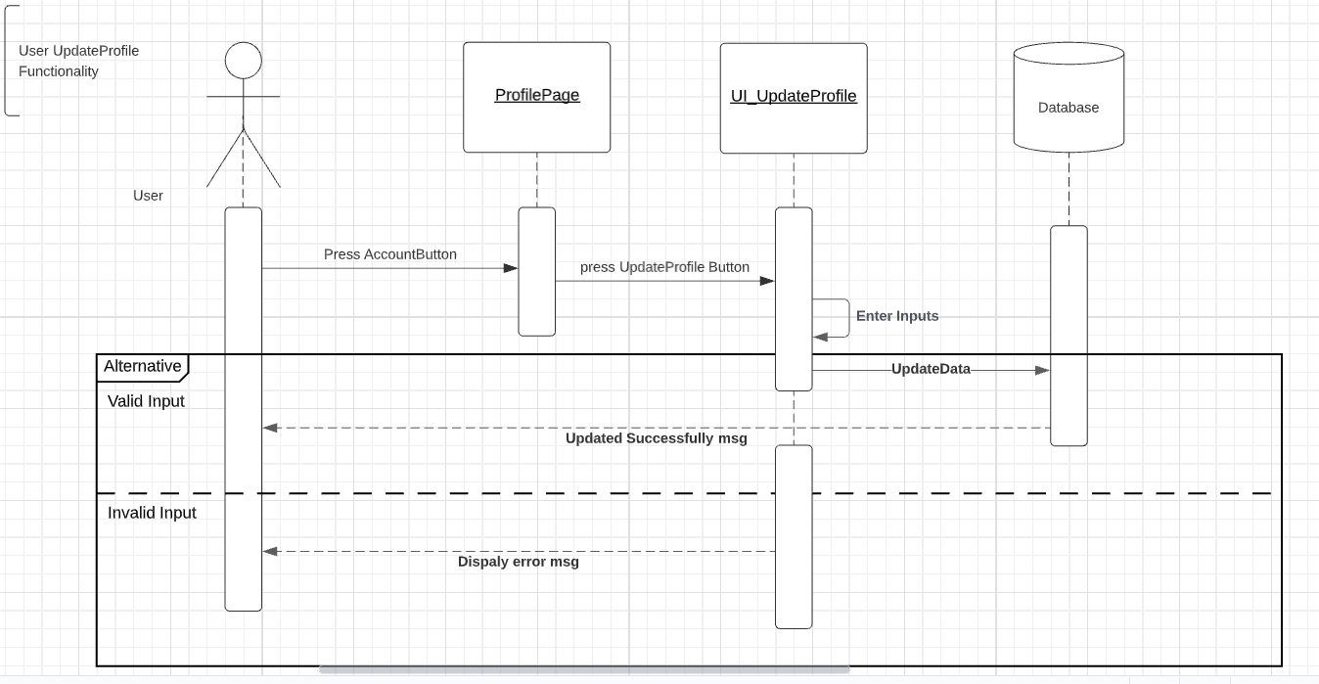**

## Search for a restaurant

| ID | Description | Priority |
| --- | --- | --- |
| F_REQ_U_sear_3.4.1 | In “foodies App”, first the user has to sign into his pre-registered account. | *HIGH* |
| F_REQ_U_sear_3.4.2 | After the user signs in successfully he will be navigated to the home page that has a fixed list of restaurants.  The user will be able to search in the fixed list of restaurants that he has.  He will write the name of the restaurant he wants in the search bar found at the top of the page and when he clicks on the “search” button, the results of the restraunts matching exactly the input he entered will be displayed.  In case the user enters a restaurant name that is not available in the system, a pop up message saying “Restaurant not found” will appear. | *Low* |

**Sequence Diagram:**

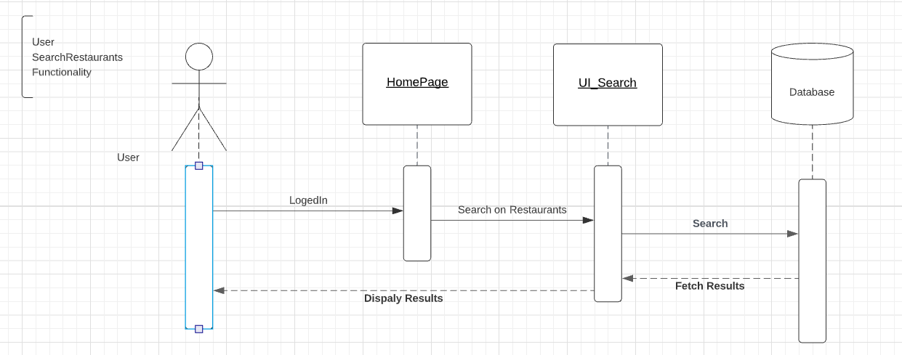

## Select a restaurant

| ID | Description | Priority |
| --- | --- | --- |
| F_REQ_U_sel_3.5.1 | In “foodies App”, first the user has to sign into his pre-registered account in order to be able to use this functionality. | *High* |
| F_REQ_U_sel_3.5.2 | After the user signs in successfully he will be navigated to the home page that has a fixed list of restaurants, the user will be able to select a restaurant and only one restaurant by clicking on the restaurant icon.  The restaurant shall show the list of meals it has after clicking on it successfully by the user. | *High* |

**Sequence Diagram:**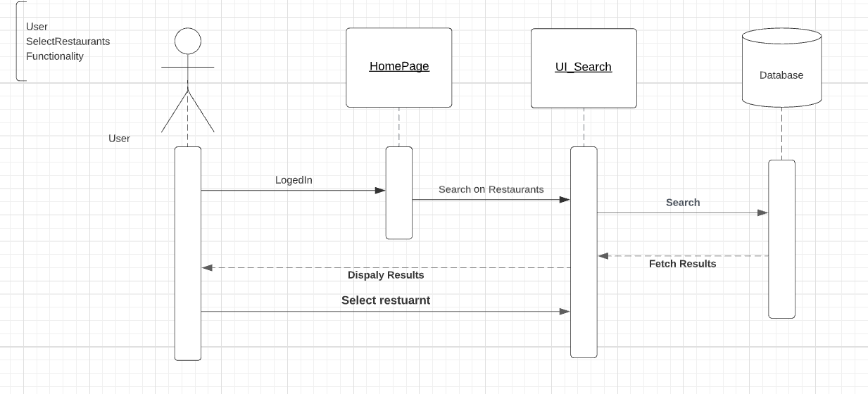

## Select meals

| ID | Description | Priority |
| --- | --- | --- |
| F_REQ_U_meal_3.6.1 | In “foodies App”,first the user has to sign into his pre-registered account. | *High* |
| F_REQ_U_meal_3.6.2 | The user has to select a specific restaurant. | *High* |
| F_REQ_U_meal_3.6.3 | The user can order from one and only one restaurant.  The user will be able to select from the menu one or more of each meal as desired.  By clicking on the “+” button beside each meal, the user can add the menu item by 1.  The user can add as many menu items as he can.  By clicking on the “-” button beside each meal, the user can decrement the menu item by 1.  The menu item can not be less than 0. | *High* |

**Sequence Diagram:**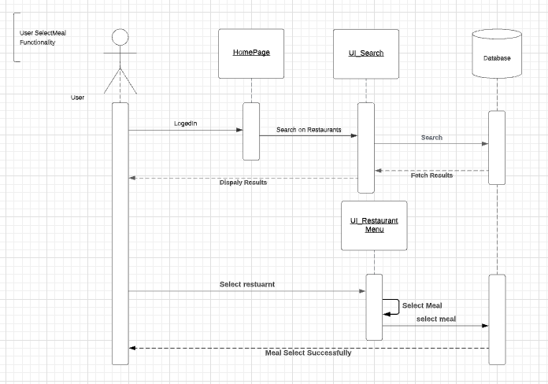

## Confirm order

| ID | Description | Priority |
| --- | --- | --- |
| F_REQ_U_conf_3.7.1 | In “foodies App”, first the user has to sign into his pre-registered account. | *High* |
| F_REQ_U_conf_3.7.2 | The user has to select a specific restaurant. | *High* |
| F_REQ_U_conf_3.7.3 | The user has to select the meals from the restaurant. | *High* |
| F_REQ_U_conf_3.7.4 | After the user has selected the desired meal items, he will click on the “Confirm Order” button at the end of the page.  If there are items selected:  The user will be navigated to another page that has a summary of the order. There will be two buttons: “Confirm” and “Cancel”.  If the user is sure of his order he will click on the “Confirm” button and a pop-up message appears saying “Order Confirmed and X points are added”.  The “X” represents the number of loyalty points he gained by ordering those meals.  If the user is not sure of his order he will click on the “Cancel” button and he will be navigated back to the menu page.  If there are NO items selected:  If the user clicks on the “Confirm Order” button while all the counters equal to zero a pop up message will appear saying “No meals have been selected” and stay in the menu page. | *High* |

**Sequence Diagram:**

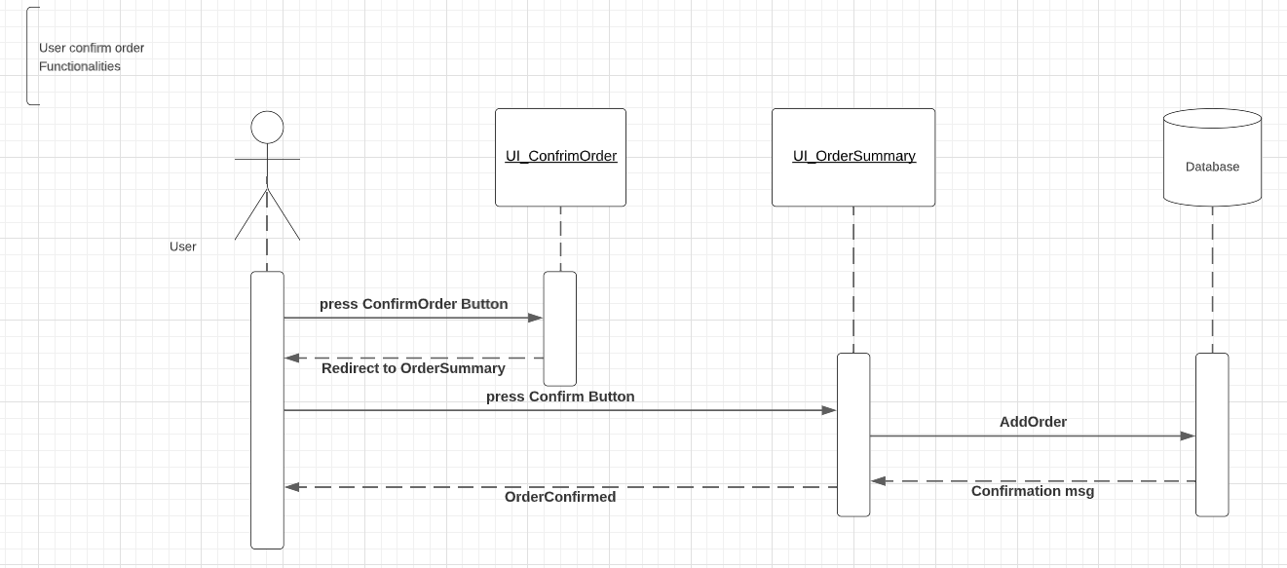

## Navigate to the “Offers and Promotions” page.

| ID | Description | Priority |
| --- | --- | --- |
| F_REQ_U_offer_3.8.1 | In “foodies App”, first the user has to sign into his pre-registered account. | *High* |
| F_REQ_U_offer_3.8.2 | The user can navigate to the “Offers and Promotions” page by clicking on “Offers” tab on the nav bar.  This page will contain two parts:  1-Offers from restaurants:  Restaurants can add discount offers with percentages (ex: 10% OFF, 5% OFF.. etc).  2-Loyalty points:  Gained by ordering.  Any item you order you get points by this equation:  Points = Price/4 | *Low* |

Sequence Diagram:

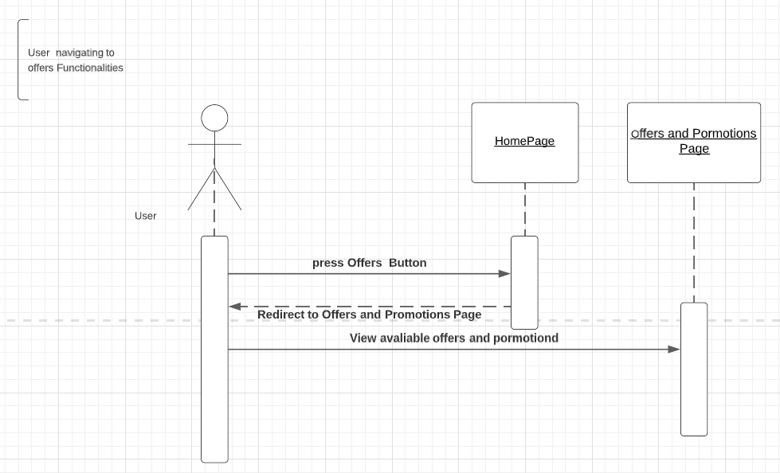

## Select an offer/Promotion to apply

| ID | Description | Priority |
| --- | --- | --- |
| F_REQ_U_SelOffer_3.9.1 | In “foodies App”, first the user has to sign into his pre-registered account. | *HIgh* |
| F_REQ_U_SelOffer_3.9.2 | The user will navigate to the “Offers and promotions” page. | *Low* |
| F_REQ_U_SelOffer_3.9.3 | The user will be able to choose if he wants to use offers or his loyalty points to decrease the total price of his order.  1-Offers from restaurants:  Beside any restaurant offer there will be a “Use” button.  If the user clicks on this button he will be redirected to the page of the menu of this specific restaurant and will find the discount on the total price in the order summary.  The user can use only one offer.  2-Loyalty points:  If the user wants to get a discount from his loyalty points he will click on “Use my loyalty points” button. After that he will be redirected to the homepage that contains all the restaurants,  And before confirming any order the user will see that a discount is applied on the order total by this equation:  Total price = items price - loyalty points  The user can either use an offer from a restaurant or use his loyalty points; he can not do both. | *Low* |

Sequence Diagram:

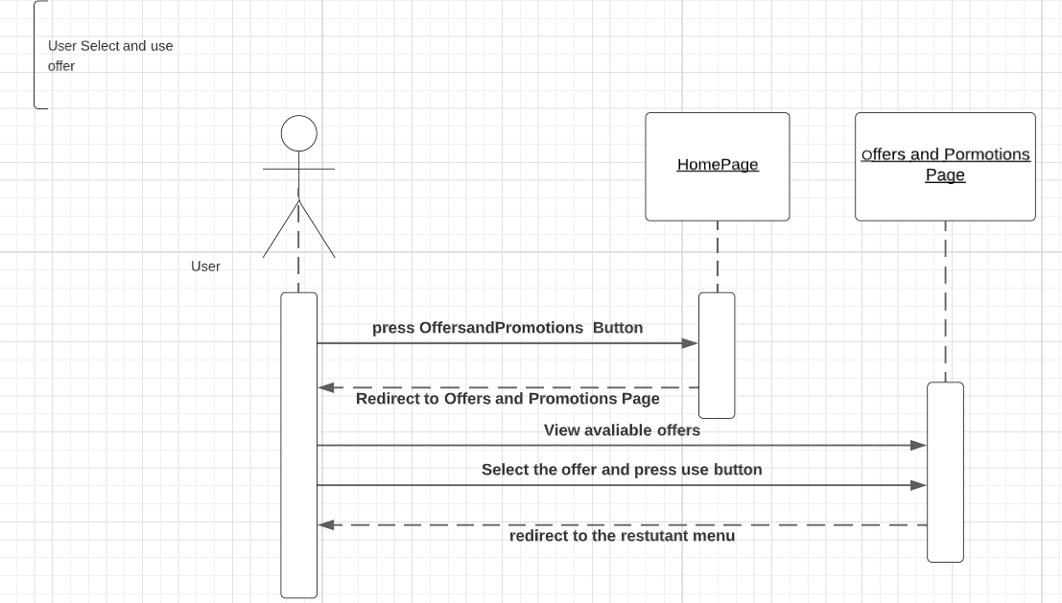

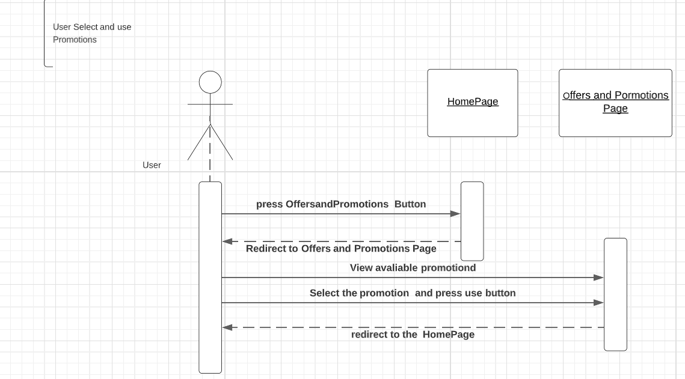

## Sign out

| ID | Description | Priority |
| --- | --- | --- |
| F_REQ_U_sear_3.10.1 | In “foodies App”, first the user has to sign into his pre-registered account. | *HIGH* |
| F_REQ_U_sear_3.10.2 | After the user signs in successfully he can sign out of his account by clicking on the “sign out” button in the nav bar found at the very right of it.  After that a pop up appears saying “Are you sure” with “Yes” and “No” buttons.  If the user clicks on “Yes” He will sign out and be navigated to the Sign in page again.  If the user clicks on “No” He will stay on the same page. | *HIGH* |

sequence diagram:

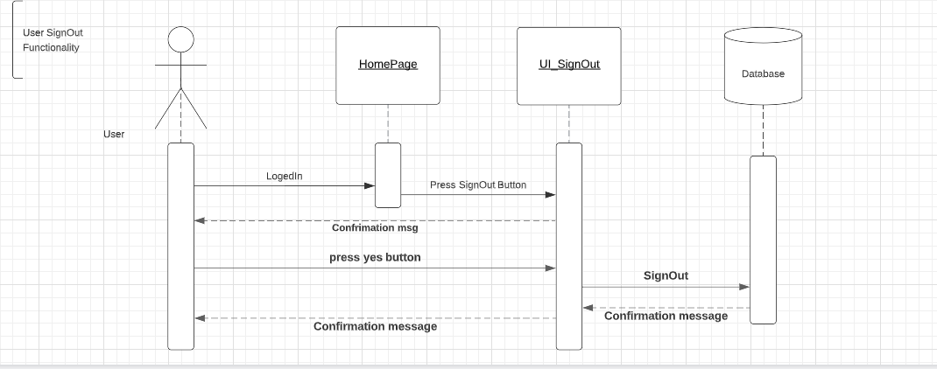

**B) ADMIN FUNCTIONALITIES**

***General Table of Amin features***

| ***General* Description** | In “foodies App”, we have two characters admin and normal users. |
| --- | --- |
| **Admin Functionality** | -Add user  -Delete users  -Update users  -Add Restaurant  -Delete Restaurant  -update Restaurant  -Add Menu  -Delete Menu  -Add offer  -Delete offer  -update offer  -Add admin |

## 3.10 Add User

| ID | Description | Priority |
| --- | --- | --- |
| F_REQ_A_AddUser_3.10.1 | **Add user**  an admin can add a normal user can access the app ,select restaurant and make order by filling the following fields:  -Full Name  -user name  -User mail  -Password  -Confirm Password  -Address  -Phone Number  After that he will have to click on “Register” Button. |  |
| F_REQ_A_AddUser_3.10.2 | system check the fields based on the following criteria:  1- the **full name** must contain characters only except for space  in case of invaild full name,an error message will appear that ”the full name must be characters only”  2- the **user name** must contain characters only  in case of invaild username,an error message will appear that ”the user name must be characters only and unique”  3-the **email** in the valid email format  in case of invaild email an error message will appear that ”the user’s email must be in this format [example@mail.com](mailto:example@mail.com)”  4- the **password** at least 5 characters and contain letters/numbers/special characters  in case of invaild password an error message will appear ”password must be at least 5 characters and contain letters/numbers/special characters”  5-the **confirmation password** must match password  if confirmation password didn’t match the password  an error message will appear “Confirmation password didn’t match the password”  6-**Address** contain characters and numbers only  in case of invaild address, an error message will appear that ”the address must be characters and numbers only”  7-**Phone Number** must contain numbers only  in case of invaild Phone Number, an error message will appear saying “the Phone Number must be numbers only”  If all the fields meet the constraints a pop up message should appear saying “Account created successfully, welcome to Foodies!”. And then get navigated to the home page that has all the restaurants in it. |  |

**Sequence Diagram:  
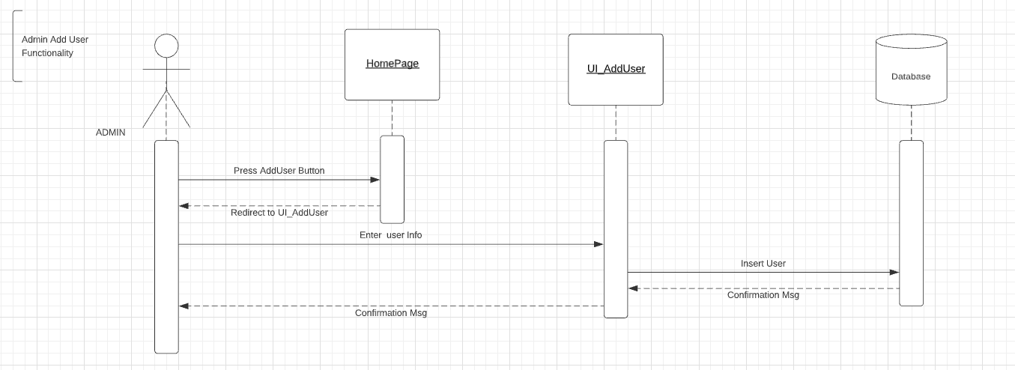**

## 3.11 Delete users

| ID | Description | Priority |
| --- | --- | --- |
| F_REQ_A_DeleteUser_3.11.1 | **Delete users**  in foodies app an admin can delete a normal user by filling the following field: UserName and then click the “Delete” button | HIGH |
| F_REQ_A_DeleteUser_3.11.2 | system check based on the following criteria: when click the “Delete” Button a pop up must appear saying “Deleted Successfully”    and if the Admin has entered userName and it doesn’t follow the field’s constraints(the **user name** must contain characters only ) a pop up message must appear to inform the Admin “invaild user name”  also if the Admin has entered a user that doesn’t exist a pop up message must appear saying“User doesn’t exist please make sure that you have entered the correct info” |  |

**Sequence Diagram:**

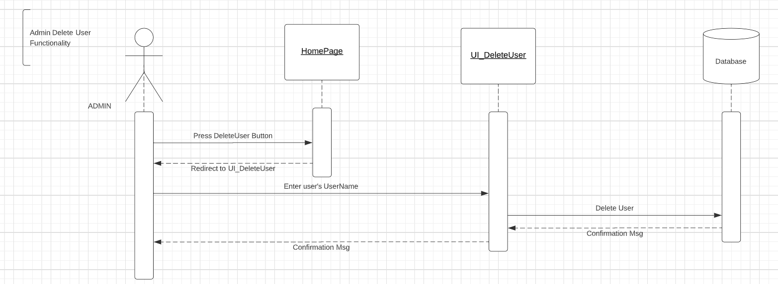

3.12 Update Users

| ID | Description | Priority |
| --- | --- | --- |
| F_REQ_A_UpdateUser_3.12.1 | **Update users**  an admin can update a normal user by filling the following field: UserName  then click “Find” | LOW |
| F_REQ_A_UpdateUser_3.12.2 | in case admin entered **valid** data all the following fields will appear with the info of the specified user:  FullName Password Confirm Password Address Phone Number  Email  and admin can edit in them however following each field constraints and then click the “Update” Button |  |
| F_REQ_A_UpdateUser_3.12.3 | The fields must match the following criteria:  1- the **full name** must contain characters only except for space  in case of invaild full name,an error message will appear that ”the full name must be characters only”  2- the **user name** must contain characters only  in case of invaild username,an error message will appear that ”the user name must be characters only and unique”  3-the **email** in the valid email format  in case of invaild email an error message will appear that ”the user’s email must be in this format [example@mail.com](mailto:example@mail.com)”  4- the **password** at least 5 characters and contain letters/numbers/special characters  in case of invaild password an error message will appear ”password must be at least 5 characters and contain letters/numbers/special characters”  5-the **confirmation password** must match password  if confirmation password didn’t match the password  an error message will appear “Confirmation password didn’t match the password”  6-**Address** contain characters and numbers only  and a pop up must appear saying “Updated Successfully” in case valid data  in case of invaild address, an error message will appear that ”the address must be characters and numbers only”  7-**Phone Number** must contain numbers only  in case of invaild Phone Number, an error message will appear saying “the Phone Number must be numbers only”  if the Admin has entered a user that doesn’t exist a pop up message must appear saying“User doesn’t exist please make sure that you have entered the correct info” |  |

**Sequence Diagram:**

## 

## 3.13 Add *Restaurant*

| ID | Description | Priority |
| --- | --- | --- |
| F_REQ_A_AddRest_3.13.1 | .**Add Restaurant**  the admin can add a Restaurant by filling the following field: Restaurant Name  Restaurant logo and then click the “Add” button | HIGH |
| F_REQ_A_AddRest_3.13.2 | The fields must match the following criteria:  1- the **Restaurant Name** must contain characters only except for space  in case of invaild Restaurant Name,an error message will appear that ”Restaurant Name must be characters only”  2- **Restaurant logo** field must contains only files with the following extension -JPG -JPEG -PNG  in case of invaild Restaurant logo,an error message will appear that ”Restaurant logo must be JPG ,JPEG or PNG extension ”  in case **valid** data pop up must appear saying “Add Successfully” |  |

**Sequence Diagram:**

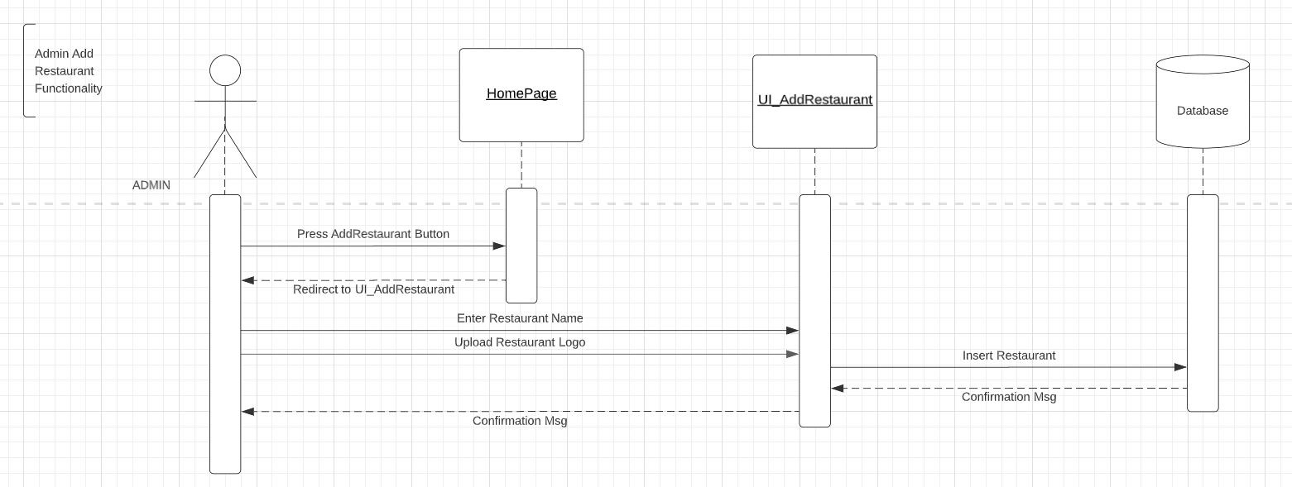

**3.14 Delete *Restaurant***

| ID | Description | Priority |
| --- | --- | --- |
| F_REQ_A_DeleteRest_3.14.1 | **Delete *Restaurant***  the admin can Delete a Restaurant by filling the following field: Restaurant Name  and then click the “Delete” Button | HIGH |
| F_REQ_A_DeleteRest_3.14.2 | The fields must match the following criteria:  1- the **Restaurant Name** must contain characters only except for space  in case of invaild Restaurant Name,an error message will appear that ”Restaurant Name must be characters only”  -in case **valid** data pop up must appear saying “Deleted Successfully”  -if admin entered a restaurant name that doesn’t exists an error message must appears “restaurant doesn’t exists” |  |

**Sequence Diagram:**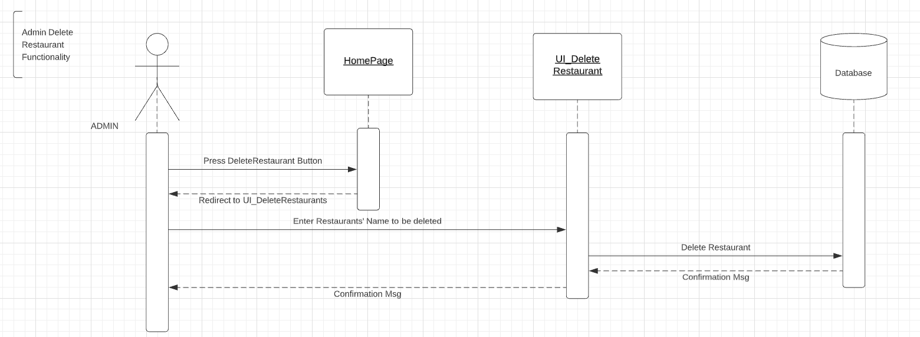

**3.15 Update Restaurant**

| ID | Description | Priority |
| --- | --- | --- |
| F_REQ_A_UpdateRest_3.15.1 | **Update Restaurant**  the admin can update aRestaurant by filling the following field: Restaurant Name  and then click the “Find”Button | HIGH |
| F_REQ_A_UpdateRest_3.15.2 | The field must match the following criteria:  1- the **Restaurant Name** must contain characters only except for space  in case of invaild Restaurant Name,an error message will appear that ”Restaurant Name must be characters only”  if the Admin has entered a Restaurant that doesn’t exist a pop up message must appear saying “Restaurant doesn’t exist please make sure that you have entered the correct info” |  |
| F_REQ_A_UpdateRest_3.15.3 | in case **valid** data all the following fields will appear with the info of the specified  Restaurant Name  Restaurant Logo  and admin can **edit** in them however following each field constraints and then click the “Update” |  |
| F_REQ_A_UpdateRest_3.15.4 | The fields must match the following criteria:  1- the **Restaurant Name** must contain characters only except for space  in case of invaild Restaurant Name,an error message will appear that ”Restaurant Name must be characters only”  2- **Restaurant logo** field must contains only files with the following extension -JPG -JPEG -PNG  in case of invaild Restaurant logo,an error message will appear that ”Restaurant logo must be JPG ,JPEG or PNG extension ” in case **valid** data pop up must appear saying “Updated Successfully” |  |

**Sequence Diagram:  
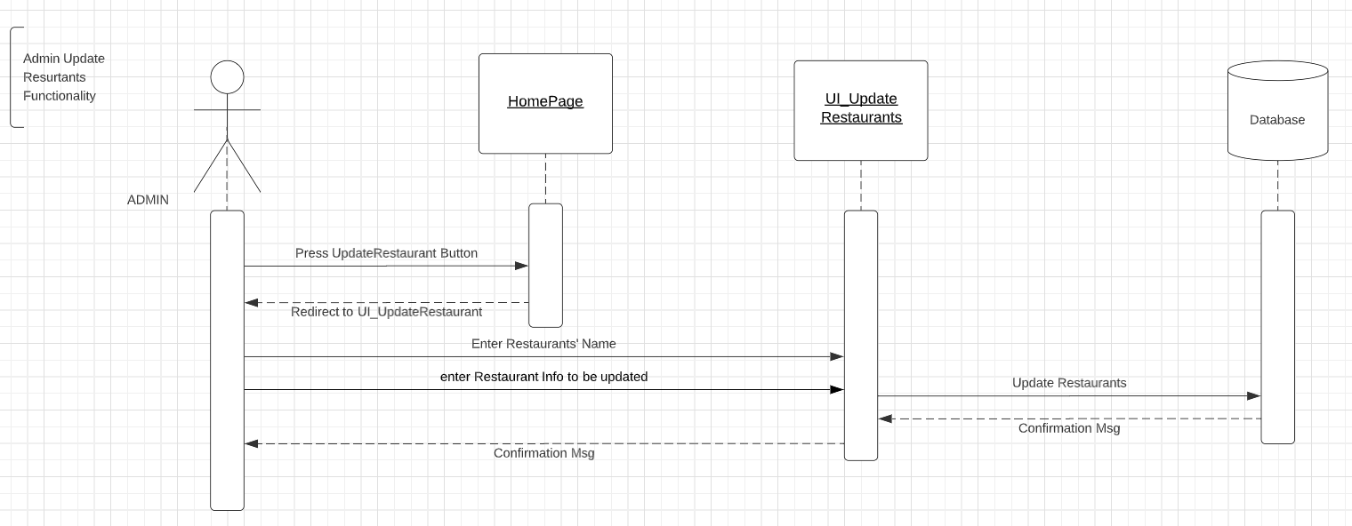**

## 3.16 Add *menu*

| ID | Description | Priority |
| --- | --- | --- |
| F_REQ_A_AddMenu_3.16.1 | **Add *menu***  an admin can add a **Restaurant menu** by selecting a specific restaurant and click on “Add Menu” button | HIGH |
| F_REQ_A_AddMenu_3.16.2 | Admin can add menu by **upload** the menu image of the restaurant then click the “Add” button |  |
| F_REQ_A_AddMenu_3.16.3 | - **menu image** field must contains only files with the following extension -JPG -JPEG -PNG  in case of invaild menu image ,an error message will appear that ”menu image must be JPG ,JPEG or PNG extension ”  in case valid data a pop up must appear saying “Add Successfully” |  |

**Sequence Diagram:**

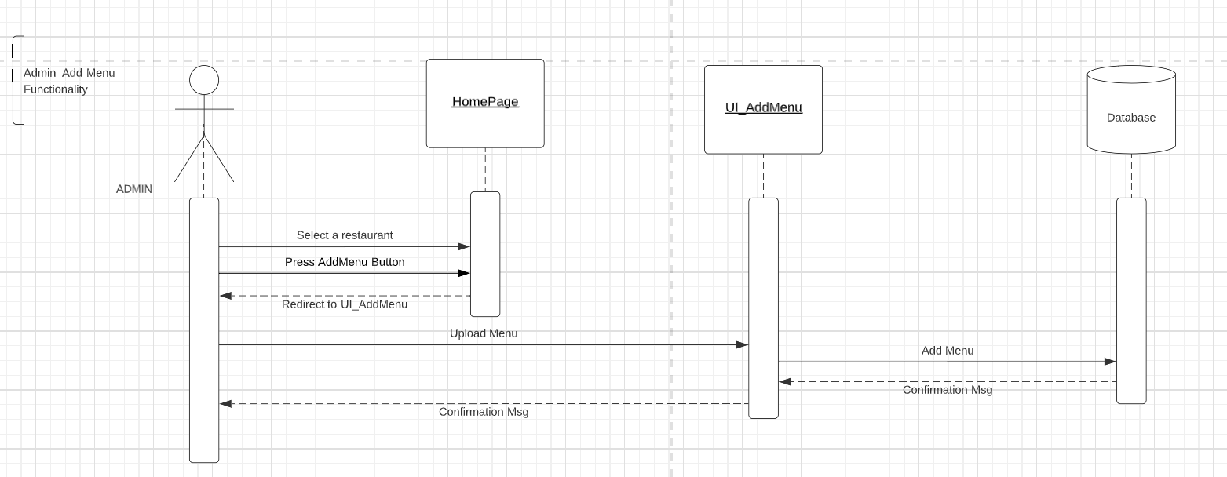

## 3.17 Delete *menu*

| ID | Description | Priority |
| --- | --- | --- |
| F_REQ_A_DeleteMenu_3.17.1 | **Delete *menu***  an admin can delete a Restaurant menu by selecting a specific restaurant and click on “Delete Menu” button | HIGH |
| F_REQ_A_DeleteMenu_3.17.2 | a small window appears saying“Are you sure you want to delete this menu” which contains also two buttons “Yes” and “No” then Admin clicks on “Yes” button then a pop up must appear saying “Deleted Successfully” |  |

**Sequence Diagram:**

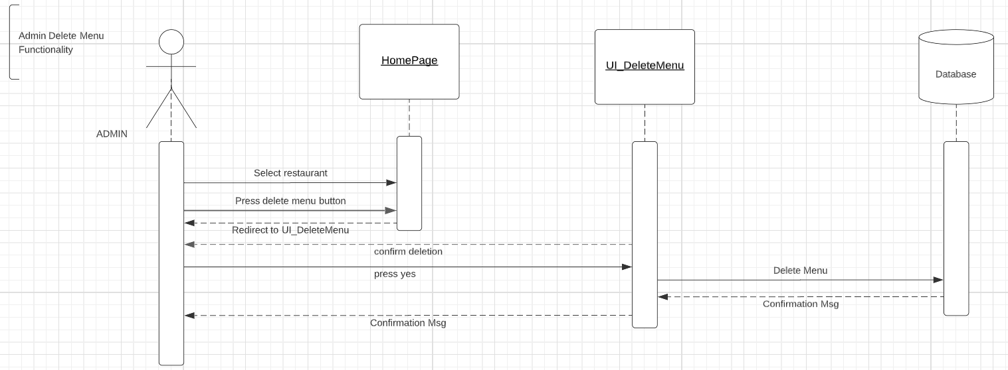

## 3.18 Add Offers

| ID | Description | Priority |
| --- | --- | --- |
| F_REQ_A_AddOffer_3.18.1 | **Add Offers**  an admin can add a promotion to a Restaurant by selecting a specific restaurant and click on “Add promotion” button | Medium |
| F_REQ_A_AddOffer_3.18.2 | Admin can Start entering the promotion info to the following fields : -offer Code  -promotion discount percentage  -Expiration Date  then click “Add” |  |
| F_REQ_A_AddOffer_3.18.3 | The fields must match the following criteria:  1- the **Offer Code** must contain characters  in case of invaild Promotion Code,an error message will appear that ”Offer Code must be 5 characters only and be be unique”  2-the  **Offerdiscount percentage** contains numbers only  in case of invaild Promotion Discount percentage,an error message will appear that ” Offer Discount percentage must be numbers only”  3-the **Expiration Date** contains only Dates  in case of invaild Expiration Datean error message will appear that ” Expiration Date must be Dateonly in the format of DD/MM/YY”  in case **valid** data pop up must appear saying “Add Successfully” |  |

## Sequence Diagram:

## 

## 3.19 Delete Offers

| ID | Description | Priority |
| --- | --- | --- |
| F_REQ_A_DeleteOffer_3.19.1 | **Delete Offers**  an admin can Delete an offer of a Restaurant by selecting a specific restaurant and click on “Delete Offer” button | HIGH |
| F_REQ_A_DeleteOffer_3.19.2 | a small window appears saying“Are you sure you want to delete this Offer” which contains also two buttons “Yes” and “No” then Admin clicks on “Yes” button then a pop up must appear saying “Deleted Successfully” |  |

## Sequence Diagram:

## 3.20 Update Offers

| ID | Description | Priority |
| --- | --- | --- |
| F_REQ_A_UpdateOffer_3.20.1 | **Update Offers**  an admin can **Update** an Offer to a Restaurant by selecting a specific restaurant and click on “Update promotion” button | Medium |
| F_REQ_A_UpdateOffer_3.20.2 | Admin can update in the following fields:  -promotion Code  -promotion discount percentage  -Expiration Date  then click “update button” |  |
| F_REQ_A_UpdateOffer_3.20.3 | The fields must match the following criteria:  1- the **Offer Code** must contain characters  in case of invaild Promotion Code,an error message will appear that ”Offer Code must be 5 characters only and be be unique”  2-the  **Offers Discount percentage** contains numbers only  in case of invaild Offer Discount percentage,an error message will appear that ” Promotion Discount percentage must be numbers only”  3-the **Expiration Date** contains only Dates  in case of invaild Expiration Datean error message will appear that ” Expiration Date must be Dateonly in the format of DD/MM/YY”  in case valid data a pop up must appear saying “Updated Successfully” |  |

## sequence Diagram:

## 

## 3.21 Add Admin

| ID | Description | Priority |
| --- | --- | --- |
| F_REQ_A_AddAdmin_3.21.1 | **Add Admin**  an admin can add another admin by clicking on “Add Admin” button  The Admin will be required to fill the following fields in order to add an account:  -Full Name  -user name  -User mail  -Password  -Confirm Password  -Address  -Phone Number  After that he will have to click on “Add” Button. | high |
| F_REQ_A_AddAdmin_3.21.2 | The fields must match the following criteria:  1- the **full name** must contain characters only except for space  in case of invaild full name,an error message will appear that ”the full name must be characters only”  2- the **user name** must contain characters only  in case of invaild username,an error message will appear that ”the user name must be characters only and unique”  3-the **email** in the valid email format  in case of invaild email an error message will appear that ”the user’s email must be in this format [example@mail.com](mailto:example@mail.com)”  4- the **password** at least 5 characters and contain letters/numbers/special characters  in case of invaild password an error message will appear ”password must be at least 5 characters and contain letters/numbers/special characters”  5-the **confirmation password** must match password  if confirmation password didn’t match the password  an error message will appear “Confirmation password didn’t match the password”  6-**Address** contain characters and numbers only an error message must appear to tell the admin.  in case of invaild address, an error message will appear that ”the address must be characters and numbers only”  7-**Phone Number** must contain numbers only  in case of invaild Phone Number, an error message will appear saying “the Phone Number must be numbers only” |  |

**Sequence Diagram:**

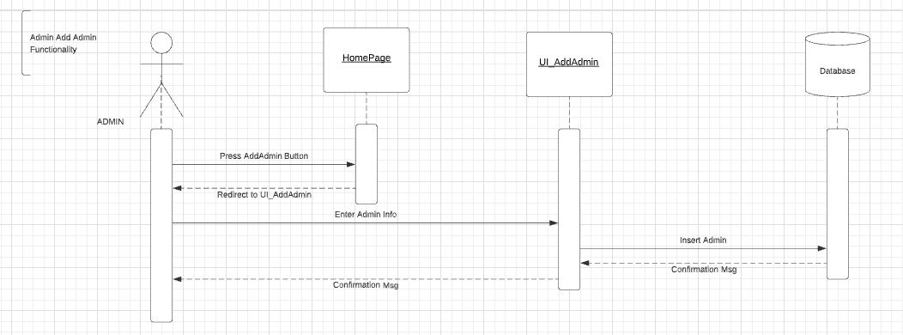

### 4. External Interface Requirements

## User Interface

*Supported Web Browsers: Chrome, Firefox and Microsoft Edge.*

## Hardware Interfaces

*N/A*

## Software Interfaces

*Database Management System: File Based.*

# Nonfunctional Requirements

## Performance Requirements

*The website’s load time should not be more than 2 seconds to respond*

## Safety Requirements

*N/A*

## Security Requirements

*-Authentication of the user and privacy of his order history is achieved by the “login Page”.*

*Resolving forgotten passwords are not handled in the project’s scope.*

*-Authorization of admin to Update/Delete/Add users, admins, restaurants,menus and promotions.*

*No one aside from the admin is allowed to have those privileges.*

## Software Quality Attributes

**Usability:** *Ease of use and user-friendly Interface the user can find it easy to deal with, having the same experience as other ordering websites.*

**Availability**: *users can search on nearby restaurant on website throughout the week at any time during the day. In the case of unplanned system downtime, all features will be available again after one working day.*

**Reliability**: *customers can access their accounts 98% of the time without failure.*

# Other Requirements

*N/A*