**1.What are the two values of the Boolean data type? How do you write them?**

*True and False*

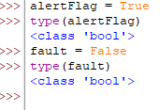

**2. What are the three different types of Boolean operators?**

*AND | OR | NOT*

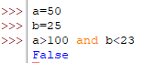

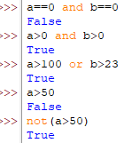

**3. Make a list of each Boolean operator's truth tables (i.e. every possible combination of Boolean values for the operator and what it evaluate ).**

| **A** | **B** | **A AND B** |
| --- | --- | --- |
| **True** | **True** | **True** |
| **True** | **False** | **False** |
| **False** | **True** | **False** |
| **False** | **False** | **False** |

| **A** | **B** | **A OR B** |
| --- | --- | --- |
| **True** | **True** | **True** |
| **True** | **False** | **True** |
| **False** | **True** | **True** |
| **False** | **Fasle** | **False** |

| **A** | **NOT A** |
| --- | --- |
| **True** | **False** |
| **False** | **True** |

**4. What are the values of the following expressions?**

(5 > 4) and (3 == 5) *-> False*

not (5 > 4) -> *True*

(5 > 4) or (3 == 5) -> *True*

not ((5 > 4) or (3 == 5)) -> *False*

(True and True) and (True == False) -> *False*

(not False) or (not True) -> *True*

**5. What are the six comparison operators?**

*Equal: x==y*

*Not equal: x!=y*

*Greater than: x>y*

*Greater than or Equal to : x>=y*

*Less than: x<y*

*Less than or equal to: x<=y*

**6. How do you tell the difference between the equal to and assignment operators?Describe a condition and when you would use one.**

*The “****=****” is an assignment operator used to assign the value on the right side operand to the operand on the left. For example*

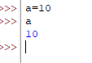

*The ‘==’ i.e. equality operator is used to check if the operands on either side are equal or not. If equal, it returns True otherwise False. For example,*

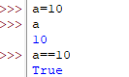

**7. Identify the three blocks in this code:**

**spam = 0**

**if spam == 10:**

**print('eggs')**

**if spam > 5:**

**print('bacon')**

**else:**

**print('ham')**

**print('spam')**

**print('spam')**

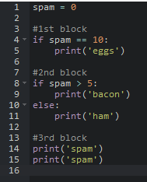

**8. Write code that prints Hello if 1 is stored in spam, prints Howdy if 2 is stored in spam, and prints Greetings! if anything else is stored in spam.**

*spam = 1*

*if(spam==1):*

*print("Hello")*

*elif(spam==2):*

*print("Howdy")*

*else:*

*print("Greetings!")*

*spam = 0*

*if(spam==1):*

*print("Hello")*

*elif(spam==2):*

*print("Howdy")*

*else:*

*print("Greetings!"*

**9.If your programme is stuck in an endless loop, what keys you’ll press?**

*Ctrl+C*

**10. How can you tell the difference between break and continue?**

*Break statement terminates a loop immediately and transfers the execution to the new statement after the loop. For example:*

*count = 0*

*while count <= 100:*

*print (count)*

*count += 1*

*if count == 10:*

*break*

*Continue statement causes a loop to skip its current execution at some point and move on to the next execution instead of terminating the loop like a break statement. For example:*

*for i in range(10,19):*

*if i == 17:*

*continue*

*print(i)*

**11. In a for loop, what is the difference between range(10), range(0, 10), and range(0, 10, 1)?**

*range(10): Loop will take 10 numbers starting from 0 till 9 and stop after 10 executions*

*range(0,10): Loop will take a series 10 numbers that will start from 0 till 9 and stop after 10 executions*

*range(0,10,1): Loop will take a series 10 numbers that will start from 0 till 9 and the differences between all of the numbers would be 1*

**12. Write a short program that prints the numbers 1 to 10 using a for loop. Then write an equivalent program that prints the numbers 1 to 10 using a while loop.**

for i in range(1,11):

print(i)

num=1

while(num<=10):

print(num)

num+=1

**13. If you had a function named bacon() inside a module named spam, how would you call it after importing spam?**

*import spam*

*spam.bacon()*