Calibrate, Adapt, or Block: A Statistically Certified Deployment Gate for Imported Sepsis Early-Warning Models
Amlan Sarkar*, Md Tobibul Islam
Department of Biomedical Engineering, Military Institute of Science and Technology, Bangladesh
amlansarkar738@gmail.com, tobibul.islam@bme.mist.ac.bd
Abstract Hospitals increasingly deploy sepsis prediction models developed elsewhere, yet performance can change at a new hospital, and point estimates from small local samples can make inadequate models appear acceptable. We present CAB (Calibrate, Adapt, or Block), a deployment gate for imported models. Before examining local labels, the hospital fixes a minimum patient-level sensitivity and a maximum false-alert rate. CAB considers keeping the model, adjusting its alert threshold and adapting it to local data, in that order, deploys the first configuration certified by exact binomial tests, and otherwise blocks it. If the requirements are fixed before labelling, the labelled patients are a random sample of the receiving hospital's patients and their labels are correct, the probability of deploying a configuration violating either requirement is at most a chosen level α, without requiring the developing and receiving hospitals to have the same patient distribution. In a retrospective evaluation on 40,336 ICU patients from two US hospitals (PhysioNet/CinC Challenge 2019), CAB was compared with eleven alternatives across labelled sample sizes of 250 to 12,000 patients. Imported models failed in direction-dependent ways: sensitivity fell to 63% against an 80% target at one hospital, while the proportion of non-septic patients alerted doubled at the other. Six conventional approaches deployed configurations violating the requirements in 77–92% of runs, and point-estimate validation did so in about a third, compared with 0.7% for CAB. CAB's observed rates were consistent with its bound at all three error levels tested. At the primary requirements, CAB blocked the unrepairable model in every run and certified an adapted model in 97% of runs with 12,000 labels. The guarantee concerns the deployment decision, not clinical benefit. Hospitals should plan for possible blocking, define their tolerated false-alert rate, and arrange label collection before deployment.
Keywords: Sepsis early warning, Dataset shift, Model updating, Local validation, Statistical certification, Clinical decision support

1 Introduction
Sepsis is a life-threatening organ dysfunction caused by a dysregulated host response to infection [1]. It remains a major cause of death worldwide: the Global Burden of Disease study estimated 48.9 million cases and 11.0 million sepsis-related deaths in 2017, almost a fifth of all deaths that year [2]. Treatment is time-critical. In a statewide study of mandated emergency sepsis care in New York, each additional hour taken to complete the initial treatment bundle was associated with higher in-hospital mortality [3]. Identifying patients at risk early, before organ dysfunction is established, is therefore an important opportunity for clinical decision support.
Early-warning models address this need by estimating each patient's risk at regular intervals, typically every hour, from routinely charted electronic health record (EHR) data such as vital signs and laboratory results, and by raising an alert when the risk score exceeds a threshold. Many hospitals do not develop such models themselves. They obtain them from EHR vendors or specialised providers, or adopt models published by other institutions. The model is then deployed with an alert threshold that was chosen on the developer's patients, although the receiving hospital may differ in its patients, its clinical practice and its tolerance for alerts.
Predictive performance is not necessarily preserved when a model moves between institutions. Differences in patient populations, measurement practices, documentation and outcome definitions produce dataset shift, which can degrade performance at the receiving site [4, 5]. Sepsis models are particularly exposed. Many of their inputs, such as serum lactate, are available only when a clinician orders the test, so their presence reflects local practice as well as the patient's condition, and the outcome itself is defined from locally recorded data. An independent external validation of a widely implemented proprietary sepsis model illustrates the consequences: it reported an area under the receiver operating characteristic curve (AUROC) of 0.63, against the developer's reported 0.76–0.83, and the model failed to identify two thirds of the patients with sepsis [6].
Performance can also degrade in different ways. A transferred model may lose sensitivity and fail to alert on patients who develop sepsis, or it may generate many more false alerts among patients who do not, adding to clinical workload and alarm fatigue. These failure modes have different clinical consequences, and Section 4 shows that the same two hospitals can produce either one, depending on which hospital supplies the model and which receives it. A summary measure such as accuracy or AUROC therefore cannot establish whether a model meets the receiving hospital's requirements. The deployment decision has to be made against those requirements directly.
A receiving hospital that can label a sample of its own patients has four options, in order of increasing intervention:
- keep the imported model and its threshold unchanged;
- calibrate it, which in this chapter means only moving the alert threshold, without retraining the model or rescaling its predicted risks;
- adapt it, by continuing its training on local patients;
- block it, so that the model is not deployed and usual care continues.
These options correspond to established strategies for updating clinical prediction models [7, 8]. Closed testing procedures select among updating strategies with significance tests of model fit [9], and sample-size guidance determines how many patients are needed to estimate performance with a given precision [10]. These methods provide guarantees for their own objectives, but estimating performance precisely and establishing that a model meets predefined safety requirements are distinct goals. None of them bounds the probability that the configuration finally deployed violates the hospital's sensitivity or false-alert requirement. A point estimate from a few hundred local patients can look acceptable when the true performance is not, and a test of fit can favour a model that still misses too many septic patients. A deployment procedure must decide not only which option to use, but also whether the available evidence justifies deploying any of them.
This chapter introduces CAB (Calibrate, Adapt, or Block), a deployment gate that makes this decision with a finite-sample statistical guarantee. Before any local outcome label is examined, the hospital specifies two requirements: a minimum patient-level sensitivity, and a maximum false-alert rate among patients who do not develop sepsis. CAB considers the options in order of increasing intervention and deploys the first configuration whose compliance with both requirements is certified by exact binomial tests on labelled local patients. An adapted model is fitted on one half of the labelled patients and certified on the other, so that no patient is used both to train and to certify it. If no configuration is certified, the model is blocked. The tests are arranged so that the probability of deploying a configuration that violates either requirement is at most a level α chosen in advance (α = 0.05 in the main analysis). This bound holds for any shift between the developing and the receiving hospital and for any number of labels, provided that the labelled patients are a random sample of the receiving hospital's patients and that their labels are correct. CAB builds on the fixed-sequence testing principle of Learn‑then‑Test risk control [11, 12], and applies it to the ordered options available to a hospital and to patient-level alerting requirements.
Two clarifications define the scope of this guarantee. First, a block is not a finding that the model is unsafe: it means that the labelled patients do not provide enough evidence to certify any configuration, which happens both when the model is unsafe and when it is safe but the labels are too few to show it. Second, certification concerns the two stated requirements at the time of deployment. It does not demonstrate clinical benefit, and it does not cover changes in the patient population after deployment.
CAB is evaluated on the PhysioNet/Computing in Cardiology Challenge 2019 data [13], which comprise 40,336 intensive care patients from two US hospitals. The six transfer scenarios comprise two whole-hospital transfers, in which the model developed at each hospital is imported into the other, and four transfers into a single ICU type, in which each model is imported into the other hospital's medical or surgical ICU. A model imported into its own hospital serves as a control in which nothing has shifted. CAB is compared with eleven alternatives over local samples of 250 to 12,000 labelled patients, nine pairs of safety requirements and 100 repetitions per setting. The labelled patients are used only by the procedures being compared; each resulting deployment is then judged on the receiving hospital's remaining patients, which were not labelled.
The chapter makes five contributions:
1. A certified deployment gate. CAB chooses among keeping, calibrating, adapting and blocking an imported model, with a finite-sample bound on the probability of deploying a configuration that violates either requirement, and without a model of the shift (Sections 3.4 and 3.5).
2. A comparison with eleven alternatives drawn from current practice and the literature, including classical closed-testing updating, point-estimate local validation, prevalence correction and Learn‑then‑Test without CAB's order (Section 4).
3. A closed-form label calculator that estimates, before any labelling, how many septic and non-septic patients certification will require (Section 4.5).
4. Practical findings for hospitals and vendors. Blocking was frequent, both when no configuration met the requirements and when the labelled patients were too few to certify one that did; samples of a few hundred labelled patients rarely allowed any configuration to be certified, even where a safe one existed; and the number of labels needed to approve an unchanged model was determined by the hospital's false-alert tolerance rather than by the vendor's threshold headroom (Sections 4.2, 4.5 and 4.7).
5. A prototype application that runs the gate on a hospital's labelled patients and then monitors patients hourly with the configuration it deployed, sharing its code with the experiments (Section 5).
The rest of the chapter is organised as follows. Section 2 reviews sepsis early warning, model updating, distribution-free risk control and the regulatory context. Section 3 describes the data, the safety requirements, the CAB procedure and its guarantee, the comparators and the experimental design. Section 4 reports the results, Section 5 presents the prototype application, Section 6 discusses the implications and limitations, and Section 7 concludes.

2 Background and Related Work
This section reviews four bodies of work that bear on the deployment decision: sepsis early-warning systems and evidence on how they transfer between hospitals, methods for updating an imported prediction model, distribution-free risk control, and corrections for dataset shift that do not need local labels. It then outlines the regulatory context and positions CAB relative to these approaches.

2.1 Sepsis Early Warning and Its Transfer between Hospitals
Rule-based bedside scores are widely used to identify deteriorating patients. Examples include the Systemic Inflammatory Response Syndrome (SIRS) criteria, the quick Sequential Organ Failure Assessment (qSOFA), the Modified Early Warning Score (MEWS) and the National Early Warning Score 2 (NEWS2) [14]. These scores are transparent and require no training data, but their accuracy for detecting deterioration in infected patients is modest. In a large cohort of ward and emergency patients with suspected infection, no score combined high sensitivity with high specificity, and the general early warning scores outperformed qSOFA [15].
Machine-learning models trained on EHR data usually discriminate better at the hospital where they are developed. The PhysioNet/Computing in Cardiology Challenge 2019 released hourly data from two US hospital systems so that algorithms could be compared on a common footing, and evaluated them on a third, undisclosed hospital system [13]. Performance on the undisclosed hospital was lower, particularly for algorithms that had learned data-collection patterns specific to the hospitals they were trained on. Prospective evidence is similarly mixed. In a multi-site implementation study of the TREWS early warning system, prompt confirmation of alerts by a clinician was associated with lower mortality, although an observational association of this kind does not by itself establish that the alerts caused the difference [16]. An external validation of a widely implemented proprietary model, by contrast, found poor discrimination and low sensitivity at a new site [6]. A recent prospective evaluation of an updated version of that model at four US health systems reported good discrimination overall but substantial variation between institutions, a low positive predictive value and a heavy alert burden, and its authors recommended that every adopting hospital validate the model locally [17]. Evaluation design also affects these conclusions: models appear considerably more accurate when alerts raised after clinicians have already begun sepsis treatment are counted as correct predictions [18]. In intensive care data from three countries, a deep-learning model lost discrimination when transferred to another database and recovered part of it after fine-tuning on a small share of the new site's patients [19].
Collectively, these studies establish that sepsis early-warning models must be evaluated at the receiving institution, and show that transfer can affect discrimination, sensitivity and alert burden. Evidence that performance has deteriorated does not, however, determine which deployment option a hospital should adopt, or whether its local data are sufficient to justify deploying any of them. This distinction motivates a deployment procedure that evaluates candidate configurations against prespecified requirements and permits non-deployment when compliance with those requirements cannot be certified.

2.2 Updating an Imported Prediction Model
Clinical prediction research distinguishes a hierarchy of updating methods for a model applied in a new population [7, 8]:
- recalibration in the large, which re-estimates the intercept;
- logistic recalibration, which re-estimates the intercept and the slope of the linear predictor;
- model revision, which re-estimates some or all of the coefficients;
- redevelopment of the model on local data.
In this literature, recalibration adjusts the relationship between predicted and observed risks, which is distinct from changing the decision threshold at which alerts are raised. In CAB, calibration denotes the latter operation only: selecting a new alert threshold while leaving the model and its predicted scores unchanged. This restricted definition reflects the deployment options evaluated in this chapter, in which the imported model is a tree ensemble and its requirements are stated for alerts at a threshold.
Vergouwe and colleagues proposed a closed testing procedure that moves up the updating hierarchy only when a likelihood-ratio test shows that the next level fits the local data significantly better [9]. Sample-size guidance for external validation determines how many patients, and how many outcome events, are needed to estimate calibration and discrimination with a target precision [10]. These methods were designed for different questions from the one considered here. Closed testing selects an updating strategy on evidence of improved fit, and sample-size calculations address the precision with which performance can be estimated. Neither objective is equivalent to controlling the probability that the selected configuration violates prespecified deployment requirements, such as a minimum sensitivity at the alert threshold in use. CAB addresses this distinct decision by requiring statistical certification before deployment and permitting the model to be blocked when certification is unsuccessful. By contrast, the updating hierarchy selects an updating strategy on the basis of model fit; it does not itself provide a certification-based decision to deploy or block a configuration.

2.3 Distribution-Free Risk Control
Distribution-free predictive inference offers guarantees that do not depend on how well a model fits. Risk-controlling prediction sets [12] and Learn‑then‑Test [11] calibrate parameters of an arbitrary pretrained model, such as a decision threshold, so that chosen risks are controlled with high probability. They require only that the calibration data be exchangeable with the data on which the model will be used. Conformal risk control instead bounds the expected value of a monotone loss [20]. CAB requires a high-probability guarantee: that the population risks of the configuration it deploys satisfy the prespecified limits, except with probability at most α.
Learn‑then‑Test formulates certification as a multiple-testing problem. Each candidate parameter value is associated with a null hypothesis that its risk exceeds a prespecified limit, and rejecting that hypothesis certifies the value. The framework accommodates several risks at once and controls the family-wise error rate over the candidates. When a single risk is monotone in a scalar parameter, fixed-sequence testing can examine the values in order of that risk and certify them without a multiplicity penalty; this property depends on the monotonicity and on the validity of each individual test.
CAB builds on this framework in three respects, which Section 3 develops formally:
1. Two patient-level requirements with a shared error budget. Sensitivity is defined over patients who develop sepsis and the false-alert rate over patients who do not, so the two requirements are tested on disjoint groups of patients. Fixed-sequence testing selects the alert threshold from the septic patients, where sensitivity falls monotonically as the threshold rises; the false-alert test is then applied at that threshold using the non-septic patients.
2. An ordered set of deployment options. CAB evaluates options that differ in kind, not only parameter values of one model: keeping the imported model with its threshold, moving the threshold, and refitting the model. The order reflects the hospital's preference for the least intervention. It is not a statistical device. Validity across the options is established by allocating the overall error level α across four unsafe-deployment events: insufficient sensitivity or excess false alerts, for the imported model and for the adapted model. Each event receives an allocation of α/4, every individual test is carried out at level α/4, and a union bound over the four events gives an overall bound of α. The imported model's two false-alert tests, at the certified threshold and at the vendor's threshold, share one allocation: given the septic patients, at most one of the two can lead to an unsafe deployment. Section 3.5 proves this.
3. An adapted model fitted and certified on separate patients. Because adaptation changes the model itself, the labelled patients are divided before fitting, and the adapted model is certified only on patients it was not fitted on. Blocking is an explicit outcome when no option is certified.

2.4 Correcting for Shift without Labels
Label shift occurs when the distribution of outcomes changes between hospitals while the distribution of features within each outcome class remains stable. Under this assumption, the imported model's predicted probabilities can be corrected using unlabelled data from the receiving hospital [21, 22]. Under covariate shift, the distribution of features changes while the distribution of the outcome given the features remains stable; training data can then be reweighted by the ratio of the target to the source feature densities [23]. These corrections are well founded when their respective assumptions hold. However, differences in outcome prevalence or in feature distributions do not by themselves reveal which type of shift is present, and unlabelled data alone cannot establish whether the required assumptions hold at the receiving hospital. The corrections therefore do not, on their own, show that the corrected model meets prespecified sensitivity and false-alert requirements. We include a prevalence correction among the comparators to assess whether it is sufficient in this setting.

2.5 Regulatory Context
Regulators increasingly expect the changes a model may need after deployment to be planned in advance. In the United States, the Food and Drug Administration's guidance on predetermined change control plans for AI-enabled device software allows a manufacturer to obtain authorisation for specified future modifications, together with the methods used to develop, validate and implement them and an assessment of their impact [24]. In the European Union, the Artificial Intelligence Act classifies as high-risk any AI system that is itself, or is a safety component of, a medical device requiring third-party conformity assessment [25]. For such systems, changes pre-determined by the provider at the initial conformity assessment and documented in the technical documentation do not constitute a substantial modification (Article 43(4)), and providers must monitor performance after the system is placed on the market. A 2026 amendment moved the date from which these obligations apply to devices covered by Annex I to 2 August 2028 [26].
These developments emphasise defining model modifications, validation procedures and acceptance criteria in advance. CAB is consistent with that emphasis: the permitted options, the order in which they are tried, the evidence each must meet and the default when none passes are all fixed before any local label is examined. CAB is nevertheless a statistical procedure to support a hospital's deployment decision. It is not a substitute for regulatory authorisation, clinical validation or monitoring after deployment.

2.6 Positioning of This Chapter
Table 1 compares CAB with the approaches reviewed above by the local data each uses, its statistical objective and its implication for deployment. The approaches were designed for different purposes, and the table is intended to show which decision each addresses, not to rank them.
Table 1 Approaches to deploying an imported prediction model at a new hospital.
Approach | Local data used | Statistical objective | Deployment implication
Deploy as supplied | None | None at the receiving site | Deploys the original configuration
Label- or covariate-shift correction [21, 22, 23] | Unlabelled | Correct predictions under a specified type of shift | Deploys the corrected configuration
Local validation with point estimates | Labelled | Compare observed performance with the requirements | Depends on the acceptance rule; no error control
Sample-size guidance [10] | Labelled (planned) | Estimate performance with a target precision | Informs the planning of validation
Closed testing for model updating [9] | Labelled | Select an updating strategy by tests of model fit | Selects an updating strategy
Risk-controlling prediction sets, Learn‑then‑Test [11, 12] | Labelled | Certify parameter values of a fixed model against one or more risk limits | Certifies configurations of that model
CAB (this chapter) | Labelled | Bound by α the probability of deploying a configuration that violates either of two patient-level requirements | Keeps, calibrates, adapts or blocks

CAB differs from these approaches in the decision it certifies. Rather than estimating performance, selecting an updating strategy on evidence of fit, or certifying parameter values of a fixed model, it evaluates an ordered set of deployment options against two prespecified patient-level requirements. It includes adaptation as a candidate option, certified on patients not used to fit it, and blocking as an explicit outcome when certification is unsuccessful. The resulting procedure links statistical risk control to the operational decision of whether, and in what form, an imported clinical prediction model should be deployed.

3 Materials and Methods

3.1 Data and Cohorts
We used the publicly available training set of the PhysioNet/Computing in Cardiology Challenge 2019 [13, 27]. It contains hourly records of intensive care unit (ICU) stays from two US hospital systems: Beth Israel Deaconess Medical Center (hospital A, 20,336 patients) and Emory University Hospital (hospital B, 20,000 patients). Each hourly record contains up to 8 vital signs, 26 laboratory values and 6 demographic and administrative fields. Sepsis is defined by the Sepsis-3 criteria [1]. The Challenge labels each septic patient's hours from 6 h before the onset of sepsis onwards, so we recover the onset time as the first labelled hour plus 6 h. This is the onset defined by the Challenge's retrospective application of Sepsis-3 to the record, not an independently adjudicated clinical onset.
Table 2 describes the two cohorts. Septic patients made up 8.8% of hospital A and 5.7% of hospital B. Within each hospital, patients were assigned at random, stratified by sepsis status, to training (60%), validation (20%) and test (20%) sets, giving 24,201, 8,067 and 8,068 patients across both hospitals. No patient appears in more than one set.
Table 2 Characteristics of the two hospital cohorts.
Hospital | Patients | Septic, n (%) | Age, median (IQR) | Male (%) | ICU hours, median (IQR) | Patient-hours
Beth Israel (A) | 20,336 | 1,790 (8.8) | 65 (52–76) | 58.2 | 39 (25–47) | 790,215
Emory (B) | 20,000 | 1,142 (5.7) | 62 (50–72) | 53.7 | 38 (23–47) | 761,995

3.2 Source Models
At each hospital we trained a LightGBM gradient-boosted tree model [28] on every hour of the training patients' stays, with the Challenge's hourly label as the target. That label is positive for a septic patient from 6 h before onset onwards, including the hours after onset, and negative otherwise. The model therefore scores every hour of a stay, and its scores are evaluated at the patient level as described in Section 3.3. Every feature at a given hour uses only data recorded up to and including that hour:
- for each vital sign, the most recent value (carried forward), an indicator of whether it was measured in that hour, the hours since its last measurement, the mean, minimum, maximum and standard deviation over the current and five preceding hours, and its change over 1 h and 6 h;
- for each laboratory value, the most recent value and the hours since it was measured;
- age, sex, the time from hospital admission to ICU admission, the hours since ICU admission and the shock index.
The ICU-type indicators were excluded so that the model could not learn the identity of the site. Each model was trained on its hospital's training set (learning rate 0.05, 63 leaves, at least 200 rows per leaf), with early stopping on the validation set.
These models play the role of a vendor's product. Each vendor also chooses its alert threshold on its own validation patients. For each sensitivity target s*, the vendor's threshold τ_{home} is the highest threshold at which the hypothesis that patient-level sensitivity is below s* is rejected by a one-sided exact binomial test at the 5% level. Because sensitivity falls as the threshold rises, the thresholds that pass this test form a contiguous range, and searching from the most sensitive end finds the highest of them. Ties among scores are handled by counting every patient whose score reaches the threshold. All six vendor thresholds (two hospitals, three targets) passed this test, so no fallback was needed. The vendor's home false-alert rate F_{home} is the observed share of its validation non-septic patients alerted at τ_{home}. It is a fixed number, published with the model and known before the receiving hospital examines any label. The vendor's 5% test is separate from CAB's own tests, which run at the stricter level δ = α/4. For comparison with current practice, four bedside scores (SIRS, qSOFA, MEWS and NEWS2) were computed in modified form from the same hourly data, at their usual cut-offs [14].

3.3 Alerting and Safety Requirements
The unit of safety is the patient, because clinicians respond to an alert about a patient rather than to an hourly score. A threshold t converts a model's hourly scores into alerts:
- a septic patient is detected if any hourly score in the window from 12 h before to 3 h after onset reaches t, the clinically useful window used by the Challenge's utility score [13];
- a non-septic patient is falsely alerted if any hourly score during the stay reaches t.
Because the window extends to 3 h after onset, a detection is not necessarily a warning before onset; Section 4.8 reports separately how early the alerts came. Let w_{i} be the highest hourly score of septic patient i within the window, and v_{j} the highest hourly score of non-septic patient j during the stay. A patient counts once, however many alerts fire. On a set of K septic and M non-septic patients, the sensitivity S(t) and the false-alert rate F(t) are the shares detected and falsely alerted:
$S(t)=\frac{1}{K}\sum_{i=1}^{K}{\text{1}[w_{i}≥t]}, F(t)=\frac{1}{M}\sum_{j=1}^{M}{\text{1}[v_{j}≥t]}$ (1)
The corresponding population rates, which we also write S(t) and F(t), are the probabilities that a septic patient is detected and that a non-septic patient is falsely alerted. Both fall as t rises.
Before any local label is examined, the receiving hospital fixes two requirements: a sensitivity target s*, and a false-alert limit f* = F_{home} + m, where m is the additional false-alert rate the hospital is willing to accept over the rate the vendor reported. Because F_{home} is the vendor's observed rate, f* is a fixed constant benchmarked against that report, not against the vendor's unobservable population rate. In every setting studied, f* lay between 0.29 and 0.58. Were F_{home} + m to reach 1, every threshold would satisfy the false-alert requirement, so no violation of it would be possible and the guarantee below would be unaffected. A deployment, consisting of a model and a threshold t, is safe if, in the receiving hospital's population,
$S(t)≥s^{*} \text{and} F(t)≤f^{*}.$ (2)
We studied nine pairs of requirements, s* ∈ {0.75, 0.80, 0.85} crossed with m ∈ {0, 0.05, 0.10}. The primary pair is s* = 0.80 and m = 0.05. Blocking deploys nothing and is therefore safe by this definition; its clinical cost is examined separately (Section 4.6).

3.4 The CAB Procedure
Fig. 1 summarises the procedure and Algorithm 1 states it exactly. The hospital labels n patients drawn at random from its own population. Before any model is fitted, CAB divides these patients, separately within the septic and the non-septic patients, into a fit half and a certification half. Let δ = α/4. Two building blocks are used.
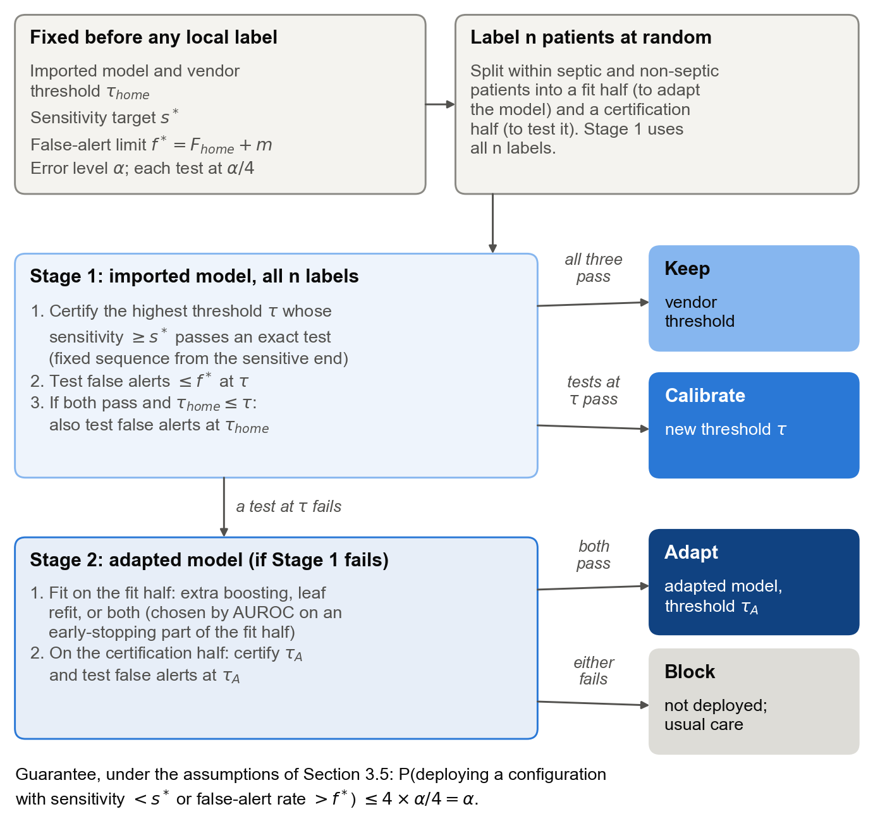
Fig. 1 The CAB procedure. Before any local label is examined, the hospital fixes its requirements and error level. Stage 1 tests the imported model on all labelled patients; Stage 2, reached only if Stage 1 certifies nothing, tests a model adapted on the fit half using the certification half. The first configuration certified is deployed; otherwise the model is blocked.
- Threshold certification. Given K labelled septic patients, sort their window-maximum scores from highest to lowest. Find the smallest number of detections d_{min} for which the exact binomial test of H0: S < s* rejects at level δ, and return the threshold that detects d_{min} patients. This is the highest threshold whose sensitivity is certified. It is the fixed-sequence form of Learn‑then‑Test [11]: thresholds are tested from the most sensitive end, and because sensitivity falls monotonically as the threshold rises, the thresholds that pass form a contiguous range.
- False-alert test. Given M labelled non-septic patients and a threshold t, reject H0: F(t) > f* if, when the true rate is f*, the exact binomial probability of observing the actual number of false alerts or fewer is at most δ.
In symbols, with w₍₁₎ ≥ … ≥ w_{(K)} the sorted window-maximum scores of the labelled septic patients and x(t) the number of labelled non-septic patients alerted at t, the certified threshold and the false-alert test are
$d_{\text{min}}=\text{min}\{d:\text{Pr}[\text{Bin}(K,s^{*})≥d]≤δ\}, τ=w_{(d_{\text{min}})}$ (3)
$\text{reject }F(t)>f^{*}\text{ if }\text{Pr}[\text{Bin}(M,f^{*})≤x(t)]≤δ$ (4)
If no d ≤ K satisfies the condition in (3), that is, if even detecting every labelled septic patient would not reject H0, d_{min} is undefined and no threshold is certified. Ties among scores are allowed: the certified threshold then detects at least d_{min} patients.
The gate then runs in two stages.
Stage 1: the imported model, on all labelled patients. CAB certifies a threshold τ. If τ is certified and the false-alert test at τ passes, CAB deploys the imported model with the vendor's threshold (KEEP) if τ_{home} is no higher than τ and the false-alert test at τ_{home} also passes; otherwise it deploys the imported model with threshold τ (CALIBRATE). If no threshold is certified, or the false-alert test at τ fails, CAB proceeds to Stage 2.
Stage 2: an adapted model, on the certification half. A random 20% of the fit-half patients is set aside as an early-stopping subset, and three adapted candidates are fitted on the remaining 80%: additional boosting rounds added to the imported trees, with early stopping on the subset (learning rate 0.03, 15 leaves, at most 1,000 rounds, patience 50); a re-estimation of the imported trees' leaf values on local data, in which each new leaf value is 0.9 times the imported value plus 0.1 times the locally estimated value (LightGBM's refit with decay 0.9); and the leaf re-estimation followed by additional boosting rounds. The candidate with the highest hourly AUROC on the early-stopping subset is retained, with ties broken in the order listed. CAB certifies a threshold τ_{A} for this model and tests its false-alert rate, both on the certification half only. If both pass, it deploys the adapted model with threshold τ_{A} (ADAPT). Otherwise the model is blocked (BLOCK), and the hospital continues its usual care.
Algorithm 1 CAB (Calibrate, Adapt, or Block).
Input: imported model g0, vendor threshold t_home; targets s*, f*;
error level alpha; n labelled patients L, drawn at random
from the receiving hospital
Output: KEEP (g0, t_home), CALIBRATE (g0, t), ADAPT (gA, tA) or BLOCK
1 delta <- alpha / 4
2 split L, within septic and non-septic patients, into halves
L_fit and L_cert
3 t <- CERTIFY(g0, L) # Stage 1: all labels
4 if t exists and FALSE_ALERT_OK(g0, L, t):
5 if t_home <= t and FALSE_ALERT_OK(g0, L, t_home):
6 return KEEP (g0, t_home)
7 return CALIBRATE (g0, t)
8 gA <- ADAPT(g0, L_fit) # Stage 2: fit half only
9 tA <- CERTIFY(gA, L_cert)
10 if tA exists and FALSE_ALERT_OK(gA, L_cert, tA):
11 return ADAPT (gA, tA)
12 return BLOCK # usual care continues
CERTIFY(g, D):
w(1) >= ... >= w(K): window-maximum scores of the K septic
patients in D
d_min <- smallest d with P(Bin(K, s*) >= d) <= delta
return w(d_min), or none if d_min > K
FALSE_ALERT_OK(g, D, t):
x <- number of the M non-septic patients in D whose stay-maximum
score is at least t
return P(Bin(M, f*) <= x) <= delta

The order reflects the cost of each option to the hospital. A hospital prefers to keep a vendor's model unchanged, because the vendor supports it and it is easier to govern. Changing the threshold is the next least intrusive option. A retrained model requires local validation and maintenance. CAB therefore tries the least intrusive option first. Stage 1 also uses all the labelled patients, not only the certification half, because the imported model and τ_{home} are fixed before labelling and no fitting takes place.
Illustration. Table 3 shows CAB's evidence in three runs at the primary requirements (s* = 0.80, f* = F_{home} + 0.05), each drawn from the 100 repetitions of Section 3.7.
- A→B with 12,000 labels (672 septic patients). At the vendor's threshold the imported model detected 443 of the 672 septic patients (65.9%, exact lower bound 61.7%), so KEEP failed. The lowest threshold that certified 80% sensitivity alerted 62.4% of non-septic patients against a limit of 45.1%, so CALIBRATE failed. The adapted model, tested on the 336 septic and 5,664 non-septic patients of the certification half, passed both tests and was deployed. On the 8,000 patients of the receiving hospital that were never labelled, it detected 86.6% of septic patients and alerted 43.5% of non-septic patients, so the deployment was safe.
- A→B with 1,000 labels (47 septic patients). With so few septic patients, certifying 80% sensitivity required a threshold so low that almost every non-septic patient was alerted (96.7% for the imported model and 97.7% for the adapted model). CAB therefore blocked. Blocking is the appropriate decision for this amount of evidence, although ADAPT would have been certified with more labels.
- B→A with 1,000 labels. Every option alerted 70–76% of non-septic patients, against a limit of 37.9%. CAB blocked, which was also the correct remedy given the full data.
Table 3 CAB's evidence in three runs at the primary requirements. Counts are detected over labelled septic patients and alerted over labelled non-septic patients; bounds are one-sided exact bounds at δ = α/4 = 0.0125. Keep and Calibrate are tested on all labelled patients, Adapt on the certification half. The false-alert limit f* is 0.451 for A→B and 0.379 for B→A.
Option | Detected | Sensitivity (lower bound) | Alerted | False-alert rate (upper bound) | Passed
A→B, 12,000 labels
Keep | 443/672 | 0.659 (0.617) | 3,560/11,328 | 0.314 (0.324) | No
Calibrate | 561/672 | 0.835 (0.800) | 7,070/11,328 | 0.624 (0.634) | No
Adapt | 286/336 | 0.851 (0.802) | 2,360/5,664 | 0.417 (0.431) | Yes
A→B, 1,000 labels
Keep | 31/47 | 0.660 (0.486) | 320/953 | 0.336 (0.371) | No
Calibrate | 44/47 | 0.936 (0.807) | 922/953 | 0.967 (0.979) | No
Adapt | 23/23 | 1.000 (0.827) | 465/476 | 0.977 (0.990) | No: block
B→A, 1,000 labels
Keep | 83/93 | 0.892 (0.799) | 635/907 | 0.700 (0.734) | No
Calibrate | 84/93 | 0.903 (0.812) | 686/907 | 0.756 (0.788) | No
Adapt | 43/46 | 0.935 (0.803) | 337/453 | 0.744 (0.789) | No: block

3.5 Statistical Guarantee
We use three assumptions.
- (A1) Sampling. The labelled patients and the patients the deployed model will serve are independent and identically distributed draws from the receiving hospital's population. Consequently, given their class, the labelled septic patients are independent with a common distribution, as are the labelled non-septic patients, and the two groups are independent of each other. For a threshold fixed independently of the labelled patients, each septic patient's detection and each non-septic patient's false alert is therefore a Bernoulli variable, with probability S(t) or F(t).
- (A2) Labels. The labels, including the onset times that define the detection window, are correct.
- (A3) Prespecification. The requirements s* and f*, the level α, the imported model and τ_{home} are fixed before labelling. The adapted model, including its training, early stopping and the choice among candidates, depends only on the fit half and is fixed before the certification half is examined.
Theorem. Under (A1)–(A3), for any shift between the developing and the receiving hospital and any number of labelled patients,
$\text{Pr}[\text{CAB deploys a configuration that violates (2)}]≤4δ=α.$ (5)
The proof combines three lemmas. Throughout, the numbers K and M of septic and non-septic patients in the data being tested are held fixed by conditioning; since each bound holds for every K and M, it also holds unconditionally.
Lemma 1 (threshold certification). The certified threshold τ satisfies Pr[S(τ) < s*] ≤ δ.
Proof. Model scores are predicted probabilities, so the window-maximum score W of a septic patient drawn from the population lies in [0, 1], and S(t) = Pr[W ≥ t] equals 1 for every t ≤ 0. Let D(t) be the number of the K labelled septic patients with w_{i} ≥ t. Since τ is the d_{min}-th highest score, at least d_{min} labelled patients score at or above τ, so D(τ) ≥ d_{min}; ties only increase D(τ). Let U = {t : S(t) < s*}. Because S is non-increasing, U is either empty, in which case the event S(τ) < s* is impossible, or an interval unbounded above. Since S(t) = 1 > s* for t ≤ 0, its lower end u = inf U lies in [0, 1]; it depends only on the population. Two cases arise.
- Case 1. u ∈ U, so that S(u) < s*. If S(τ) < s*, then τ ≥ u, and since detections can only fall as the threshold rises, D(u) ≥ D(τ) ≥ d_{min}.
- Case 2. u ∉ U. Every t > u lies in U. As t decreases to u the events {W ≥ t} increase to {W > u}, so Pr[W > u] is the limit of S(t), and it is at most s*. If S(τ) < s*, then τ > u, and the number C(u) of labelled septic patients with w_{i} > u satisfies C(u) ≥ D(τ) ≥ d_{min}.
In either case the event S(τ) < s* implies that a count at a fixed, population-defined threshold, D(u) or C(u), is at least d_{min}. By (A1) that count is binomial with K trials and success probability S(u) < s* or Pr[W > u] ≤ s*, so it is stochastically no larger than Bin(K, s*). Hence Pr[S(τ) < s*] ≤ Pr[Bin(K, s*) ≥ d_{min}] ≤ δ by (3). ∎
Lemma 2 (false-alert test at a threshold chosen from the septic patients). Let t be a threshold that depends only on the septic patients' data. Then Pr[F(t) > f* and the false-alert test passes at t] ≤ δ.
Proof. Condition on the septic patients' data, which fixes t. By (A1) the non-septic patients are independent of the septic patients, so the number x(t) of non-septic patients alerted at t is Bin(M, F(t)). If F(t) ≤ f*, the event is empty. If F(t) > f*, then x(t) is stochastically larger than Bin(M, f*), so the exact test (4) passes with probability at most δ. Removing the conditioning preserves the bound. ∎
Lemma 3 (Stage 1 false alerts share one allocation). The probability that Stage 1 deploys a configuration whose false-alert rate exceeds f* is at most δ.
Proof. Condition on the septic patients' data. This fixes τ, and τ_{home} is fixed by (A3), so the population rates F(τ) and F(τ_{home}) are fixed numbers. Three cases are possible.
- Case 1. F(τ) > f*. CALIBRATE deploys at τ. KEEP deploys at τ_{home}, but it too is reached only after the false-alert test at τ has passed. Every unsafe deployment therefore requires the test at τ to pass, which has probability at most δ by Lemma 2.
- Case 2. F(τ) ≤ f*, KEEP is possible (τ_{home} ≤ τ) and F(τ_{home}) > f*. CALIBRATE is safe. An unsafe deployment requires KEEP, and therefore the test at τ_{home} to pass, which has probability at most δ by Lemma 2.
- Case 3. Otherwise, every configuration that Stage 1 can deploy has a false-alert rate of at most f*, and the probability is zero.
The case is determined by the septic patients alone, so in every case the conditional probability is at most δ, and so is the unconditional probability. ∎
Proof of the theorem.
- Stage 1, sensitivity. CALIBRATE deploys at τ. KEEP deploys at τ_{home} ≤ τ, so S(τ_{home}) ≥ S(τ). A sensitivity violation by either option therefore implies S(τ) < s*, which has probability at most δ by Lemma 1.
- Stage 1, false alerts. At most δ, by Lemma 3.
- Stage 2. By (A3) the adapted model is a fixed function of the fit half, and by (A1) the certification half is independent of the fit half. Conditional on the fit half, Lemmas 1 and 2 apply on the certification half and bound the adapted model's sensitivity and false-alert violations by δ each. Whether Stage 2 is reached depends on all the labelled patients, including the certification half; this does not affect the bound, because the event "Stage 2 deploys an unsafe adapted model" is contained in the event "the adapted model is unsafe and passes certification", whose probability is at most 2δ whether or not Stage 2 is reached.
- Union bound. CAB deploys at most one configuration, so the probability that it deploys an unsafe one is at most δ + δ + 2δ = 4δ = α. ∎
The bound holds exactly in finite samples. It requires no model of the shift and no assumption that the model's predicted probabilities are well calibrated. Two things are not guaranteed: that CAB finds a safe configuration when one exists, which depends on the number of labels; and that the deployed configuration remains safe if the population changes after deployment.

3.6 Comparators
CAB was compared with the eleven alternatives in Table 4. They cover what a hospital might do without local labels, the updating and validation practices that use labels without certification, and two certified alternatives. The point-estimate policies set their thresholds and judge whether the requirements are met on the same labelled patients, as a hospital without certification would; this reuse of data is part of what the comparison examines. LABEL-FREE matches the share of alerted patient-hours, a different quantity from the patient-level false-alert rate in (2).
Table 4 The eleven comparators.
Group | Policy | What it does
Without labels | AS-IS | Imported model, vendor's threshold.
Without labels | LABEL-FREE | Threshold that matches the vendor's home share of alerted patient-hours on unlabelled local data.
Without labels | LABEL-SHIFT | Probabilities corrected for the local sepsis prevalence [21]; vendor's threshold.
Labels, point estimates | RECALIBRATE | Imported model, highest threshold reaching s* on the labelled patients.
Labels, point estimates | FINE-TUNE | Adapted model, threshold set the same way on the certification half.
Labels, point estimates | RETRAIN | New model trained on the fit half, threshold set on the certification half.
Labels, point estimates | CLOSED-TEST | Classical updating by significance tests of model fit [9]; never blocks.
Labels, point estimates | NAIVE-VAL | CAB's order of options, each accepted on point estimates without a test.
Labels, point estimates | NAIVE-500 | Keep or recalibrate on point estimates from the first 500 labelled patients.
Certified | LTT-DIRECT | Imported and adapted models both certified on the certification half; no order.
Certified | CERT-RECAL | CAB without the adapt stage (an ablation).

The rules of four comparators need more detail. LABEL-SHIFT estimates the local prevalence from unlabelled patient-hours as the vendor's prevalence multiplied by the ratio of the mean local prediction to the mean home prediction. CLOSED-TEST first applies a likelihood-ratio test (2 degrees of freedom, all labelled patient-hours) of logistic recalibration against the model as supplied, and then a one-sided bootstrap test (200 resamples of certification-half patients) of whether the adapted model's patient-level log-likelihood exceeds that of a recalibration fitted on the fit half; each test is at the 5% level, and the policy chooses ADAPT if revision is significant, otherwise CALIBRATE if recalibration is significant, otherwise KEEP, with the threshold set as in FINE-TUNE, RECALIBRATE or AS-IS respectively. NAIVE-500 uses the first 500 labelled patients in random order, or all of them when fewer are labelled, and blocks if neither option meets the requirements. LTT-DIRECT applies CAB's tests to both models on the certification half; if both pass, it deploys the one with the lower observed false-alert rate there, and if neither passes it blocks.

3.7 Experimental Design
Scenarios. We studied six transfer scenarios. Two are whole-hospital transfers: hospital A's model at hospital B (A→B) and hospital B's model at hospital A (B→A). Four are transfers into a single ICU type: each of these models imported into the receiving hospital's medical ICU (MICU) or surgical ICU (SICU). In addition, each hospital's model was imported into its own hospital (A→A and B→B), a control in which nothing has shifted.
Label budgets and patient sets. In the whole-hospital and ICU-type transfers, labelled patients were drawn at random from the receiving hospital's training and validation patients, and deployments were judged on all its other patients, including its test set. Budgets were 250, 500, 1,000, 2,000, 4,000, 8,000 and 12,000 labelled patients in the whole-hospital transfers; the size of each unit limited them to 4,000 in the transfers into hospital B's units and to 2,000 in those into hospital A's units. In the home control, the source model had been fitted on the hospital's training set, with its validation set used for early stopping and for choosing the vendor's threshold, so both labelling and judging used only its test patients, which limited budgets to 2,000.
Separation of labelled and judged patients. The labelled patients, including those used for fitting, early stopping, threshold selection and certification, were used only by the policies being compared. Every resulting deployment was then judged on the receiving hospital's eligible patients that had not been labelled; the eligible patients are all of its patients (or all of the unit's) in the transfers, and its test patients in the home control.
Repetitions. Each combination of scenario, budget and pair of requirements was repeated 100 times with different random samples. The random seed depended only on the scenario, the budget and the repetition, so all policies saw exactly the same labelled patients and the same split into fit and certification halves.
Correct remedy. As an evaluation reference, not a procedure available to a hospital, we defined the correct remedy for each scenario and pair of requirements as the first of KEEP, CALIBRATE and ADAPT that met both requirements on all eligible patients of the receiving hospital, or BLOCK if none did. For the transfers, the adapted model used for this purpose was fitted on the receiving hospital's training set, with early stopping on its validation set, and checked on its test set. In the home control the correct remedy was determined in the same way. Because f* is benchmarked against the vendor's observed validation rate rather than its population rate, KEEP was the correct remedy in 13 of the 18 home settings, including both at the primary requirements; with no additional tolerance (m = 0), the vendor's threshold sometimes exceeded f* on the test patients.
Outcomes. We report the share of runs in which each policy deployed an unsafe configuration (unsafe); deployed an unsafe configuration that appeared safe on its own labelled patients (silent failure); and chose the correct remedy (correct). We also report clinical impact per 100 admissions; when CAB blocks, the hospital is assumed to fall back to a modified NEWS2 score of 5 or more.

3.8 Label Calculator
Each candidate configuration is assessed against the two requirements, minimum patient-level sensitivity and maximum patient-level false-alert rate, using exact binomial tests at level δ. The number of labels needed therefore depends on two quantities: the margin by which the model's true rates satisfy the requirements, and the share of septic patients among those labelled.
The calculator works at a fixed operating point with given true rates. It finds the smallest number of septic patients for which the sensitivity test passes with probability √0.9, and the smallest number of non-septic patients for which the false-alert test does. At a fixed threshold the two tests use independent groups of patients, so both then pass with probability at least 0.9. These counts are converted into total patients at the hospital's prevalence and doubled for ADAPT, because half the labelled patients are used for fitting. In CAB the threshold of CALIBRATE and ADAPT is chosen from the septic patients, so the two outcomes are not independent and the 90% figure is a planning approximation rather than a guarantee for the full procedure. A hospital can apply the calculator before labelling, using the vendor's published operating curve as an estimate of the margin. We checked its predictions against simulations of CAB's exact rule on patients resampled with replacement from the receiving hospital (Section 4.5).

3.9 Implementation and Prototype
The analysis was written in Python using LightGBM, NumPy, pandas, SciPy and scikit-learn. All final experiments ran in a single fixed software environment. Every random choice is driven by fixed seeds recorded in the code: one seed for the data splits and the source models, and, for each run, a seed that depends only on the scenario, the budget and the repetition, which drives the label sample, the fit and certification halves and the fitting of the adapted and retrained models. The gate is also implemented in a research prototype, the CAB Sepsis Monitor, which shares its code with the experiments and is described in Section 5. The code, including the exact tests, the data splits, the random seeds, the model parameters, the adaptation candidates, the calculator and the scripts that produce every table and figure, is openly available with the application at https://github.com/AmlanWTK/CAB-ECG.

4 Results
Unless stated otherwise, results are for the primary requirements (s* = 0.80, m = 0.05) and the error level α = 0.05. "Correct" refers to the correct remedy of Section 3.7, an evaluation reference computed from the receiving hospital's full data that no policy could know at deployment.

4.1 Imported Models Failed Differently in Each Direction
Imported unchanged, with the vendor's threshold for 80% sensitivity, both models violated the receiving hospital's requirements, but in opposite ways (Fig. 2; Table 5).
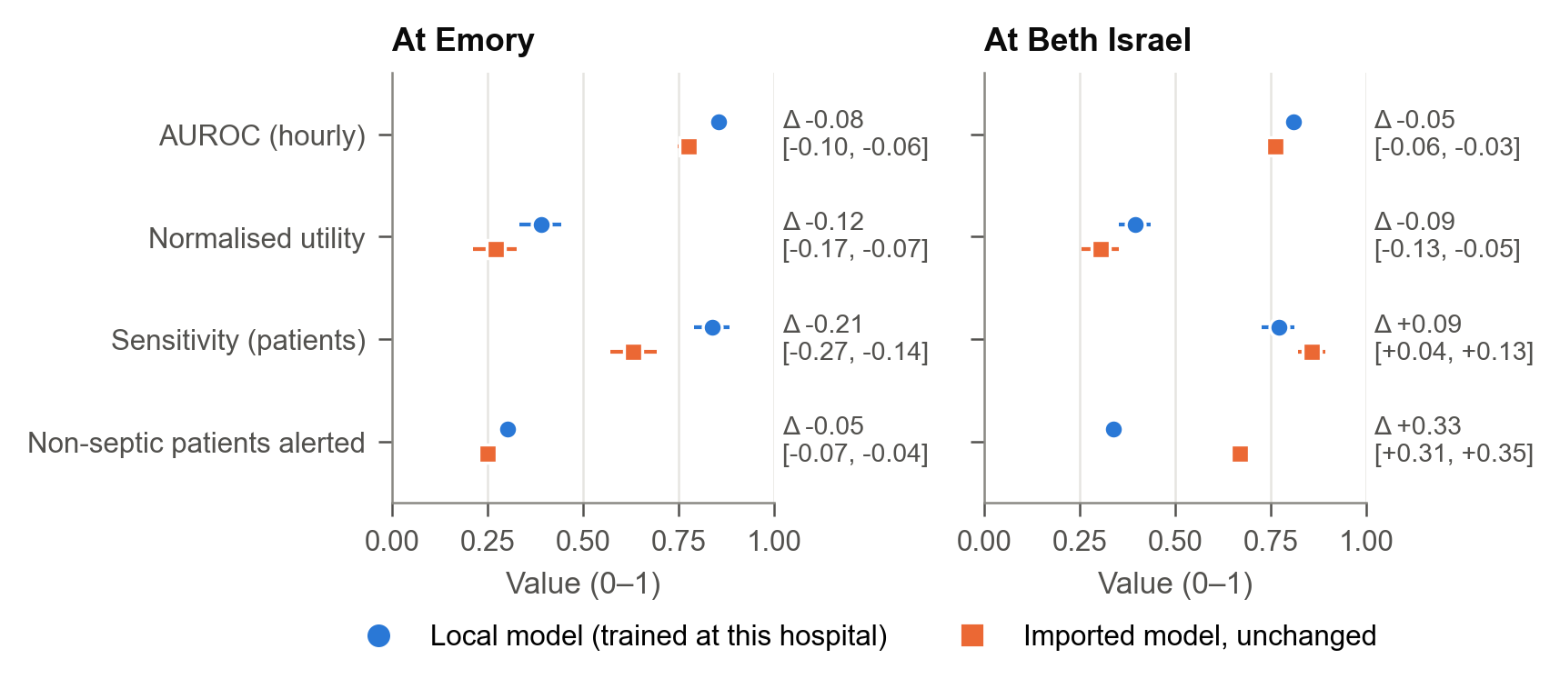
Fig. 2 Local and imported model at each receiving hospital: hourly AUROC, normalised utility, patient-level sensitivity and the share of non-septic patients alerted, with 95% patient-bootstrap confidence intervals, on the receiving hospital's test patients.
Hospital A's model at hospital B (A→B) lost sensitivity. Hourly AUROC fell from 0.855 for the local model to 0.777 (difference −0.078, 95% CI −0.102 to −0.057), and only 63% of septic patients were detected, against 84% for the local model and a target of 80%.
Hospital B's model at hospital A (B→A) remained sensitive, detecting 86% of septic patients, but alerted far more patients who were not septic: 67%, against 34% for the local model (difference +0.33, 95% CI 0.31 to 0.35). Alarms per patient-day rose from 0.51 to 0.92.
Table 5 Imported and local models at each receiving hospital, on its test patients. Each model uses its own vendor threshold. The local model is the receiving hospital's own source model. Confidence intervals are paired percentile intervals from resampling patients with replacement (2,000 resamples; 200 for AUROC), with both models evaluated on the same resampled patients.
At | Imported from | Measure | Local | Imported | Difference [95% CI]
Emory (B) | Beth Israel (A) | Hourly AUROC | 0.855 | 0.777 | −0.078 [−0.102, −0.057]
 |  | Sensitivity (patients) | 0.838 | 0.632 | −0.206 [−0.268, −0.143]
 |  | Non-septic patients alerted | 0.303 | 0.250 | −0.053 [−0.070, −0.036]
Beth Israel (A) | Emory (B) | Hourly AUROC | 0.810 | 0.761 | −0.049 [−0.064, −0.032]
 |  | Sensitivity (patients) | 0.771 | 0.858 | +0.087 [0.039, 0.134]
 |  | Non-septic patients alerted | 0.339 | 0.669 | +0.330 [0.312, 0.348]

These failures determined the correct remedy in each direction. For A→B, recalibration could not restore both requirements but adaptation could, so the correct remedy was ADAPT for all nine pairs of requirements. For B→A, no option met the primary requirements, so the correct remedy was BLOCK; with the most tolerant false-alert limit (m = 0.10) an adapted model would have sufficed. In the same-hospital control the correct remedy at the primary requirements was KEEP.
No bedside score met both requirements in any of the 72 combinations of scenario and requirement pair (eight scenarios, including the two controls, and nine pairs), with each of the four scores evaluated at every cut-off on all eligible patients. A blocked model therefore leaves the hospital with its usual care, not with a certified alternative.

4.2 CAB Rarely Deployed an Unsafe Model; Conventional Updating Usually Did
Fig. 4 shows the share of runs in which each policy deployed an unsafe configuration at the primary requirements, by budget, in the whole-hospital transfers and the same-hospital control. Table 6 summarises the same outcome more broadly: averaged over the whole-hospital transfers and the same-hospital control, all nine requirement pairs and all budgets, the conventional policies were unsafe in most runs. AS-IS was a silent failure in every unsafe run, because the vendor's own figures always looked acceptable. For the updating policies, between a fifth and two fifths of runs were silent failures: the hospital's own labelled patients suggested the deployment was safe when it was not.
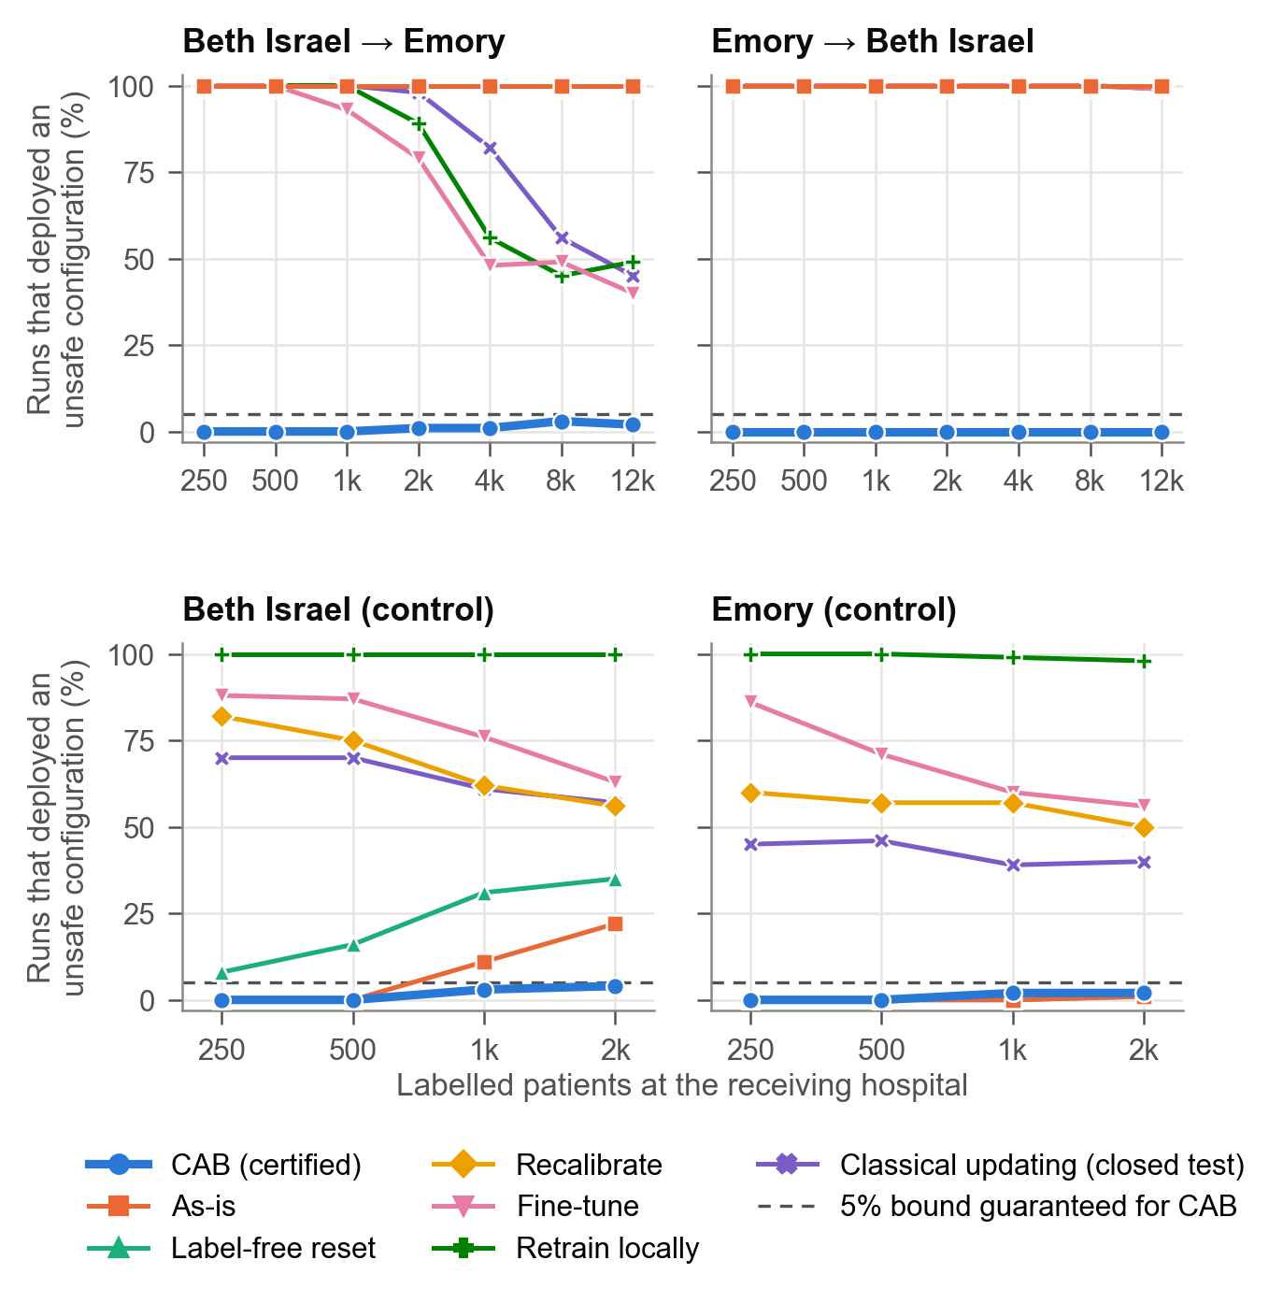
Fig. 4 Share of runs in which each policy deployed an unsafe configuration, by policy and number of labelled patients, at the primary requirements (100 runs per budget). The dashed line marks the 5% level that CAB's guarantee bounds. Some lines coincide: As-is, Label-free and Recalibrate for hospital A's model at B; As-is, Label-free, Recalibrate and Retrain, and also Fine-tune and Closed test, for hospital B's model at A; and As-is and Label-free in hospital B's control.
Table 6 Share of runs in which the conventional policies deployed an unsafe configuration, and in which they did so while appearing safe on their own labelled patients (silent failure), averaged over the whole-hospital transfers and the same-hospital control, all requirement pairs and all budgets. LABEL-FREE uses no labelled patients, so it has no apparent result.
Policy | Unsafe | Silent failure
AS-IS | 77.4% | 77.4%
LABEL-FREE | 79.2% | –
FINE-TUNE | 82.3% | 39.9%
RECALIBRATE | 88.1% | 25.8%
RETRAIN | 91.9% | 18.2%
CLOSED-TEST | 80.9% | 32.4%

On the same basis, CAB deployed an unsafe configuration in 0.7% of runs, with the same silent-failure rate; Table 7 breaks this down by group of settings, averaging over all requirement pairs and budgets within each group. In the ICU-type transfers, CLOSED-TEST was unsafe in 97% of runs.
Table 7 Share of runs in which CAB deployed an unsafe configuration, by group of settings (α = 0.05; a setting is one scenario, requirement pair and budget, with 100 runs).
Group | Settings | Mean | Worst setting
Whole-hospital transfers | 126 | 0.5% | 6%
Same-hospital control | 72 | 1.0% | 7%
ICU-type transfers | 162 | 0.3% | 5%

CAB's decisions followed the correct remedy as the number of labels grew (Fig. 3). For B→A it blocked in every run at every budget from 250 to 12,000 labelled patients. For A→B it blocked while the evidence was insufficient, then certified the adapted model in 10% of runs at 4,000 labels, 70% at 8,000 and 97% at 12,000 (about 690 septic patients). In the same-hospital control it deployed a configuration in at most 25% of runs at 2,000 labels, and kept or recalibrated the unchanged model in at most 23%; Section 4.5 explains why. With 250 or 500 labelled patients (a median of 18 and 35 septic patients), CAB deployed a configuration in at most 2.1% of runs in any scenario, over all requirement pairs, including those in which a safe configuration existed.
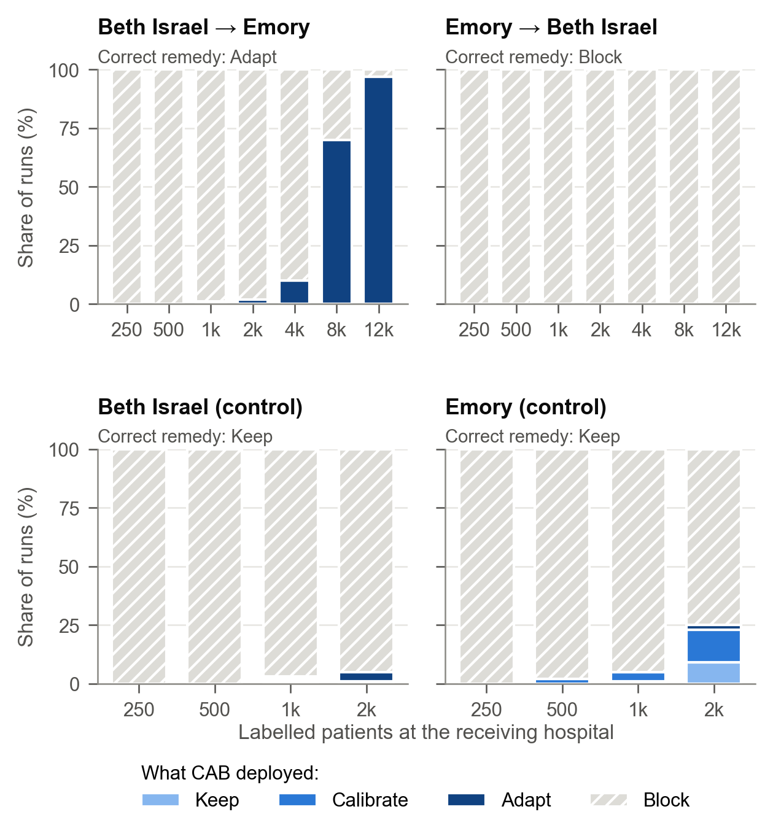
Fig. 3 What CAB deployed, by the number of labelled patients, in each whole-hospital transfer and in the same-hospital control, at the primary requirements (100 runs per budget). The correct remedy, an evaluation reference computed from the receiving hospital's full data, is shown above each panel.
The ablation without the adapt stage (CERT-RECAL) was almost never unsafe, but it also almost never deployed anything in the whole-hospital transfers, because recalibration alone could not repair either model. The adapt stage is therefore what allows CAB to deploy at all after a real shift.

4.3 Comparison with Practical Alternatives
Fig. 5 compares CAB with the alternatives a hospital is most likely to use instead.
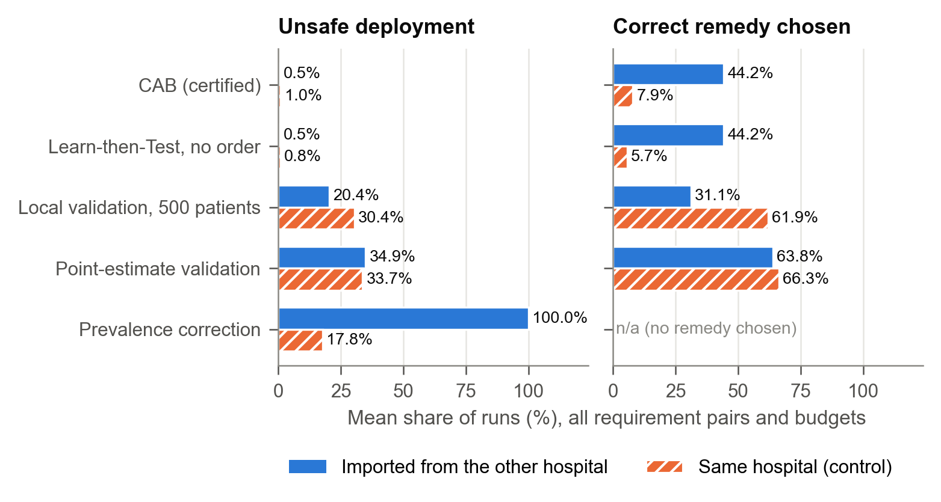
Fig. 5 CAB against practical alternatives: share of runs that deployed an unsafe configuration and share that chose the correct remedy, averaged over all requirement pairs and budgets (100 runs per setting), for the whole-hospital transfers and the same-hospital control.
Prevalence correction did not help. LABEL-SHIFT estimated the receiving hospital's share of septic patient-hours reasonably well, at 1.7% and 2.4% against true values of 1.4% and 2.2%, yet it was unsafe in 100% of runs in the whole-hospital transfers. The models failed because the relationship between measurements and sepsis differed between the hospitals, not because sepsis was more or less common.
Point-estimate validation was often unsafe. NAIVE-VAL was unsafe in 34.9% of runs in the whole-hospital transfers and 33.7% in the same-hospital control, and the typical 500-patient validation (NAIVE-500) in 20.4% and 30.4%. Point estimates often chose the correct remedy, in 64–66% of runs, but they also often accepted a configuration just short of the requirements. More labels did not remove this: for B→A with 12,000 labelled patients, NAIVE-VAL still deployed an unsafe configuration in 29% of runs. In the ICU-type transfers NAIVE-VAL was unsafe in 35.9% of runs on average and in up to 72% in the worst setting, against 0.3% for CAB.
Learn‑then‑Test without CAB's order made the same decision as CAB in every run of the whole-hospital transfers. In the same-hospital control it deployed a configuration less often than CAB, in 3.1% against 8.0% of runs, and chose the correct remedy less often, in 5.7% against 7.9%. CAB tests the unchanged model on all the labelled patients, whereas the unordered procedure spends half of them fitting an adapted model that was not needed. At hospital B with 2,000 labels, CAB chose the correct remedy in 9% of runs and the unordered procedure in none.

4.4 Empirical Unsafe-Deployment Rates Were Consistent with the Guarantee
The simulations cannot prove the guarantee, which follows from the proof in Section 3.5, but they can show whether the observed behaviour is consistent with it. Each setting was repeated 100 times with independent label samples, so its measured unsafe-deployment rate is a binomial proportion with its own exact confidence interval. Table 8 compares the measured rates with the nominal level for α = 0.01, 0.05 and 0.10. Given the fixed hospital data, each repetition draws its own labelled sample, fits its own adapted model and is judged on its own unlabelled patients, using a seed of its own; the 100 outcomes of a setting are therefore independent, and each per-setting interval describes the probability of an unsafe deployment under this repeated-sampling design for these hospitals' patients, not uncertainty about a wider population. Within a run, however, the nine requirement pairs share the same labelled sample, so runs pooled across settings are not independent; the group means in Table 8 are therefore descriptive, and inference rests on the per-setting intervals.
Table 8 CAB's measured unsafe-deployment rate against the nominal level α. Mean and worst setting are descriptive summaries over the settings of each group (100 runs each); the last column counts settings whose exact (Clopper–Pearson) 95% interval lies wholly above α.
α | Group | Settings | Mean | Worst setting | Settings with interval above α
0.01 | Whole hospital | 126 | 0.11% | 2% | 0
0.01 | Same hospital | 72 | 0.14% | 2% | 0
0.05 | Whole hospital | 126 | 0.51% | 6% | 0
0.05 | Same hospital | 72 | 0.97% | 7% | 0
0.05 | ICU type | 162 | 0.28% | 5% | 0
0.10 | Whole hospital | 126 | 0.91% | 13% | 0
0.10 | Same hospital | 72 | 2.06% | 12% | 0

Some settings' measured rates exceeded α, which is expected from sampling variation in 100 runs. At α = 0.05, one whole-hospital setting and three same-hospital settings exceeded 5%, but no setting's exact confidence interval lay wholly above α, at any of the three levels. Had every setting's true rate been exactly 5%, about 48 of the 126 whole-hospital settings would have shown a measured rate above 5% by chance alone. The three same-hospital settings above 5% all used 2,000 labels, where only 110–180 septic patients remained unlabelled to judge safety; with so few, a configuration whose true sensitivity is exactly at the target is judged unsafe about half the time.
The error level trades safety against approval. For A→B, CAB certified the adapted model in 82%, 97% and 98% of runs at 12,000 labels for α = 0.01, 0.05 and 0.10, and in 35%, 70% and 81% at 8,000 labels. B→A was blocked in every run at every level.

4.5 How Many Labels Certification Needs
The labels needed fall steeply as the model's margin over the target grows (Fig. 6a). To certify sensitivity at s* = 0.80, the calculator requires about 5,800 septic patients when the true sensitivity is 2 points above the target, about 870 at 5 points and about 190 at 10 points.
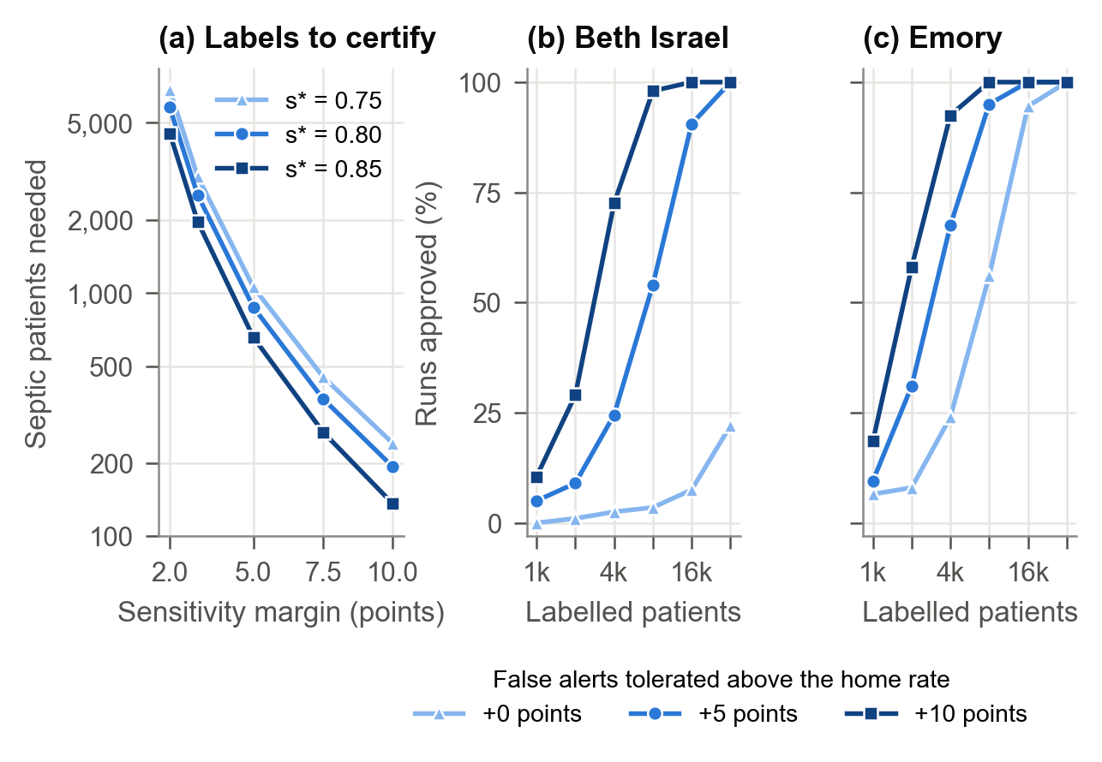
Fig. 6 What certification costs, and what changes it. (a) Septic patients needed to certify sensitivity, by the model's true margin over the target (calculator at a fixed threshold; power 0.9, α/4 per test). (b, c) Share of samples in which CAB approved the unchanged model (KEEP or CALIBRATE) in the same-hospital control, by the hospital's false-alert tolerance, with the models held fixed and labelled samples drawn with replacement from the test patients (200 samples per point).
We also applied the calculator to each scenario's actual operating curve and compared its estimate with a simulation of CAB's exact rule. The simulation held the imported model and an adapted model fitted on the receiving hospital's full training set fixed, drew labelled samples with replacement from the receiving hospital's patients (400 samples per budget), and recorded the smallest budget on a coarse grid at which CAB chose the correct remedy in at least 90% of samples. For A→B the calculator's estimates agreed with the simulated budgets to within 1–18%. Because the simulated samples are drawn with replacement, they may contain the same patient more than once, so this agreement is empirical evidence under that sampling design rather than a guarantee of the number of distinct patients a hospital would need. At the primary requirements it estimated 6,127 labelled patients, including the half set aside for fitting, against 6,000 (about 340 septic) in simulation. Because CALIBRATE and ADAPT choose their threshold from the data, this agreement is an empirical check of the calculator as a planning tool, not a guarantee. When the adapted model was instead refitted on the fit half of each sample, as CAB does, about twice as many were needed: 12,000 patients, about 690 of them septic. This is consistent with a model fitted on a few thousand local patients having a smaller margin over the requirements than one fitted on the hospital's full training set.
The same-hospital control shows why certification can be slow even when nothing is wrong. At hospital A, the vendor's threshold detected 81.6% of septic patients on the test patients, against a target of 80%. Certifying a margin of 1.6 points would require about 9,600 septic patients, roughly 109,000 admissions. This is why CAB rarely kept the unchanged model at home with up to 2,000 labels, although KEEP was the correct remedy: the model was not unsafe, but its safety could not be demonstrated with so few labels.
No single ICU type had enough patients to certify an adapted model reliably: in the ICU-type transfers of A's model, CAB certified ADAPT in only 7% (MICU) and 11% (SICU) of runs at 4,000 labels, the largest budget the units allowed.

4.6 What Blocking Costs
A blocked model does not leave the ward without monitoring; the hospital keeps its usual care, modelled here as a modified NEWS2 score of 5 or more. Per 100 admissions, this fallback missed about 1.1–1.2 septic patients, and falsely alerted about 71 non-septic patients at hospital A and 56 at hospital B, with 2.2 and 1.4 alarms per patient-day respectively.
The benefit of blocking is therefore avoiding an unsafe model, not avoiding alarms. For B→A with 12,000 labelled patients, every point-estimate policy deployed a configuration that violated a requirement in 99–100% of runs, while CAB never did. Those policies alerted 35–65 non-septic patients per 100 admissions, against 71 for CAB's bedside fallback; CAB's price for safety was the noisier fallback.
When CAB adapted the model (A→B with 12,000 labels), it deployed the adapted model in 97% of runs and an unsafe configuration in 2%. Averaged over all runs, it missed 0.87 septic patients and falsely alerted 37 non-septic patients per 100 admissions, with 0.55 alarms per patient-day.

4.7 The Hospital's Tolerance, Not the Vendor's Headroom, Decides the Labels Needed
One might expect a vendor to make certification easier by shipping a threshold with extra sensitivity above the target. We examined this in a separate simulation of the same-hospital control. The vendor's threshold was set to reach a home sensitivity of s* + h, for headroom h from 0 to 10 points, while f* stayed as in the main experiment. With the models held fixed and no adaptation, CAB's rule was applied to labelled samples drawn with replacement from the hospital's test patients (200 samples per cell). Because sampling is with replacement, budgets could extend beyond the main experiment's 2,000 labels, to 32,000 (Fig. 6b, c). The larger budgets therefore contain repeated patients and represent repeated sampling from the test patients' empirical distribution; they show how approval responds to headroom and tolerance, and should not be read as the evidence that labelling the same number of distinct patients would provide. Approval of the unchanged model at home, KEEP or CALIBRATE, hardly changed: averaged over budgets of 1,000 to 32,000 labels, it stayed at about 46% at hospital A and 66% at hospital B, varying by at most 3 points. CAB's calibration step chooses its own threshold from the hospital's labelled patients, so headroom only changes whether an approval is recorded as KEEP or CALIBRATE. Large headroom (8–10 points) also raised the vendor's own false-alert rate by 6–15 points.
The hospital's false-alert tolerance m did change approval. With 8,000 labels, approval at hospital A was 4% with no additional tolerance, 54% with 5 points and 98% with 10 points; the pattern at hospital B was similar. A hospital should therefore set its tolerance deliberately before labelling, and a vendor should publish its full operating curve rather than a single threshold, so that the hospital can plan its labels with the calculator.

4.8 Lead Time and Robustness
Lead time. Because detection counts alerts up to 3 h after onset, we examined how early the alerts came (Table 9). In A→B with 12,000 labels, the configurations CAB deployed detected 85% of septic patients and alerted 64% of all septic patients at least 6 h before onset, the highest share of any policy. Recalibration and fine-tuning alerted 58–59% that early, and the imported model as supplied 44%. The imported model's longer median lead time reflects the fewer patients it detected, not earlier alerts; lead times are capped at 12 h by the detection window. The imported model's sensitivity here (68%) differs from Table 5 (63%) because the patient sets differ: Table 5 uses hospital B's 4,000 test patients, on which the 95% interval is 57–69%, whereas Table 9 averages over the unlabelled patients of each run; over all of hospital B's patients the figure is 67%. For the same reason, and because it is a different model with a different threshold, Table 9's local model is not the local model of Table 5.
Table 9 Lead time before sepsis onset, A→B, 12,000 labels, primary requirements. The first four rows average 20 runs, each judged on the about 8,000 patients of hospital B not labelled in that run; CAB deployed the adapted model in all 20. The two reference rows are single evaluations on hospital B's test patients: its own local model (trained on its training set, threshold set to 80% sensitivity on those patients) and the bedside score. Lead times are among detected patients; the last column is the share of all septic patients.
Alerting system | Septic patients detected | Median lead time, h (IQR) | Alerted ≥ 6 h before onset
CAB (adapted model) | 85% | 10.7 (5.7–12) | 64%
Recalibration | 82% | 11.4 (5.1–12) | 59%
Fine-tuning | 80% | 9.7 (5.2–12) | 58%
Imported model, as supplied | 68% | 11.9 (3.7–12) | 44%
Hospital's own local model | 80% | 7.0 (5.0–12) | 58%
Modified NEWS2 ≥ 5 | 79% | 8.0 (3.8–12) | 49%

A shorter detection window. We repeated the whole-hospital experiment counting a septic patient as detected only from 6 h, rather than 12 h, before onset, applying the shorter window throughout (the vendor's threshold, CAB's tests and the judging), with 30 runs per setting and budgets of 1,000, 4,000 and 12,000 labels. The correct remedies at the primary requirements were unchanged (ADAPT for A→B, BLOCK for B→A), and so were the conclusions. CAB was unsafe in 0.9% of runs on average (worst setting 3.3%); the conventional policies were unsafe in 81–100%; and at 12,000 labels CAB certified the adapted A→B model in every run.
Imperfect labels. The guarantee assumes that the labels are correct. We relaxed this by recording 5%, 10% or 20% of the labelled septic patients as non-septic in the data CAB sees, while still judging safety with the true labels (20 runs each). Under this one-sided noise, CAB remained conservative in these simulations. Its unsafe-deployment rate stayed between 0% and 5% of runs (at most 1 of 20), as with correct labels; for A→B it deployed the adapted model in 65% of runs at 20% noise, against 100% with correct labels; and for B→A it blocked in every run at every noise level. A septic patient recorded as non-septic leaves the sensitivity test, which then has fewer patients, and joins the false-alert test, where, if alerted, it adds a false alert; in these runs the net effect was fewer deployments, although it need not be in every case. Point-estimate recalibration remained unsafe in every run at every noise level. With 20 runs per condition, and without over-calling of sepsis or errors in onset times, this is a limited robustness check rather than a guarantee under imperfect labels.

5 Application: The CAB Sepsis Monitor
To show how the gate fits into a hospital's adoption of an external model, we built a research prototype, the CAB Sepsis Monitor. A safety officer runs the gate before any alert reaches a ward, and clinicians later see which alerting system is in use and whether the gate certified it. The prototype has two screens, a deployment gate and a ward monitor. The figures show hospital A's model being installed at hospital B, using a random sample of 12,000 labelled patients drawn by the application from hospital B's training and validation patients, as in the experiments. The application splits them, within septic and non-septic patients, into a fit half and a certification half, exactly as in Algorithm 1. This sample differs from the one in Table 3, so its counts differ slightly; the figures quoted below are the application's own output for this sample.

5.1 Deployment Gate
The deployment gate collects the three inputs that CAB needs:
- The hospital's requirements. Two sliders set the sensitivity target and the additional false-alert rate the hospital will accept above the vendor's reported home rate.
- Its labelled patients. The user enters how many patients have been labelled and how they were chosen: a random sample, or a sample enriched so that half are septic. An enriched sample is valid for these tests when the septic and the non-septic patients are each sampled at random within their class, as the application does. The sensitivity test uses only the septic patients and the false-alert test only the non-septic patients, and the proof in Section 3.5 conditions on the numbers of each. A convenience sample enriched for sepsis, such as patients selected because clinicians suspected it, would not meet this condition.
- What arrived with the model. A panel shows the vendor's threshold, the home validation counts the vendor reports and the limits these imply at the receiving hospital.
Running the gate produces the decision as a coloured banner, followed by the evidence for each option in order of intervention: the counts, the exact one-sided bounds at level α/4 and whether each test passed. In Fig. 7, keeping the model fails because its sensitivity can be certified only to be at least 62.3%. Calibration certifies 80% sensitivity but fails the false-alert test, with an upper bound of 63.2% against a limit of 45.1%. The adapted model passes both tests, with a lower bound of 80.2% for sensitivity and an upper bound of 37.1% for false alerts, and is deployed.
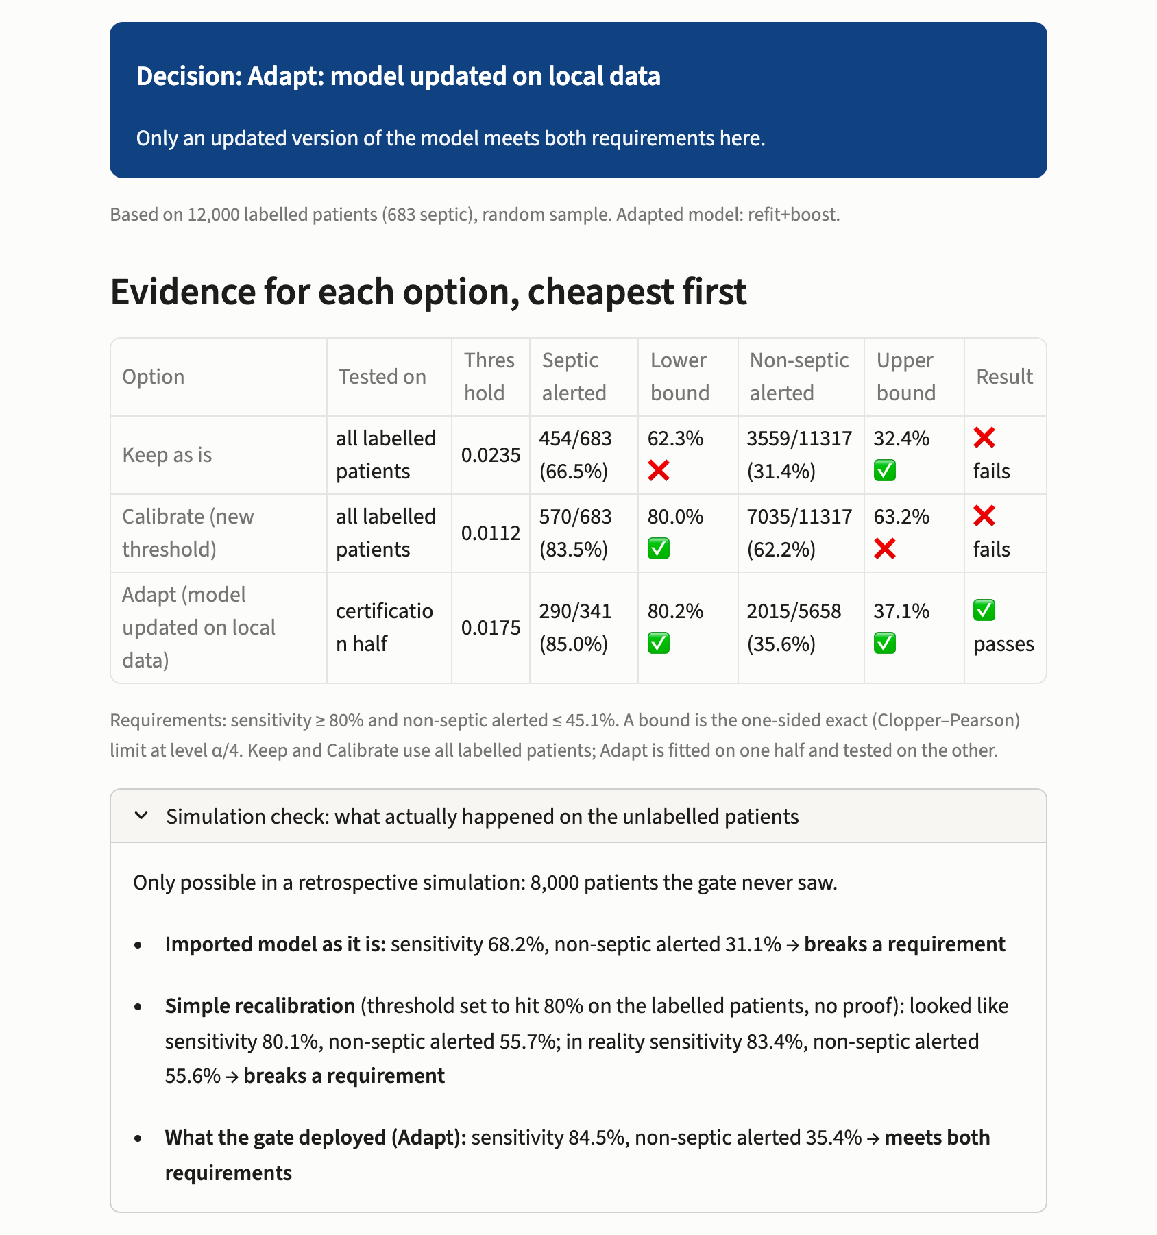
Fig. 7 The deployment gate of the prototype application, installing hospital A's model at hospital B with 12,000 randomly labelled patients (requirements: sensitivity at least 80%, non-septic patients alerted at most 45.1%): the decision, the evidence for each option in order of intervention (counts, exact one-sided bounds at α/4 and the result), and the retrospective simulation check on the 8,000 patients the gate did not see.
Because the prototype runs on retrospective data, it can also show what each choice would have done on the 8,000 patients of the receiving hospital that were not labelled: its 4,000 remaining training and validation patients and all 4,000 of its test patients. These patients play no part in any decision of the gate, which uses only the labelled patients, and this check is not available in real deployment. It is an empirical comparison, separate from the certification bounds, which come from the labelled patients alone. In this sample the adapted model detected 84.5% of septic patients and alerted 35.4% of non-septic patients, meeting both requirements. The imported model as supplied detected only 68.2%. A recalibration without certification, whose threshold was set to reach 80% sensitivity on the labelled patients, appeared to alert 55.7% of non-septic patients there and alerted 55.6% of the unseen ones, violating the false-alert limit; it would have been rejected by CAB's test.

5.2 Ward Monitor
The ward monitor (Fig. 8) replays the receiving hospital's test patients, hour by hour, with whatever configuration the gate deployed. These patients are part of the 8,000 used in the retrospective check above, so none of them was labelled, used to fit a model or used by the gate. For illustration, each ward is a sample of 16 test patients with at least 12 hours in the ICU, 4 of them septic. If the gate blocked, the monitor uses the modified NEWS2 score with a cut-off of 5 instead. A header states which alerting system is in use and whether the gate certified it against the hospital's configured requirements; certification in this sense is not a demonstration of clinical safety or benefit.
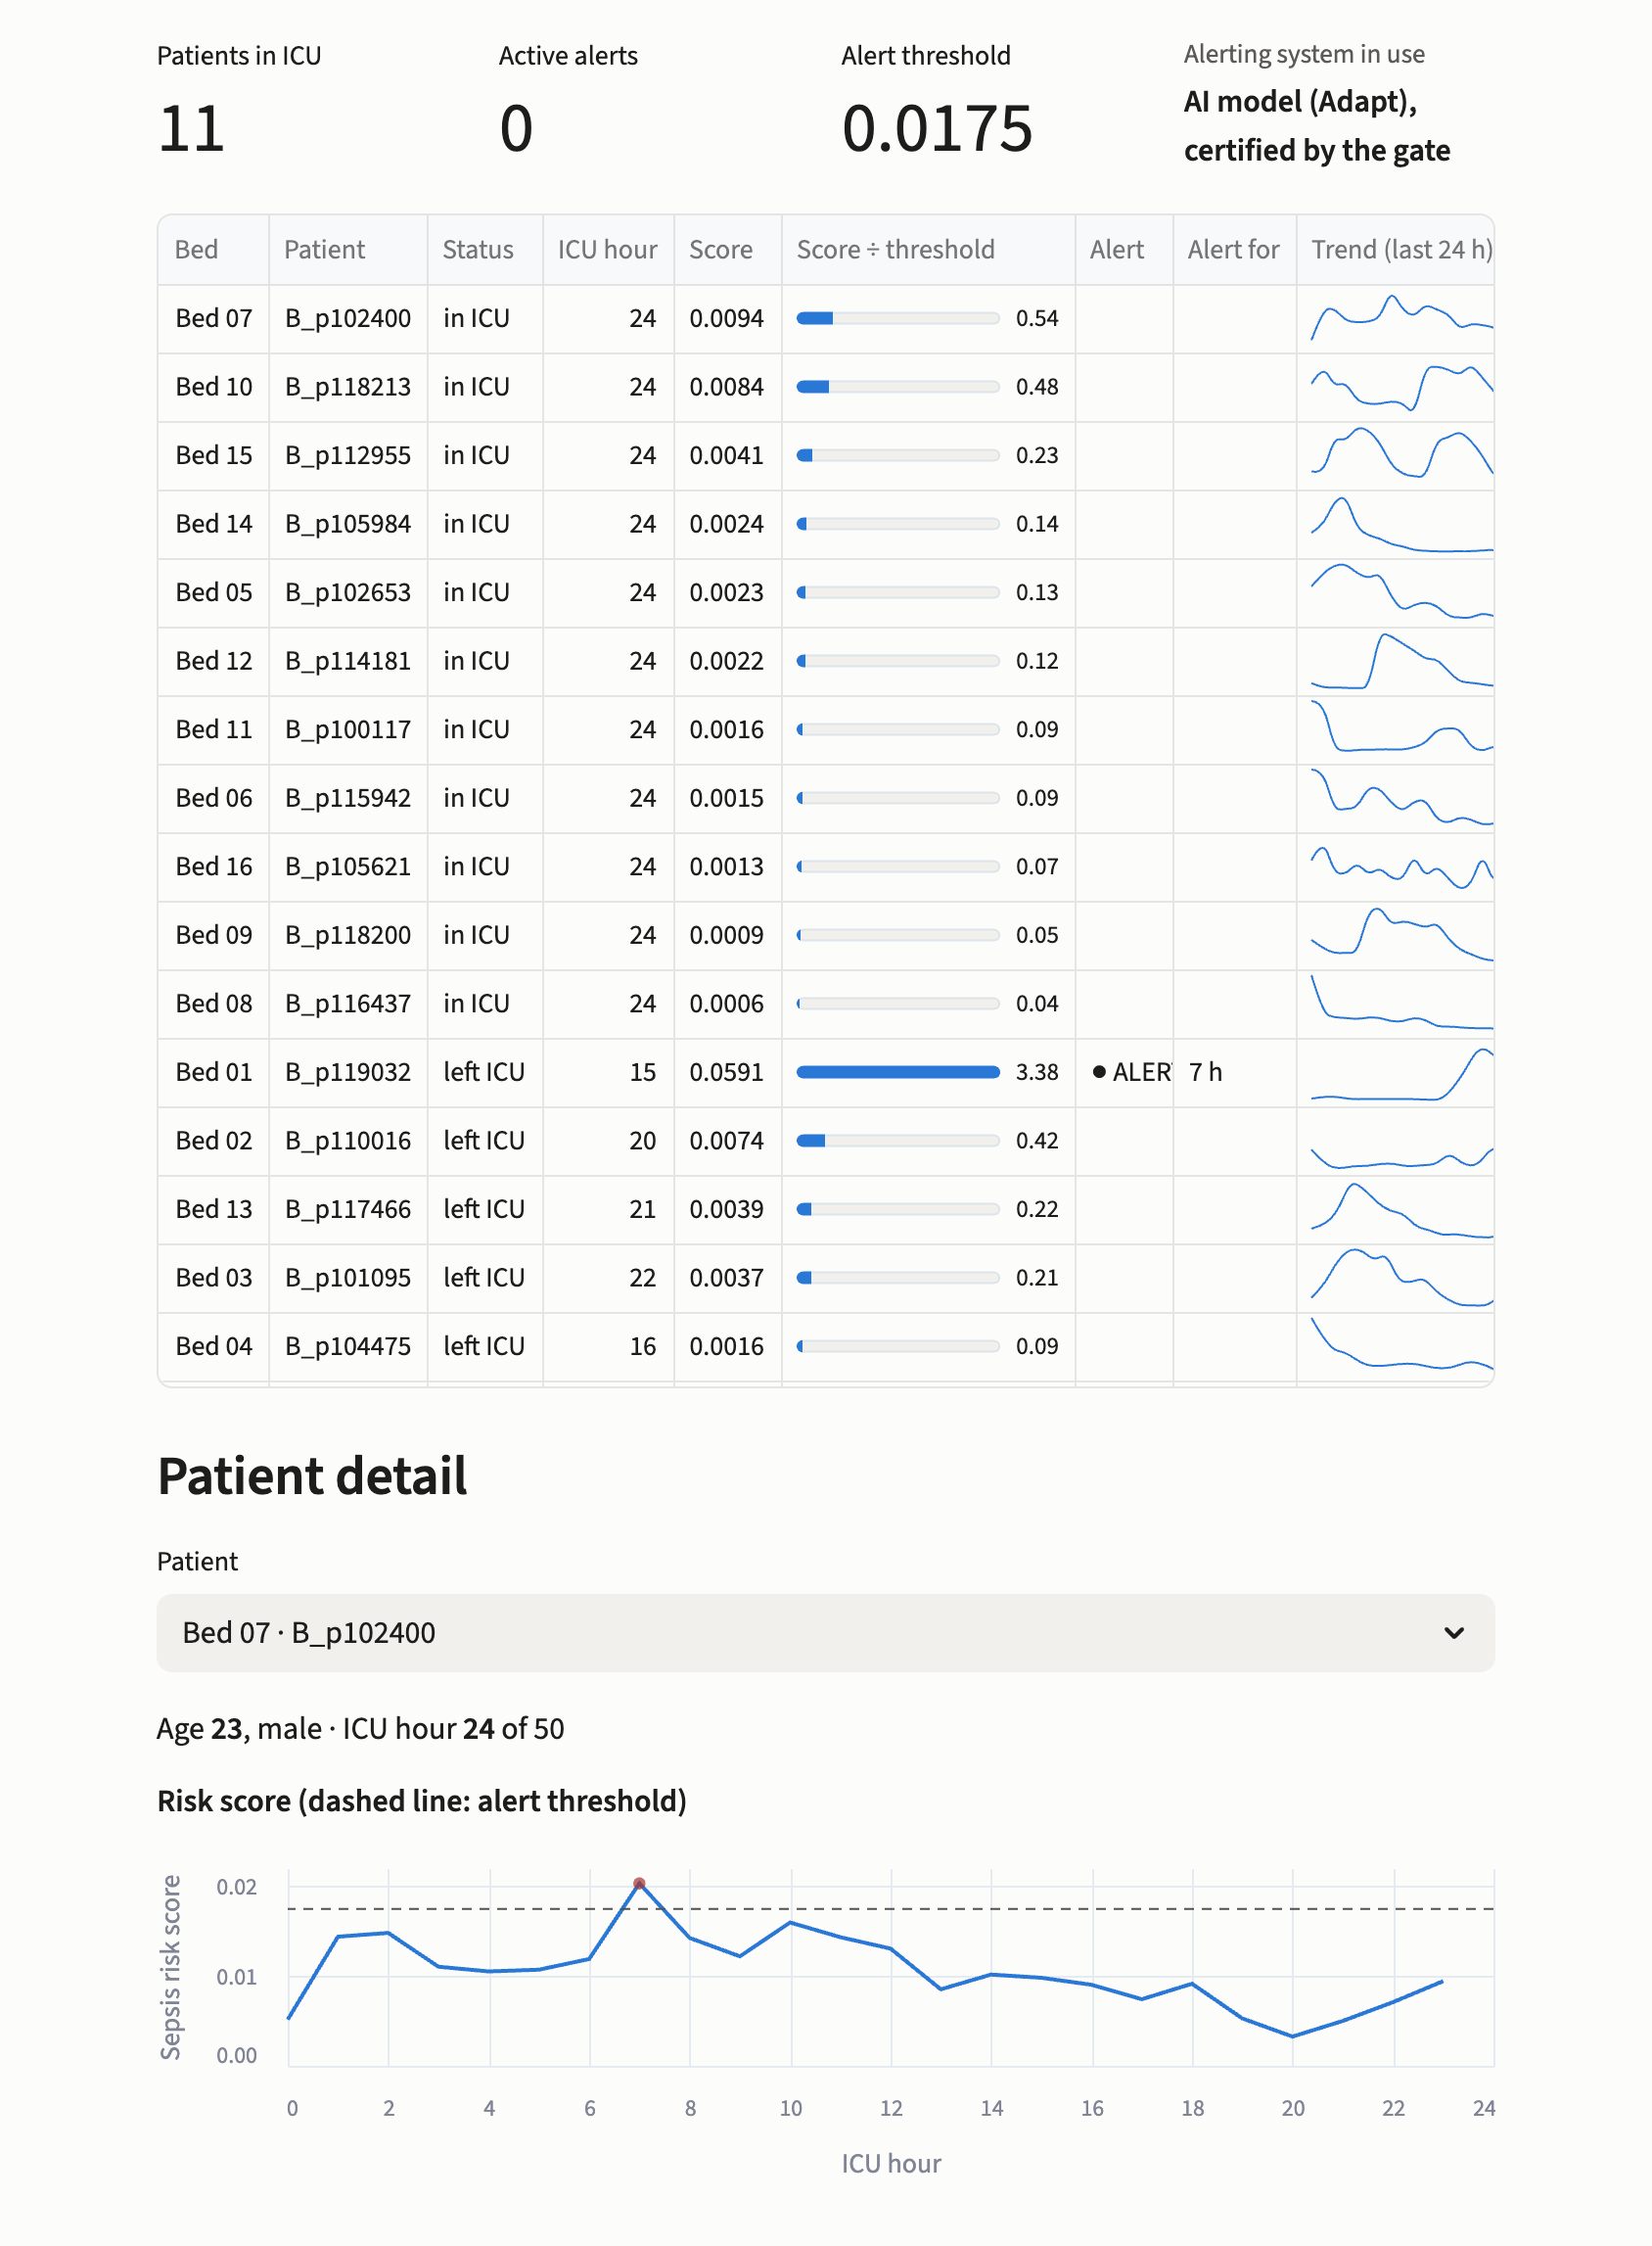
Fig. 8 The ward monitor, replaying hospital B's test patients at hour 24 with the adapted model certified in Fig. 7: the alerting system in use, the ward table with each patient's score relative to the threshold, alert status and 24-hour trend, and one patient's risk trajectory against the alert threshold.
The ward table lists each bed with the current score relative to the alert threshold, the alert status and how long the alert has been active, and a 24-hour trend. The patient view plots the risk score against the threshold, together with the main vital signs and laboratory results, so that a clinician can see what preceded an alert. A switch, available only in this simulation, reveals the recorded onset of sepsis.

5.3 Engineering
- One code path. The application calls the same gate implementation as the experiments. An automated test compares the application's decision function with the experiment's on 3,000 randomly generated cases covering all four outcomes (534 KEEP, 1,088 CALIBRATE, 740 ADAPT and 638 BLOCK); the decisions and thresholds were identical in every case. This test covers the decision function, not the whole interface.
- Local operation. The application runs on a single workstation, and no patient data leave it; this alone does not establish compliance with any data-protection or regulatory requirement.
- The vendor package as a specification. The gate needs only the model, its threshold and its home validation counts. A vendor that also publishes its full home operating curve allows the hospital to plan its labels with the calculator of Section 3.8 before it starts labelling.
- Limitations. The prototype uses public retrospective data and is not intended for clinical use. Integration with an electronic health record, for example through HL7 FHIR, monitoring after deployment and prospective evaluation would all be needed before any clinical use.

6 Discussion

6.1 Principal Findings
Three findings stand out, and they rest on different kinds of evidence. The first is empirical: sepsis models transferred between two hospitals violated the receiving hospital's requirements in ways that depended on the direction of transfer. One model lost sensitivity; the other alerted two thirds of the patients who were not septic. A single summary measure such as AUROC would not have revealed which requirement was broken.
The second is also empirical: the usual ways of handling an imported model deployed configurations that violated the requirements in most runs, whether the model was used as supplied, given a new threshold, retrained or updated by classical closed testing. Many of these were silent failures, in which the hospital's own labelled patients suggested that the configuration was acceptable. Point-estimate validation, the closest analogue of current local validation, was unsafe in about a third of runs, and in our largest budgets it still deployed unsafe configurations, for example in 29% of runs for B→A with 12,000 labels. Although larger samples improve estimation, they do not by themselves give a point-estimate decision rule an explicit finite-sample bound on the probability of an unsafe deployment.
The third combines a theoretical guarantee with empirical support. Under the assumptions of Section 3.5, CAB bounds by α the probability, over repeated labelled samples, of deploying a configuration that violates either requirement. The bound does not require the developing and receiving hospitals to have the same patient distribution, but it depends on the validity of the receiving hospital's sampling and certification procedure. In every setting we examined, at three error levels, the observed unsafe-deployment rates were consistent with that bound. Throughout, an unsafe-deployment rate is the share of all runs, with blocked runs counted as safe, because that is the probability the guarantee bounds; among only the runs in which something was deployed, the share is necessarily higher. The price is explicit: certification needs enough labelled patients to demonstrate safety, and when they are not available CAB blocks.
These findings should be kept distinct from what a single deployment shows. The theorem describes the procedure's behaviour over repeated labelled samples; a certification decision is the outcome of the exact tests on one hospital's sample; and the retrospective evaluations in Sections 4 and 5 describe how the deployed configurations performed on patients the gate did not use. None of them, on its own, shows that deploying the model improves patient outcomes.

6.2 What the Guarantee Covers
The guarantee is a statement about the deployment decision, under three assumptions. The labelled patients must be a random sample of the patients the model will serve, or a sample drawn at random within the septic and non-septic groups. The labels, including onset times, must be correct. And the requirements, the imported model and the vendor's threshold must be fixed before labelling, with the adapted model depending only on the fit half.
Each assumption has practical consequences. Labelling only the patients clinicians flagged, or only those admitted in a period that differs from the deployment period, breaks the first. Retrospective sepsis labels derived from the record, such as the Challenge's, can be wrong or mistimed. In our limited label-noise experiment, missed sepsis labels resulted in fewer deployments rather than an observed increase in unsafe deployments; this does not establish robustness to other forms of label error, including false-positive labels or inaccurate onset times. The third assumption is a matter of governance: a hospital that adjusts its requirements after seeing the labels, or a vendor that tunes the model on the receiving hospital's data, removes the basis for the bound.
The guarantee also has a fixed scope in time. It covers the moment of deployment, not the period after it. Changes in the patient population, clinical practice or documentation after deployment can invalidate assumptions that held at go-live, so a configuration certified then can drift out of compliance. Relevant regulatory frameworks address lifecycle oversight, controlled changes to AI-enabled systems and, where applicable, post-market monitoring [24, 25]; the obligations that apply to a particular deployment depend on the system and its regulatory context.

6.3 Implications for Hospitals and Vendors
Planning for blocking. Blocking was the appropriate decision under CAB's rule for one direction of transfer at the primary requirements, and whenever the available labels were insufficient for certification. Blocking avoids deploying an uncertified model, but it does not guarantee that the fallback meets the same requirements: in our analysis no bedside score met both of them. A hospital adopting an external model should therefore decide in advance what care it will provide if the model is blocked.
Planning label collection. Septic patients are the binding resource. In our evaluated settings, local samples of a few hundred patients, with a few dozen septic cases, were often enough to block a badly broken model but rarely enough to certify a working one. The calculator lets a hospital estimate in advance whether certification is achievable with the labels it can afford. For the A→B transfer at the primary requirements, two estimates bracket the cost. When adaptation is needed, CAB fits the adapted model on one half of the labelled sample and certifies it on the other. In a simulation that held fixed an adapted model fitted on the hospital's full training set, so that the fit half went unused, a total of about 6,000 labelled patients (about 340 septic, about 170 of them in the certification half) let CAB certify that model in 90% of samples. In the full experiment, where CAB refits the adapted model on the fit half of each sample, about 12,000 labelled patients (about 690 septic in total) were needed for the same 90%, consistent with the smaller fitting sample producing an adapted model that cleared the requirements by a smaller margin. These are estimates for that transfer and configuration, not a general minimum for CAB. The calculator is a planning approximation for data-selected thresholds, not a guarantee of the labels required.
Tolerance and headroom. In our same-hospital control, the hospital's false-alert tolerance had a substantially larger effect than the vendor's threshold: raising the tolerance from 0 to 10 points changed approval of the unchanged model at 8,000 labels from 4% to 98% of samples, whereas extra sensitivity headroom in the vendor's threshold changed approval by at most 3 percentage points. Hospitals should therefore state how many additional false alerts they will accept before labelling begins. Vendors can help most by publishing their full home operating curve, with confidence intervals, rather than a single tuned threshold.
Order of the options. The order saves labels. Testing the unchanged model first preserves the full labelled sample for its certification when no adaptation is needed, whereas an unordered procedure that reserves part of the sample for fitting has less independent certification data for that case. The same-hospital control showed the effect: CAB chose the correct remedy more often than the unordered procedure.
Change control. The gate fits existing change-control processes. A vendor could propose recalibration and local adaptation as pre-specified modifications in a predetermined change control plan or relevant technical documentation, where permitted by the applicable regulatory framework, with CAB's tests serving as proposed acceptance criteria and blocking as the fallback [24, 25]. The gate's output, the option chosen with its confidence bounds, would then document the decision. This is our reading of the frameworks, not regulatory advice. Whether a hospital-run test could serve as a manufacturer's acceptance criterion is a question for regulators, a hospital's CAB result does not by itself satisfy a manufacturer's regulatory obligations, and CAB does not replace regulatory authorisation or clinical validation.

6.4 Limitations
- Two hospitals, one country, one definition. The Challenge data come from two US hospital systems, with a single, retrospectively applied Sepsis-3 definition. Larger multi-hospital databases such as eICU [29] would allow many more transfers and different practice patterns to be studied.
- Retrospective evaluation. All the evidence is retrospective. The deployments were judged on held-out patients from the same records, not observed prospectively, and no effect on clinical decisions or patient outcomes was measured.
- The definition of detection. A septic patient counts as detected if alerted from 12 h before to 3 h after onset, so a detection is not necessarily an early warning; Section 4.8 reports separately how many patients were alerted at least 6 h before onset. The requirements also count patients rather than weighing how early an alert comes or the consequences of each missed case.
- Finite evaluation populations. Safety was judged on finite sets of held-out patients, so the measured unsafe-deployment rate is noisy in the settings with the fewest unlabelled septic patients. The per-setting intervals describe repeated sampling conditional on these two hospitals' data, not uncertainty over other hospitals or future patient populations.
- Simulations with replacement. The calculator check and the headroom and tolerance analyses resample patients with replacement and hold the models fixed. They describe sampling from the observed patients' distribution, not the evidence that the same number of distinct patients would provide.
- Conservativeness. The union bound and the exact tests make CAB conservative. Across the evaluated settings, the observed unsafe-deployment rates were at most about a fifth of the nominal level. This motivates investigating less conservative error allocations or alternative tests, but any such change would need its own theoretical justification to preserve the guarantee.
- A research prototype. The application has not been integrated with an electronic health record, evaluated for usability or validated for clinical use.

6.5 Two Variations of CAB
Two variations were evaluated with 100 runs per setting: the first in the whole-hospital transfers and the same-hospital control, the second in A→B. Changing the split of labelled patients to 30% for fitting and 70% for certification did not improve the share of correct remedies. A screen that skips Stage 1 when the share of alerted patient-hours on unlabelled data from the receiving hospital indicates a large shift, and then runs Stage 2 alone with its two tests at α/2, deployed the adapted model more often for A→B at the same budgets (in 25% of runs against 21%, averaged over budgets and requirement pairs), with unsafe deployments in 1.2% of all runs against 0.8% (with 100 runs in every setting, this equals the mean of the per-setting rates). Pooling all runs across settings, among those resulting in deployment, these rates were 4.9% and 3.6%, respectively. In these experiments the screen's decision was a fixed function of the unlabelled pool, made once before any label was drawn, and conditional on that decision the argument of Section 3.5 bounds the probability of an unsafe deployment by α. In practice the same holds only if the screen is computed before labelling on data independent of the labelled sample; a screen computed on data that overlap the labelled patients would need its own justification. Both variations are reported as empirical explorations, not as part of the method evaluated in Section 4.

6.6 Future Work
Four extensions follow directly. First, fewer labels. Prediction-powered inference [30] could potentially use the model's predictions on unlabelled patients to reduce the labels needed, provided the resulting procedure preserves the risk-control guarantee. Sequentially valid tests or confidence sequences could allow labelling to stop once the evidence is sufficient, without invalidating error control through repeated checking; repeatedly applying the fixed-sample tests used here would not. Second, a less conservative allocation of the error level between the stages than the equal split used here, with its own proof. Third, monitoring after deployment: combining the gate with sequentially valid monitoring of audited patients could extend a guarantee beyond the moment of deployment. Fourth, other settings: the same certification framework could potentially be extended to other imported classifiers with alert thresholds, such as automated electrocardiogram interpretation, provided that the corresponding requirements, sampling assumptions and finite-sample tests can be established, and to multi-hospital sepsis data in which many transfers can be studied.

7 Conclusion
Importing a sepsis early-warning model is a deployment decision with consequences for patients, and it can be made with a stated statistical guarantee. CAB considers the options available to a receiving hospital in order of increasing intervention: keeping the imported model, moving its alert threshold, and adapting it to local data. It deploys the first configuration whose patient-level sensitivity and false-alert rate are certified by exact binomial tests against requirements fixed in advance, and blocks the model otherwise. Under the assumptions of Section 3.5, chiefly that the labelled patients are a random sample of the receiving hospital's patients and that their labels are correct, the probability of deploying a configuration that violates either requirement is at most a chosen level α, without requiring the developing and receiving hospitals to have the same patient distribution.
In retrospective experiments on two US hospitals, imported models violated the receiving hospitals' requirements in ways that depended on the direction of transfer. The usual approaches, from deploying the model as supplied to point-estimate validation and classical updating, frequently deployed configurations that violated the requirements, including many that appeared acceptable on the hospital's own labelled patients. CAB's observed unsafe-deployment rates were consistent with its bound in every setting examined. Its cost is the labelled data required for certification: in the evaluated settings, a few hundred labelled patients generally led to blocking, while certifying an adapted model in the main transfer required several thousand.
These results support three practical steps for a hospital considering an external model: decide in advance what care will continue if the model is blocked; fix the sensitivity target and the tolerated increase in false alerts before labelling; and plan the number of labelled patients, particularly septic patients, before starting. The guarantee concerns the deployment decision. It does not establish clinical benefit, and any deployed configuration still requires prospective evaluation and monitoring after deployment.

Competing Interests
The authors have no competing interests to declare that are relevant to the content of this chapter.

Data Availability
The PhysioNet/Computing in Cardiology Challenge 2019 data analysed in this chapter are openly available from PhysioNet under the Creative Commons Attribution 4.0 licence [13, 27].

Code Availability
The analysis code, the label calculator, the scripts that produce every table and figure, and the prototype application are openly available at https://github.com/AmlanWTK/CAB-ECG.

Figures and Tables
All figures and tables were produced by the authors from the data above; the application screenshots show the authors' own software. No third-party material requiring permission is reproduced.

References
[1] M. Singer, C. S. Deutschman, C. W. Seymour, et al., “The Third International Consensus Definitions for Sepsis and Septic Shock (Sepsis-3),” JAMA, vol. 315, no. 8, pp. 801–810, 2016.
[2] K. E. Rudd, S. C. Johnson, K. M. Agesa, et al., “Global, Regional, and National Sepsis Incidence and Mortality, 1990–2017: Analysis for the Global Burden of Disease Study,” The Lancet, vol. 395, no. 10219, pp. 200–211, 2020.
[3] C. W. Seymour, F. Gesten, H. C. Prescott, et al., “Time to Treatment and Mortality during Mandated Emergency Care for Sepsis,” New England Journal of Medicine, vol. 376, no. 23, pp. 2235–2244, 2017.
[4] S. G. Finlayson, A. Subbaswamy, K. Singh, et al., “The Clinician and Dataset Shift in Artificial Intelligence,” New England Journal of Medicine, vol. 385, no. 3, pp. 283–286, 2021.
[5] A. Subbaswamy and S. Saria, “From Development to Deployment: Dataset Shift, Causality, and Shift-Stable Models in Health AI,” Biostatistics, vol. 21, no. 2, pp. 345–352, 2020.
[6] A. Wong, E. Otles, J. P. Donnelly, et al., “External Validation of a Widely Implemented Proprietary Sepsis Prediction Model in Hospitalized Patients,” JAMA Internal Medicine, vol. 181, no. 8, pp. 1065–1070, 2021.
[7] E. W. Steyerberg, “Clinical Prediction Models: A Practical Approach to Development, Validation, and Updating,” 2nd ed., Springer: Cham, Switzerland, 2019.
[8] B. Van Calster, D. J. McLernon, M. van Smeden, et al., “Calibration: The Achilles Heel of Predictive Analytics,” BMC Medicine, vol. 17, art. 230, 2019.
[9] Y. Vergouwe, D. Nieboer, R. Oostenbrink, et al., “A Closed Testing Procedure to Select an Appropriate Method for Updating Prediction Models,” Statistics in Medicine, vol. 36, no. 28, pp. 4529–4539, 2017.
[10] R. D. Riley, T. P. A. Debray, G. S. Collins, et al., “Minimum Sample Size for External Validation of a Clinical Prediction Model with a Binary Outcome,” Statistics in Medicine, vol. 40, no. 19, pp. 4230–4251, 2021.
[11] A. N. Angelopoulos, S. Bates, E. J. Candès, M. I. Jordan, and L. Lei, “Learn then Test: Calibrating Predictive Algorithms to Achieve Risk Control,” The Annals of Applied Statistics, vol. 19, no. 2, pp. 1641–1662, 2025.
[12] S. Bates, A. Angelopoulos, L. Lei, J. Malik, and M. Jordan, “Distribution-Free, Risk‑Controlling Prediction Sets,” Journal of the ACM, vol. 68, no. 6, art. 43, 2021.
[13] M. A. Reyna, C. S. Josef, R. Jeter, et al., “Early Prediction of Sepsis from Clinical Data: The PhysioNet/Computing in Cardiology Challenge 2019,” Critical Care Medicine, vol. 48, no. 2, pp. 210–217, 2020.
[14] Royal College of Physicians, “National Early Warning Score (NEWS) 2: Standardising the Assessment of Acute-Illness Severity in the NHS,” Royal College of Physicians: London, UK, 2017.
[15] M. M. Churpek, A. Snyder, X. Han, et al., “Quick Sepsis-Related Organ Failure Assessment, Systemic Inflammatory Response Syndrome, and Early Warning Scores for Detecting Clinical Deterioration in Infected Patients outside the Intensive Care Unit,” American Journal of Respiratory and Critical Care Medicine, vol. 195, no. 7, pp. 906–911, 2017.
[16] R. Adams, K. E. Henry, A. Sridharan, et al., “Prospective, Multi-Site Study of Patient Outcomes after Implementation of the TREWS Machine Learning-Based Early Warning System for Sepsis,” Nature Medicine, vol. 28, pp. 1455–1460, 2022.
[17] A. Wong, D. Currey, M. Schwinne, et al., “Multicenter Prospective Validation of an Updated Proprietary Sepsis Prediction Model,” JAMA Network Open, vol. 9, no. 2, art. e260181, 2026.
[18] F. Kamran, D. Tjandra, A. Heiler, et al., “Evaluation of Sepsis Prediction Models before Onset of Treatment,” NEJM AI, vol. 1, no. 3, 2024.
[19] M. Moor, N. Bennett, D. Plečko, et al., “Predicting Sepsis Using Deep Learning across International Sites: A Retrospective Development and Validation Study,” eClinicalMedicine, vol. 62, art. 102124, 2023.
[20] A. N. Angelopoulos, S. Bates, A. Fisch, L. Lei, and T. Schuster, “Conformal Risk Control,” in Proc. the 12th International Conference on Learning Representations (ICLR), Vienna, Austria, 2024.
[21] M. Saerens, P. Latinne, and C. Decaestecker, “Adjusting the Outputs of a Classifier to New a Priori Probabilities: A Simple Procedure,” Neural Computation, vol. 14, no. 1, pp. 21–41, 2002.
[22] Z. C. Lipton, Y.-X. Wang, and A. J. Smola, “Detecting and Correcting for Label Shift with Black Box Predictors,” in Proc. the 35th International Conference on Machine Learning (ICML), Stockholm, Sweden, 2018, pp. 3122–3130.
[23] H. Shimodaira, “Improving Predictive Inference under Covariate Shift by Weighting the Log-Likelihood Function,” Journal of Statistical Planning and Inference, vol. 90, no. 2, pp. 227–244, 2000.
[24] U.S. Food and Drug Administration, “Marketing Submission Recommendations for a Predetermined Change Control Plan for Artificial Intelligence-Enabled Device Software Functions: Guidance for Industry and Food and Drug Administration Staff,” 2024 (current version August 2025), https://www.fda.gov/regulatory-information/search-fda-guidance-documents/marketing-submission-recommendations-predetermined-change-control-plan-artificial-intelligence, [Retrieved: October 2026].
[25] European Parliament and Council of the European Union, “Regulation (EU) 2024/1689 Laying Down Harmonised Rules on Artificial Intelligence (Artificial Intelligence Act),” Official Journal of the European Union, L 2024/1689, 2024, https://eur-lex.europa.eu/eli/reg/2024/1689/oj/eng, [Retrieved: October 2026].
[26] European Parliament and Council of the European Union, “Regulation (EU) 2026/1744 Amending Regulation (EU) 2024/1689 (Digital Omnibus on AI),” Official Journal of the European Union, 24 July 2026, https://eur-lex.europa.eu/eli/reg/2026/1744/oj/eng, [Retrieved: October 2026].
[27] A. L. Goldberger, L. A. N. Amaral, L. Glass, et al., “PhysioBank, PhysioToolkit, and PhysioNet: Components of a New Research Resource for Complex Physiologic Signals,” Circulation, vol. 101, no. 23, pp. e215–e220, 2000.
[28] G. Ke, Q. Meng, T. Finley, et al., “LightGBM: A Highly Efficient Gradient Boosting Decision Tree,” in Proc. Advances in Neural Information Processing Systems 30 (NeurIPS), Long Beach, CA, USA, 2017, pp. 3146–3154.
[29] T. J. Pollard, A. E. W. Johnson, J. D. Raffa, et al., “The eICU Collaborative Research Database, a Freely Available Multi-Center Database for Critical Care Research,” Scientific Data, vol. 5, art. 180178, 2018.
[30] A. N. Angelopoulos, S. Bates, C. Fannjiang, M. I. Jordan, and T. Zrnic, “Prediction-Powered Inference,” Science, vol. 382, no. 6671, pp. 669–674, 2023.

